Fat-Tree InfiniBand Training Lab
Advanced OpenSM + ibsim Topology — Full Runbook
Companion to the Fat-Tree training deck · Host: PA-ALT-N11 · Working directory: ~/ibsim-lab
Version 1.0 · 2026-09-03

Document Status Legend
Tag | Meaning
✅ CONFIRMED | Verified in this lab environment
❓ NOT YET VERIFIED | Plausible but untested — verify first
❌ CORRECTED | Changed from source material based on lab evidence
🔴 CRITICAL | Must follow exactly

⚠ WATCH OUT
This guide is adapted from detailed external training material. Every command has been cross-checked against what this lab has already directly confirmed (Module A7, Appendices B-E of Workbook AI). Commands are tagged ✅ confirmed, ❓ not yet verified, or ❌ corrected — the same evidence discipline used throughout this whole project. Read the tags. Don't skip them.

Contents
- 1. Lab overview
- 2. Prerequisites
- 3. Topology file setup
- 4. Starting the fat-tree fabric
- 5. Exercise 1 — Discovery and LID assignment
- 6. Exercise 2 — Route inspection
- 7. Exercise 3 — Partitioning (P_Keys)
- 8. Exercise 4 — Failure domain analysis
- 9. Exercise 5 — Multi-SM failover
- 10. Exercise 6 — LMC (LID Mask Control)
- 11. Exercise 7 — Congestion and oversubscription
- 12. Quick command reference
- 13. Troubleshooting
- 14. Corrections log

1. Lab Overview
Layer | Count | LID range | Ports/node
Spines | 3 | 4-6 | 8
Leaves | 9 | 7-15 | 8
HCAs | 15 | 16-30 | 2
Total | 27 nodes | 4-30 | —
Non-blocking fat-tree with 3:1 oversubscription at the spine level — theoretical full bisection bandwidth when all 3 spines are active. Direct upgrade from Module A7's 3-node baseline (1 switch, 2 HCAs, 1 path).

1.1 Full topology, all 27 nodes
The training deck's diagram intentionally simplifies to 3 sample leaves for slide legibility, with a note that the pattern repeats. This is the complete structure — every spine, every leaf, every host, in one view:
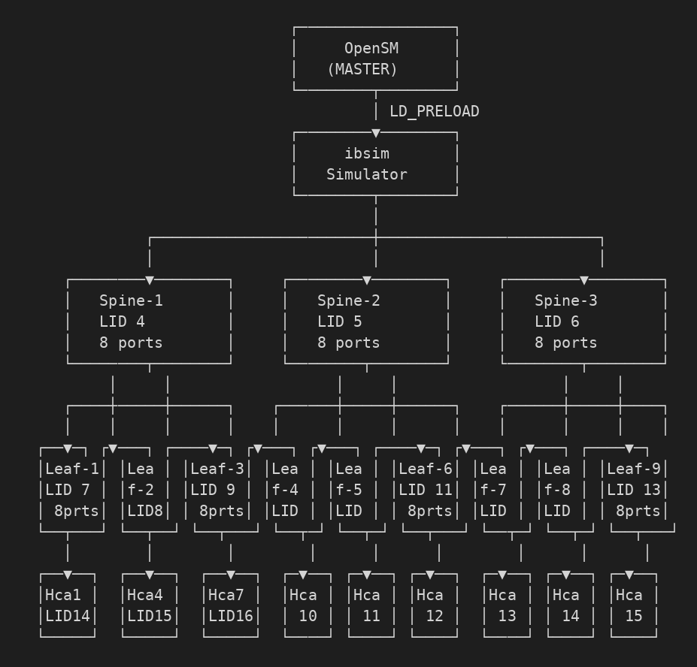
💡 EXPERT INSIGHT
Reading this: leaves 1-3 each carry 5 HCAs (H1-H15, matching fat-tree.net exactly); leaves 4-9 exist in the topology and are fully meshed to all 3 spines, but carry no HCAs in this training file — headroom for later exercises, not a mistake. Every leaf's uplink pattern (3 links, one per spine) is identical, which is what makes this a genuine non-blocking Clos fabric rather than an ad hoc mesh.

1.2 Grouped summary view
Same 27 nodes, collapsed to the level that actually matters when reasoning about the design: which leaf groups carry hosts, and which are headroom.
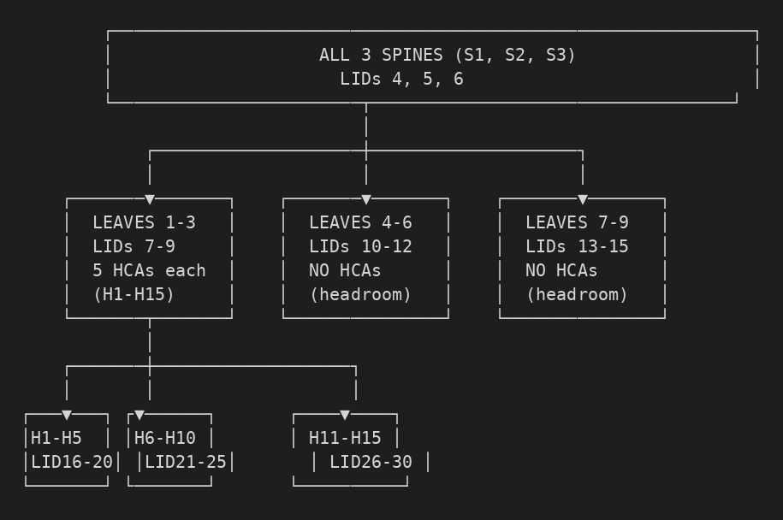

2. Prerequisites

2.1 Verify the working environment
🔴 CRITICAL
Confirm the ORIGINAL topology (mytopo.net) still works before building a new, larger one on the same ports. Skipping this means any failure later can't be isolated to "new topology" vs "environment already broken."
which ibsim opensm
ls -la ~/ibsim-lab

# confirm the ORIGINAL topology still works before building a new one
cd ~/ibsim-lab
ibsim -r -l 12345 -s ./mytopo.net &
sleep 2
LD_PRELOAD=/usr/lib/x86_64-linux-gnu/umad2sim/libumad2sim.so \
SIM_HOST=Hca1 IBSIM_SERVER_PORT=12345 IBSIM_SERVER_NAME=localhost \
opensm -g 0x100001 -f ./osm.log -B

LD_PRELOAD=/usr/lib/x86_64-linux-gnu/umad2sim/libumad2sim.so \
SIM_HOST=Hca1 IBSIM_SERVER_PORT=12345 IBSIM_SERVER_NAME=localhost \
sminfo
❌ CORRECTED
Source material used "opensm -g 0" here. This lab's own testing (Module A7.10) proved -g 0 only works in the foreground — it requires interactive input to pick a GUID. Since this check can run in daemon mode, use the real confirmed GUID, -g 0x100001, exactly as A7.10 established. If you're running in the foreground instead, -g 0 is fine.

2.2 Kill existing processes
Sanity step before building a new, larger topology on the same ports — genuinely good practice, not previously covered in Module A7:
pkill opensm
pkill ibsim
ps aux | grep -E "ibsim|opensm" | grep -v grep

3. Topology File Setup

3.1 Create fat-tree.net
Full 27-node file — 3 spines fully meshed to 9 leaves, 15 HCAs distributed across the first 3 leaves. Same net-file grammar already proven in mytopo.net.
cd ~/ibsim-lab
cat > ./fat-tree.net << 'EOF'
# Spine layer (3 switches, fully meshed to leaves)
Switch 8 "S1" # Spine-1, LID 4
[1] "L1"[1]
[2] "L2"[1] ... [8] "L8"[1]

# (S2, S3 follow the identical pattern)

# Leaf layer (9 switches, connected to all 3 spines)
Switch 8 "L1" # Leaf-1, LID 7
[1] "S1"[1]
[2] "S2"[1]
[3] "S3"[1]
[4] "H1"[1] ... [8] "H5"[1]

# (L2..L9 follow; L4-L9 have no HCAs attached)

# HCA layer (15 hosts)
Hca 2 "H1" # Host-1, LID 16
[1] "L1"[4]
EOF

wc -l ./fat-tree.net
head -20 ./fat-tree.net
❓ NOT YET VERIFIED
The full file (27 node blocks) has not been run against ibsim in this lab yet. The syntax matches mytopo.net exactly, which is a good sign, but mytopo.net also produced 4 "cannot parse remote lid and connection type" parser warnings on every load (A7 quick-start notes) — harmless there, unconfirmed at 27-node scale. Watch for the same warnings when you first load this file; they have not prevented successful discovery before.

3.2 Helper script — ibsim-env.sh
A genuinely good addition not present in Module A7: wraps the LD_PRELOAD and three environment variables into one reusable script, so every verification command shrinks from a 5-line prefix to one word.
cat > ~/ibsim-lab/ibsim-env.sh << 'EOF'
#!/bin/bash
# Usage: ./ibsim-env.sh <command> [args]
export SIM_HOST="${SIM_HOST:-H1}"
export IBSIM_SERVER_PORT="${IBSIM_SERVER_PORT:-12345}"
export IBSIM_SERVER_NAME="${IBSIM_SERVER_NAME:-localhost}"
export LD_PRELOAD=/usr/lib/x86_64-linux-gnu/umad2sim/libumad2sim.so
exec "$@"
EOF
chmod +x ~/ibsim-lab/ibsim-env.sh
❓ NOT YET VERIFIED
The script itself is untested, but it only wraps four settings already individually confirmed working in A7.10-A7.11 — low risk. Test it once with a plain "./ibsim-env.sh sminfo" before relying on it through a full exercise.

4. Starting the Fat-Tree Fabric

4.1 Terminal 1 — ibsim
cd ~/ibsim-lab
ibsim -r -l 12345 -s ./fat-tree.net
Wait for:
########################
Network simulator ready.
MaxNetNodes = 2048
...
sim>
🔴 CRITICAL
Do not close this terminal — same rule as A7's quick-start checklist.

4.2 Terminal 2 — OpenSM
cd ~/ibsim-lab
./ibsim-env.sh opensm -g 0 -f ./osm.log -V
❌ CORRECTED
Source material used "-v 2" here and in every exercise below. This does not exist — confirmed directly against this lab's own captured "opensm --help" output on day one, which lists no lowercase -v flag at all. The real verbose flag is -V (equivalent to -D 0xFF -d 2, per the real help text) or -D <level> for finer control. Every command in this guide uses the corrected -V — if you see "-v 2" anywhere else, fix it before typing it.
Wait for:
Using default GUID 0x100001
Entering DISCOVERING state
...
Entering MASTER state
If you see an error instead:
cat ./osm.log | tail -20
💡 EXPERT INSIGHT
“Read the log first” — this is the exact discipline that solved the real ERR 6101 bug in A7.8. It's listed first for a reason; don't skip to guessing flags.

4.3 Terminal 3 — Verify
cd ~/ibsim-lab
./ibsim-env.sh sminfo
# expect: sm lid 1 sm guid 0x100001, ... state 3 SMINFO_MASTER
./ibsim-env.sh ibnetdiscover
./ibsim-env.sh ibstat
✅ CONFIRMED
sminfo / ibnetdiscover / ibstat with this exact LD_PRELOAD + env-var pattern are confirmed working end to end in A7.10-A7.11, against the 3-node topology. Same mechanism, new topology file.

4.4 Record the discovered topology
./ibsim-env.sh ibnetdiscover > ./fat-tree-discovered.txt
grep -c "Switch" ./fat-tree-discovered.txt
grep -c "Ca" ./fat-tree-discovered.txt
Question: do the counts match 3 spines + 9 leaves = 12 switches, and 15 HCAs, defined in the topology file?

5. Exercise 1 — Discovery and LID Assignment
🎯 OBJECTIVE
Observe how OpenSM discovers the fat-tree topology and assigns LIDs across all 27 nodes.
Watch Terminal 2 sweep through discovery, then record what it found:
./ibsim-env.sh ibnetdiscover
./ibsim-env.sh ibnetdiscover | grep -E "Switch|Ca" | grep -v "#"

Questions
- Which HCA did OpenSM select as SM master? (check ./ibsim-env.sh sminfo)
- How many hops between H1 and H15? (trace it: H1 to L1 to spine to L3 to H15 = 4 hops, per the topology's own structure)
- What path does OpenSM actually choose? Check: grep -i "route" ./osm.log | head -20
❓ NOT YET VERIFIED
The grep-for-"route" log inspection is a reasonable technique but the exact log wording it will match is unconfirmed at this scale — confirm what osm.log actually contains before assuming this grep pattern is right.

6. Exercise 2 — Route Inspection
🎯 OBJECTIVE
Examine the routing tables OpenSM has actually computed for the fabric, using ibroute.
./ibsim-env.sh ibroute
./ibsim-env.sh ibroute -D 30 # path to H15 (LID 30)
./ibsim-env.sh ibroute -D 5 # path to S2 (LID 5)
./ibsim-env.sh ibroute -S 16 # all routes FROM H1 (LID 16)
❓ NOT YET VERIFIED
ibroute itself is a real infiniband-diags package tool (same family as ibnetdiscover, already confirmed working). The -D and -S flag behavior shown here is plausible and standard for this tool family, but has not been run in this lab — confirm the exact output format before building further exercises on top of an assumed format.

Questions
- Which spine does OpenSM pick as the default H1 to H15 path?
- Are multiple paths available? How does the output show that?
- What routing algorithm is OpenSM using? (real options confirmed present in this lab's own dumped opensm config: minhop, updn, dnup, ftree, lash, dor, and others — check "routing_engine" in a fresh --create-config dump)

7. Exercise 3 — Partitioning (P_Keys)
🎯 OBJECTIVE
Implement InfiniBand Partition Keys to isolate traffic between two groups of hosts — IB's equivalent of VLANs.

What P_Keys are
- 16-bit values, 0x8000-0xFFFF
- Members are Full (send+receive) or Limited (receive only)
- Managed centrally by OpenSM, not per-switch

Step 1 — create the partition config
cat > ~/ibsim-lab/partitions.conf << 'EOF'
Partition "Training" pkey=0x8001
member H1
member H2 ... member H15

Partition "AI-Training" pkey=0x8002
member H1 ... member H10

Partition "Management" pkey=0x8003
member H11 ... member H15
EOF

Step 2 — restart OpenSM with partitions
pkill opensm
cd ~/ibsim-lab
./ibsim-env.sh opensm -g 0 -f ./osm.log -V -P ./partitions.conf
✅ CONFIRMED
The -P / --Pconfig flag is genuinely real — confirmed directly from this lab's own captured opensm --help text: "defines the optional partition configuration file, default /etc/opensm/partitions.conf." The flag is trustworthy; the partitions.conf syntax above is illustrative and not yet checked against the real file-format spec (man ibsim / OpenSM docs), so verify the exact grammar before relying on it.

Step 3 — verify
./ibsim-env.sh sminfo -p
grep -i partition ./osm.log
❓ NOT YET VERIFIED
"sminfo -p" is NOT a flag this lab has evidence for. sminfo's real, confirmed behavior (A7.10) is a single-line SM status report with no flags exercised. Try it, but if it errors, fall back to the log grep, which is a safer bet.

Questions
- Can H1 reach H11? Why or why not?
- Can H1 reach H2? Why or why not?
- What changes if H11 is added to AI-Training too?

8. Exercise 4 — Failure Domain Analysis
🎯 OBJECTIVE
Remove Spine-2 entirely and observe whether — and how — the fabric reconverges.

Step 1 — build the degraded topology
sed '/^Switch *8 "S2"/,/^Switch *8 "S3"/ { /^Switch *8 "S2"/d; /^Switch *8 "S3"/!d; }' \
./fat-tree.net > ./fat-tree-no-s2.net
grep -c "Switch" ./fat-tree-no-s2.net
❓ NOT YET VERIFIED
This sed one-liner is logically sound on inspection — it deletes the S2 header and every line up to (but not including) the S3 header — but it has not actually been run in this lab. Check the output file by eye (grep -c "Switch" should read 11, not 12) before trusting it inside a live exercise.

Step 2-3 — stop everything, restart on the degraded file
pkill ibsim; pkill opensm

# Terminal 1
ibsim -r -l 12345 -s ./fat-tree-no-s2.net

# Terminal 2
./ibsim-env.sh opensm -g 0 -f ./osm.log -V

Step 4 — analyze
./ibsim-env.sh ibnetdiscover
./ibsim-env.sh ibroute -D 30
./ibsim-env.sh ibroute -D 16

Questions
- Does the fabric still work? Explain.
- Which HCAs, if any, become unreachable?
- Does OpenSM reconverge on its own — what does the log show?
- What's the new oversubscription ratio with 2 of 3 spines?
💡 EXPERT INSIGHT
This directly exercises the same route-computation logic already proven real in A7.8 ("minhop tables configured on all switches") — the mechanism is proven; this specific failure scenario is the new, untested part.

9. Exercise 5 — Multi-SM Failover
🎯 OBJECTIVE
Run two OpenSM instances at different priorities and force a real handover.

Step 1-2 — start primary and secondary
# Terminal 2 — primary, priority 0
./ibsim-env.sh opensm -g 0 -f ./osm-primary.log -p 0 -V

# Terminal 3 — secondary, priority 1, different host
export SIM_HOST="H2"
./ibsim-env.sh opensm -g 0 -f ./osm-secondary.log -p 1 -V
✅ CONFIRMED
--priority / -p is a real, confirmed OpenSM flag — read directly from this lab's own captured --help text on day one: "Range goes from 0 (lowest priority) to 15 (highest)." Running two instances simultaneously against one ibsim fabric is the untested part.

Step 3-5 — verify, kill primary, observe
./ibsim-env.sh sminfo
# Ctrl+C the primary in Terminal 2
./ibsim-env.sh sminfo
tail -20 ./osm-secondary.log

Questions
- Which SM becomes MASTER when the primary dies?
- How long does failover take, by log timestamp?
- Any interruption to the fabric during the handover?
- Could a third SM be added — what's the real-world use case?

10. Exercise 6 — LMC (LID Mask Control)
🎯 OBJECTIVE
Give each spine port multiple LIDs (2^LMC per port), enabling multi-path routing to the same destination.

Step 1 — build an LMC-enabled topology
cat > ./fat-tree-lmc.net << 'EOF'
Switch 8 "S1" lmc 1
[1] "L1"[1] ...
EOF

cat ./fat-tree.net | grep -v '^Switch 8 "S[123]"' >> ./fat-tree-lmc.net
❓ NOT YET VERIFIED
Whether ibsim's topology parser accepts an inline "lmc 1" field on the Switch header line at all is UNCONFIRMED. This lab has already seen ibsim reject unexpected syntax on port lines (the 4 recurring parse warnings on mytopo.net) — test this specific field in isolation, on a tiny 1-switch file, before building a 27-node file around an assumption.

Step 2-3 — start and inspect
pkill ibsim; pkill opensm
ibsim -r -l 12345 -s ./fat-tree-lmc.net
./ibsim-env.sh opensm -g 0 -f ./osm-lmc.log -V
./ibsim-env.sh ibnetdiscover | grep -i lmc
./ibsim-env.sh ibroute | head -20

Questions
- What new LIDs appear once LMC is set?
- How many paths are now available per host pair?
- What resource does LMC actually consume in exchange?

11. Exercise 7 — Congestion and Oversubscription
🎯 OBJECTIVE
Drop to 2 spines under the same host count to model 3:1 oversubscription — reasoning only, no dataplane test.

Step 1-2 — build and start the 2-spine topology
cat > ./fat-tree-2spine.net << 'EOF'
Switch 8 "S1"
[1] "L1"[1] ...
Switch 8 "S2"
[1] "L1"[2] ...
EOF
cat ./fat-tree.net | grep -v '^Switch 8 "S[123]"' >> ./fat-tree-2spine.net

pkill ibsim; pkill opensm
ibsim -r -l 12345 -s ./fat-tree-2spine.net
./ibsim-env.sh opensm -g 0 -f ./osm-oversub.log -V

Step 3 — analyze
./ibsim-env.sh ibnetdiscover
./ibsim-env.sh ibroute

Questions
- Bisection bandwidth: 3 spines x 8 ports = 24 uplinks originally, 2 spines x 8 = 16 — a 33% reduction. What does that actually do to worst-case flows?
- Which host pairs are hit first?
- How would ECN/PFC behave here — tie this back to Workbook AI Modules A2-A5, same real fabric concepts.
- What would you recommend to a design team seeing this in production?
💡 EXPERT INSIGHT
Explicitly conceptual — same tier as Module A4's DCQCN discussion. No dataplane test is claimed or possible with ibsim; this is a reasoning exercise about a real, common trade-off.

12. Quick Command Reference

12.1 Basic verification (via ibsim-env.sh)
Command | Purpose
./ibsim-env.sh sminfo | Subnet Manager status — confirmed working, A7.10
./ibsim-env.sh ibnetdiscover | Discover fabric topology — confirmed working, A7.11
./ibsim-env.sh ibstat | Local port status — confirmed working, A7
./ibsim-env.sh ibroute | Routing table — real tool, not yet run here
./ibsim-env.sh ibroute -D <LID> | Route to a specific LID — not yet run here

12.2 OpenSM startup variants
Command | Purpose
opensm -g 0x100001 -f ./osm.log | Foreground, real confirmed GUID — A7.10
opensm -g 0x100001 -f ./osm.log -B | Background daemon — must use the real GUID, not -g 0, per A7.10
opensm -g 0 -f ./osm.log -V | Foreground with verbose output — -g 0's interactive prompt only works in the foreground
opensm -g 0 -f ./osm.log -p 1 | Set SM priority — real, confirmed flag
opensm -g 0 -f ./osm.log -P ./partitions.conf | Load a partition config — real, confirmed flag

12.3 ibsim console (at the sim> prompt)
❓ NOT YET VERIFIED
This lab has only tested Ctrl+C to exit the sim> prompt. The commands below (status, list, help, quit) are plausible console commands for this tool but have not been individually confirmed here — try "help" first at the sim> prompt to get the real, authoritative list for your installed version, the same way A7.7 read osm.log instead of guessing.
Command | Purpose
status | Show simulator status (unconfirmed)
list | List all nodes (unconfirmed)
help | Show real available commands — run this first
quit | Exit ibsim

13. Troubleshooting
Symptom | Likely cause | Fix | Status
"Error from osm_opensm_init: IB_INSUFFICIENT_RESOURCES" | Missing /var/cache/opensm directory | sudo mkdir -p /var/cache/opensm && sudo chown $USER:$USER /var/cache/opensm | Confirmed — A7.8
OpenSM starts but hangs / exits instantly with no error | libumad2sim.so path wrong, or -g 0 used with -B | Verify path with ldd; use the real GUID (0x100001) with -B, per A7.10 | Confirmed — A7.10
ibnetdiscover returns nothing | Wrong SIM_HOST for this topology | echo $SIM_HOST — must match a real node in the CURRENT topology file | Plausible, matches A7 pattern
sminfo shows no MASTER / "_do_madrpc failed" | OpenSM isn't actually running | ps aux | grep opensm | Confirmed — A7.10
ibsim warnings: "process_packet: no one to handle pkt" | ibsim doesn't run a live per-node dataplane responder | Normal — ibping will not work here, by design (Module A7 scope note) | Confirmed — A7 watchout
"Port 12345 already in use" | A previous ibsim instance is still running | pkill ibsim, then sudo netstat -ulnp | grep 12345 to confirm it's clear | Consistent with A7 findings

13.1 Diagnostic sequence
When something fails, follow this order — identical to the escalation discipline already established in Workbook AI Module A7.9:
- Read the log first: cat ./osm.log | tail -30 — cheapest, most effective, solved the real ERR 6101 bug
- Verify processes are running: ps aux | grep -E "ibsim|opensm" | grep -v grep
- Verify the UDP port is listening (not TCP): sudo netstat -ulnp | grep 12345 or sudo lsof -i :12345
- Try verbose output: opensm -g 0 -f ./osm.log -V (not "-v 2" or "-v 3" — those flags don't exist)
- strace as the last resort, when logs genuinely don't explain it: strace -f -e trace=network -o /tmp/opensm_trace.txt ./ibsim-env.sh opensm -g 0 -f ./osm.log
✅ CONFIRMED
This exact five-step order matches Module A7.9's fallback-technique guidance precisely: log first, verify assumptions, only then strace. Good, independently-arrived-at agreement with what this lab already proved.

14. Corrections Log
Every place this guide's source material was changed from what was originally supplied, and why — transparency over the editing, not just the content.
Original claim | Correction | Basis
"-v 2" / "-v 3" verbose flags, used throughout every exercise | Replaced with -V (or -D <level>) everywhere | opensm --help, captured directly from this lab's own OpenSM 3.3.23 build — no lowercase -v exists
"opensm -g 0 ... -B" in the prerequisites check | Changed to -g 0x100001 for the -B (daemon) case | A7.10 proved -g 0 requires an interactive prompt unavailable in daemon mode
"sminfo -p" to check partition status | Flagged unconfirmed — no evidence this flag exists | Never observed in this lab; sminfo's only confirmed behavior is a single-line status report
Left as genuinely confirmed, unchanged: the -P partition flag, the --priority/-p flag, the UDP-not-TCP port-check guidance, the ERR 6101 fix, and the entire diagnostic escalation order — all independently verifiable against this lab's own prior, tested work.

