**FOLDER STRUCTURE APPLICATION**

**What is the project?**

It is a CLI based application, which can be used to ADD, VIEW, DELETE and FILTER folder structures. The folders could have subfolders and files of different types.

**How to run this application?**

Prerequisites:

1. MYSQL
2. Python3

List of queries to run in MySQL:

1. *CREATE SCHEMA `folder_structure` ;*
2. *CREATE TABLE `folder_structure`.`folders` (*

*`folder_id` INT NOT NULL AUTO_INCREMENT,*

*`parent_id` INT,*

*`name` VARCHAR(128) NOT NULL,*

*`created_time` DATETIME NOT NULL,*

*`updated_time` DATETIME NOT NULL,*

*`size` INT NOT NULL,*

*`type` VARCHAR(45) NULL,*

*PRIMARY KEY (`folder_id`),*

*FOREIGN KEY (`parent_id`) REFERENCES folders(`folder_id`)*

*ON DELETE CASCADE*

*);*

1. *INSERT INTO `folder_structure`.`folders` (`parent_id`, `name`, `created_time`, `updated_time`, `size`) VALUES (NULL, 'root', ' 2021-05-18 16:15:33', ' 2021-05-18 16:15:33', '1');*

Python Libraries to install:

* *pip install MySQL-python*

Command to start the application:

*python main.py*

**Motivation behind design choices**

**Code structure:**

I have decoupled the functionality into multiple modules, so that any future changes in a functionality doesn’t affect other modules extensively.

Created common.py, which includes all the general functions used by other modules for code reusability.

**Data structure:**

Since the application is based on file system and requires traversing, I have used Tree data structure implemented using python dictionary

**DB:**

I have used single self-referencing table to store the folder structure.

**To be continued 🡪**

**Working example of the application**

1. View/add

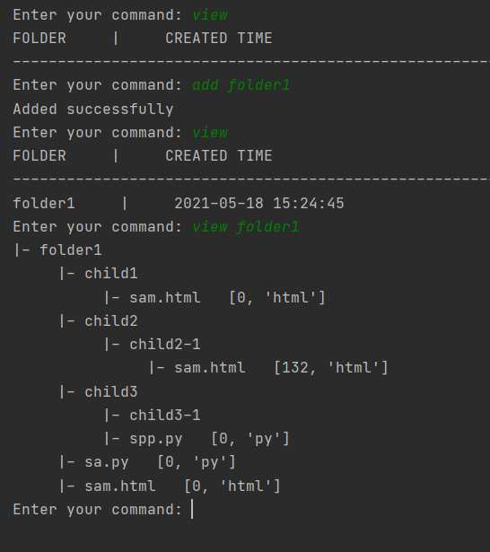

Sample folder structure

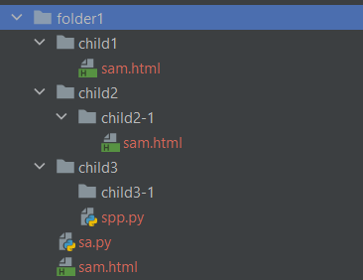

1. Filter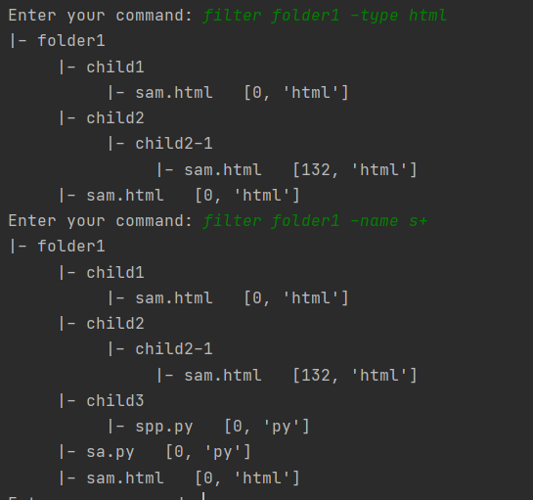
2. Delete

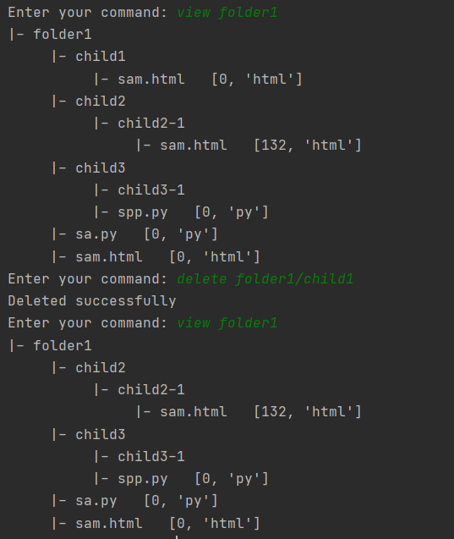

Known issue:

* Folder names with space and “.” in between throws error