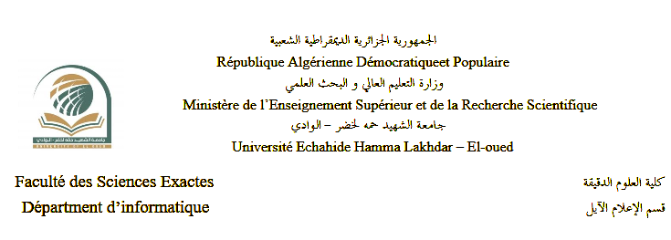

Thesis
Presented for the attainment of a license
Degree in computer science

Presented By : Bekkari Haithem

Drihem Abdelmoumen

Theme

A mobile app for police to track car status

Supervised by : Mohammed Amine Yagoub

Academic Year : 2024/2025

Résumé
The objective of our final year project, presented in this report, is the design and development of a mobile application dedicated to the police for tracking and managing the status of vehicles. This project aims to address several issues, such as the quick verification of vehicle information, real-time detection of infractions, and the optimization of law enforcement interventions.
The application will enable police officers to instantly access registered vehicle information, report anomalies, and facilitate the verification of administrative documents. With an intuitive and user-friendly interface, the application will simplify data management and enhance the efficiency of police services.
For the design, we used the UML modeling language, while the database management is handled by a MySQL server.
Keywords : Mobile Application, Police, Vehicle Management, Services, Car Status Tracker, SQL, MySql, Kotlin, Jetpack Compose, Adobe Figma, Node.js, Express, Railway(for api deployment).

(الفهرس لم يتم انجازه بعد)

Contents
1 Introduction 1
1.1 Aims and Objectives . . . . . . . . . . . . . . . . . . . . . . . . . . . . . . 3
1.2 Project Timeline . . . . . . . . . . . . . . . . . . . . . . . . . . . . . . . . . 4
2 Literature review 7
2.1 An interesting topic . . . . . . . . . . . . . . . . . . . . . . . . . . . . . . . 8
2.1.1 Lots of details about this topic . . . . . . . . . . . . . . . . . . . . . 9
3 Theory 11
3.1 Mathematics . . . . . . . . . . . . . . . . . . . . . . . . . . . . . . . . . . 11
3.2 Plotting in LATEX . . . . . . . . . . . . . . . . . . . . . . . . . . . . . . . . 12
3.3 Diagrams in LATEX . . . . . . . . . . . . . . . . . . . . . . . . . . . . . . . . 14
3.4 Displayed code in LATEX . . . . . . . . . . . . . . . . . . . . . . . . . . . . . 15
Notation 17
A This is the first appendix 19
A.1 Safety . . . . . . . . . . . . . . . . . . . . . . . . . . . . . . . . . . . . . . 19
A.2 Additional Calculations . . . . . . . . . . . . . . . . . . . . . . . . . . . . . 20
A.3 Code . . . . . . . . . . . . . . . . . . . . . . . . . . . . . . . . . . . . . . . 20
A.31 Code example from file - basic style . . . . . . . . . . . . . . . . . . 21

Introduction
Today, the world is witnessing significant technological advancements in all sectors, particularly in road safety and vehicle tracking. Modern technologies now enable law enforcement agencies to use mobile applications to monitor and manage vehicle status in real time.
Police officers often face numerous challenges, such as quickly identifying vehicles, verifying documents, and detecting infractions. Thanks to computing and web services, it is now possible to enhance the efficiency of these operations by automating the process of vehicle control and tracking.
In this context, we have been led to design, develop, and implement a mobile application dedicated to vehicle management by the police. This application aims to centralize information, provide instant access to vehicle data, and facilitate officers' interventions in the field.
Our application is designed to improve vehicle management and optimize law enforcement operations to enhance the reliability of inspections, reduce response times, and minimize human errors.
This project consists of three chapters presented as follows:
- The first chapter is dedicated to the theoretical presentation and functional requirements.
- Chapter II provides several UML diagrams and specifications.
- Chapter III allows for the visualization and understanding of different system interfaces.
Finally, we will conclude this report with a summary of the work accomplished and an introduction to future perspectives for this project.

Section 1: System Context

1. Introduction
This chapter provides a general overview of the work context and the objectives of our final year project. We will begin by outlining some of the challenges faced by law enforcement and the importance of an information system for police operations.

2. Challenges in Police Operations
Law enforcement agencies often encounter various difficulties when managing vehicle-related data, including:
- Difficulty in searching for vehicle records manually.
- Time-consuming processes leading to delays in operations.
- Risk of document loss or damage in paper-based systems.
- Limited storage capacity for physical records.
- Inaccurate or outdated record-keeping.
- Challenges in statistical analysis and reporting.
- Difficulty in accessing real-time vehicle information.
- Lack of an efficient system for verifying license plates and retrieving related data.

3. Role of an Information System for Law Enforcement
A digital system can significantly improve police operations by offering:
- Automatic license plate recognition and vehicle status tracking.
- Quick and efficient vehicle information retrieval.
- Secure storage of police records with encryption.
- Integration with external databases (e.g., insurance, stolen vehicles, tickets).
- Real-time data updates and synchronization.
- Enhanced communication between police departments and external entities.

How the Police Monitor Vehicle Condition and Detect Violations
Monitoring the condition of vehicles is a key responsibility of the police to ensure road safety and reduce accidents. Police officers rely on a set of documents and standards to determine whether a vehicle complies with traffic laws. This document highlights five main factors that help the police monitor vehicle condition and detect potential violations.
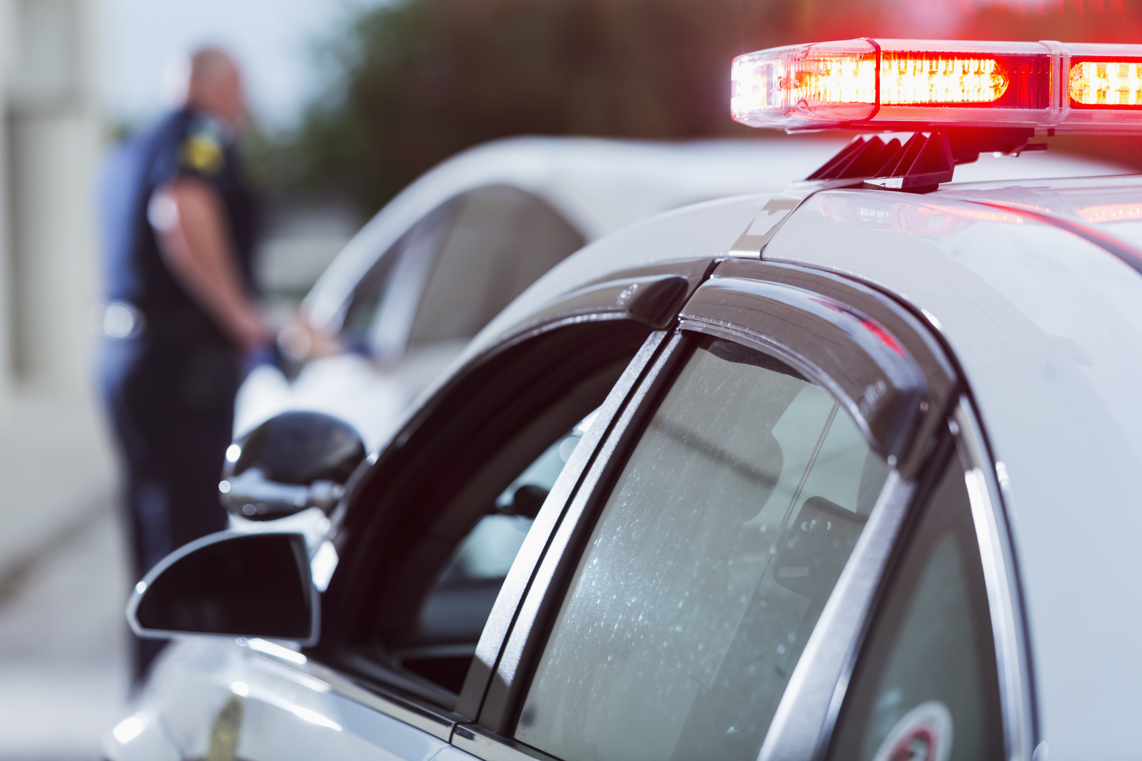

1. Driver's License
The driver's license is an essential document that drivers must carry while driving. The police verify the validity of the license to ensure that the driver is legally qualified to operate a vehicle. If the license is expired or invalid, it is considered a violation.

2. Vehicle Registration Certificate
The vehicle registration certificate (also known as the gray card) proves ownership of the vehicle and contains important information such as the chassis number and engine number. The police check this document to confirm that the vehicle is legally registered and not stolen. Any discrepancies or tampering with the information can result in fines.
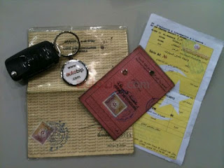

3. Insurance Certificate
A valid insurance certificate is a legal requirement for drivers. The police verify the presence of an active insurance policy, as driving without insurance is a legal violation. Insurance protects both drivers and pedestrians in the event of an accident.
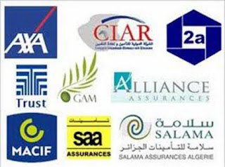

4. Periodic Technical Inspection
Laws in many countries require vehicles to undergo regular technical inspections to ensure their safety and efficiency. The police check for a valid technical inspection certificate to confirm that the vehicle meets the required mechanical and safety standards. Failing to undergo periodic inspections can result in penalties.

5. Tax Receipt
The tax receipt serves as proof that the necessary vehicle taxes have been paid. The police verify this document to ensure that the driver complies with financial regulations related to vehicle ownership. Failure to pay taxes can lead to fines or even vehicle impoundment.

The police rely on these five key documents and standards to maintain road safety and ensure that all drivers comply with traffic laws. It is essential for drivers to keep their documents valid and up to date to avoid violations and penalties.

Simple Diagram Shwocasing diffirent possible dirvers violations

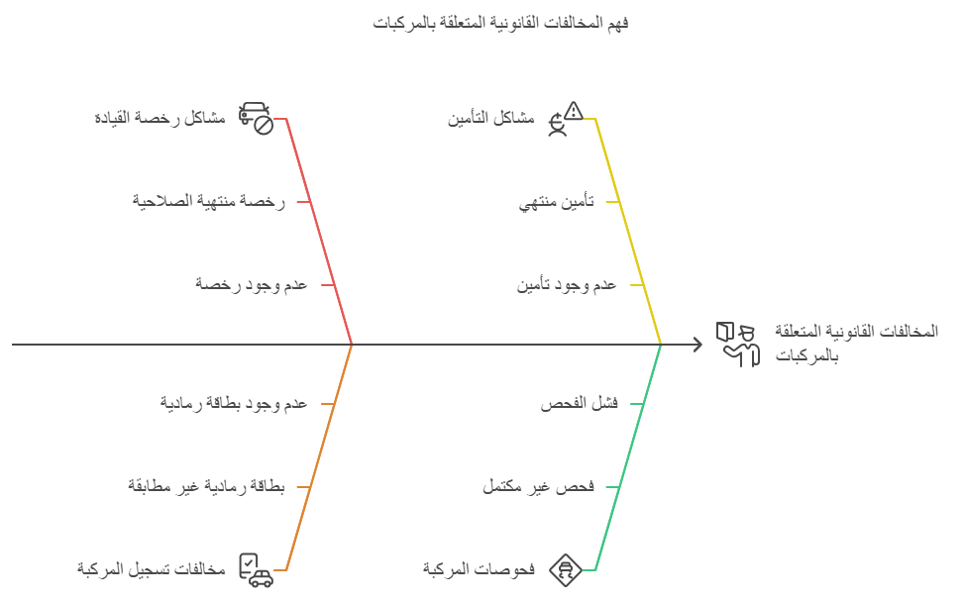

Conclusion
Manual vehicle inspection management is a time-consuming task prone to errors. Integrating a mobile system not only simplifies these operations but also significantly enhances the efficiency of law enforcement. Therefore, implementing this application is essential for modernizing and optimizing the work of police officers.

Section 2 :Conception de systéme

1. Introduction:
In this chapter, we will present the design of our system. We will use the UML toolbox while respecting the UP unification process, namely: the use case diagram, the sequence diagram, and the class diagram.

2. Needs Analysis:
2.1 Definition of UML:
UML (Unified Modeling Language) is an object-oriented modeling language or formalism that represents a way to specify and respect the components of an information system.

2.2 Using the UML approach to model a mobile app for police to track car status:
In this part of the work, we try to model as many fragments as possible from the car status tracking domain for police through the mobile application.
The use case diagrams and sequence diagrams used only present the use cases and system interactions with different actors such as officers and traffic management. The internal system processing and system structure will be described in detail in other diagrams.

2.3 Identification of Actors
An actor represents a role played by an external person or a process that interacts with the system [6].
The actors of our system are:
- The Police Officer: Can be the administrator of the system. He can manage the daily car tracking tasks. He can add, modify, or delete car status information, traffic violations, and car-related data. He can also search for car status and consult reports.
- Traffic Management Department: Can verify car status, generate reports, and search for registered cars.
- Car Owner: Can consult the car status, view fines or violations, and request updates or corrections to the information.

User | Role
Traffic Management | - Add a new car.  - Search and consult car status.  - Search and consult violations.
 | - Manage traffic violations.  - Manage car reports.  - Manage car-related data.
  Police Officer
 | - Consult car status.
  Car Owner

Table 1: Table of roles for traffic management, police officer, and car owner

2.4 Use Case Diagrams:
Definition:
A use case diagram allows representing graphically the use cases. It is the main diagram of the UML model, where the relationship between the user and the objects implemented by the system is ensured.

2.4.1 Cas d’utilisation ” Police Officer” :

Driver's License

Vehicle Registration <<extend>> Certificate

<<extend>>

Police Officer Check Files <<extend>>
Insurance Certificate

<<include>> <<extend>>

<<extend>> Periodic Technical Inspection

Authenticate Tax Receipt

2.4.2 Cas d’utilisation ” Traffic Management” :

Add a new car

Config Files Search and consult car status

Management

Search and consult violations

2.4.2 Cas d’utilisation ” Car Owner” :

Traffic
Management

Consult car status Authenticate

Car Owner

