NIP Project — Submission Template
Pega Platform project · This document is your complete submission
Read this before you start:
1. Fill in Section 1 completely. The Pega application name must follow the format NIP-[Project]-[YourName].
2. Create a new Operator in Pega with your full name and log in as that operator before taking any screenshot.
3. When you create your test case, enter YOUR FULL NAME in the Issue Description (Vehicle) or Movie Name (Movie) field.
4. Complete only the section for your chosen project. Delete the other project section.
5. Paste one screenshot per user story (10 total). Follow the screenshot rules in your selected project section.
6. Answer every question in Sections 3 and 4 in your own words.
7. Save the file using this format: ProjectName_FirstName_LastName.docx. Use VehicleService or MovieTicket as the ProjectName. Examples: VehicleService_Ravi_Kumar.docx or MovieTicket_Ravi_Kumar.docx.

Section 1 — Your Details
Full Name
Email ID (registered on NIP)
Phone Number
College Name
Course (e.g. IT, CS)
State
Project Chosen (Vehicle Service OR Movie Ticket Booking)
Pega Application Name (e.g. NIP-VehicleService-YourName)
Case Type Name (exact)
Pega Instance URL
Operator Name (created in Pega with your full name)

Section 2A — Vehicle Service Management Application
Complete this section only if you selected this project. Delete the other project section before submitting.

Screenshot rules — IMPORTANT before you start:
1. Name your Pega application as: NIP-VehicleService-YourName OR NIP-MovieTicket-YourName
2. Create a new Operator in Pega with your full name (Security → Operators) and log in as that operator.
3. When you create your test case, enter YOUR FULL NAME in the Issue Description (Vehicle) or Movie Name (Movie) field.
4. The logged-in operator name must be visible in every screenshot wherever the Pega interface displays it.
5. The student's full name must be visible in all running-case screenshots.
6. Configuration screenshots must clearly show the relevant application or rule name.
Screenshots that do not show these will not be accepted.

US-001 — Submit Vehicle Service Request
What is expected:
Case created, customer submits Vehicle ID, Vehicle Model, Issue Description. Validation applied.
Screenshot — paste your screenshot below this line:
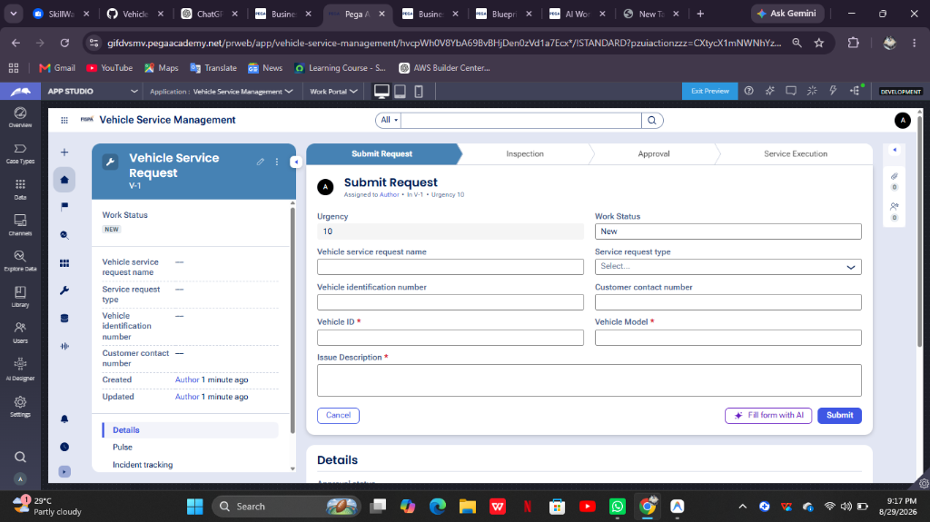

What I built for this (1–2 lines in your own words):
Created Vehicle Service Request case type with Submit Request stage capturing required Vehicle ID, Vehicle Model, and Issue Description (including student name).

US-002 — Perform Vehicle Inspection
What is expected:
Inspection stage with Service Advisor step. Inspection Notes and Condition Rating captured.
Screenshot — paste your screenshot below this line:
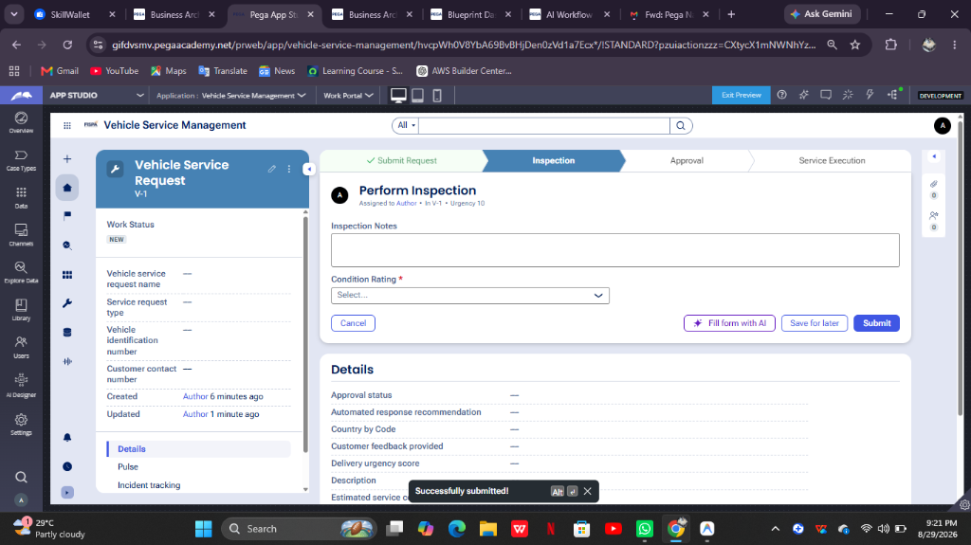

What I built for this (1–2 lines in your own words):
Configured Inspection stage with Perform Inspection step for Service Advisor capturing Inspection Notes and mandatory Condition Rating.

US-003 — Generate Service Estimate
What is expected:
Labor Cost and Parts Cost captured. Total Cost calculated automatically by declare expression.
Screenshot — paste your screenshot below this line:
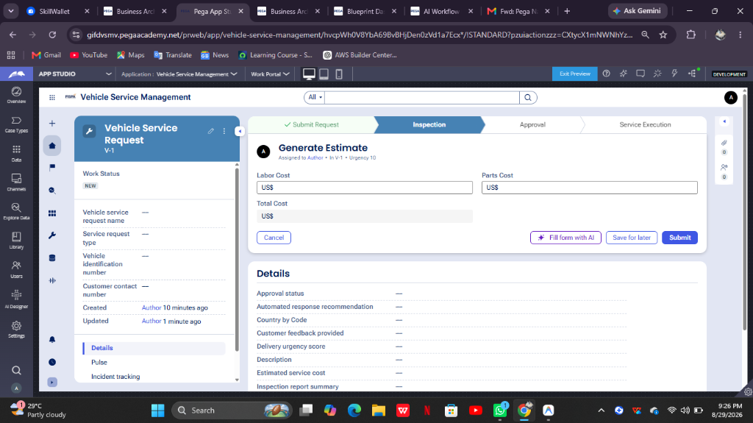

What I built for this (1–2 lines in your own words):
Created Generate Estimate step capturing Labor Cost and Parts Cost with expression rule automatically calculating Total Cost.

US-004 — Approve Service Estimate
What is expected:
Approval stage assigned to Customer. Approval Status captured. Flow branches on approve/reject.
Screenshot — paste your screenshot below this line:
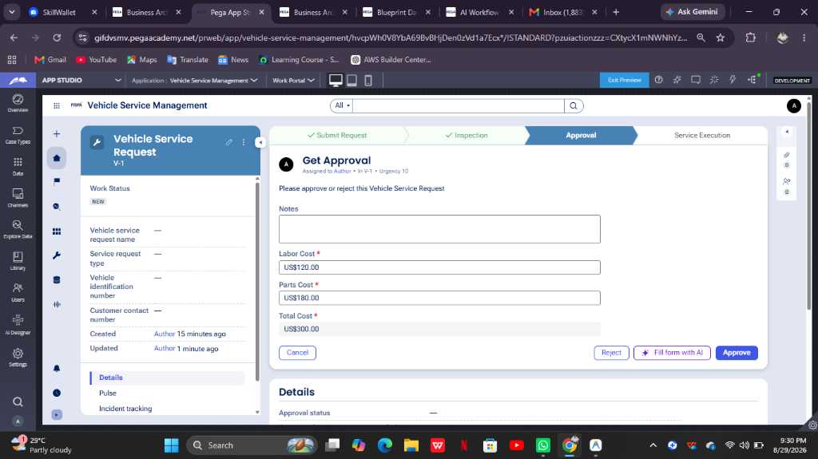

What I built for this (1–2 lines in your own words):
Configured Approval stage with Approve Estimate step assigned to Customer persona with Approve and Reject decision branching.

US-005 — Maintain Vehicle Data
What is expected:
Reusable Vehicle data object created with Vehicle ID, Model, Type — linked to case.
Screenshot — paste your screenshot below this line:
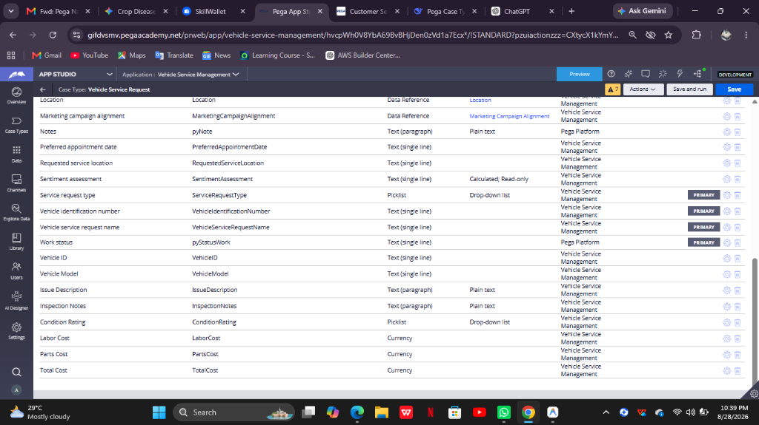

What I built for this (1–2 lines in your own words):
Created reusable Vehicle data object with properties Vehicle ID, Model, and Type associated with the case type.

US-006 — Review Service Estimate
What is expected:
Approval screen shows Labor Cost, Parts Cost and Total Cost clearly to the Customer persona.
Screenshot — paste your screenshot below this line:


What I built for this (1–2 lines in your own words):
Configured Approval view presenting Labor Cost, Parts Cost, and calculated Total Cost in read-only format for Customer review.

US-007 — Auto Assign Technician
What is expected:
Service Execution stage with routing to HeavyVehicleQueue or LightVehicleQueue. Assigned Technician and Service Status properties maintained.
Screenshot — paste your screenshot below this line:
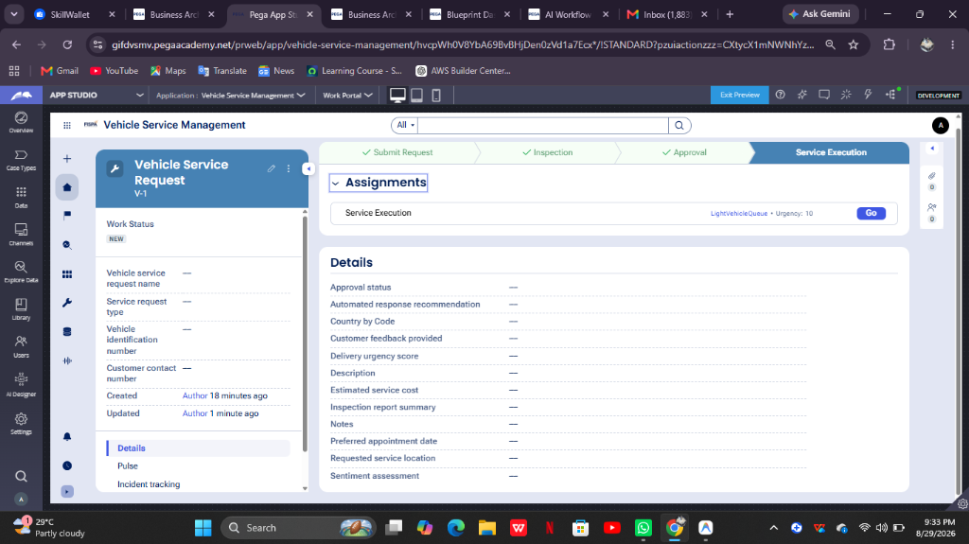

What I built for this (1–2 lines in your own words):
Configured Service Execution stage with assignment routing to Technician work queue and tracking technician status.

US-008 — Notify Service Completion
What is expected:
Correspondence rule created and triggered on case resolution. Email includes case and vehicle details.
Screenshot — paste your screenshot below this line:
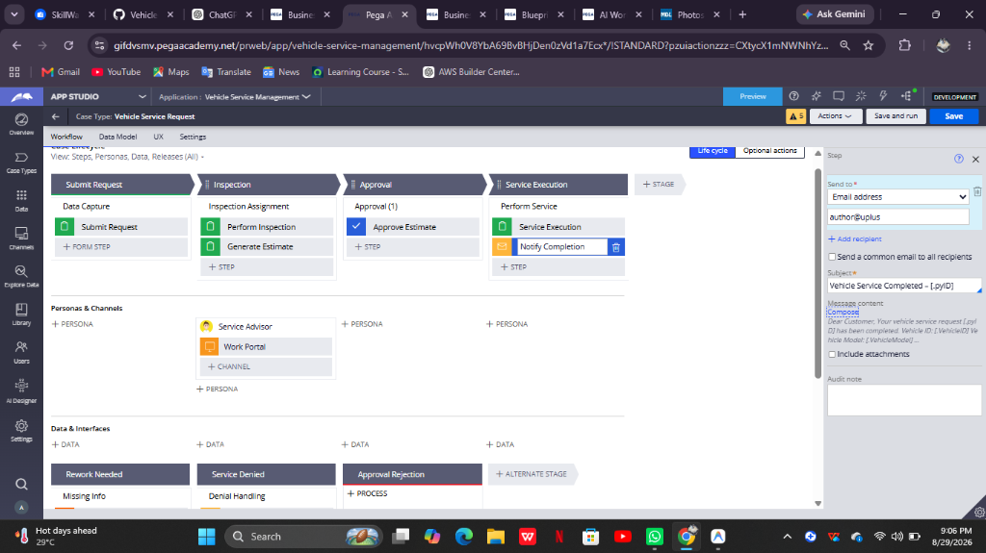

What I built for this (1–2 lines in your own words):
Configured Send Email notification step triggered upon case resolution sending service details and costs to Customer.

US-009 — Define Service SLA
What is expected:
SLA configured on the case type. Goal: 2 days. Deadline: 3 days. Priority increases on breach.
Screenshot — paste your screenshot below this line:
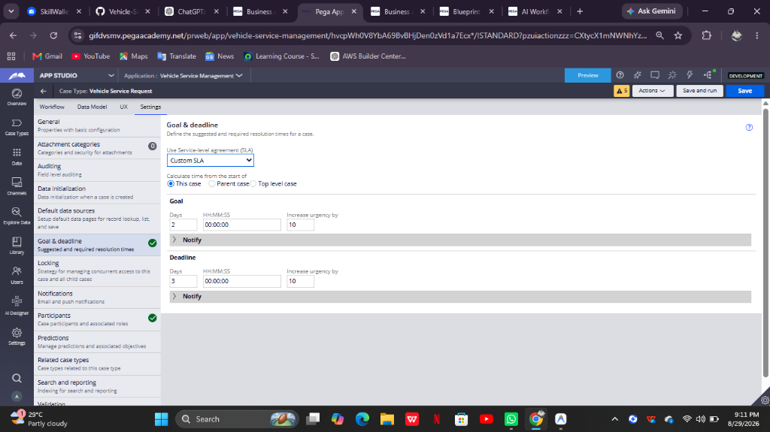

What I built for this (1–2 lines in your own words):
Configured Case SLA with Goal of 2 days and Deadline of 3 days automatically increasing urgency upon breach.

US-010 — Route by Vehicle Type
What is expected:
Routing rule or Decision Table routes to HeavyVehicleQueue or LightVehicleQueue based on Vehicle Type property.
Screenshot — paste your screenshot below this line:
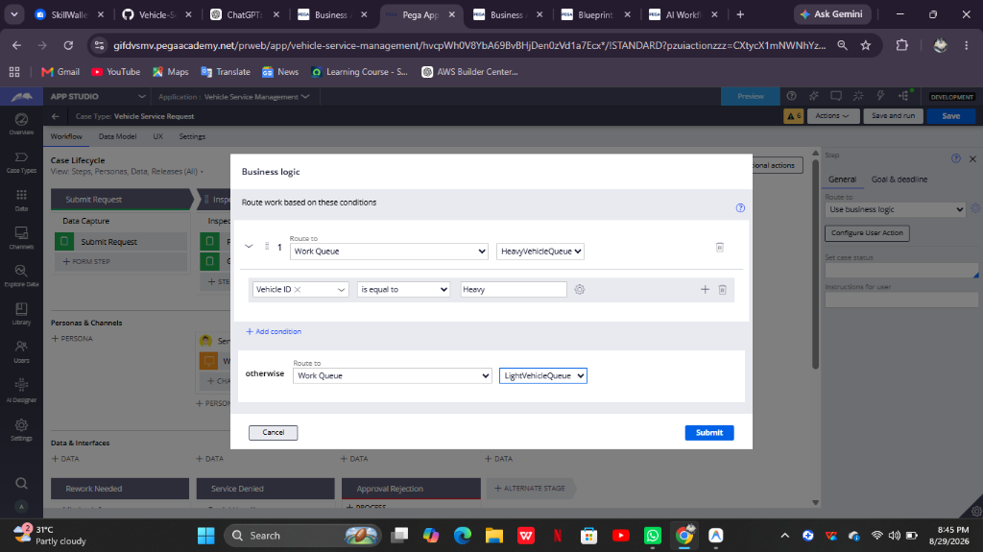

What I built for this (1–2 lines in your own words):
Configured Business Logic routing rule sending heavy vehicles to HeavyVehicleQueue and all others to LightVehicleQueue.

Section 2B — Movie Ticket Booking Management Application
Complete this section only if you selected this project. Delete the other project section before submitting.

Screenshot rules — IMPORTANT before you start:
1. Name your Pega application as: NIP-VehicleService-YourName OR NIP-MovieTicket-YourName
2. Create a new Operator in Pega with your full name (Security → Operators) and log in as that operator.
3. When you create your test case, enter YOUR FULL NAME in the Issue Description (Vehicle) or Movie Name (Movie) field.
4. The logged-in operator name must be visible in every screenshot wherever the Pega interface displays it.
5. The student's full name must be visible in all running-case screenshots.
6. Configuration screenshots must clearly show the relevant application or rule name.
Screenshots that do not show these will not be accepted.

US-001 — Submit Movie Ticket Request
What is expected:
Case created, customer submits Movie Name, Show Date, Show Time, Number of Tickets. Validation applied.
Screenshot — paste your screenshot below this line:
[ Paste screenshot here - follow the screenshot rules above ]

What I built for this (1–2 lines in your own words):
[ Type here ]

US-002 — Check Show Availability
What is expected:
Availability stage. Seat Availability Status and Available Seats Count captured. Booking proceeds only if available.
Screenshot — paste your screenshot below this line:
[ Paste screenshot here - follow the screenshot rules above ]

What I built for this (1–2 lines in your own words):
[ Type here ]

US-003 — Calculate Booking Cost
What is expected:
Total Cost calculated automatically from Ticket Price and Number of Tickets using a business rule.
Screenshot — paste your screenshot below this line:
[ Paste screenshot here - follow the screenshot rules above ]

What I built for this (1–2 lines in your own words):
[ Type here ]

US-004 — Confirm Booking Request
What is expected:
Approval stage assigned to Customer. Booking Status captured. Flow branches on confirm/cancel.
Screenshot — paste your screenshot below this line:
[ Paste screenshot here - follow the screenshot rules above ]

What I built for this (1–2 lines in your own words):
[ Type here ]

US-005 — Maintain Movie and Show Data
What is expected:
Reusable Movie and Show data objects created with Movie Name, Genre, Show Date, Show Time, Seat Capacity — linked to case.
Screenshot — paste your screenshot below this line:
[ Paste screenshot here - follow the screenshot rules above ]

What I built for this (1–2 lines in your own words):
[ Type here ]

US-006 — Review Booking Details
What is expected:
Confirmation screen shows Movie Name, Show Timing, Number of Tickets and Total Cost clearly.
Screenshot — paste your screenshot below this line:
[ Paste screenshot here - follow the screenshot rules above ]

What I built for this (1–2 lines in your own words):
[ Type here ]

US-007 — Process Ticket Booking
What is expected:
Booking Execution stage. Seat Numbers, Ticket ID and Booking Confirmation Status maintained.
Screenshot — paste your screenshot below this line:
[ Paste screenshot here - follow the screenshot rules above ]

What I built for this (1–2 lines in your own words):
[ Type here ]

US-008 — Notify Booking Confirmation
What is expected:
Correspondence rule triggered on case resolution. Email includes movie, show, seat and cost details.
Screenshot — paste your screenshot below this line:
[ Paste screenshot here - follow the screenshot rules above ]

What I built for this (1–2 lines in your own words):
[ Type here ]

US-009 — Define Booking SLA
What is expected:
SLA configured on the case type. Goal: 1 day. Deadline: 2 days. Priority increases on breach.
Screenshot — paste your screenshot below this line:
[ Paste screenshot here - follow the screenshot rules above ]

What I built for this (1–2 lines in your own words):
[ Type here ]

US-010 — Route by Show Type
What is expected:
Routing rule or Decision Table routes to PremiumShowQueue or StandardShowQueue based on Show Type property.
Screenshot — paste your screenshot below this line:
[ Paste screenshot here - follow the screenshot rules above ]

What I built for this (1–2 lines in your own words):
[ Type here ]

Section 3 — About Your Application
These answers are checked against your screenshots. Write exactly what is in your application.

Q1. List your stages in the order they appear in your case lifecycle.
Stage names in order, separated by commas.
Submit Request, Inspection, Approval, Service Execution

Q2. Name the data object(s) you created and the properties inside them.
Data object name and its properties.
Vehicle data object containing Vehicle ID, Model, and Type.

Q3. What is the exact name and type of the rule you used to calculate Total Cost?
Provide:
• Rule Name
• Rule Type
• Properties used in the calculation
• Formula used
Rule Name: TotalCost
Rule Type: Declare Expression / Expression
Properties: LaborCost, PartsCost
Formula: .LaborCost + .PartsCost

Section 4 — Your Understanding
Short, honest and specific answers score well.

Q4. What did Blueprint generate for you, and what did you add or change yourself afterwards?
Be specific about what was already there and what you built or modified on top.
Pega Blueprint generated the initial application structure, case type, and default stages. Afterwards, I refined the stage lifecycle to 4 core stages, added required validations, built the calculated Total Cost expression, set read-only approval views, configured work queue business logic routing, added email correspondence, and configured case SLA.

Q5. Was there anything Blueprint created that you had to correct or configure further? Describe one example.
A real example from your own work.
Blueprint generated extra default stages (like Service Estimation and Resolution Delivery) and unused default data objects. I cleaned up the extra stages into 4 streamlined primary stages and added the required Vehicle data object.

Q6. Explain your case flow from creation to resolution, in order.
What happens first, who does what, when the case closes.
The case starts when a customer submits vehicle details and issue description in Submit Request stage. In Inspection stage, the Service Advisor records notes, rating, labor and parts costs (calculating Total Cost). In Approval stage, the customer reviews read-only costs and approves. In Service Execution stage, the case is routed automatically to LightVehicleQueue/HeavyVehicleQueue, executed, and completed with an email notification sent upon resolution.

Q7. Pick two design choices you made in your application and explain why you made them.
For each design choice, provide:
• What you implemented
• Why you chose that approach
• What benefit it provides to the application
Choice 1: Using expression rules for Total Cost to ensure real-time accuracy without manual entry errors. Choice 2: Business logic routing to separate heavy and light vehicles into dedicated queues to optimize work distribution.

Q8. What was the hardest part, and how exactly did you fix it?
Specific and honest. A real challenge scores much better than a generic answer.
Configuring the calculation formula required starting with dot notation (.LaborCost + .PartsCost). I resolved it by selecting properties from the autocomplete prompt.

Q9. If the approval step was only needed when Total Cost is above a certain amount, what would you change in your application?
Explain what you would change and where. You do not need to build this.
I would add a condition on the Approval stage or step to evaluate 'Total Cost > Threshold Amount'. If false, the case would skip approval and go directly to Service Execution.

Q10. List three exact rule names from your application that you personally created or modified.
Include the rule name and rule type for each one (for example: CalculateTotalCost - Declare Expression).
1. TotalCost - Declare Expression
2. VehicleServiceRequest - Case Type
3. Vehicle - Data Object
Q11. List all personas used in your application.
List the persona names exactly as they appear in your application.
Customer, Service Advisor, Technician
Q12. List all work queues used in your application and explain when each one is used.
For each work queue, provide its exact name and the condition or type of work routed to it.
1. HeavyVehicleQueue: Used when Vehicle Type equals Heavy.
2. LightVehicleQueue: Used for all other vehicle types.
Before You Submit — Check These
Read through once before uploading.
1. Section 1 filled in. Application named as NIP-[Project]-[YourName]. Names match the actual application.
2. New Operator created in Pega with my full name. I logged in as that operator for all screenshots.
3. Only my chosen project section remains — the other project section is deleted.
4. All 10 user story screenshots are pasted and follow the operator, running-case, application, and rule-name evidence requirements.
5. Every question in Sections 3 and 4, including Q10, Q11, and Q12, is answered in my own words.
6. This file is named using the required format: ProjectName_FirstName_LastName.docx (for example, VehicleService_Ravi_Kumar.docx or MovieTicket_Ravi_Kumar.docx) and uploaded as required.

