# Project Requirement:

* Select users (not more than 3) and generate random value with the help of REST API .
* Each User can get 3 chances to bet and should not be same number.
* Should generate 3 random values and find who got won.

# Technologies:

* HTML
* CSS
* Java Script
* JSP ( To pass prize value from one page to another )
* Ajax (Rest API call)

# Software Requirement:

* Apache tomcat Server

# Sequence diagramme:

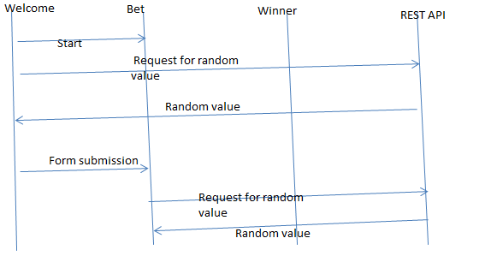

# Screen Shots:

