Plagiarizm – Human vs AI Text Classifier

Nom et prénom : NASR MOUNIB
Classe : ING2_TD1

Objective: Deploying a Web Application with CI/CD Pipeline Locally using Docker and kubernetes

Phase 1: Version Control (1 hour)
Steps:
Create GitHub Repository:
https://github.com/mounibnasr45/Plagia_Websie_Devops.git
Clone the Repository Locally:
Add a .gitignore File:
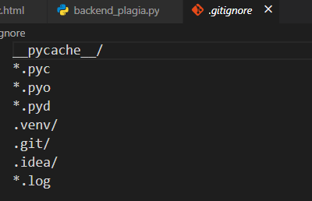

Commit Initial Structure:
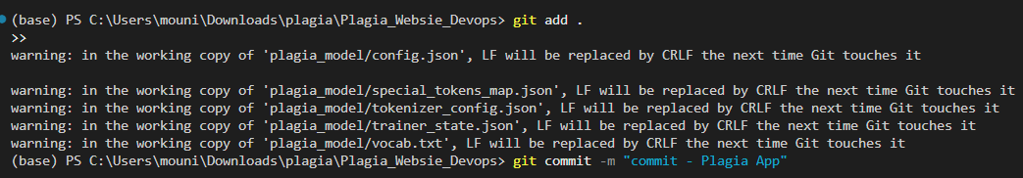
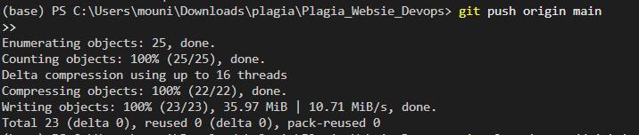

Phase 3: Containerize the App (2 hours)
Objective: Create a Docker image for the Plagia web application to make it easily deployable.
Create Dockerfile:
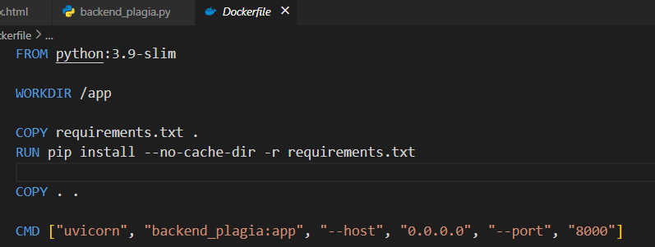
Create requirements.txt:
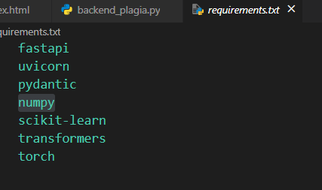

Build and Run Docker Image:
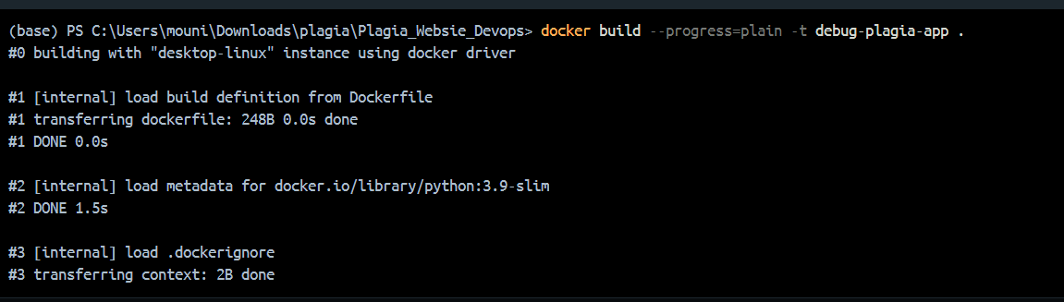
Build and run the Docker image locally:
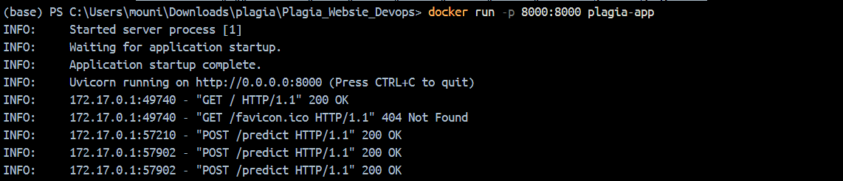

Test the app by visiting http://localhost:8000

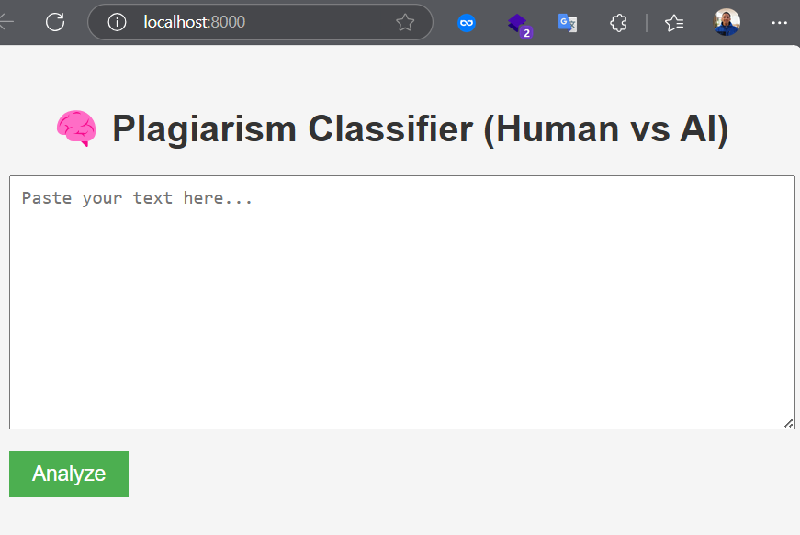

Phase 4: Continuous Integration (CI) (2 hours)
Objective: Automate the build process using a Continuous Integration (CI) pipeline.
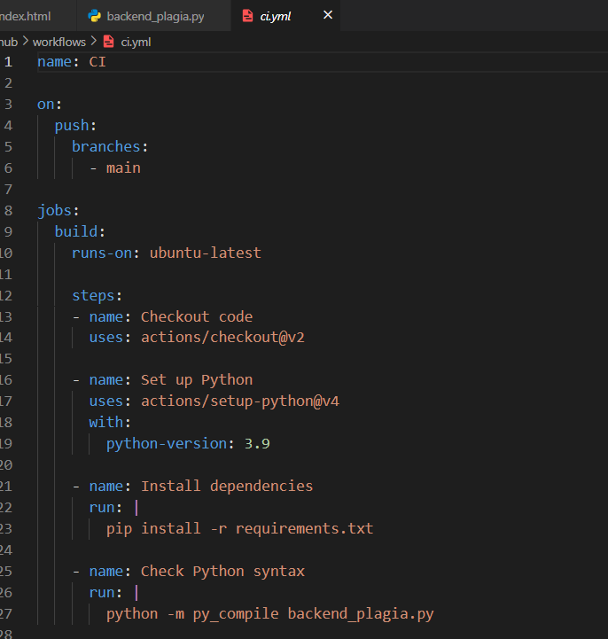

Phase 5: Continuous Deployment (CD) (2 hours) :
Objective: Automate the deployment process using a Continuous Deployment (CD) pipeline.
Steps:
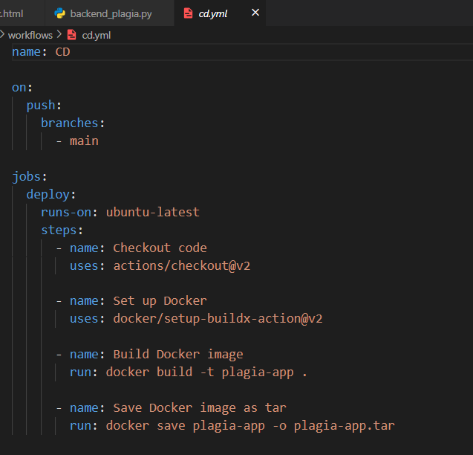

Phase 6: Kubernetes Integration
Objective: Deploy the web application on a local Kubernetes cluster.
Steps:
- Set Up Local Kubernetes Cluster:
- Use Minikube or Kind to set up a local Kubernetes cluster.
- Create Kubernetes Manifests:
deployment.yaml: Define deployment configurations for the FastAPI app.
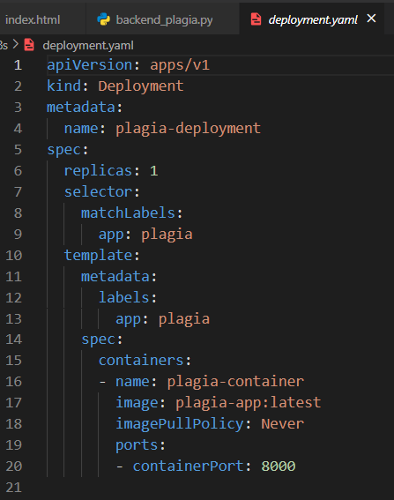

service.yaml: Expose the FastAPI app as a service.
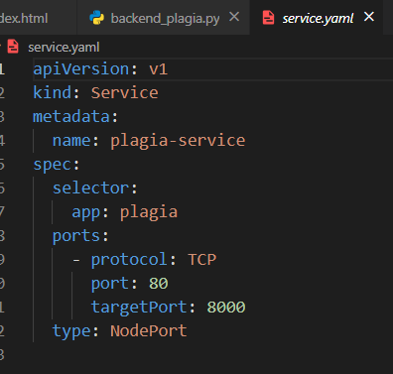
Apply Kubernetes Manifests:
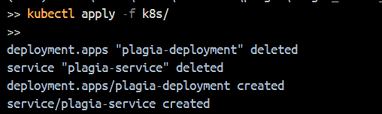
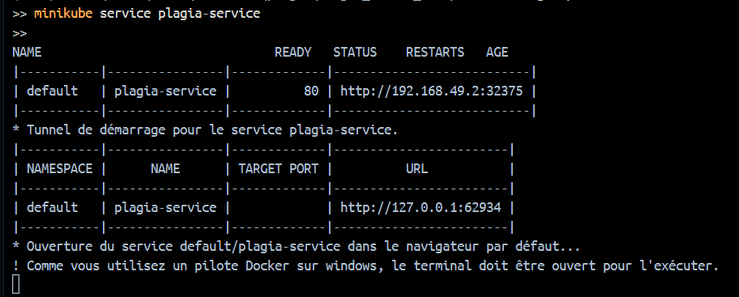

DEMO (Hosted ) :
