When a new user wants to create an account, he clicks on Sign Up and the following screen appears where he needs to enter all the details as prompted to. Once the user clicks on ‘Create an account’ button after filling in all the information, the account will be created and next time he can click on Sign in button and enter username and password to log into the application.

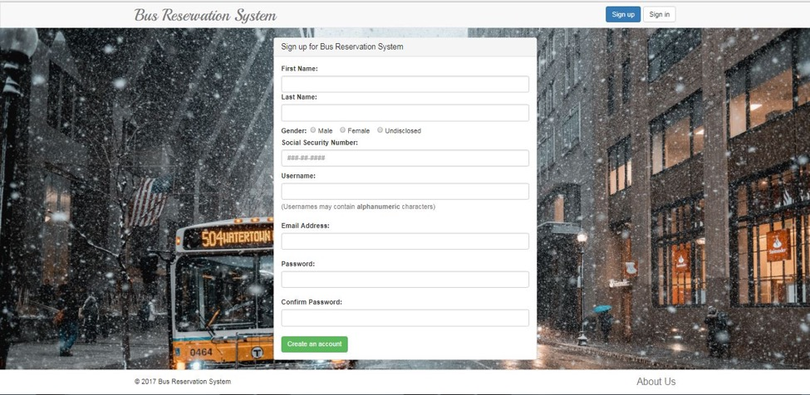

The following screen appears when some user clicks on our website or after signing up, when the user clicks on ‘Sign in’ Button.

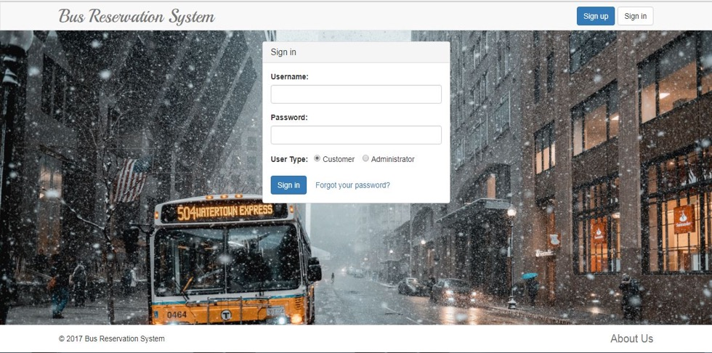

When the user clicks on ‘Forgot your password’, the following screen appears. The user needs to enter SSN in order to reset password.

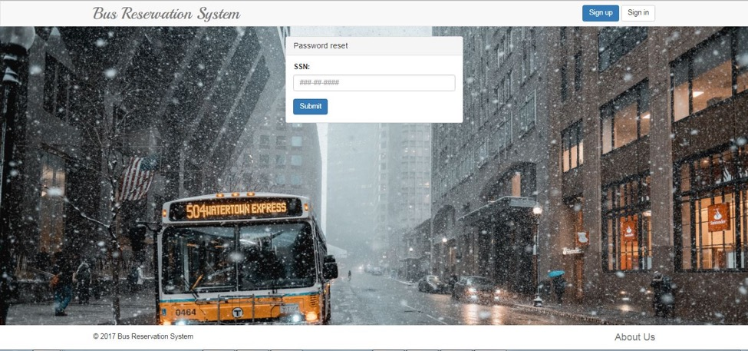

If the user enters the Correct SSN, he will be prompted to enter new password and then confirm password. Once the user clicks on submit, the password will be reset.

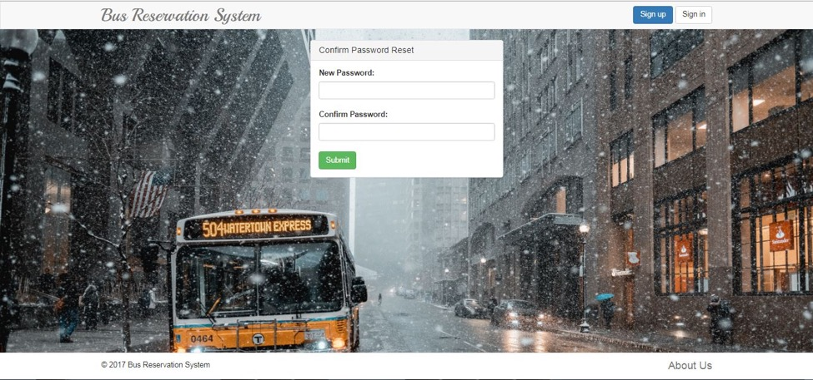

The following screen appears as the home page, when the customer logs in.

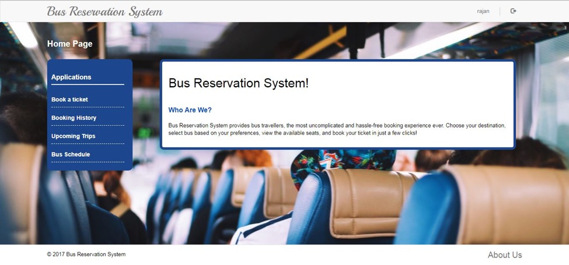

The following is the screen that appears when the customer logs in and clicks on Book a ticket option. The customer needs to enter source, destination and travel date to search for a bus. He can also give start time and end time to search for a bus that operates in a particular time, but these are optional fields.

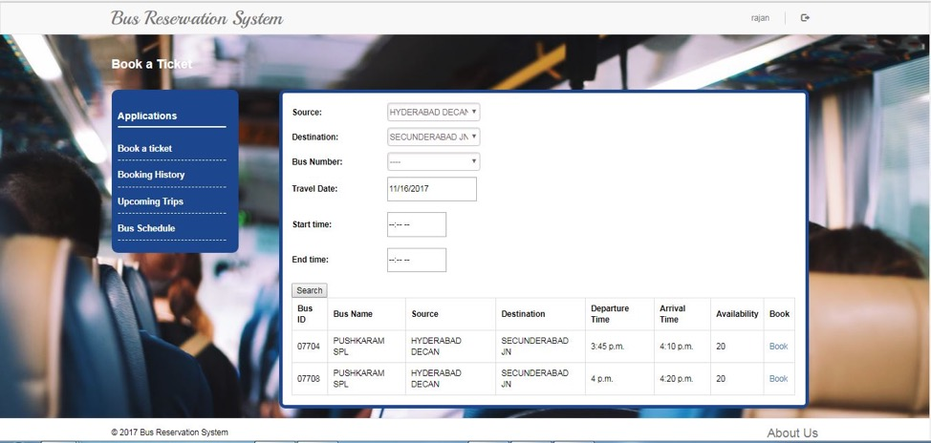

This screen appears when the customer clicks on ‘Book’ button. Here the customer enters all the passenger details and then click on Confirm, Modify or Exit buttons accordingly.

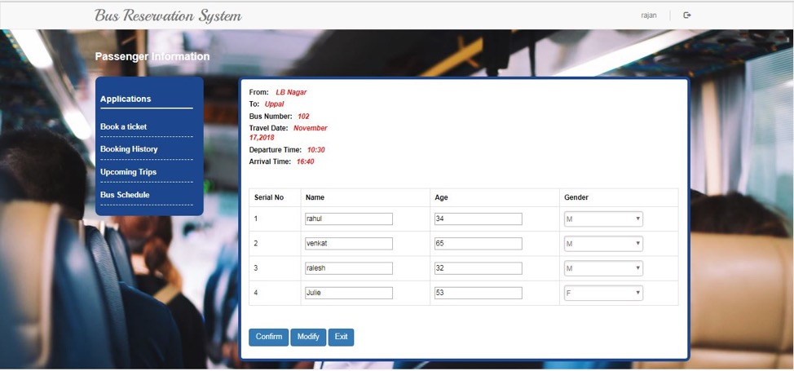

The following is the Booking history screen that will be visible to Customer. When the customer logs in and clicks on Booking history, he can see the information about all the past trips.

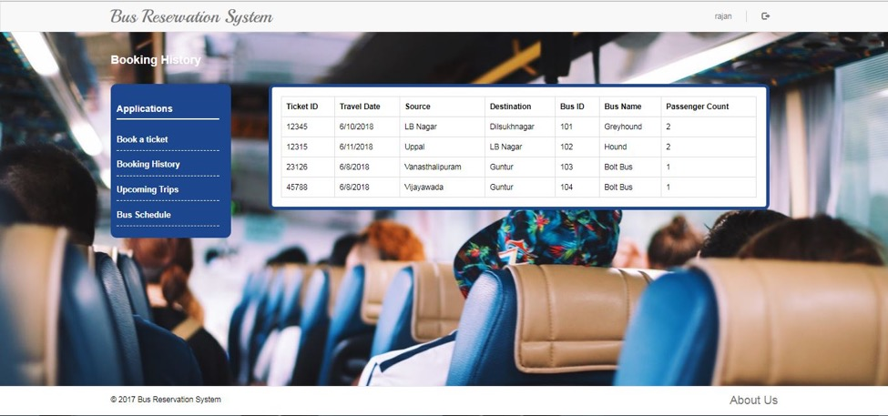

The following screen appears when customer logs in clicks on ‘Bus Schedule’ option. The customer should give either a Bus ID or a Bus Name to see the schedule of a particular bus.

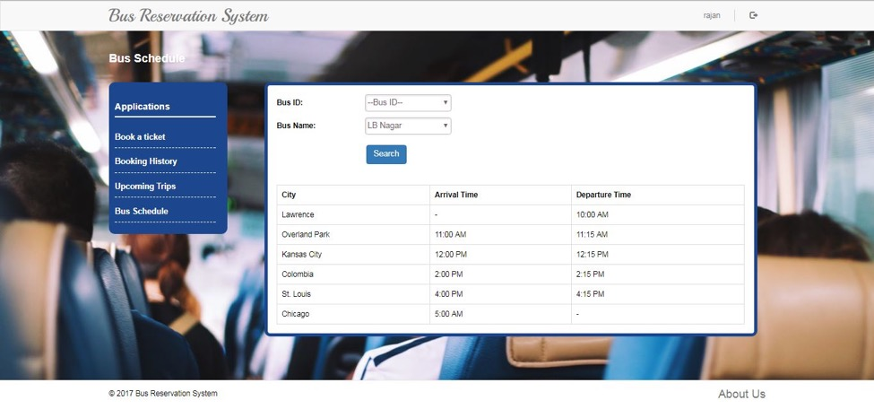

The following screen appears when the customer clicks on ‘Upcoming trips’. This page will have the information about the trips that are yet to be done. So, the Customer will also have the option to cancel the ticket.

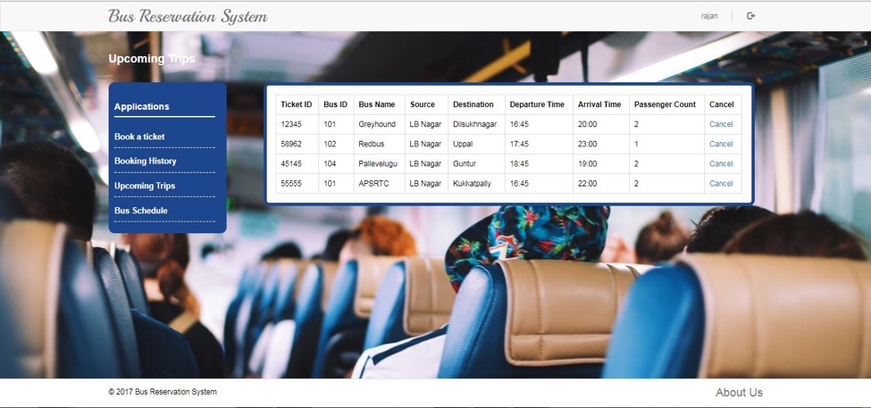

When the customer clicks on Cancel ticket option, the following screen appears with a checkbox beside each passenger. So the customer cancel ticket only for some passengers rather than cancelling the ticket for all the passengers. If he wishes to cancel the complete ticket, he needs to check all the check boxes.

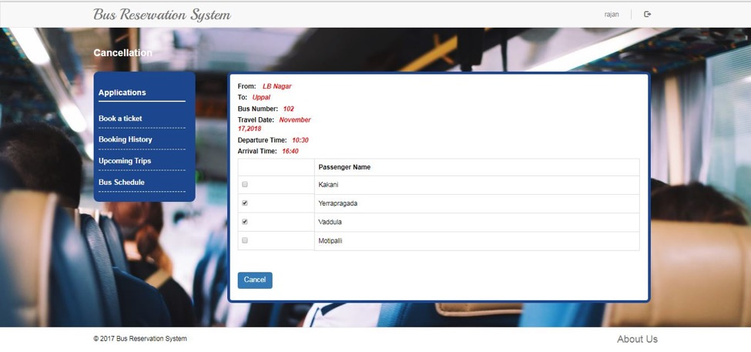

The following screen appears when admin logs into the system and clicks on ‘Add a new Bus’ option. Admin enters source and destination of the new bus and searches for the existing buses that are present, for the same source and destination. Since in our application the only way to add a new bus is to duplicate the existing one, he selects one of the buses that is being displayed.

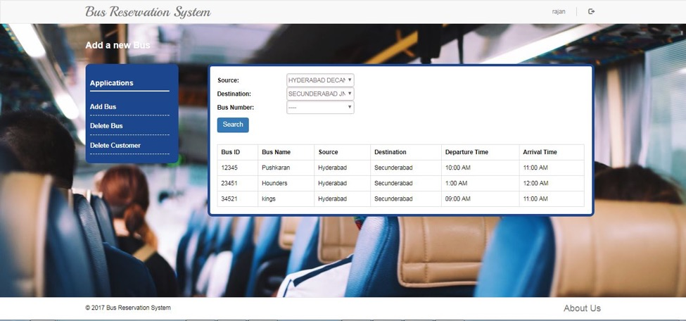

The following screen appears when admins logs in Clicks on ‘Delete Bus’ option. The admin needs to enter the Bus Id and then click on ‘Remove Bus’ button in order to delete the bus.

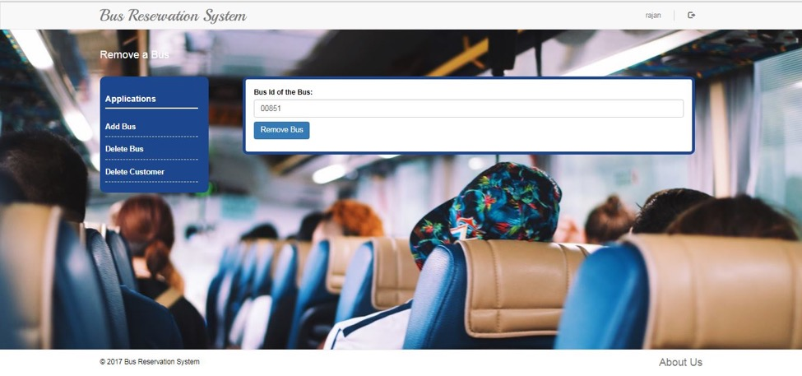

The following screen appears for the admin when he logs in and clicks on ‘Delete Customer’ option. The admin needs to know the user id in order to delete a user.

