Inventory Management

**ADVANCED SOFTWARE ENGINEERING**

**UNDER THE GUIDANCE OF Dr. Yugyung Lee**

**Team Members**

**Viswanath Nemani**

**Mounica Reddy Poondla**

**Avani Kapa**

**Sirisha Ayyagari**

***Introduction:***

For the success of any business, an obvious maintenance of records is very much necessary. A good application to maintain and note these records will make the calling very easy. This is web application which will be used by UMKC to provide best possible services to faculty members.

***Web Service:***

**Admin Login**

Admin Login enables administrator to log into Admin Page where there will be an access to various functionalities. This page allows admin to enter username and password. After entering the details, the details are checked and gets validated with the database. Once details are verified , the page gets redirected to Admin Home Page.

**User Login**

User Login enables user to log into user Page where there will be an access to various functionalities for user. This page allows user to enter his username and password. After entering the details, the details are checked and gets validated with the database. If the details entered are correct, the page gets redirected to User Home Page.

**Login Sequence Diagram:**

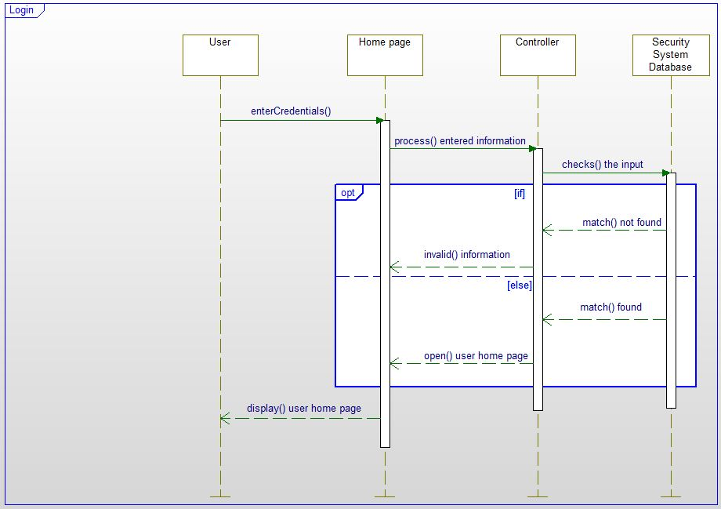

**Admin Home Page**

Admin page is one of the most complicated part in our web application. It serves several functionalities to admin like Inventory (in which product information etc is available), orders(in which information about request for products from users, product orders to merchants is available) etc.

**Admin view Sequence Diagram:**

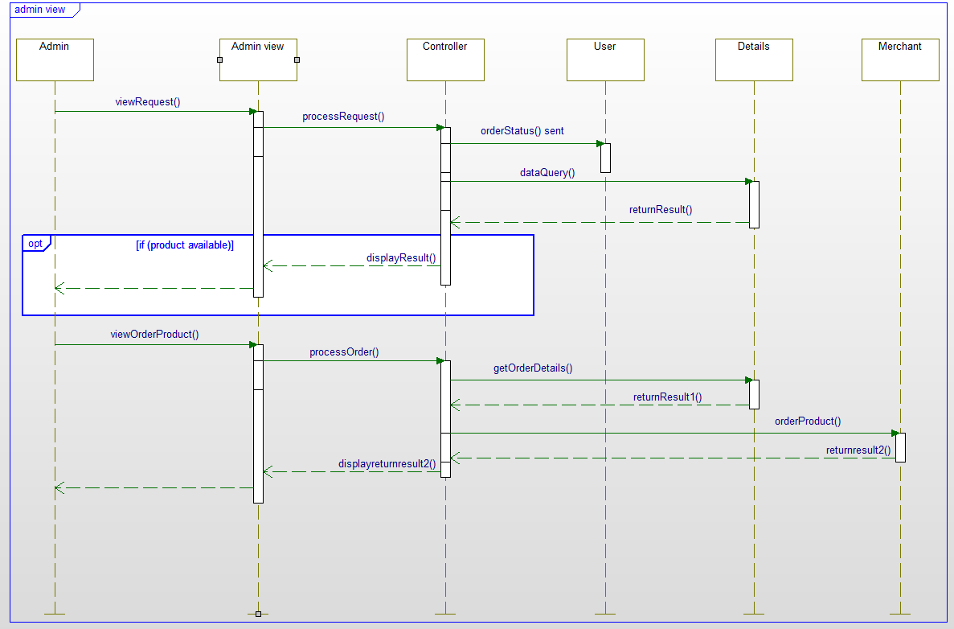

**User Home Page**

User Home Page is a part of our web application which provides user with some functionalities which the administrator serves. **Search** is one of the main features of this page which allows users to search information about the desired product, order for new products etc. Besides Search, there are also other features like viewing the user's profile, View order status(allows user to view the status of the ordered product).

**User View Sequence Diagram:**

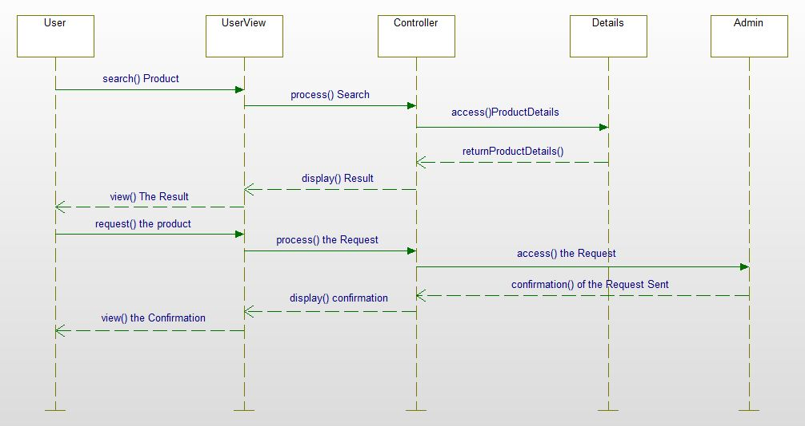

**Class Diagram:**

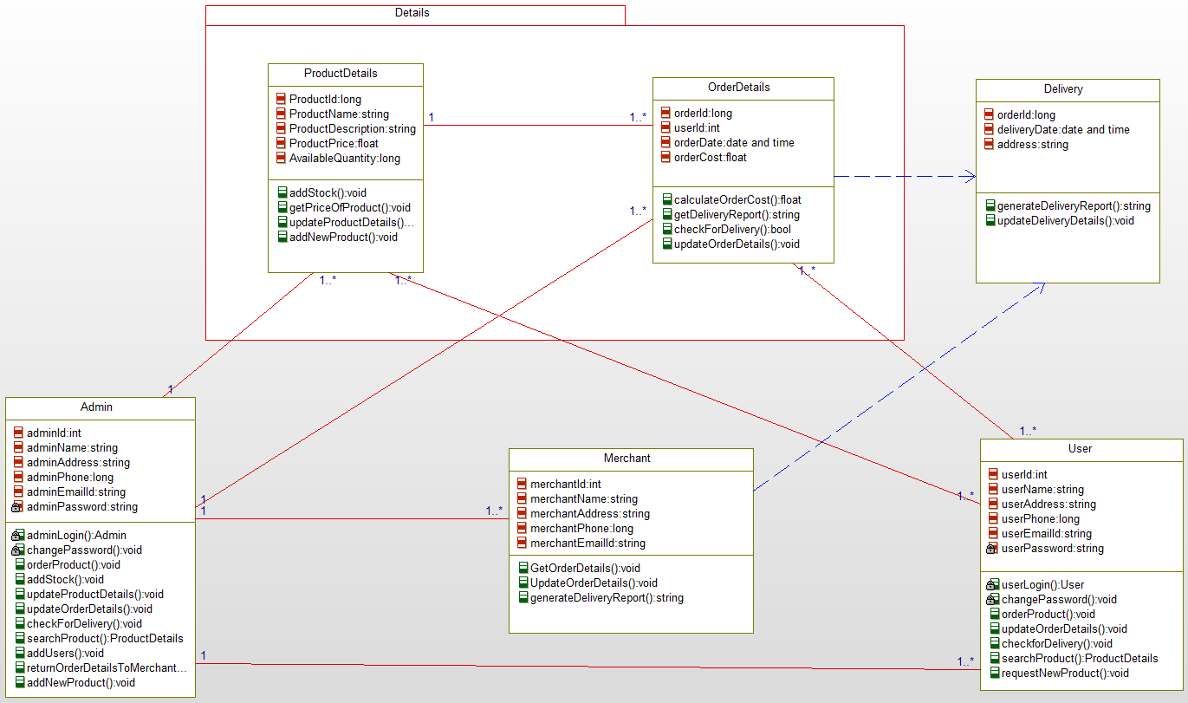

**Implementation**

user interface:

Our project is developed in C# and HTML for the web application. The app has four activities in this increment. There are Admin Login, User Login, Admin and User Homepages.

Our Homepage:

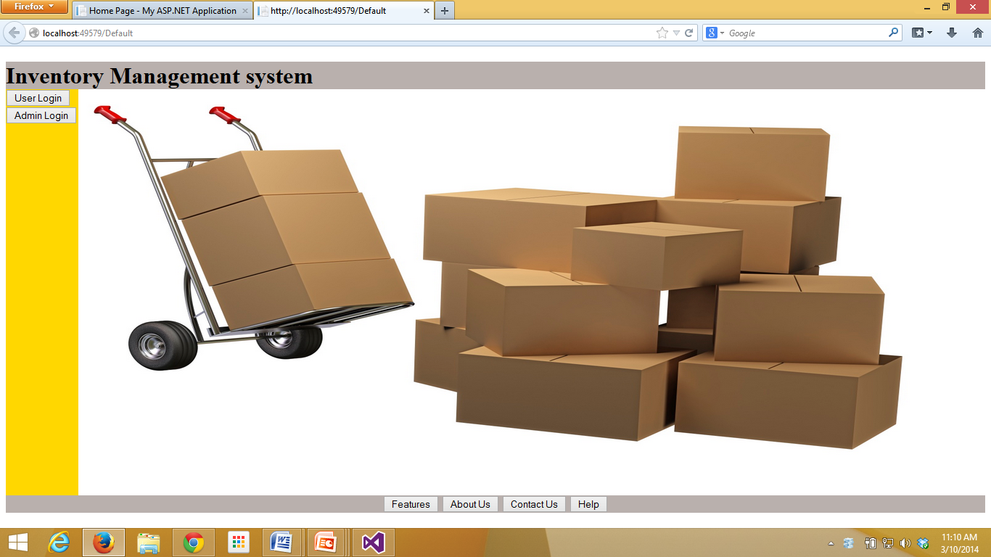

User Login:

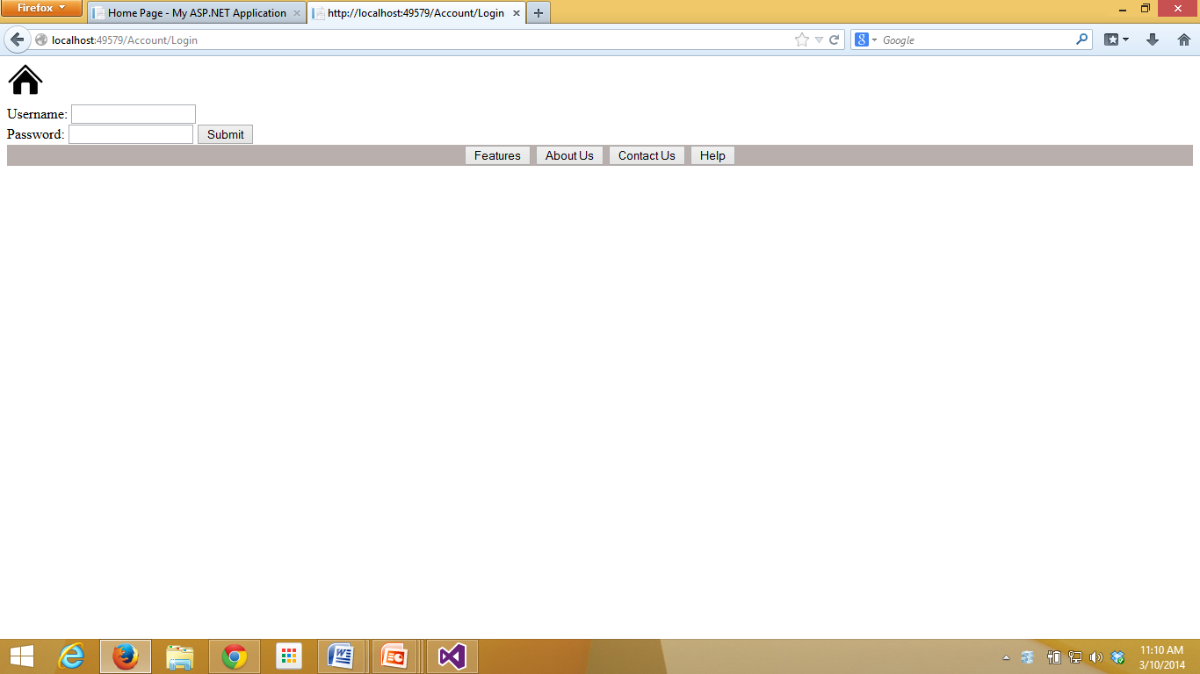

User Home Page:

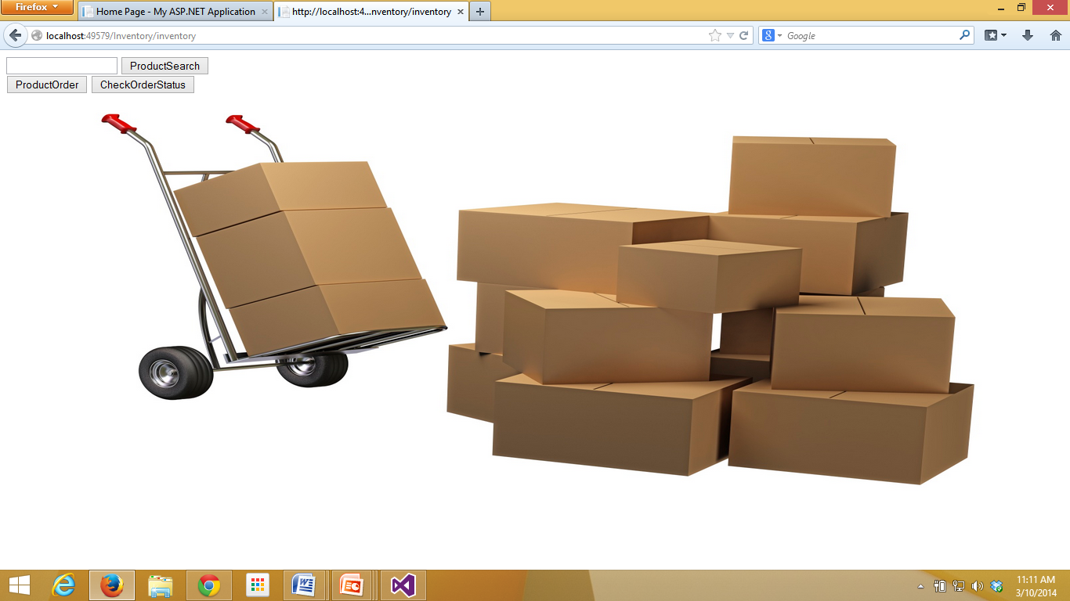

Admin Login:

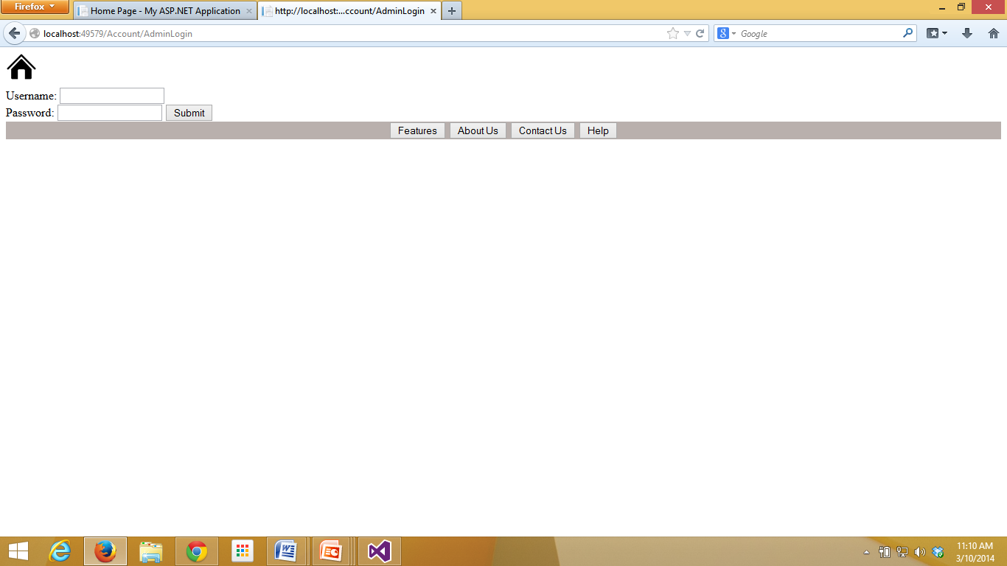

***Testing:***

**Validation1:** Checks whether user ID and password are correct with the database. If it is not validated, then shows error. Screenshot is provided below.

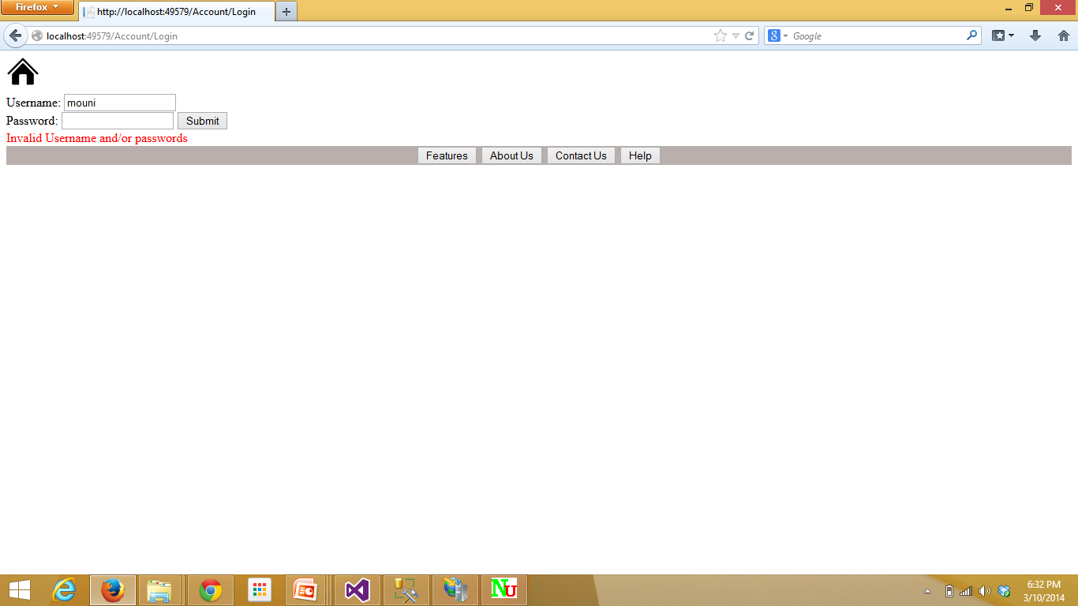

**Validation2:** Checks whether admin ID and password are correct with the database. If it is not validated, then shows error. Screenshot is provided below.

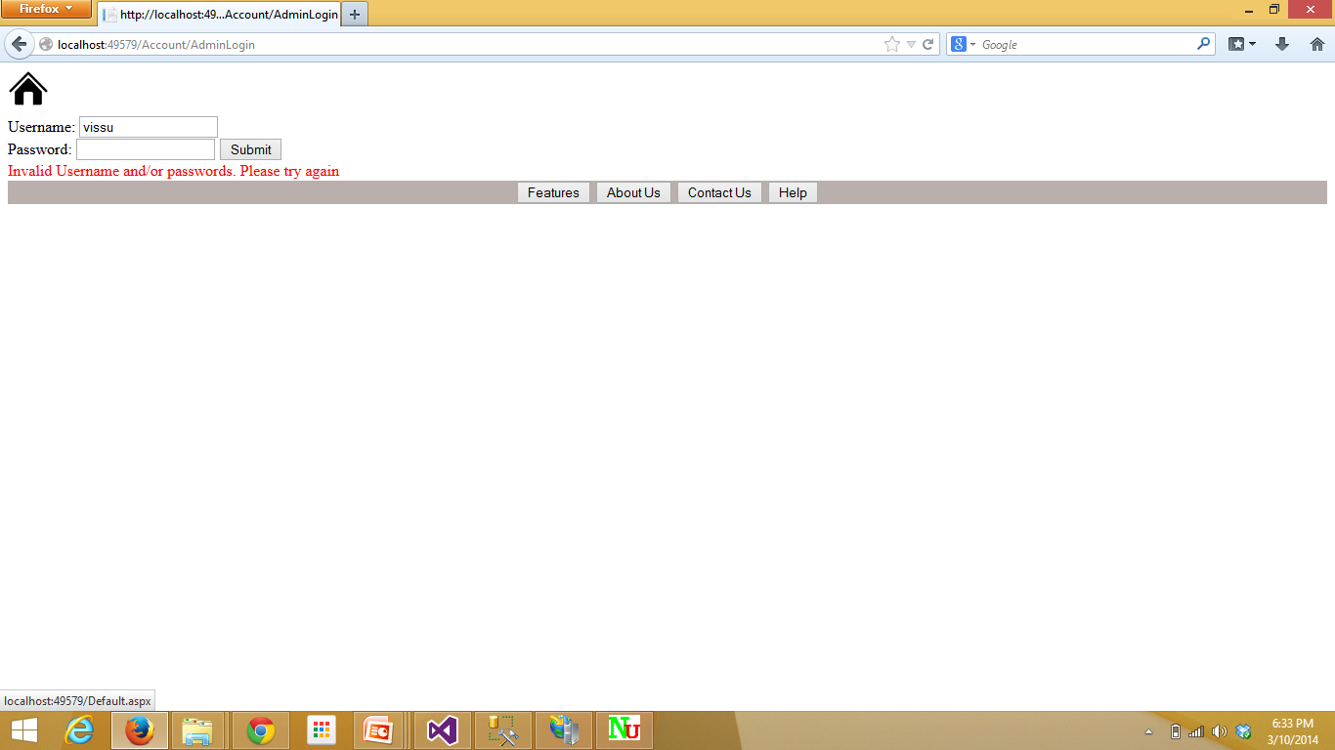

***Mobile application website URL to the project cloud instance:***

<http://kc-sce-cs551.kc.umkc.edu/aspnet_client/Group7/InventoryManagement/InventoryManagement/Default>

***GitHub:***

Project file i.e. source code and report are posted to the following github link.

Link: https://github.com/mounica1704/Inventory-Management

***ScrumDo:***

ScrumDo Link : http://www.scrumdo.com/projects/project/inventory-management1/summary

ScrumDo Id: group7

Showing the tasks done:

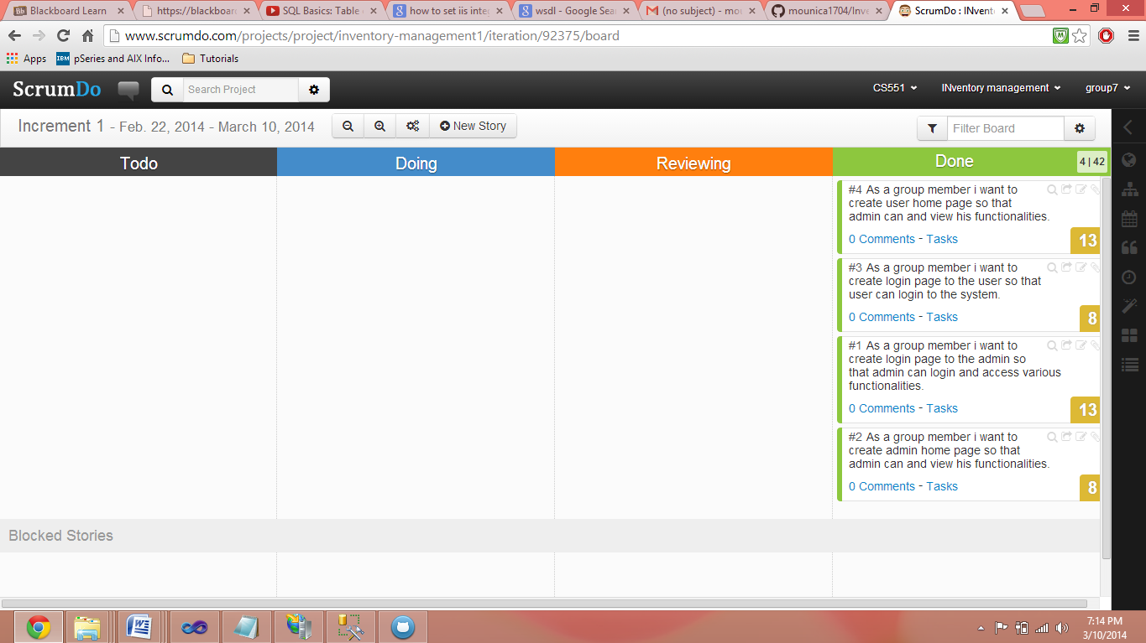

Showing the Increment-1 is completed:

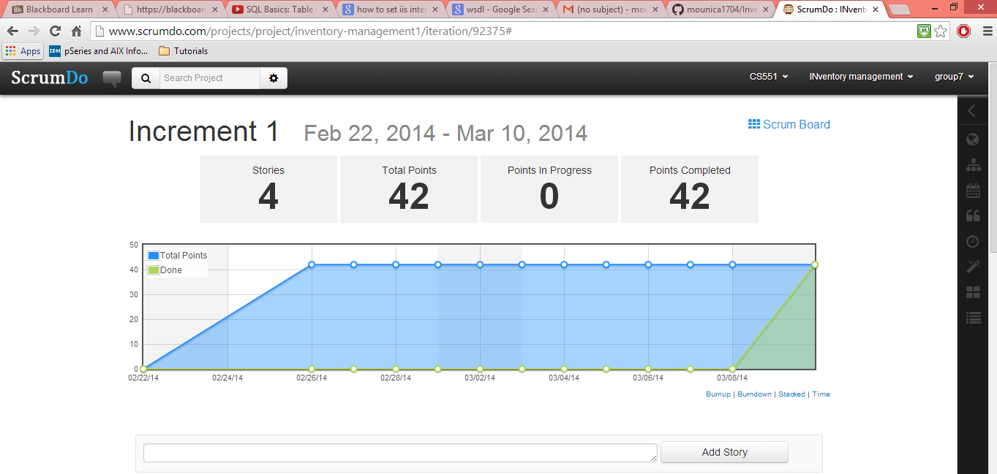

Increment-2 is in progress:

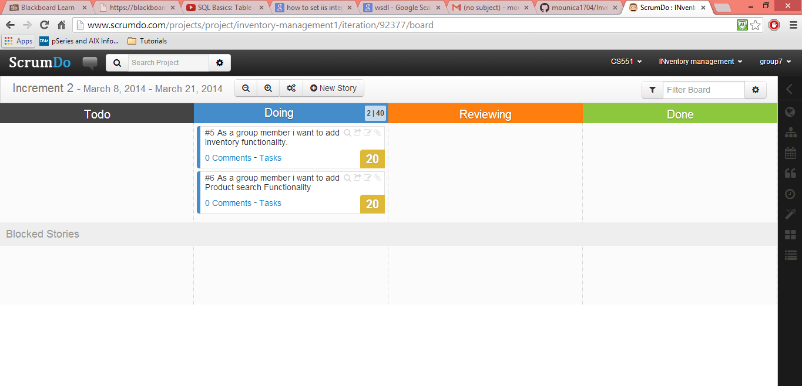

***Project management:***

Member: Viswanath Nemani

Creating home page;

Creating user login page;

Creating user home page;

business logic;

GUI;

Member : Mounica Reddy Poondla

Database creation;

writing the logic to connect the database to the source code;

business logic;

project first increment report.

Member: Avani Kapa

Creating admin login page;

business logic;

GUI;

project plan;

Member: Sirisha Ayyagari

Creating admin home page;

business logic;

GUI;

project proposal report.