**CS5551 Lab Assignment – 3 Report**

**1.  Extend the Mobile Web Client Application you implemented in Lab 2 with HTML5 Local Database**

I have extended the mobile web client application that I have implemented in lab2 with HTML5 Local database. I have kept clear, store and print options. The directions from one city to other city will be stored to the local database using store option. Similarly, we can print and clear the directions. But, I had a trouble printing the directions. It is not a string, so I could print them. But It is getting stored.

JSFIDDLE LINK: http://jsfiddle.net/mounicapoondla/jF9zU/4/

**Screenshots:**

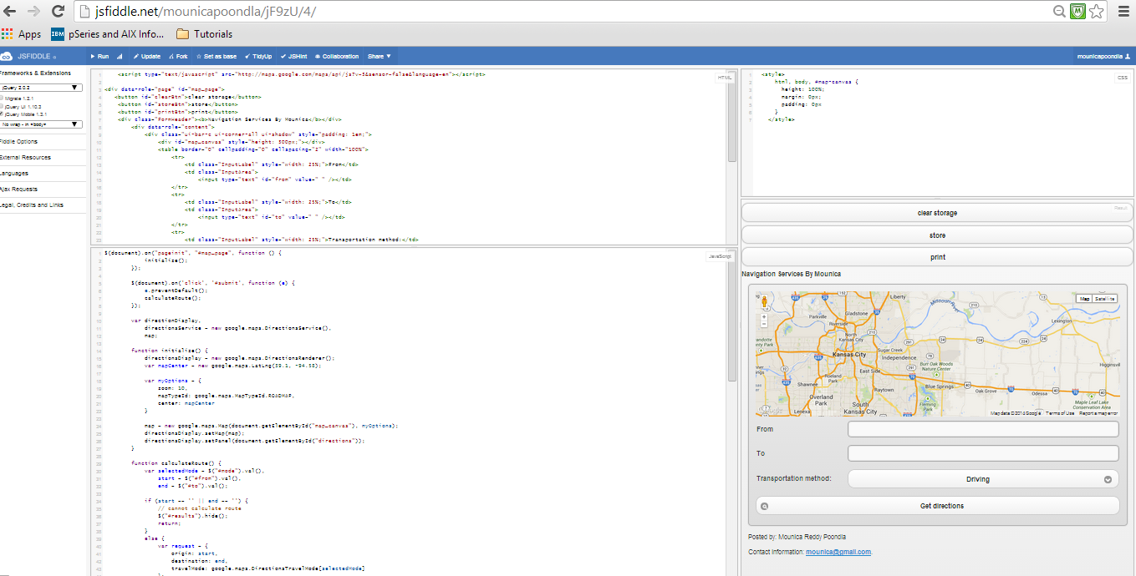

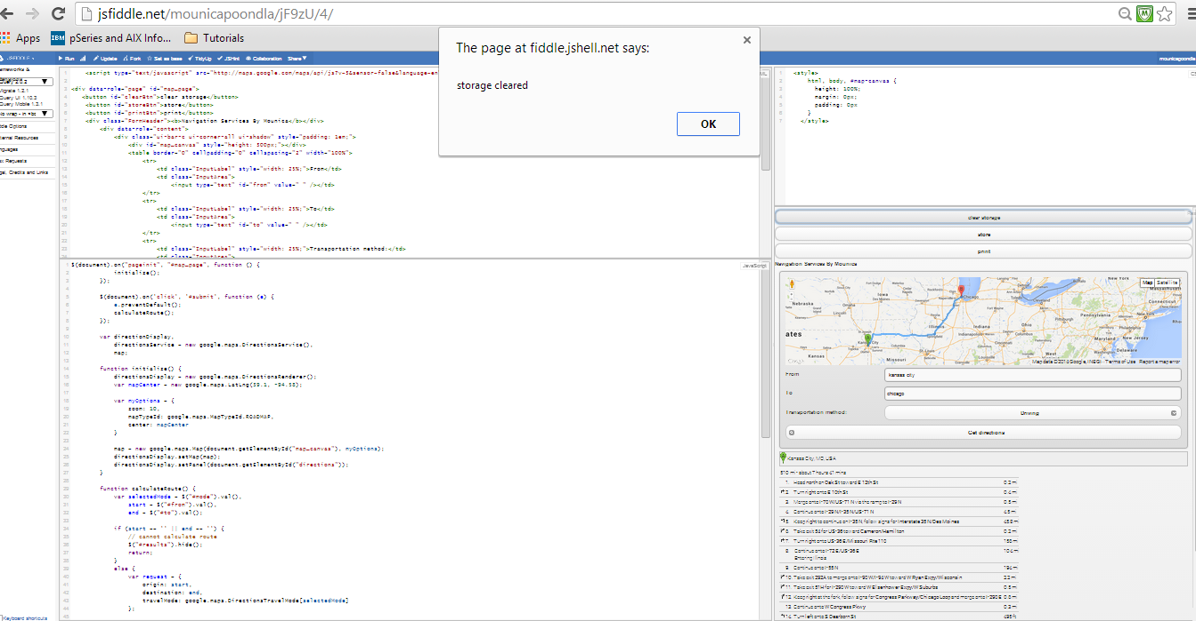

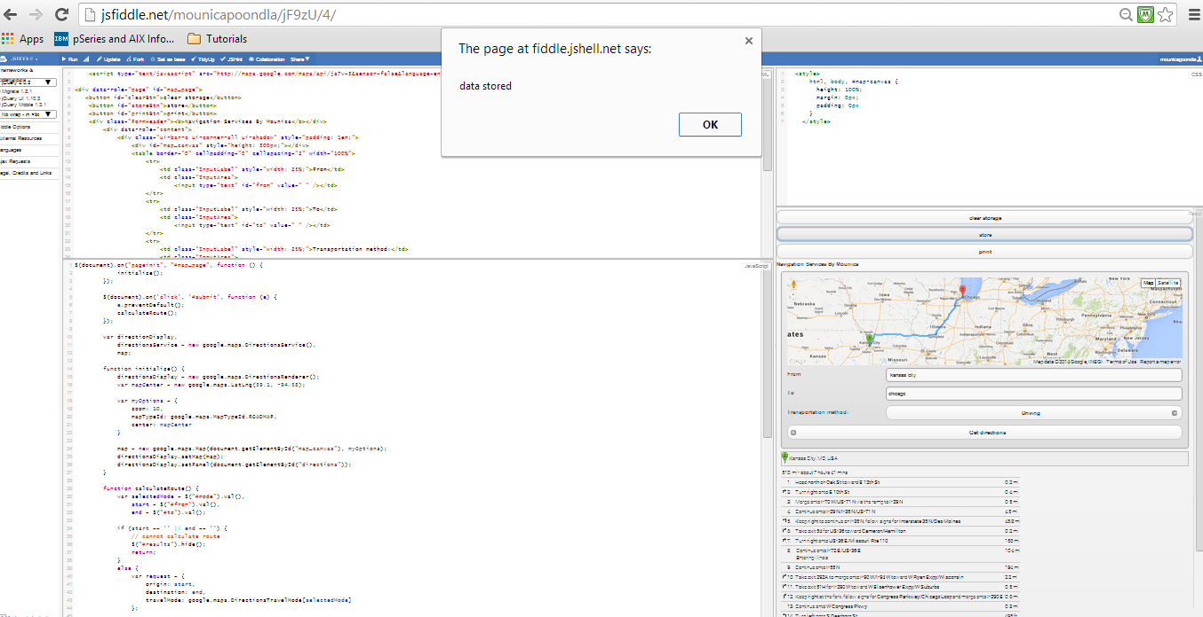

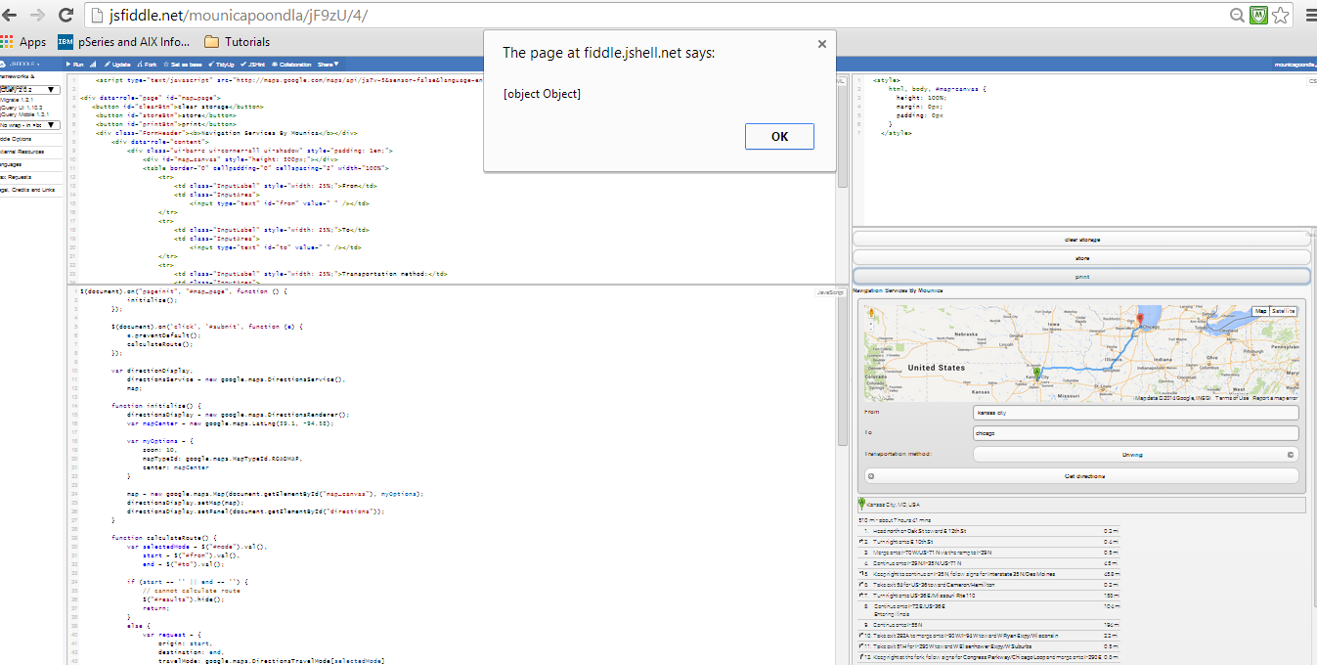

**2. Make a Mash up application:**

I have implemented the mash up application using Google maps and weather services. It displays traffic layer, weather conditions and cloud layer on a map.

JSFIDDLE LINK: http://jsfiddle.net/mounicapoondla/QNk4z/74/

**Screenshots:**

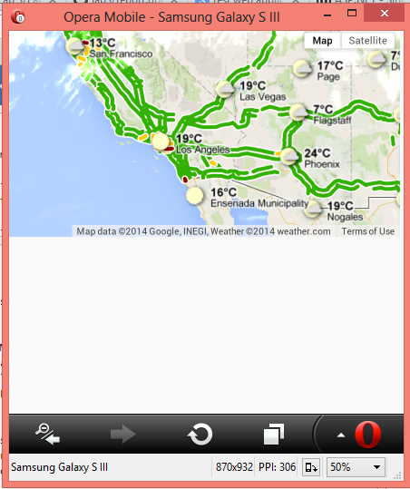

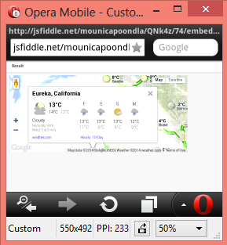

**3. Implement your own REST Web Services**

I have implemented the REST web service which displays name , ID, Mail ID, Stream and Major. WCF service is run using local Host without any data input. Screenshot is shown below.

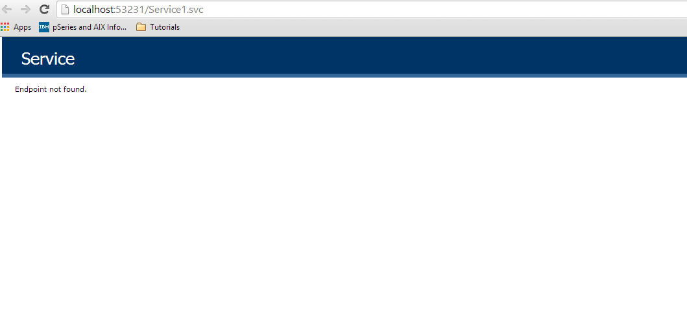

WCF service is run using local Host with data input. Screenshot is shown below.

