**UB Room Reservation System**

**Fall 2017**

**Mounica Ghanta**

**UB ID: 1020243**

**University of Bridgeport**

**Description:**

There are three types of users

1. Admin
2. Student
3. Faculty
4. Admin:

Here admin can change anything from the database such as deleting the particular student from a course, adding the student into a course, assigning a faculty to a particular course, updating the faculty if needed..etc

1. Student:

A student must first register himself inorder to have access. After registration, he can login into his account and can be able send messages to the particular faculty he wishes. Student can also see the rating given by particular faculty.

1. Faculty:

After Faculty logs on to particular account, he can see the messages sent by the particular student. Faculty can also give rating to particular student.

**ER DIAGRAM:**

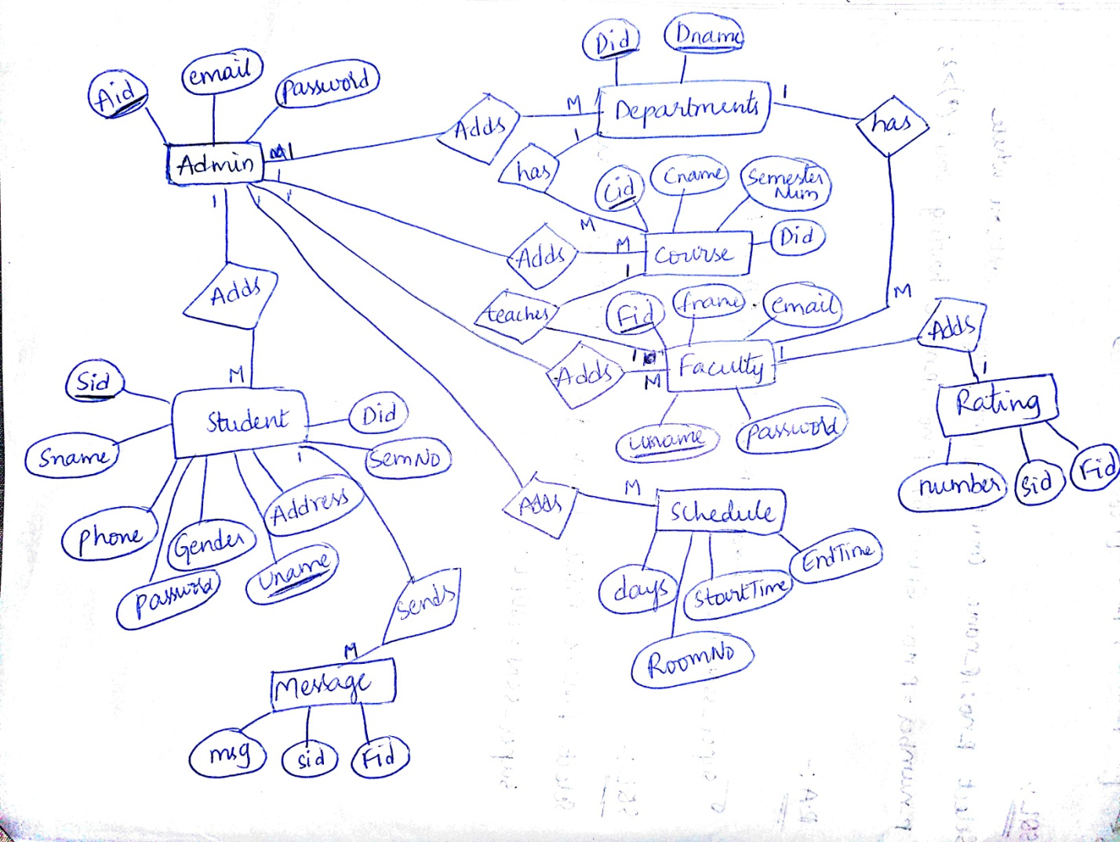

**EER diagram to represent the generalization and specialization:**

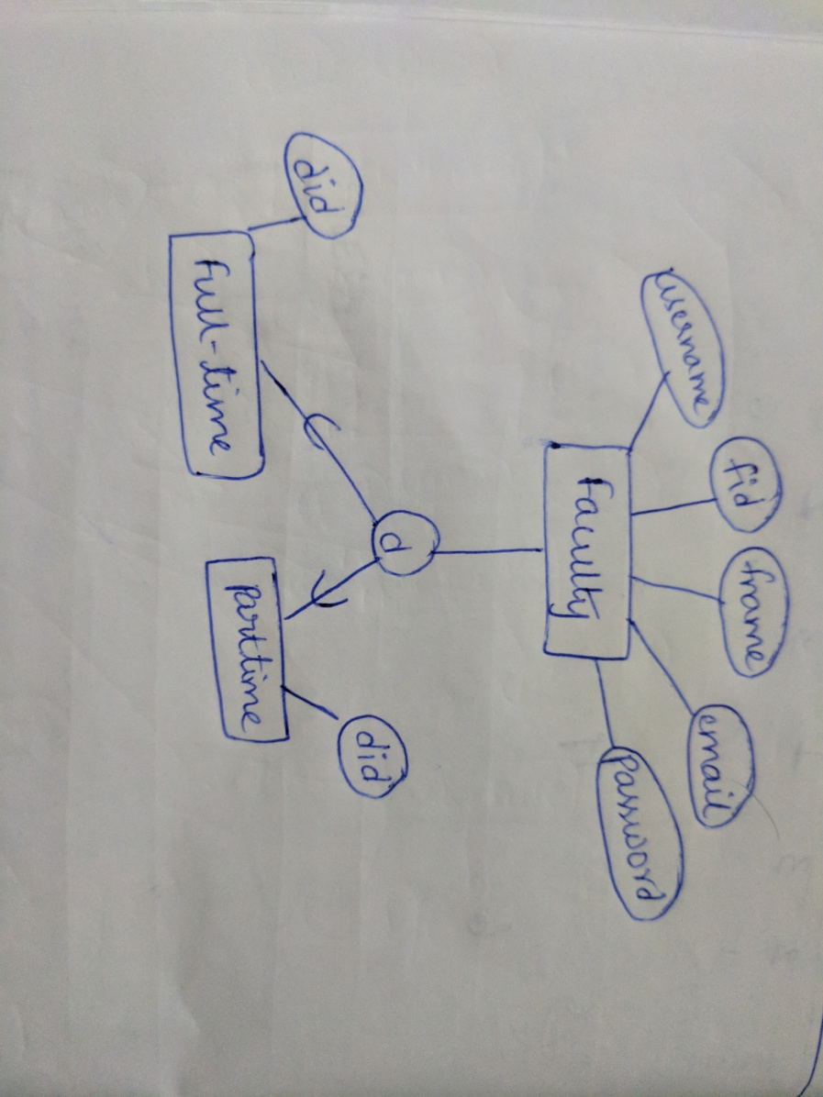

**RELATIONAL SCHEMA:**

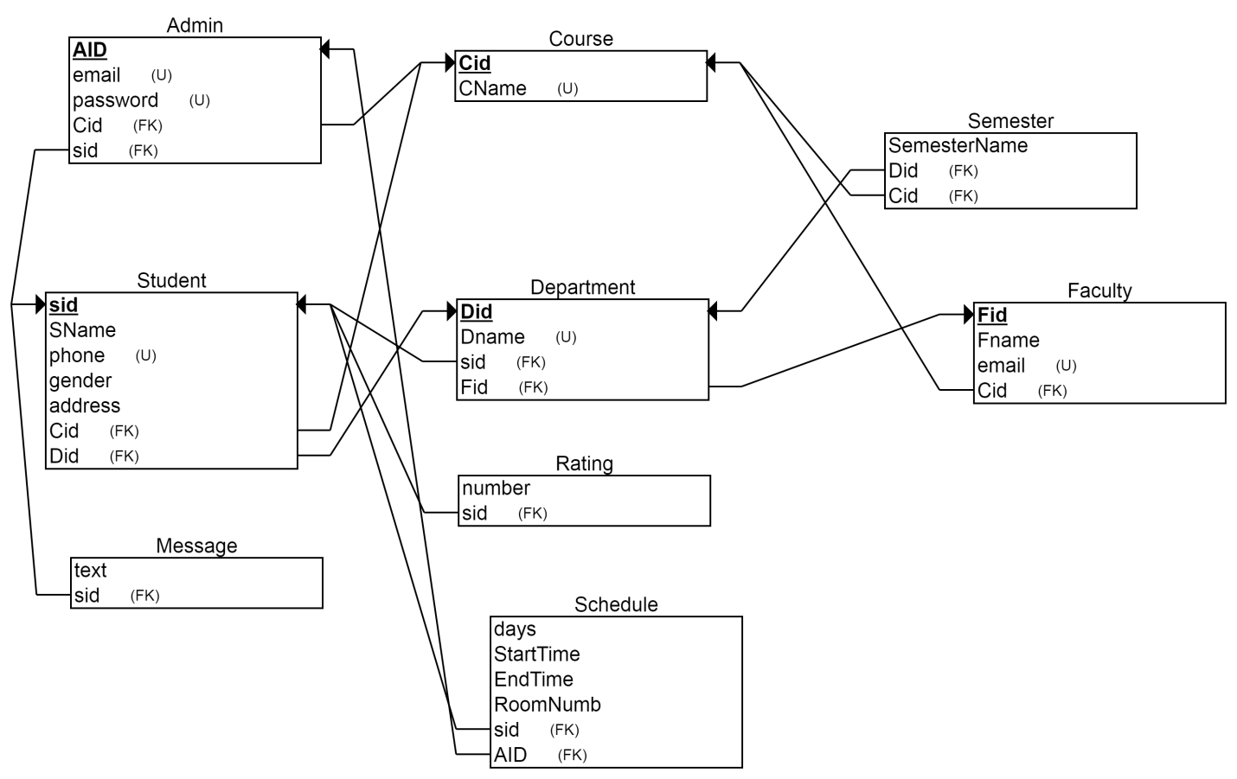

**Assumptions:**

1. Admin can add/delete/edit the department name, student details, faculty details, schedule and courses.
2. Each faculty can teach only one course.
3. Each faculty can give only 1 rating to the particular student.
4. Students can send messages to the particular faculty.

**Steps performed in phase 3:**

I have created a project named ADB-1020243.

1. In the google cloud platform go to cloud instances page
2. Create an instance
3. Select MYSQL
4. Choose a second generation instance
5. Instance id= instance1
6. Root password=root1
7. Root= root
8. Choose the region
9. Now click create

**Connecting to MySQL instance:**

1. Download mysql from MYSQL community server. Mine is Windows 7 32-bit. Download it.
2. Keep your ip address ready. If you don’t know your ip address google it.
3. Now go to MySQL instance page.
4. Go to authorization tab
5. Type the name for the authorization network
6. Type the ip address
7. Click done and save it

Steps to connect to MySQL cloud instance

1. Now open command prompt on your system.
2. Change the path to the the downloaded mysql folder’s bin
3. Type the command

mysql --host=”ipv4 address on the gcp sql instance” --user=root –password

mysql --host= 104.198.17.21 --user=root –password

1. It prompts for the password. Type the password
2. Mysql prompt appears

The below image shows the connection to the database using cloud sql .

SQL prompt appeared. We can now create tables here.

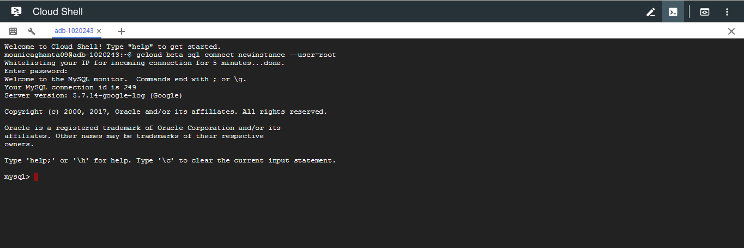

**creating web application server**

I am using php as a web programming language.

1. First create an app engine application on google cloud. When it asks for the language click PHP
2. Open the command prompt and go to the the required folder where the project is present(where the app.yaml file is present)
3. Type the command “gcloud app deploy”
4. Now one link is created on the app engine as shown as below
5. 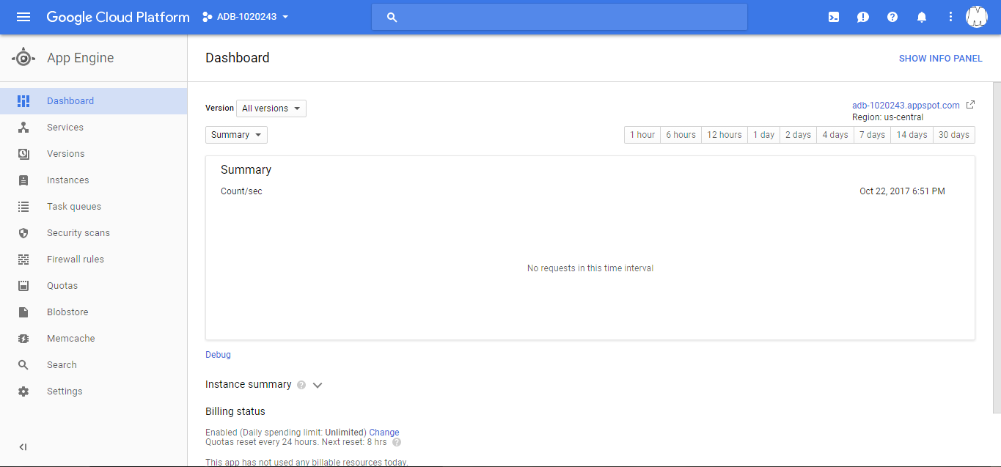
6. It is on the right hand side of the image i.e., adb-1020243.appspot.com
7. If we click the link, directly the output of the project will be displayed on the web page.

**SQL Scripts:**

**dbDDL.sql**

**Table structure for table `admin`**

CREATE TABLE `admin` (

`Aid` int(5) NOT NULL AUTO_INCREMENT,

`email` varchar(100) NOT NULL,

`password` varchar(100) NOT NULL,

PRIMARY KEY (`Aid`)

) ENGINE=InnoDB;

**Table structure for table `course`**

CREATE TABLE `course` (

`Cid` int(11) NOT NULL AUTO_INCREMENT,

`Cname` varchar(50) NOT NULL,

`semesterNum` int(11) NOT NULL,

`Did` int(5) NOT NULL,

PRIMARY KEY (`Cid`),

KEY `Did` (`Did`)

) ENGINE=InnoDB;

-- **Table structure for table `department`**

CREATE TABLE `department` (

`Did` int(5) NOT NULL AUTO_INCREMENT,

`Dname` varchar(50) NOT NULL,

PRIMARY KEY (`Did`),

UNIQUE KEY (`Dname`)

) ENGINE=InnoDB;

**-- Table structure for table `faculty`**

CREATE TABLE `faculty` (

`Fid` int(5) NOT NULL AUTO_INCREMENT,

`fname` varchar(50) NOT NULL,

`email` varchar(50) NOT NULL,

`Did` int(5) NOT NULL,

`Cid` int(11) NOT NULL,

`Uname` varchar(50) NOT NULL,

`password` varchar(50) NOT NULL,

PRIMARY KEY (`Fid`),

UNIQUE KEY (`Uname`),

KEY (`Cid`),

KEY (`Did`)

) ENGINE=InnoDB;

**-- Table structure for table `message`**

CREATE TABLE `message` (

`Mid` int(4) NOT NULL AUTO_INCREMENT,

`msg` text NOT NULL,

`Sid` int(4) NOT NULL,

`Fid` int(5) NOT NULL,

KEY `Sid` (`Sid`),

KEY `Fid` (`Fid`),

PRIMARY KEY (`Mid`)

) ENGINE=InnoDB;

**-- Table structure for table `rating`**

CREATE TABLE `rating` (

`Rid` int(4) NOT NULL AUTO_INCREMENT,

`number` int(2) NOT NULL,

`Sid` int(4) NOT NULL,

`Fid` int(5) NOT NULL,

KEY `Fid` (`Fid`),

KEY `Sid` (`Sid`),

PRIMARY KEY (`Rid`)

) ENGINE=InnoDB;

**-- Table structure for table `schedule`**

CREATE TABLE `schedule` (

`Secid` int(4) NOT NULL AUTO_INCREMENT,

`days` int(3) NOT NULL,

`StartTime` varchar(10) NOT NULL,

`EndTime` varchar(10) NOT NULL,

`RoomNo` int(3) NOT NULL,

`Cid` int(5) NOT NULL,

KEY `Cid` (`Cid`),

PRIMARY KEY (`Secid`)

) ENGINE=InnoDB;

**-- Table structure for table `student`**

CREATE TABLE `student` (

`Sid` int(4) NOT NULL AUTO_INCREMENT,

`Sname` varchar(50) NOT NULL,

`Phone` int(15) NOT NULL,

`Gender` varchar(1) NOT NULL,

`Address` text NOT NULL,

`semesterNum` int(11) NOT NULL,

`Did` int(5) NOT NULL,

`Uname` varchar(50) NOT NULL,

`password` varchar(50) NOT NULL,

PRIMARY KEY (`Sid`),

UNIQUE KEY (`Uname`),

KEY (`Did`)

) ENGINE=InnoDB;

**-- Constraints for dumped tables**

**-- Constraints for table `course`**

ALTER TABLE `course`

ADD CONSTRAINT `course_ibfk_1` FOREIGN KEY (`Did`) REFERENCES `department` (`Did`);

**-- Constraints for table `faculty`**

ALTER TABLE `faculty`

ADD CONSTRAINT `faculty_ibfk_1` FOREIGN KEY (`Cid`) REFERENCES `course` (`Cid`),

ADD CONSTRAINT `faculty_ibfk_2` FOREIGN KEY (`Did`) REFERENCES `department` (`Did`);

**-- Constraints for table `message`**

ALTER TABLE `message`

ADD CONSTRAINT `message_ibfk_1` FOREIGN KEY (`Sid`) REFERENCES `student` (`Sid`),

ADD CONSTRAINT `message_ibfk_2` FOREIGN KEY (`Fid`) REFERENCES `faculty` (`Fid`);

**-- Constraints for table `rating`**

ALTER TABLE `rating`

ADD CONSTRAINT `rating_ibfk_1` FOREIGN KEY (`Fid`) REFERENCES `faculty` (`Fid`),

ADD CONSTRAINT `rating_ibfk_2` FOREIGN KEY (`Sid`) REFERENCES `student` (`Sid`);

**-- Constraints for table `schedule`**

ALTER TABLE `schedule`

ADD CONSTRAINT `schedule_ibfk_1` FOREIGN KEY (`Cid`) REFERENCES `course` (`Cid`);

**-- Constraints for table `student`**

ALTER TABLE `student`

ADD CONSTRAINT `student_ibfk_1` FOREIGN KEY (`Did`) REFERENCES `department` (`Did`);

**dbDML.sql:**

INSERT INTO `department` (`Did`, `Dname`) VALUES

(NULL, 'ECE'),

(NULL, 'EEE'),

(NULL, 'MECH'),

(NULL, 'CIVIL'),

(NULL, 'CME'),

(NULL, 'IT'),

(NULL, 'CSE'),

(NULL, 'DNA'),

(NULL, 'RNA');

INSERT INTO `student` (`Sid`, `Sname`, `Phone`, `Gender`, `Address`, `semesterNum`, `Did`, `Uname`, `password`) VALUES

(NULL, 'std1', '123456', 'M', 'xyz,\r\nabc', '1', '2', 'abcd1', 'abcd1'),

(NULL, 'std2', '1234567', 'F', 'abc,\r\nabc', '2', '3', 'abcd2', 'abcd2'),

(NULL, 'std3', '12345678', 'M', 'xml,\r\nabc', '3', '4', 'abcd3', 'abcd3'),

(NULL, 'std4', '123456789', 'M', 'css,\r\nabc', '4', '6', 'abcd4', 'abcd4'),

(NULL, 'std5', '12345678', 'M', 'node,\r\nabc', '5', '1', 'abcd5', 'abcd5'),

(NULL, 'std6', '1234567', 'F', 'sksi,\r\nabc', '6', '4', 'abcd6', 'abcd6'),

(NULL, 'std7', '123456', 'M', 'sdfv,\r\nabc', '3', '1', 'abcd7', 'abcd7'),

(NULL, 'std8', '1234567', 'F', 'dga,\r\nabc', '1', '1', 'abcd8', 'abcd8'),

(NULL, 'std9', '1253467', 'm', 'mnb\r\nlih', '5', '4', 'abcd9', 'abcd9'),

(NULL, 'std10', '12345678', 'f', 'son\r\ndad', '3', '1', 'abcd10', 'abcd10');

INSERT INTO `course` (`Cid`, `Cname`, `semesterNum`, `Did`) VALUES

(NULL, 'AES', '2', '5'),

(NULL, 'BEE', '1', '6'),

(NULL, 'BECM', '5', '2'),

(NULL, 'MATHS', '2', '1'),

(NULL, 'AC', '3', '1'),

(NULL, 'EDC', '6', '4'),

(NULL, 'DE', '1', '6'),

(NULL, 'EMI', '7', '7'),

(NULL, 'NA', '8', '5'),

(NULL, 'PHYSIC', '1', '6');

INSERT INTO `faculty` (`Fid`, `fname`, `email`, `Did`, `Cid`, `Uname`, `password`) VALUES

(NULL, 'fact1', 'fact1@abcd.com', '5', '2', 'fact1', 'fact1'),

(NULL, 'fact2', 'fact2@abcd.com', '7', '3', 'fact2', 'fact2'),

(NULL, 'fact3', 'fact3@gmail.com', '2', '4', 'fact3', 'fact3'),

(NULL, 'fact4', 'fact4@abcd.com', '5', '1', 'fact4', 'fact4'),

(NULL, 'fact5', 'fact5@abcd.com', '2', '2', 'fact5', 'fact5'),

(NULL, 'fact6', 'fact6@abcd.com', '3', '6', 'fact6', 'fact6'),

(NULL, 'fact7', 'fact7@abcd.com', '7', '4', 'fact7', 'fact7'),

(NULL, 'fact8', 'fact8@abcd.com', '7', '8', 'fact8', 'fact8'),

(NULL, 'fact9', 'fact9@abcd.com', '1', '9', 'fact9', 'fact9'),

(NULL, 'fact10', 'fact10@abcd.com', '4', '5', 'fact10', 'fact10') ;

INSERT INTO `schedule` (`days`, `StartTime`, `EndTime`, `RoomNo`, `Cid`) VALUES

('35', '11', '12', '301', '2'),

('55', '10', '15', '25', '3'),

('45', '12', '21', '201', '9'),

('65', '9', '12', '205', '6'),

('75', '12', '14', '300', '1'),

('25', '11', '13', '222', '4'),

('16', '10', '18', '11', '5'),

('15', '9', '15', '13', '7'),

('12', '8', '12', '5', '8'),

('85', '17', '20', '88', '10');

INSERT INTO `message` (`msg`, `Sid`, `Fid`) VALUES

('msg1', '3', '1'),

('msg2', '4', '7'),

('msg3', '1', '1'),

('msg4', '2', '7'),

('msg5', '6', '10'),

('msg6', '5', '8'),

('msg7', '3', '9'),

('msg8', '5', '5'),

('msg9', '7', '10'),

('msg10', '7', '8');

INSERT INTO `rating` (`number`, `Sid`, `Fid`) VALUES

('5', '2', '1'),

('8', '4', '1'),

('2', '6', '7'),

('1', '8', '10'),

('3', '6', '9'),

('4', '4', '9'),

('6', '4', '6'),

('7', '6', '9'),

('9', '3', '10'),

('10', '7', '9');

INSERT INTO `admin` (`Aid`, `email`, `password`) VALUES

(NULL, 'aid1@abcd.com', 'aid1'),

(NULL, 'sun@abcd.com', 'sun1'),

(NULL, 'now@abcd.com', 'now1'),

(NULL, 'hit@abcd.com', 'hit1'),

(NULL, 'guy@abcd.com', 'guy1'),

(NULL, 'buy@abcd.com', 'buy1'),

(NULL, 'fan@abcd.com', 'fan1'),

(NULL, 'key@abcd.com', 'key1'),

(NULL, 'dad@abcd.com', 'dad1'),

(NULL, 'mom@abcd.com', 'mom1');

**dbDROP.sql:**

ALTER TABLE `admin` AUTO_INCREMENT = 1;

ALTER TABLE `course` AUTO_INCREMENT = 1;

ALTER TABLE `department` AUTO_INCREMENT = 1;

ALTER TABLE `faculty` AUTO_INCREMENT = 1;

ALTER TABLE `student` AUTO_INCREMENT = 1;

DROP TABLE `admin`;

DROP TABLE `rating`;

DROP TABLE `message`;

DROP TABLE `schedule`;

DROP TABLE `faculty`;

DROP TABLE `course`;

DROP TABLE `student`;

DROP TABLE `department`;

**dbSQL.sql:**

**--get all course taken by ECE students right now**

SELECT DISTINCT c1.Cname FROM `course` c1,`department` d1 where

c1.semesterNum IN

(SELECT s.semesterNum FROM `student` s,`department` d WHERE

d.Dname='ECE' AND

s.Did = d.Did)AND

d1.Did = c1.Did AND

d1.Dname='ECE';

**-- department of student with highest average rating**

SELECT d.Dname FROM student s,(SELECT Sid,AVG(number) AS 'avg' FROM rating GROUP BY Sid) r1,department d WHERE

s.Sid = r1.Sid AND

r1.avg =(SELECT MAX(r.avg) FROM (SELECT Sid,AVG(number) AS 'avg' FROM rating GROUP BY Sid) r) AND

s.Did = d.Did;

**-- all student names for department CIVIL**

SELECT Sname from student s, department d WHERE s.Did = d.Did AND d.Dname = 'CIVIL';

**-- all messages from student st7 to faculty fact8**

SELECT m.msg FROM student s,faculty f, message m WHERE

m.Sid = s.Sid AND

m.Fid = f.Fid AND

f.fname = 'fact8' AND

s.Sname = 'std7';

**--schedule for courses in department IT**

SELECT s.days,s.StartTime,s.EndTime,s.RoomNo FROM schedule s,course c,department d WHERE

s.Cid = c.Cid AND

c.Did = d.Did AND

d.Dname = 'IT';

**System Diagram:**

Add/delete/edit courses, student details, department name, faculty details, schedule.

ADMIN

Sends messages to particular faculty

STUDENTS

Can give rating to particular student.

FACULTY

**Conclusion:**

In this project I have learnt so much about the databases like how to connect the tables using keys. I also have learnt about the views, relationships, generalization and specialization. I have used PHP as the web server. I was able to connect it using PHP. Google cloud commands became handy.

**“The code for the full project is zipped with this document.”**