Nodejs is based javascript, used to (run on / execute logic) on server side (backend).

ES6 is a javascript syntax used in nodejs.

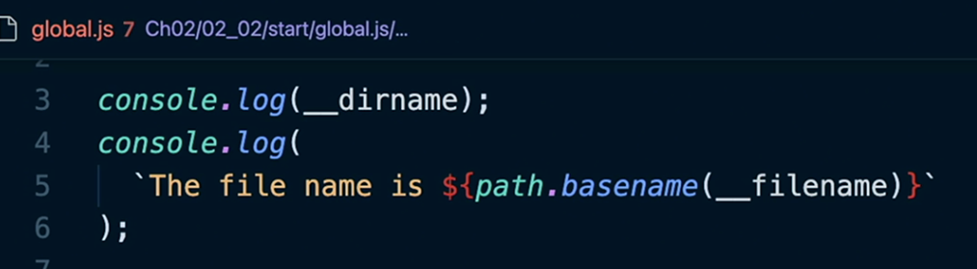

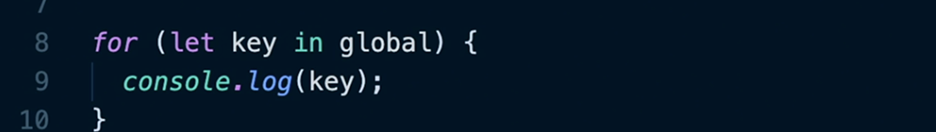

References:

1. <https://www.linkedin.com/learning/node-js-essential-training-14888164/using-the-require-function?autoSkip=true&resume=false&u=2108001>

2. <https://nodejs.org/api/process.html>