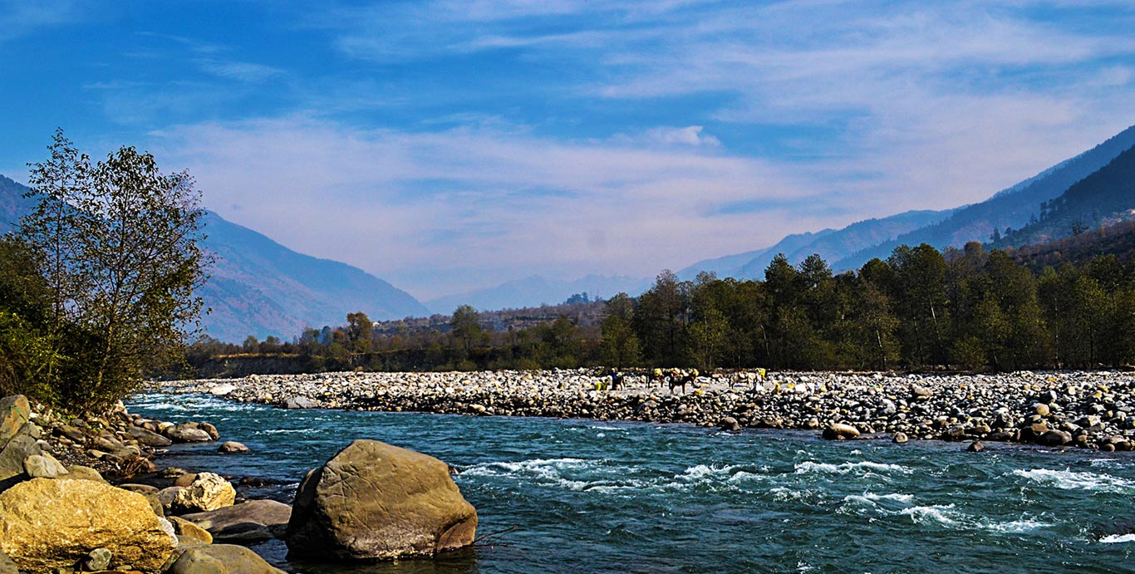

URL: <https://www.kullu-manali-packages.com/images/wallhaven-27263.jpg>

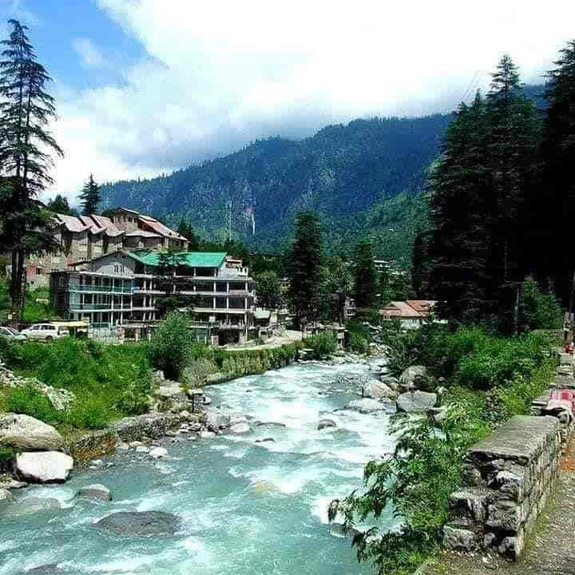

URL: <https://content3.jdmagicbox.com/comp/manali/j5/9999p1901.1901.190614123457.y7j5/catalogue/manalsu-cafe-manali-zsapbsnq2m.jpg>



URL: <https://www.outlookindia.com/outlooktraveller/resizer.php?src=https://www.outlookindia.com/outlooktraveller/public/uploads/articles/explore/shutterstock_1495480766.jpg&w=500&h=400>

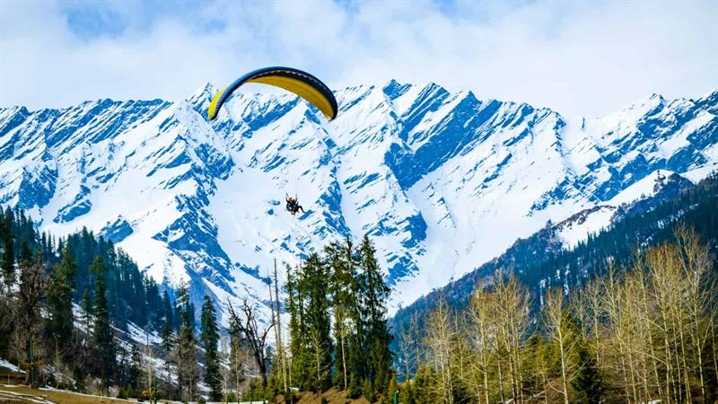

URL: <https://aryantourtravel.com/wp-content/uploads/2020/04/5542-1-manali.jpg>

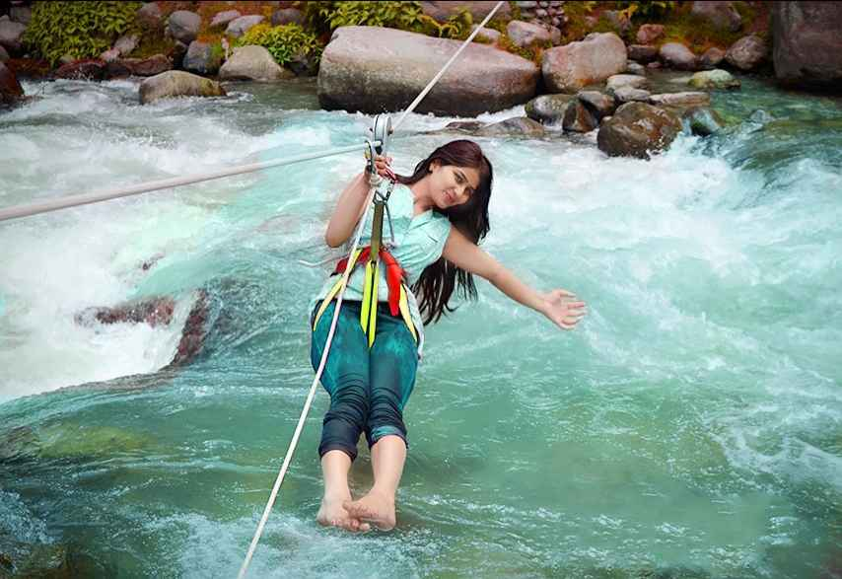

URL: <https://static2.tripoto.com/media/filter/tst/img/1355783/SpotDocument/1550151166_1550151145806.jpg>

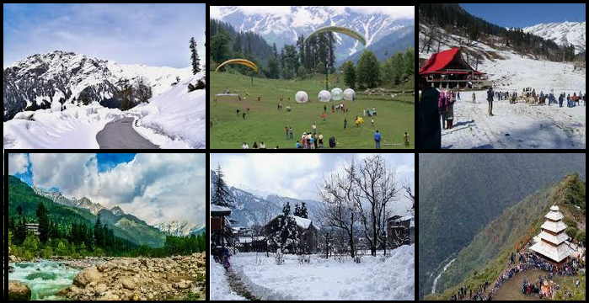

URL: https://stepuphimalaya.com/wp-content/uploads/2018/10/Kullu-Manali-tourist-places.png