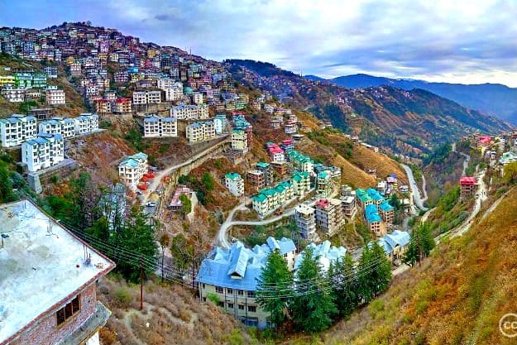

URL: <https://s3.india.com/travel/wp-content/uploads/2017/03/shimla-14.jpg>

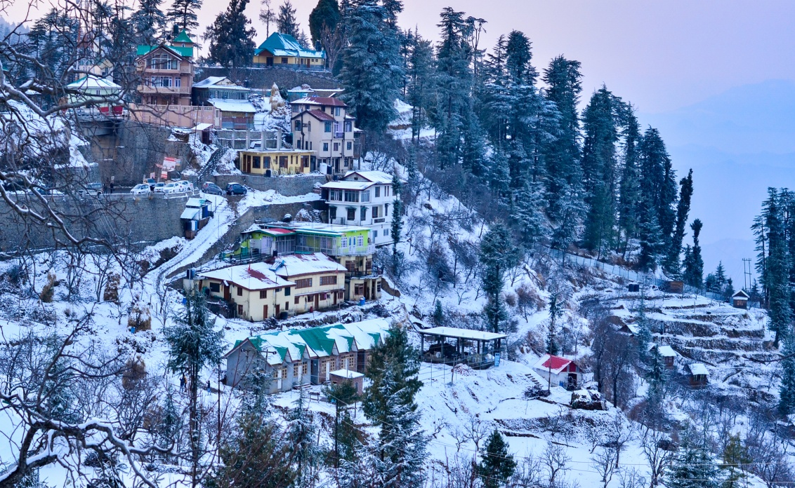

URL: <https://www.clubmahindra.com/blog/media/section_images/shuttersto-1a47b83e6a03271.jpg>

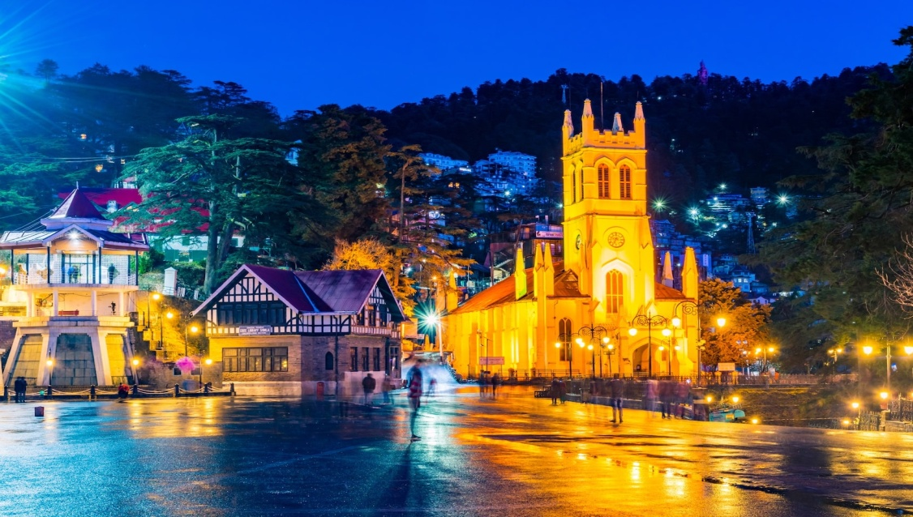

URL: <https://cdn1.goibibo.com/voy_ing/t_fs/himachal-pradesh-shimla-147616947938o.jpeg>

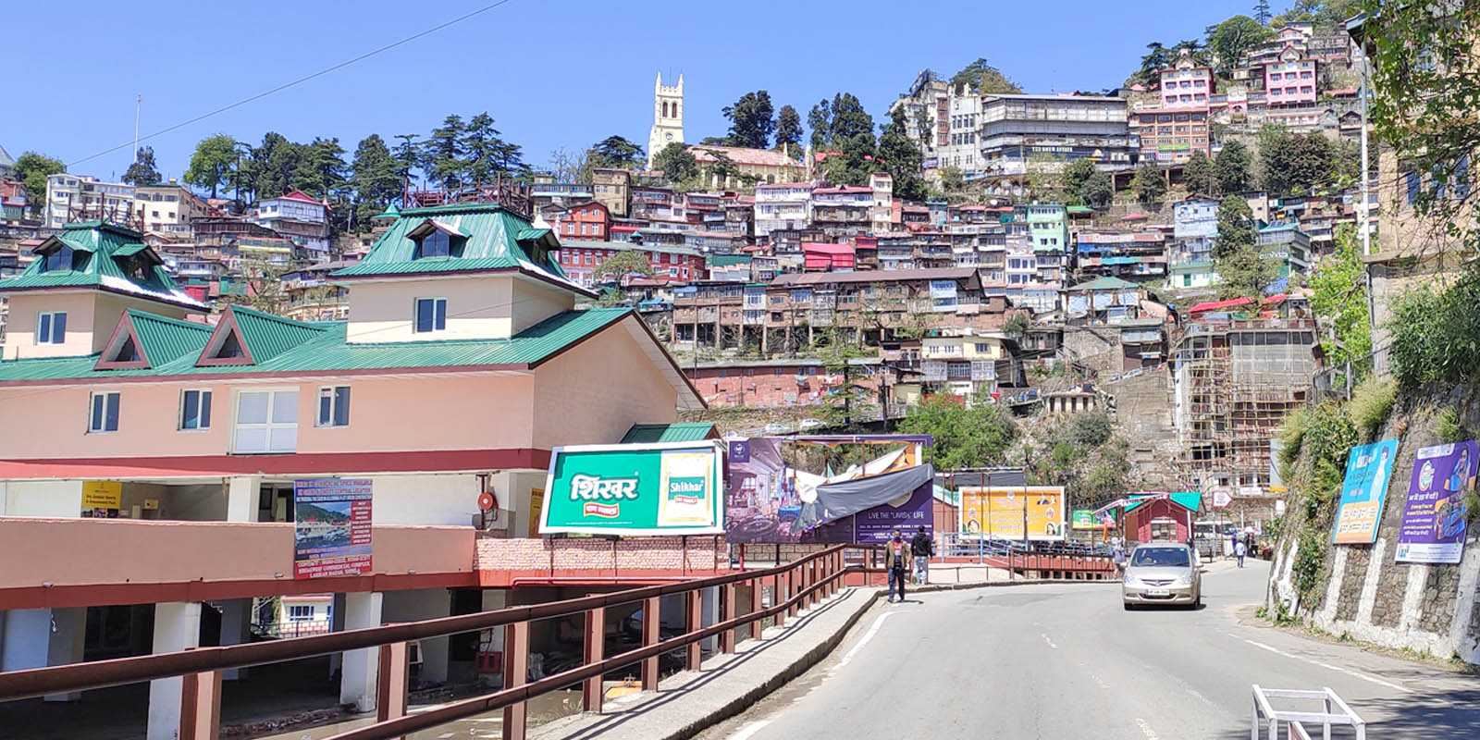

URL: <https://himachalwatcher.com/wp-content/uploads/2021/04/new-rules-for-entry-to-shimla-district.jpg>

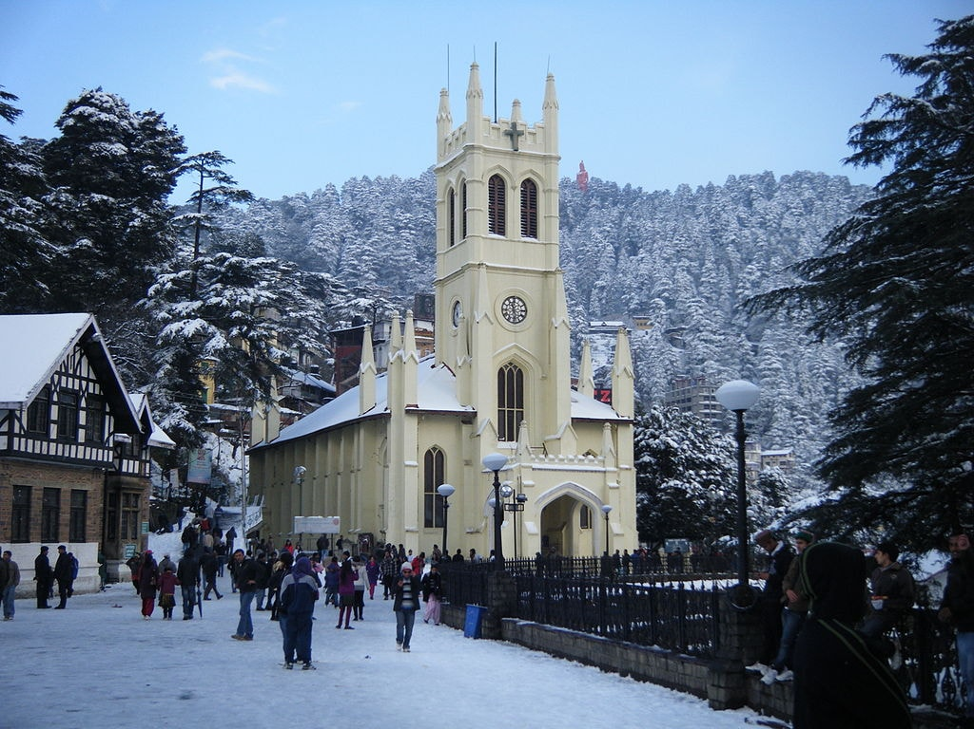

URL: <https://cdn.theculturetrip.com/wp-content/uploads/2017/10/shimla-featured.jpg>

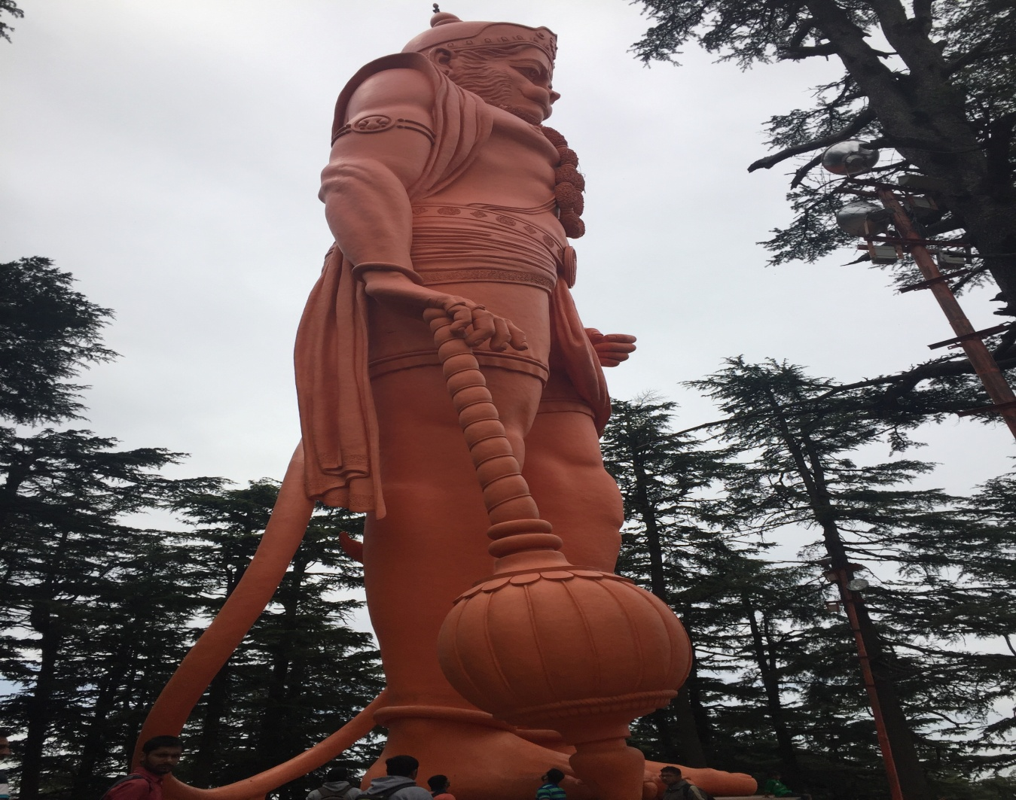

<URL:https://upload.wikimedia.org/wikipedia/commons/9/9e/Jhakoo_Temple_Hanuman.jpg>

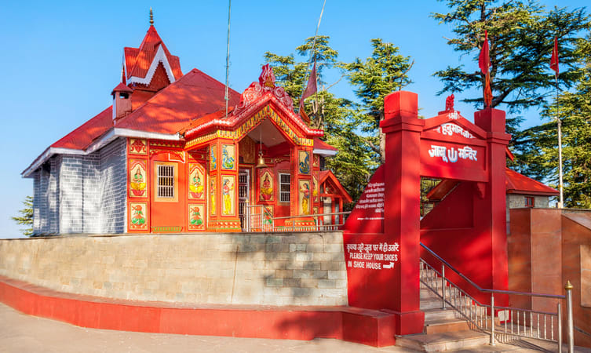

URL: https://images.thrillophilia.com/image/upload/s--SPu7RY6B--/c_fill,g_center,h_450,q_auto,w_753/dpr_1.0,f_auto,fl_strip_profile/v1/images/photos/000/170/755/original/1568113259_shutterstock_1415970905.jpg.jpg