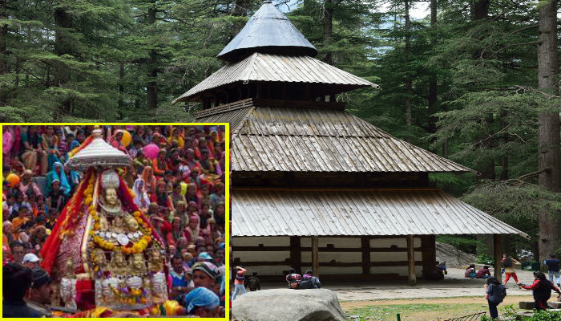

URL: <https://clickfeeds.in/wp-content/uploads/2020/10/Hidimba-Devi-Temple-in-Himachal-pradesh.jpg>

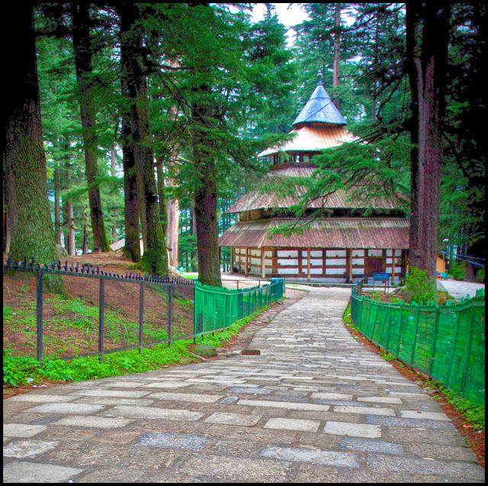

URL: <https://2.bp.blogspot.com/-d-F4lLjmQl0/WGYwhDH6aBI/AAAAAAAAIeI/-O7qFL04vqM9YGneutZvchu-hBGDHBu7ACLcB/s640/1.jpg>

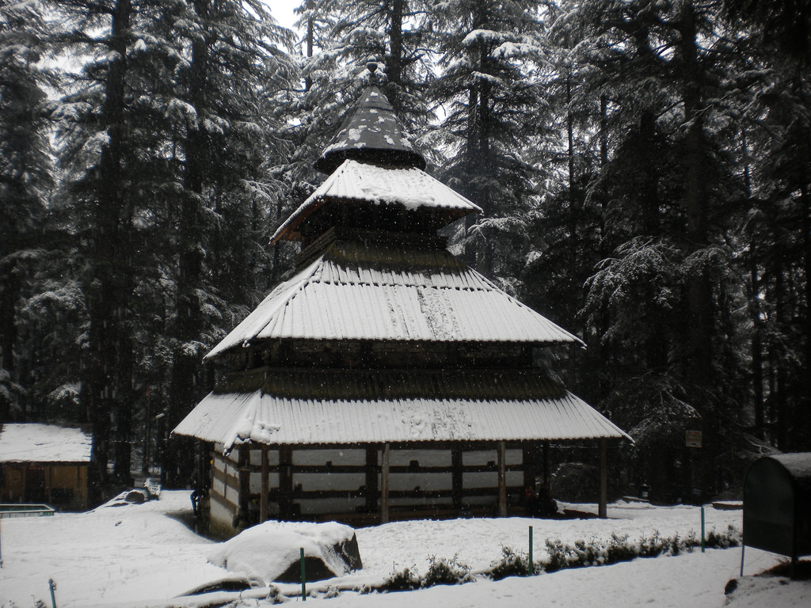

URL: <https://himachalwatcher.com/wp-content/uploads/2014/02/Hadimba-temple-in-snowfall.jpg>

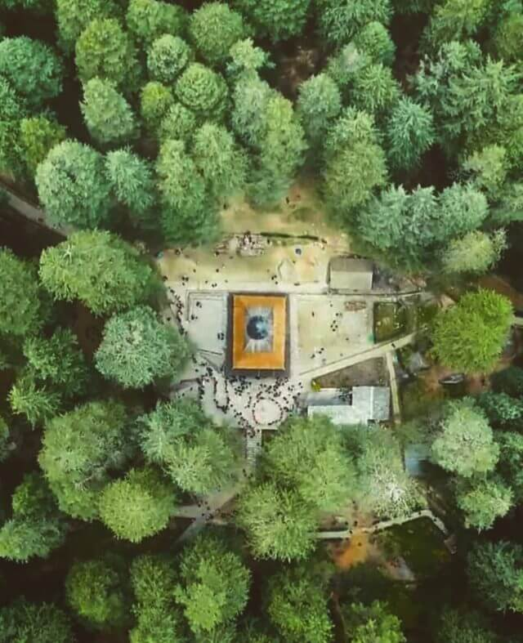

URL: <https://www.honeymoonpackagesmanali.org/uploads/8/2/6/1/8261259/aerial-view-of-hadimba-temple_orig.jpg>