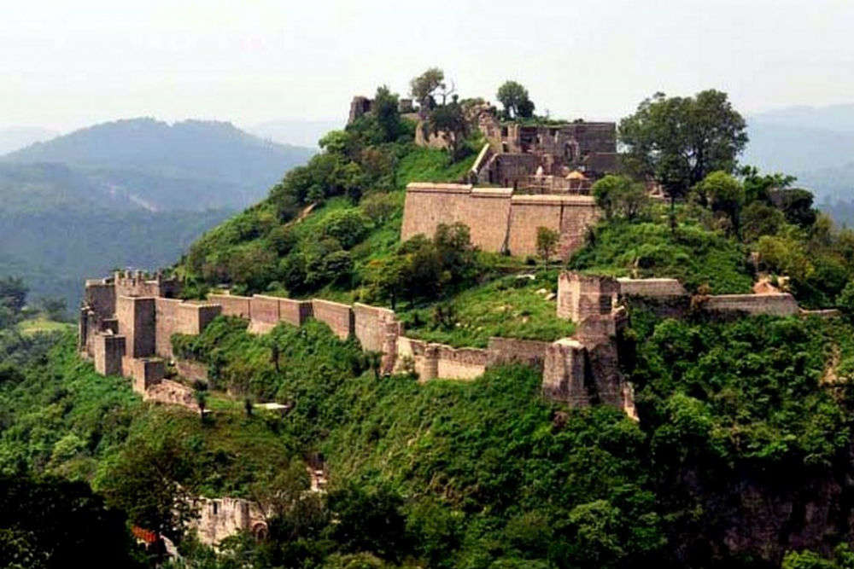

URL: <https://static.toiimg.com/photo/msid-49845109,width-96,height-65.cms>

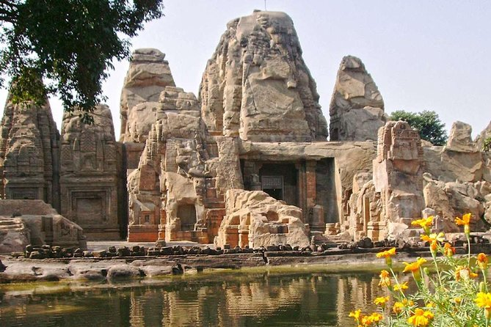

URL: <https://media.tacdn.com/media/attractions-splice-spp-674x446/0a/8d/c2/66.jpg>

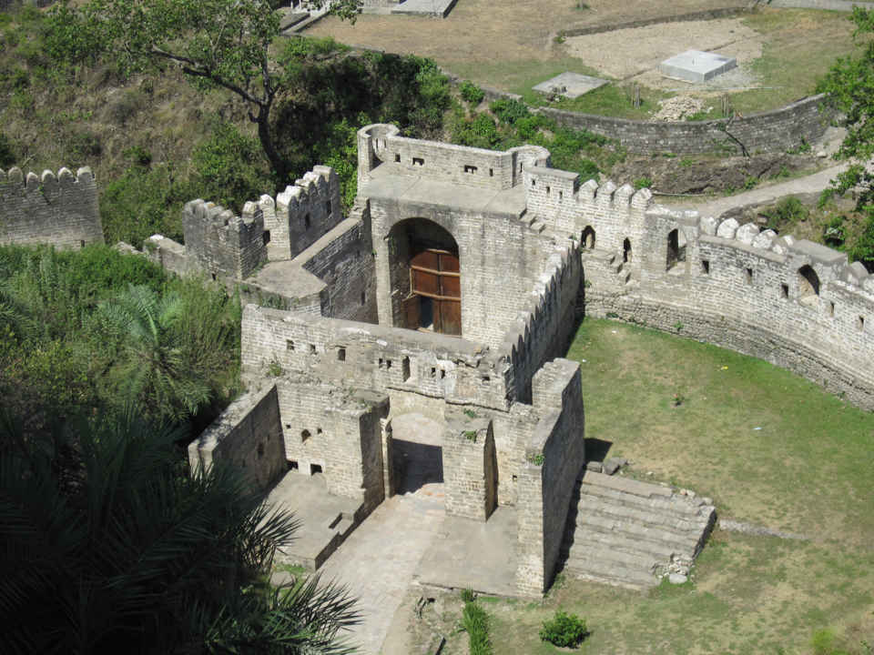

URL: <https://static2.tripoto.com/media/filter/tst/img/215408/TripDocument/1446917329_img_0087.jpg>

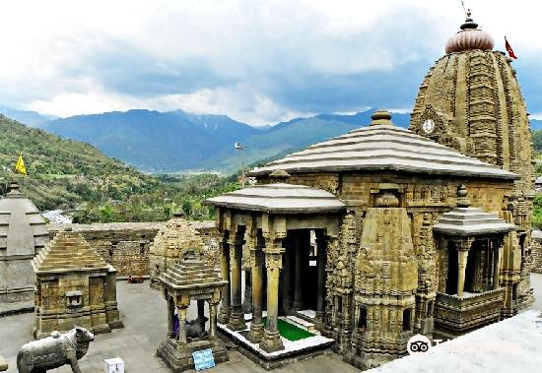

URL: <https://youimg1.tripcdn.com/target/ww081f000001gkce20ACE.png?proc=source%2Ftrip>

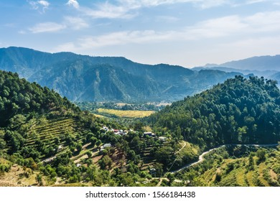

URL: <https://image.shutterstock.com/image-photo/green-valley-kangra-himachal-india-260nw-1566184438.jpg>



URL: https://static.toiimg.com/photo/49845139.cms