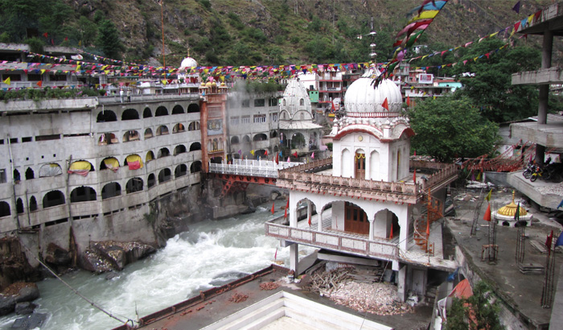

URL: <https://www.makemytrip.com/travel-guide/media/dg_image/manali/Manikaran-Gurudwara-Manali.jpg>

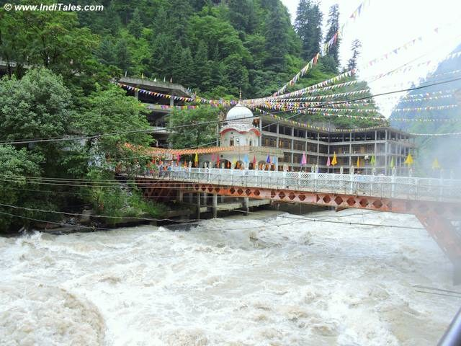

URL: <https://www.inditales.com/wp-content/uploads/2016/06/manikaran-sahib.jpg>

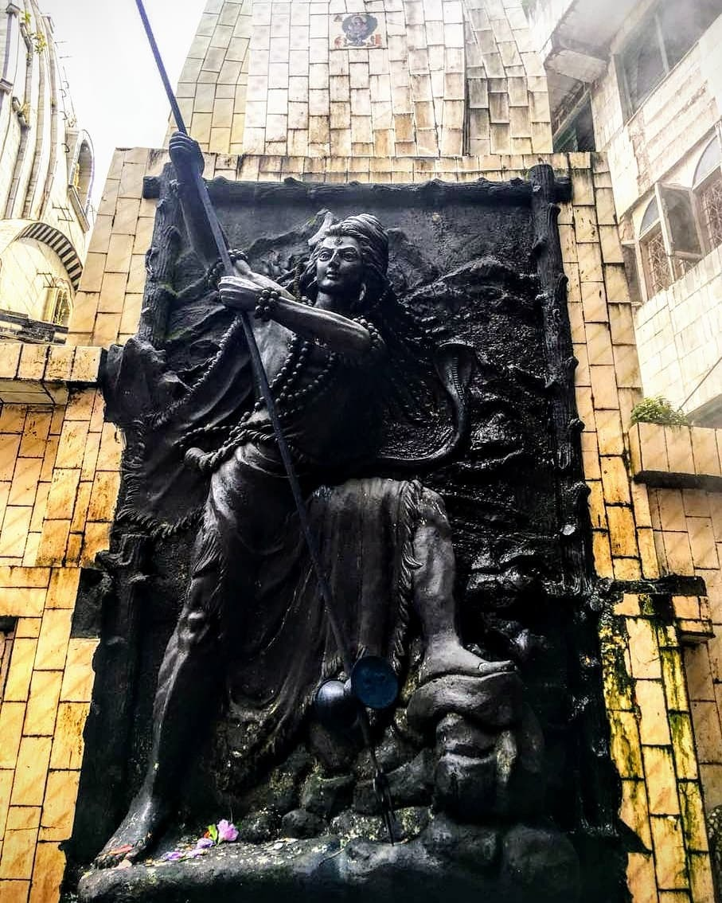

URL: <https://64.media.tumblr.com/e292920f8087d10f8c406c8430349fc6/tumblr_pdwjquqt4e1ru322to1_r1_1280.jpg>

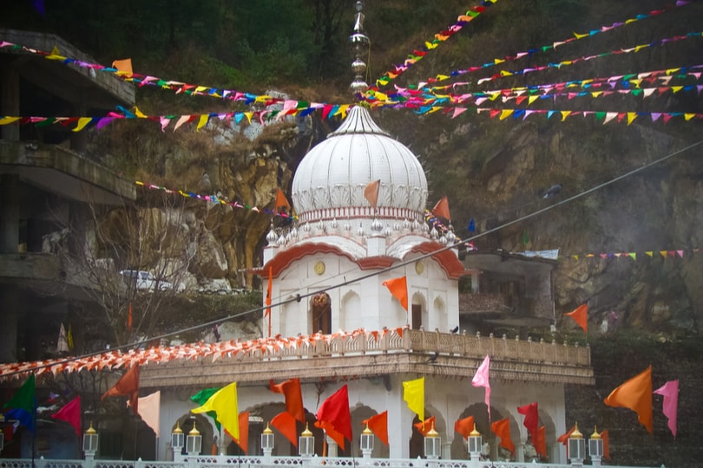

URL: https://www.oyorooms.com/travel-guide/wp-content/uploads/2020/01/Generic-2-17.jpg 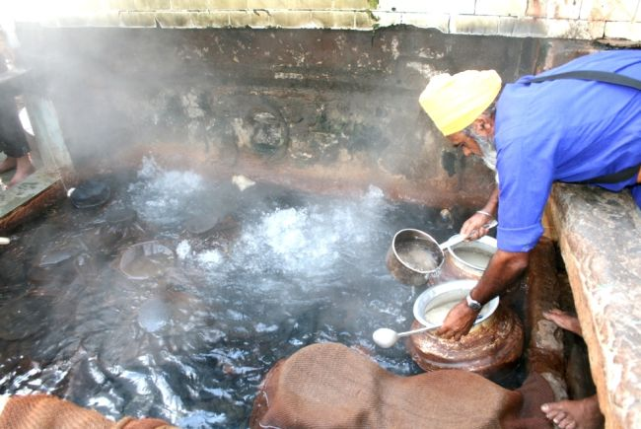

URL: https://www.realbharat.org/wp-content/uploads/2017/06/Hot-Springs-at-Manikaran.jpg

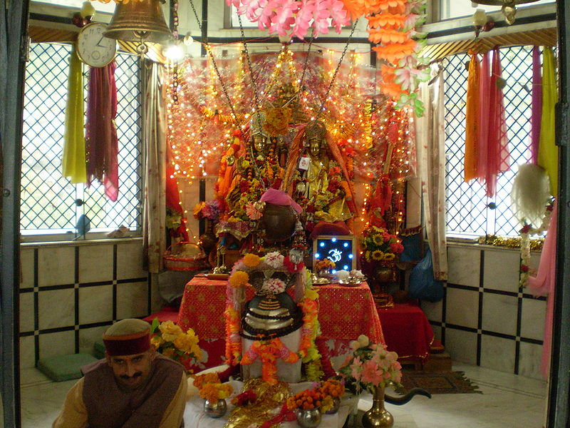

URL: https://upload.wikimedia.org/wikipedia/commons/thumb/f/fc/Manikaran_Vashnu_temple.JPG/800px-Manikaran_Vashnu_temple.JPG