**File Manipulation using System Calls in C++ on Linux**

**Objective:**

**Create a C++ program that performs file manipulation using Linux system calls. The program should be able to:**

**Create a new file.**

**Write a specified string to the file.**

**Read the contents of the file and display them on the console.**

**Append additional text to the file.**

**Delete the file.**

**Requirements:**

**Use system calls like open, read, write, close, and unlink.**

**Handle errors appropriately by checking the return values of system calls and using perror to print error messages.**

**Ensure the program is modular with separate functions for each file operation (create, write, read, append, delete).**

#include <iostream>

#include <fcntl.h>

#include <unistd.h>

#include <cstring>

#include <cerrno>

void createFile(const char* filename) {

int fd = open(filename, O_CREAT | O_WRONLY, 0644);

if (fd == -1) {

perror("Error creating file");

return;

}

close(fd);

}

void writeFile(const char* filename, const char* content) {

int fd = open(filename, O_WRONLY | O_TRUNC);

if (fd == -1) {

perror("Error opening file for writing");

return;

}

if (write(fd, content, strlen(content)) == -1) {

perror("Error writing to file");

}

close(fd);

}

void readFile(const char* filename) {

int fd = open(filename, O_RDONLY);

if (fd == -1) {

perror("Error opening file for reading");

return;

}

const size_t bufferSize = 1024;

char buffer[bufferSize];

ssize_t bytesRead;

while ((bytesRead = read(fd, buffer, bufferSize - 1)) > 0) {

buffer[bytesRead] = '\0';

std::cout << buffer;

}

if (bytesRead == -1) {

perror("Error reading file");

}

close(fd);

}

void appendFile(const char* filename, const char* content) {

int fd = open(filename, O_WRONLY | O_APPEND);

if (fd == -1) {

perror("Error opening file for appending");

return;

}

if (write(fd, content, strlen(content)) == -1) {

perror("Error appending to file");

}

close(fd);

}

void deleteFile(const char* filename) {

if (unlink(filename) == -1) {

perror("Error deleting file");

}

}

int main() {

const char* filename = "testfile.txt";

const char* content = "This is a test string.\n";

const char* appendContent = "This is appended text.\n";

std::cout << "Creating file..." << std::endl;

createFile(filename);

std::cout << "Writing to file..." << std::endl;

writeFile(filename, content);

std::cout << "Reading file contents..." << std::endl;

readFile(filename);

std::cout << "\nAppending to file..." << std::endl;

appendFile(filename, appendContent);

std::cout << "Reading file contents again..." << std::endl;

readFile(filename);

std::cout << "\nDeleting file..." << std::endl;

deleteFile(filename);

return 0;

}

**OUPUT:**

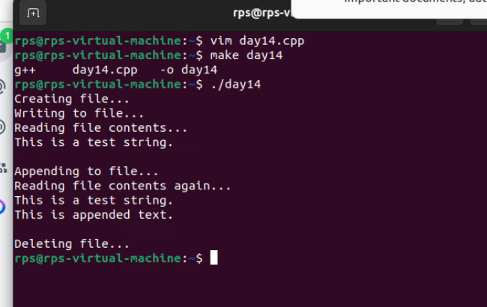

**SERVER**

#include <iostream>

#include <cstring>

#include <unistd.h>

#include <arpa/inet.h>

#define DEFAULT_PORT 8080

#define DEFAULT_BUFLEN 512

int main() {

int serverSocket;

struct sockaddr_in serverAddr, clientAddr;

socklen_t clientAddrLen = sizeof(clientAddr);

char recvbuf[DEFAULT_BUFLEN];

int recvbuflen = DEFAULT_BUFLEN;

// Create a socket for the server

serverSocket = socket(AF_INET, SOCK_DGRAM, 0);

if (serverSocket < 0) {

std::cerr << "Socket creation failed" << std::endl;

return 1;

}

// Set up the sockaddr_in structure

serverAddr.sin_family = AF_INET;

serverAddr.sin_port = htons(DEFAULT_PORT);

serverAddr.sin_addr.s_addr = INADDR_ANY;

// Bind the socket

if (bind(serverSocket, (struct sockaddr*)&serverAddr, sizeof(serverAddr)) < 0) {

std::cerr << "Bind failed" << std::endl;

close(serverSocket);

return 1;

}

// Receive data

while (true) {

int recvLen = recvfrom(serverSocket, recvbuf, recvbuflen, 0, (struct sockaddr*)&clientAddr, &clientAddrLen);

if (recvLen < 0) {

std::cerr << "recvfrom failed" << std::endl;

close(serverSocket);

return 1;

}

recvbuf[recvLen] = '\0'; // Null-terminate the received data

std::cout << "Received: " << recvbuf << std::endl;

// Echo the data back to the client

int sendLen = sendto(serverSocket, recvbuf, recvLen, 0, (struct sockaddr*)&clientAddr, clientAddrLen);

if (sendLen < 0) {

std::cerr << "sendto failed" << std::endl;

close(serverSocket);

return 1;

}

}

// Cleanup

close(serverSocket);

return 0;

}

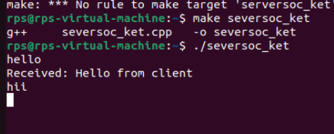

**CLIENT:**

#include <iostream>

#include <cstring>

#include <unistd.h>

#include <arpa/inet.h>

#define DEFAULT_PORT 8080

#define DEFAULT_BUFLEN 512

int main() {

int clientSocket;

struct sockaddr_in serverAddr;

char sendbuf[DEFAULT_BUFLEN] = "Hello from client";

char recvbuf[DEFAULT_BUFLEN];

int recvbuflen = DEFAULT_BUFLEN;

socklen_t serverAddrLen = sizeof(serverAddr);

// Create a socket for the client

clientSocket = socket(AF_INET, SOCK_DGRAM, 0);

if (clientSocket < 0) {

std::cerr << "Socket creation failed" << std::endl;

return 1;

}

// Set up the sockaddr_in structure

serverAddr.sin_family = AF_INET;

serverAddr.sin_port = htons(DEFAULT_PORT);

inet_pton(AF_INET, "127.0.0.1", &serverAddr.sin_addr);

// Send data to the server

int sendLen = sendto(clientSocket, sendbuf, strlen(sendbuf), 0, (struct sockaddr*)&serverAddr, sizeof(serverAddr));

if (sendLen < 0) {

std::cerr << "sendto failed" << std::endl;

close(clientSocket);

return 1;

}

std::cout << "Sent: " << sendbuf << std::endl;

// Receive data from the server

int recvLen = recvfrom(clientSocket, recvbuf, recvbuflen, 0, (struct sockaddr*)&serverAddr, &serverAddrLen);

if (recvLen < 0) {

std::cerr << "recvfrom failed" << std::endl;

close(clientSocket);

return 1;

}

recvbuf[recvLen] = '\0'; // Null-terminate the received data

std::cout << "Received: " << recvbuf << std::endl;

// Cleanup

close(clientSocket);

return 0;

}

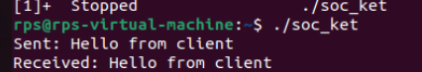

**File send Client to Server:**

**Server:**

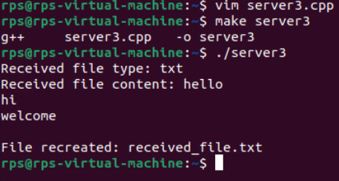

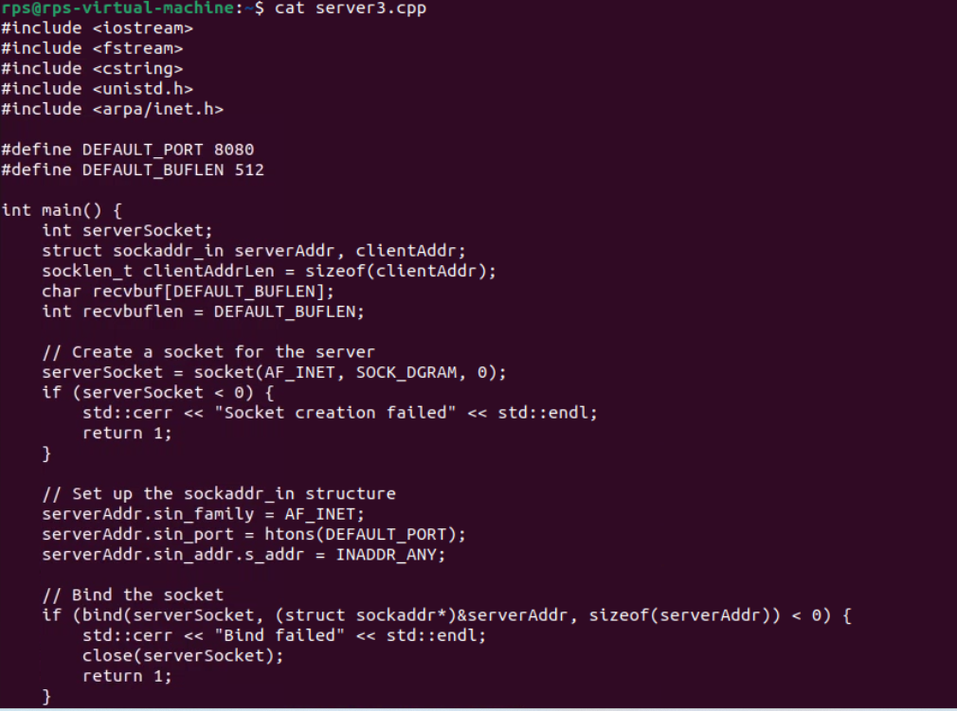

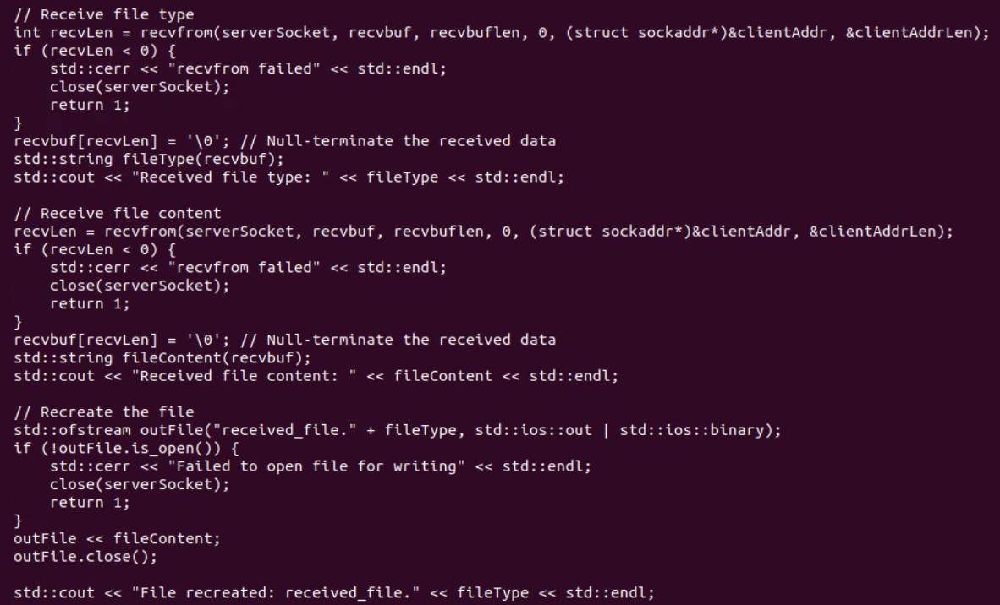

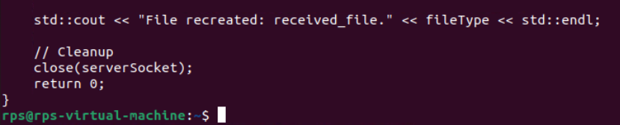

**Client:**

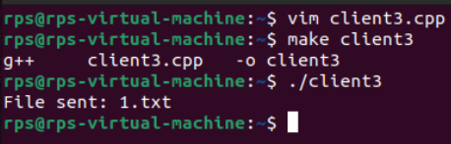

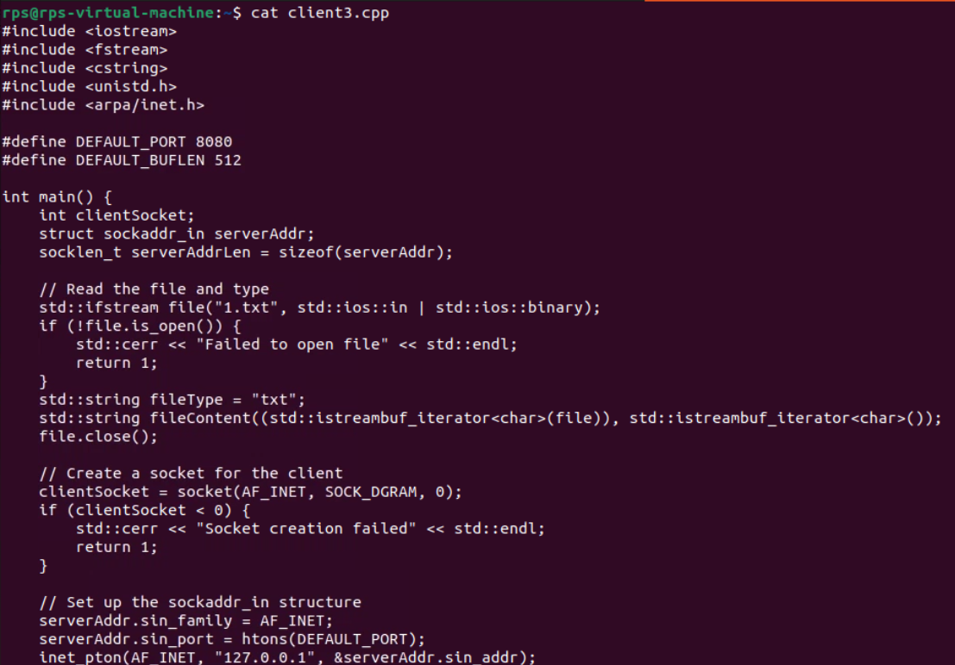

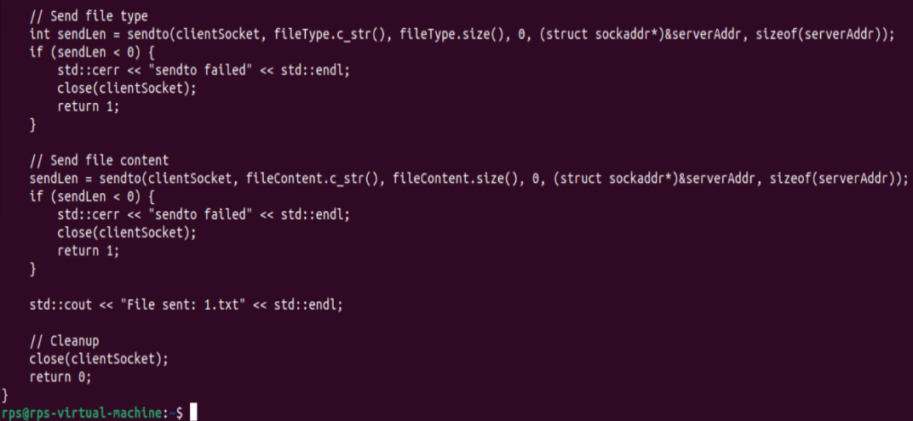

**UDP Server Implementation:**

**Create a UDP socket.**

**Bind the socket to a specified port.**

**Implement a loop to continuously listen for incoming messages.**

**Upon receiving a message:**

**Print the received message along with the client’s address and port.**

**Send an acknowledgment message ("Message received") back to the client.**

**Ensure proper error handling and resource cleanup.**

**2. UDP Client Implementation:**

**Create a UDP socket.**

**Allow the user to input the server’s IP address and port number.**

**Send a predefined message (e.g., "Hello, Server!") to the server.**

**Wait for an acknowledgment from the server.**

**Print the acknowledgment message to the console.**

**Ensure proper error handling and resource cleanup.**

**Server:**

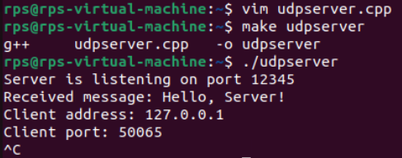

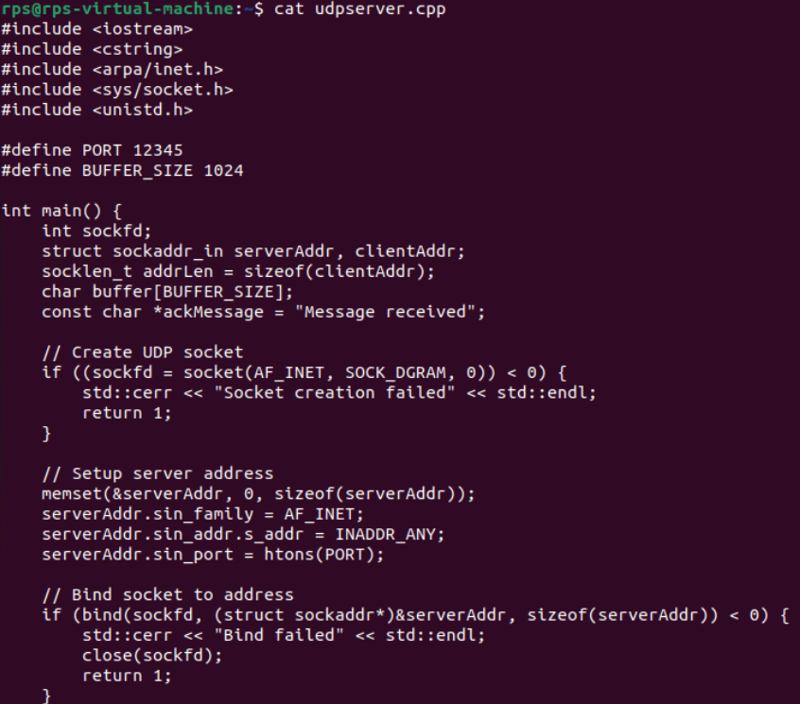

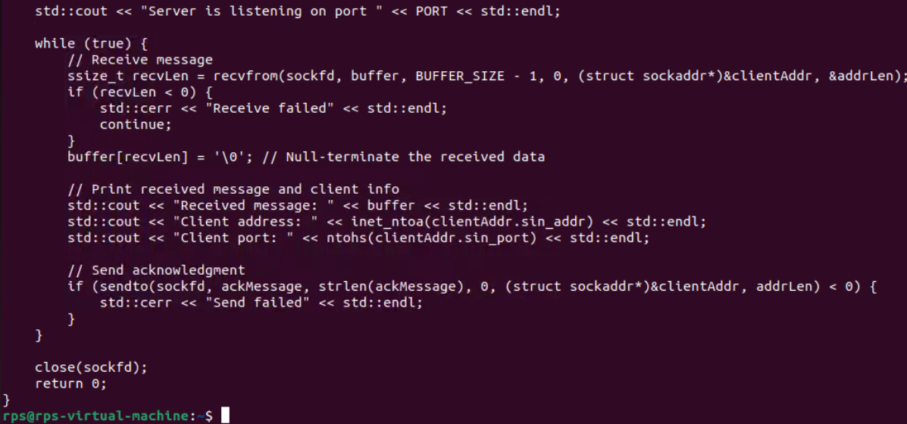

**Client:**

