**TCP Server-Client Communication:**

**Problem Statement: Write a TCP server and client program in C++ where the server listens for incoming connections and echoes back any message it receives from the client. The client should be able to send a message to the server and display the echoed message.**

**Requirements:**

**The server should run indefinitely, waiting for client connections.**

**The client should take a message as input from the user, send it to the server, and display the response.**

**Implement proper error handling and cleanup (e.g., closing sockets).**

**Server:**

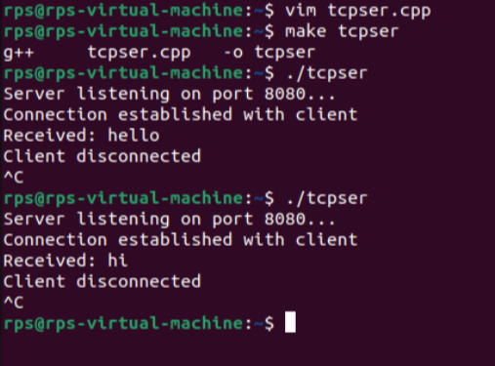

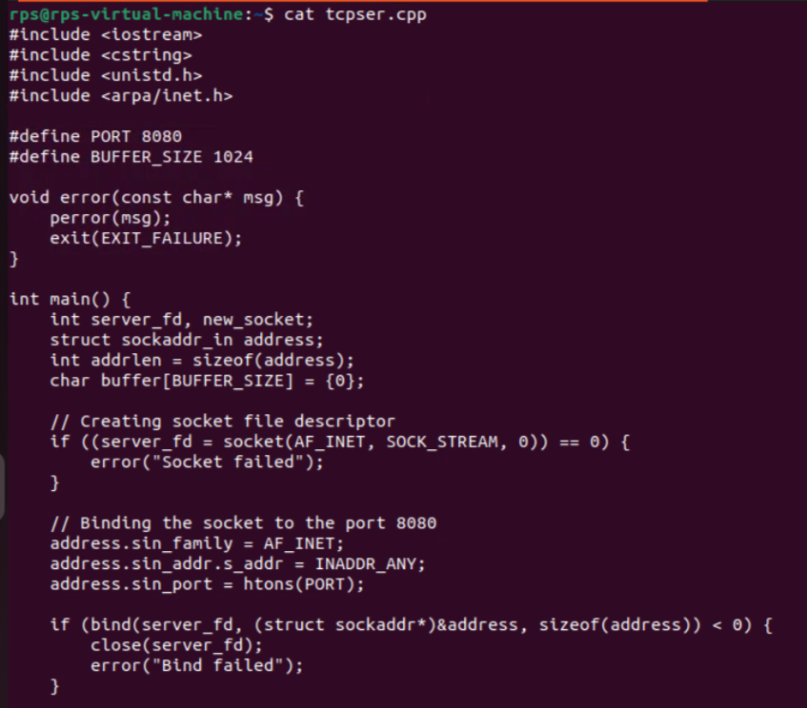

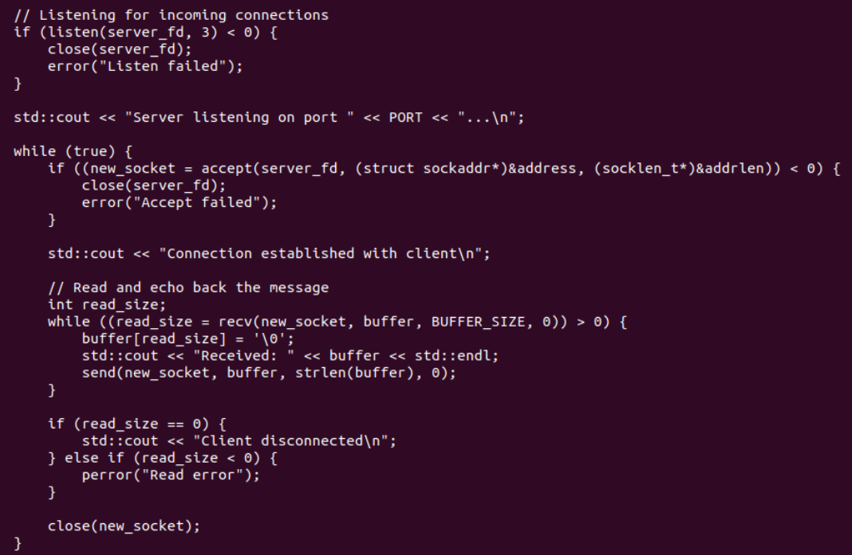

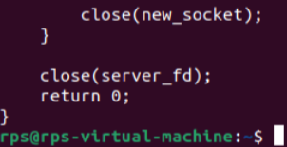

**Client:**

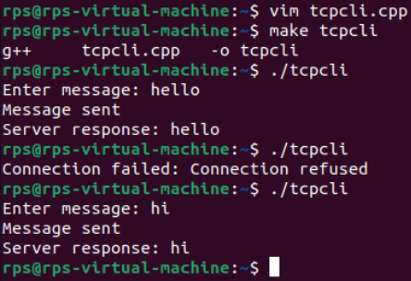

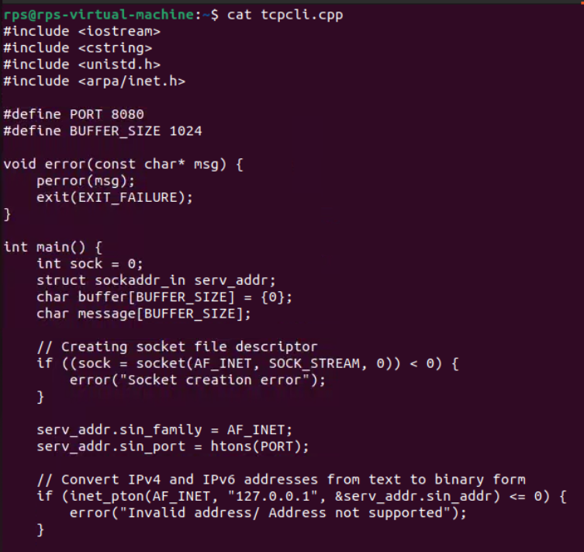

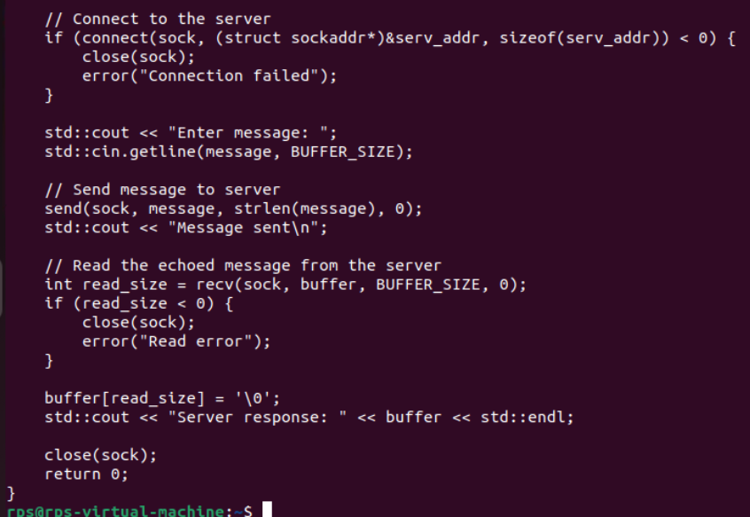

**UDP Server-Client Communication:**

**Problem Statement: Write a UDP server and client program in C++ where the server listens on a specific port and responds with "Hello, Client!" whenever it receives a message. The client should send a message to the server and print the response.**

**Requirements:**

**The server should run indefinitely, waiting for incoming messages.**

**The client should send a predefined message (e.g., "Hello, Server!") and display the server's response.**

**Implement proper error handling.**

**Server:**

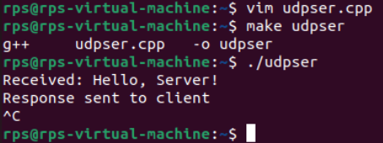

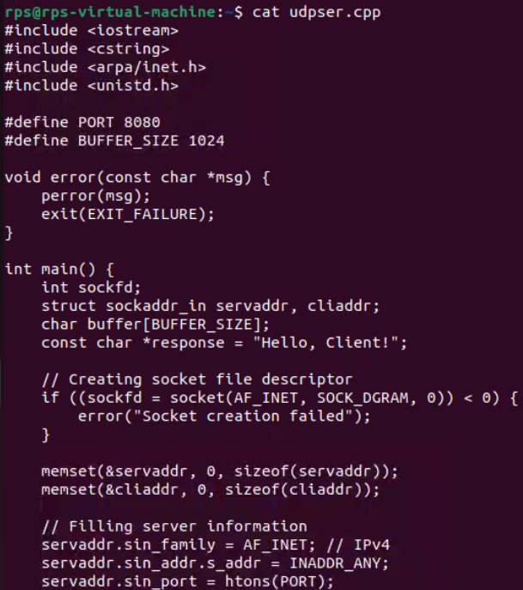

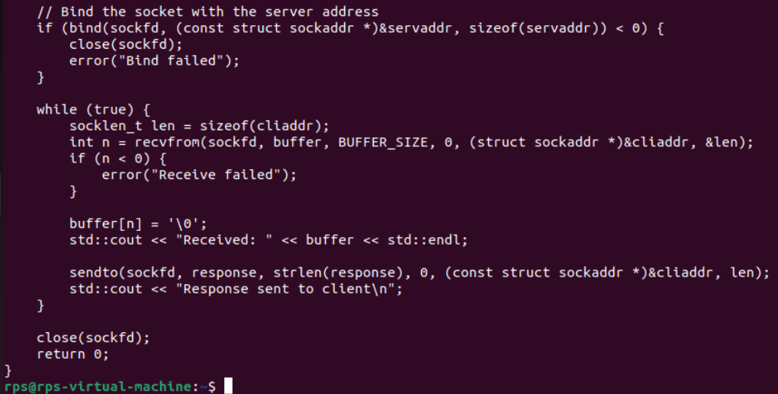

**Client:**

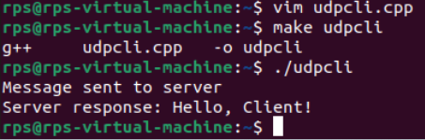

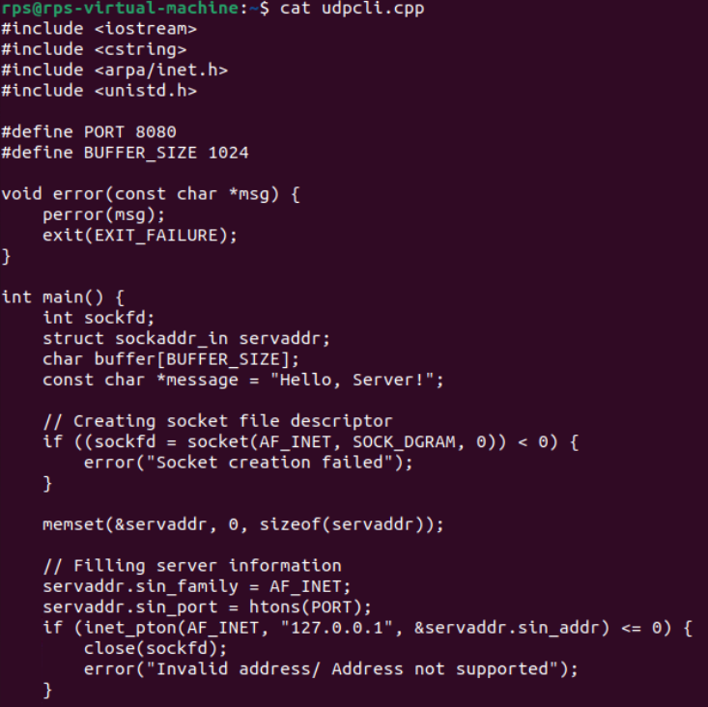

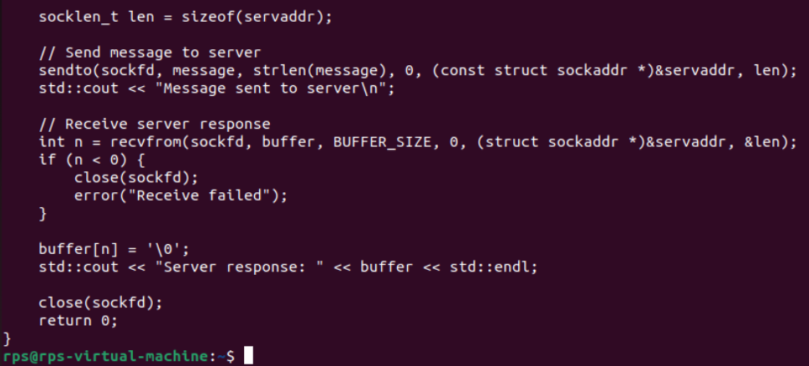

**File Transfer using TCP:**

**Problem Statement: Write a TCP server and client program in C++ to transfer a file from the client to the server. The server should save the received file with the same name, and the client should specify the file to be sent.**

**Requirements:**

**The server should run indefinitely, waiting for file transfer requests.**

**The client should prompt the user for a file path, read the file, and send its contents to the server.**

**Implement proper error handling and file operations.**

**Server:**

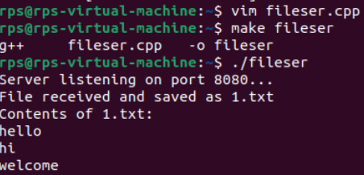

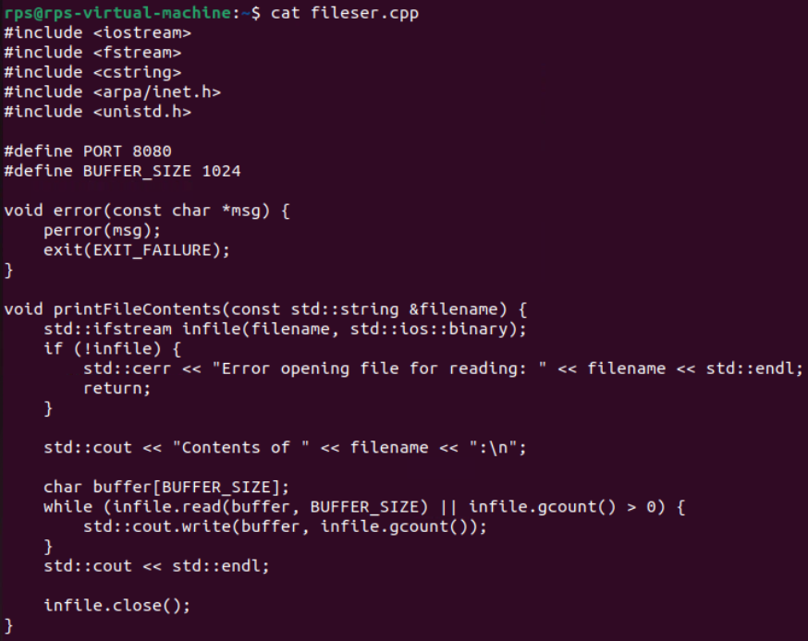

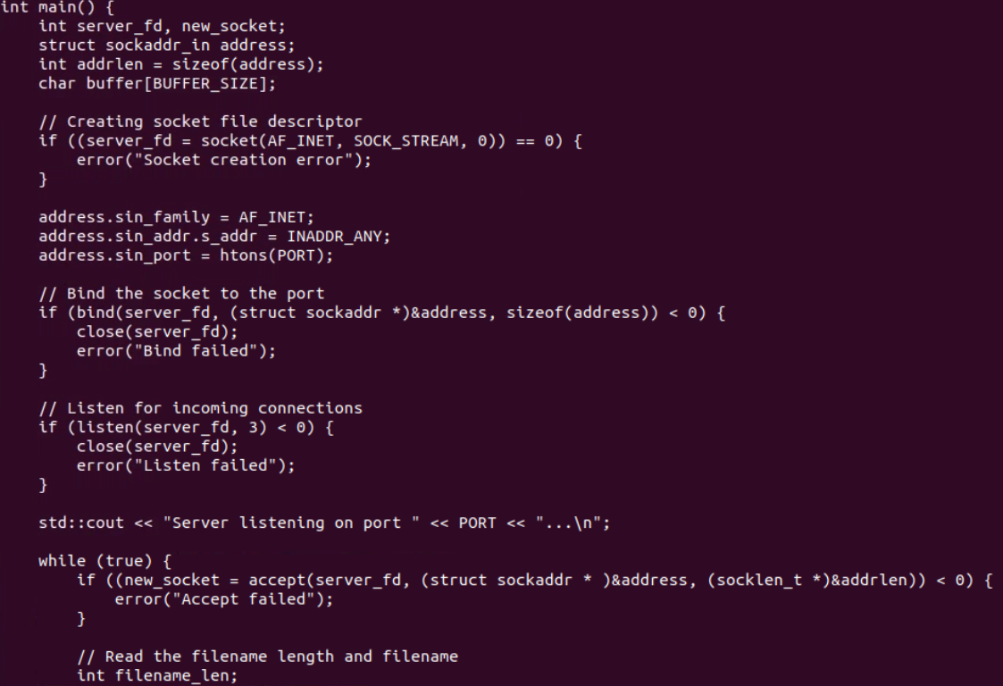

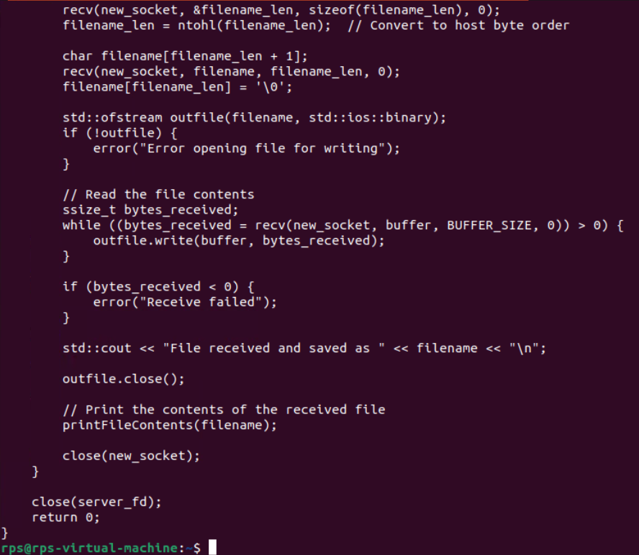

**Client:**

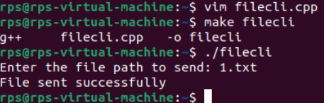

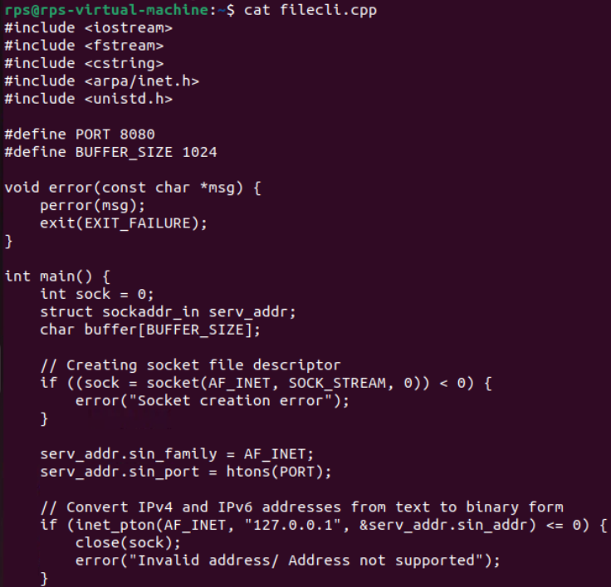

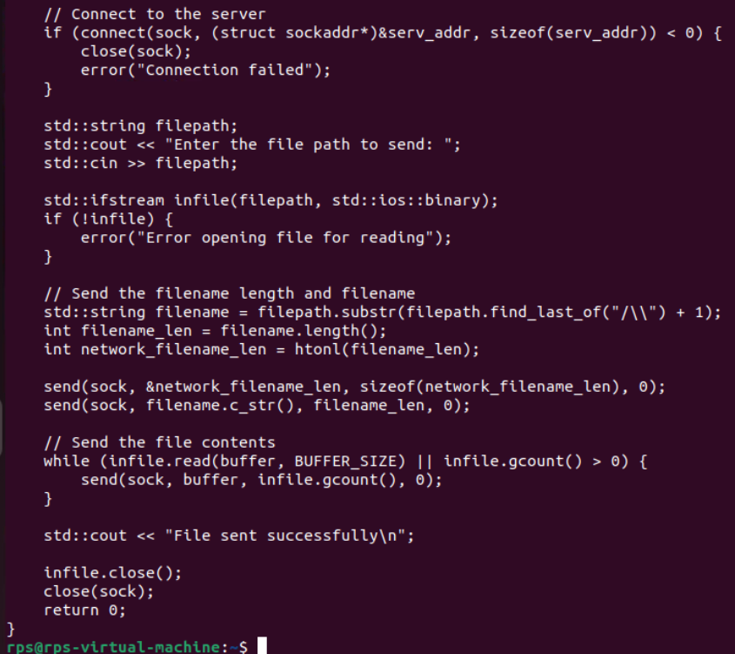

**Broadcast Messaging using UDP:**

**Problem Statement: Write a UDP server and client program in C to implement a simple broadcast messaging system. The server should broadcast a message to all clients in the network, and each client should display any broadcast messages it receives.**

**Requirements:**

**The server should send a broadcast message to a specific port.**

**Each client should listen on the same port and display any messages it receives.**

**Implement proper error handling and use UDP broadcast mechanisms.**

**SERVER:**

#include <iostream>

#include <cstring>

#include <unistd.h>

#include <arpa/inet.h>

#define BROADCAST_IP "172.20.0.53"

#define BROADCAST_PORT 12345

#define MESSAGE "Hello, this is a broadcast message!"

int main() {

int sockfd;

struct sockaddr_in broadcast_addr;

int broadcast = 1;

if ((sockfd = socket(AF_INET, SOCK_DGRAM, 0)) < 0) {

perror("socket creation failed");

exit(EXIT_FAILURE);

}

if (setsockopt(sockfd, SOL_SOCKET, SO_BROADCAST, &broadcast, sizeof(broadcast)) < 0) {

perror("setsockopt (SO_BROADCAST) failed");

close(sockfd);

exit(EXIT_FAILURE);

}

memset(&broadcast_addr, 0, sizeof(broadcast_addr));

broadcast_addr.sin_family = AF_INET;

broadcast_addr.sin_port = htons(BROADCAST_PORT);

broadcast_addr.sin_addr.s_addr = inet_addr(BROADCAST_IP);

if (sendto(sockfd, MESSAGE, strlen(MESSAGE), 0, (struct sockaddr*)&broadcast_addr, sizeof(broadcast_addr)) < 0) {

perror("sendto failed");

close(sockfd);

exit(EXIT_FAILURE);

}

std::cout << "Broadcast message sent." << std::endl;

close(sockfd);

return 0;

}

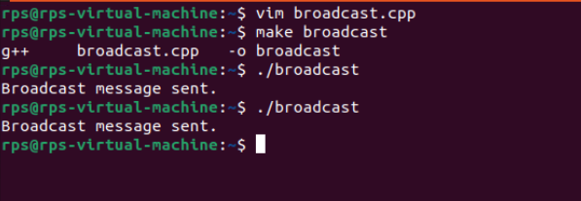

**CLIENT:**

#include <iostream>

#include <cstring>

#include <unistd.h>

#include <arpa/inet.h>

#define BROADCAST_PORT 12345

#define BUFFER_SIZE 1024

int main() {

int sockfd;

struct sockaddr_in recv_addr;

char buffer[BUFFER_SIZE];

int recv_len;

socklen_t addr_len = sizeof(recv_addr);

if ((sockfd = socket(AF_INET, SOCK_DGRAM, 0)) < 0) {

perror("socket creation failed");

exit(EXIT_FAILURE);

}

memset(&recv_addr, 0, sizeof(recv_addr));

recv_addr.sin_family = AF_INET;

recv_addr.sin_port = htons(BROADCAST_PORT);

recv_addr.sin_addr.s_addr = INADDR_ANY;

if (bind(sockfd, (struct sockaddr*)&recv_addr, sizeof(recv_addr)) < 0) {

perror("bind failed");

close(sockfd);

exit(EXIT_FAILURE);

}

std::cout << "Listening for broadcast messages on port " << BROADCAST_PORT << "..." << std::endl;

while (true) {

recv_len = recvfrom(sockfd, buffer, BUFFER_SIZE - 1, 0, (struct sockaddr*)&recv_addr, &addr_len);

if (recv_len < 0) {

perror("recvfrom failed");

close(sockfd);

exit(EXIT_FAILURE);

}

buffer[recv_len] = '\0';

std::cout << "Received broadcast message: " << buffer << std::endl;

}

close(sockfd);

return 0;

}