**Basic Signal Handling**

**Simple Signal Handler: Write a C++ program that handles the SIGINT signal (Ctrl+C) gracefully by printing a custom message before exiting.**

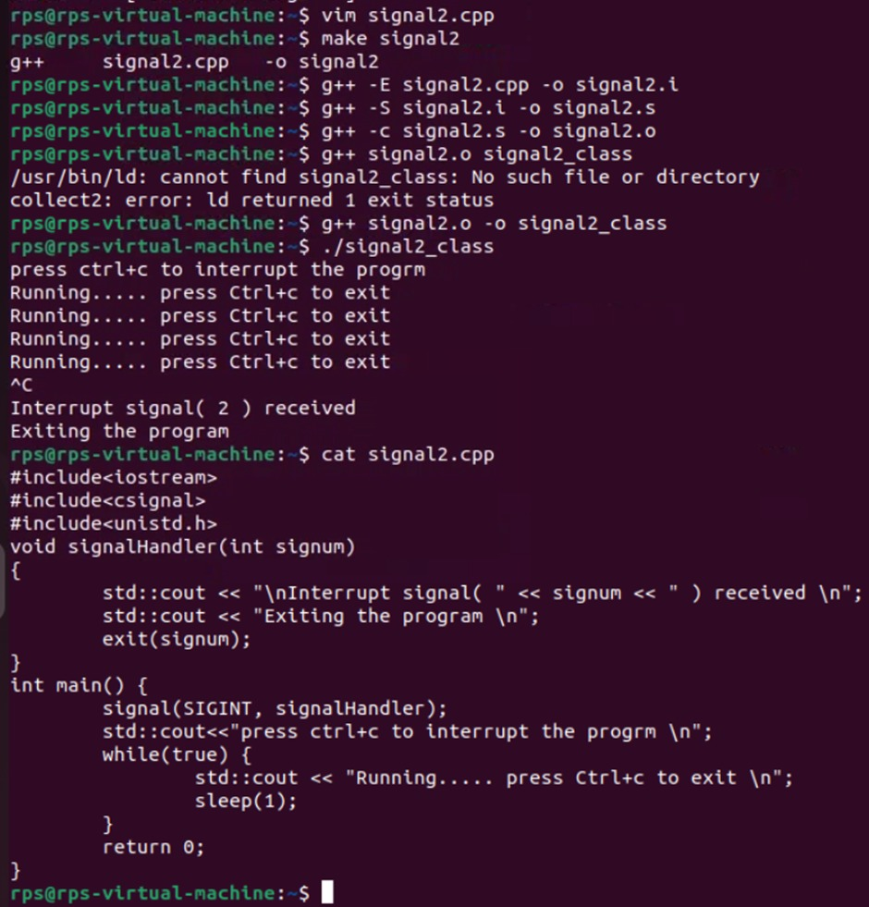

**Multiple Signal Handling: Create a program that handles both SIGINT and SIGTERM signals, printing a different message for each.**

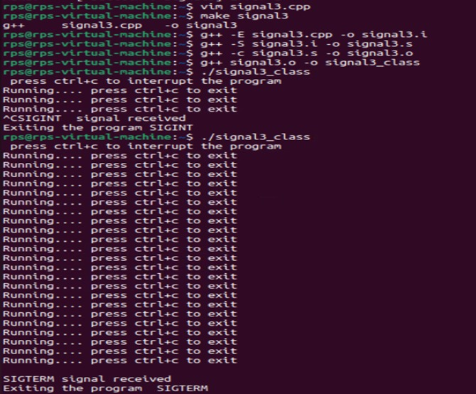

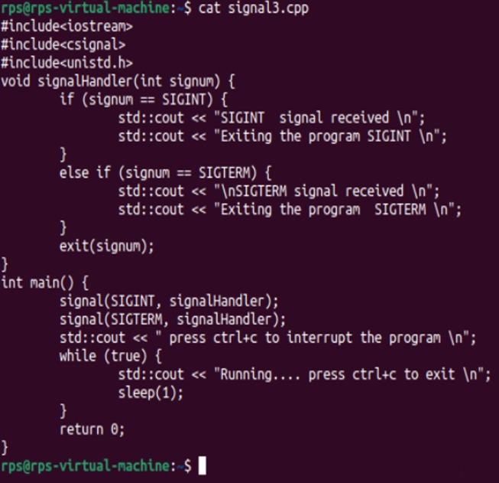

**Ignoring Signals: Develop a program that ignores the SIGTERM signal and continues execution even after it's sent.**

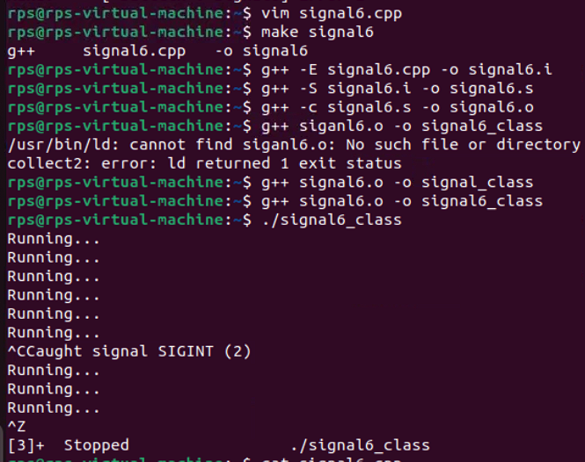

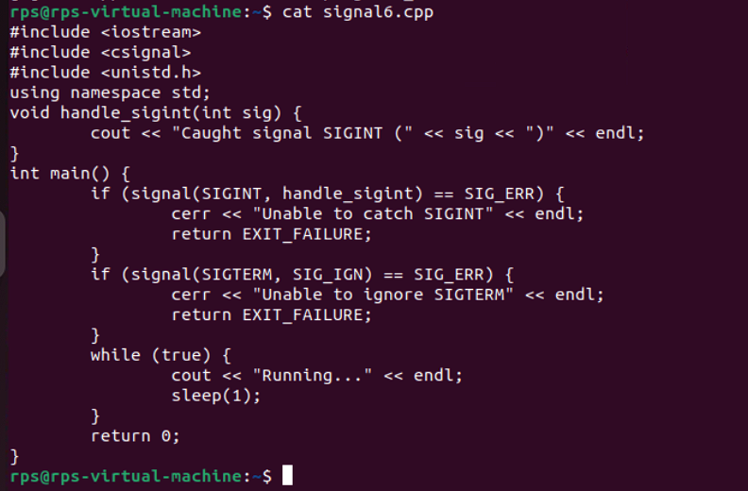

**Sig_raise:**

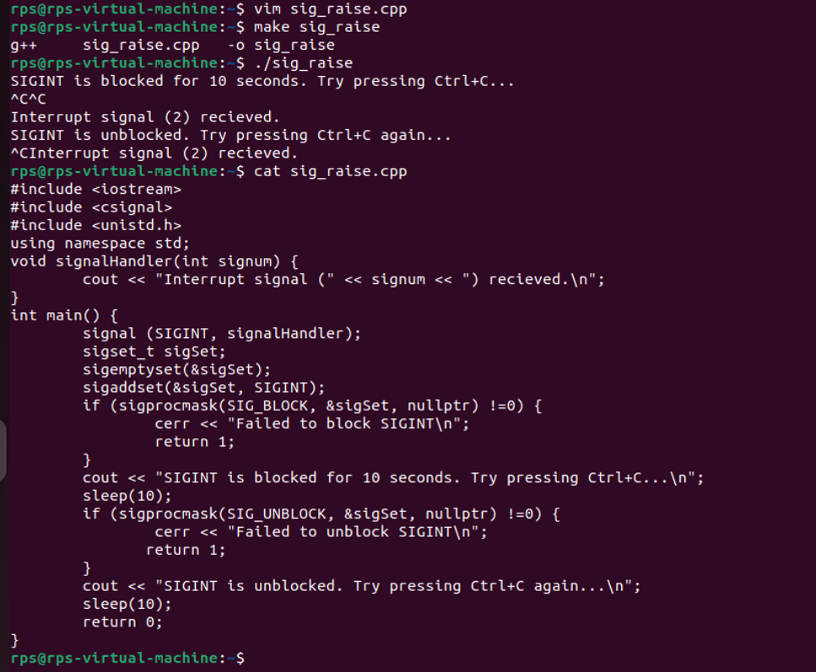

**Sig_mask:**

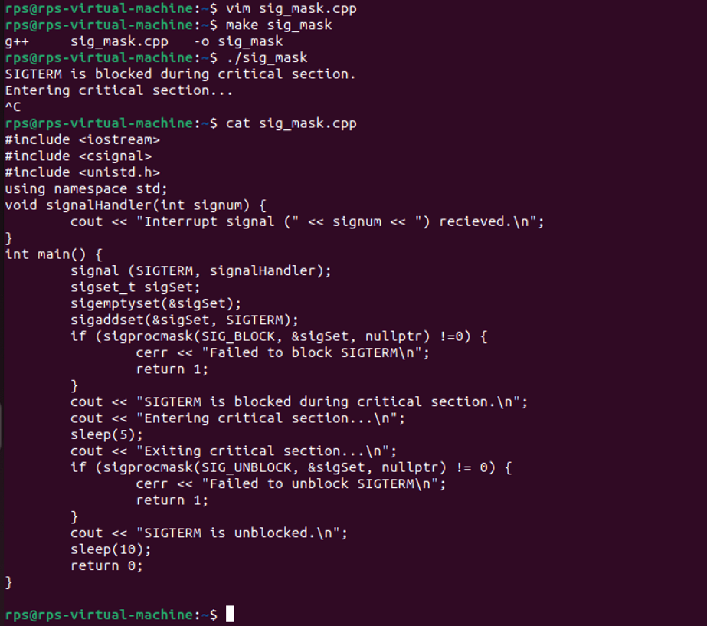

**write a code where you handle signals from 1-9 as shown**

**and try to mask few and handle others and test**

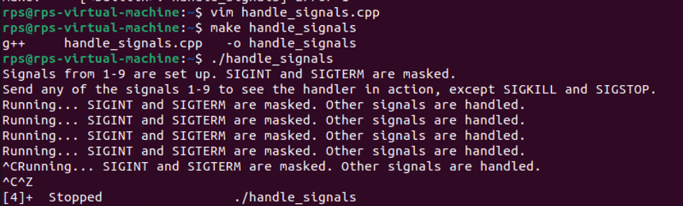

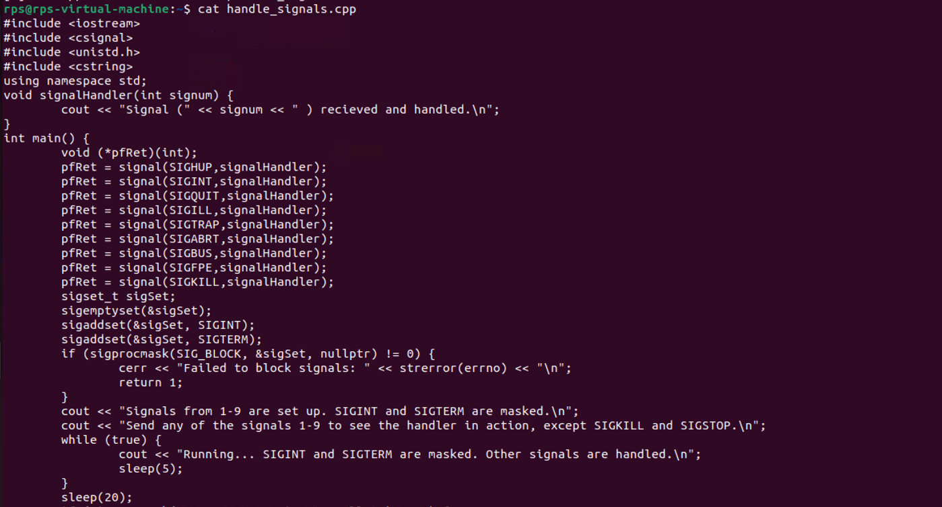

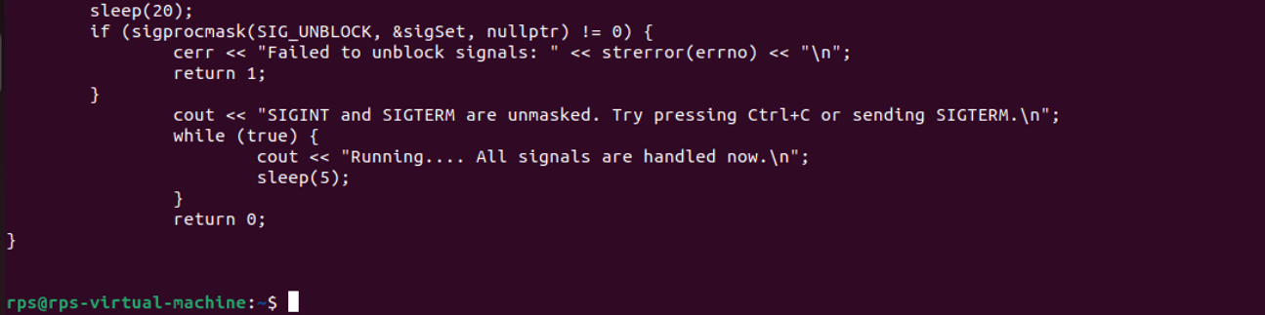

**Problem Statement 2: Signal Masking and Unmasking for Graceful Shutdown**

**Problem: Develop a C++ application that gracefully handles termination signals (e.g., SIGTERM, SIGINT) by masking specific signals during critical operations and unmasking them afterwards. Implement a clean shutdown procedure that ensures all resources are released before the process exits.**

**Key Challenges:**

**Determining the appropriate signals to mask during critical operations.**

**Ensuring timely unmasking of signals to avoid process hangs.**

**Implementing a robust shutdown mechanism that handles unexpected interruptions.**

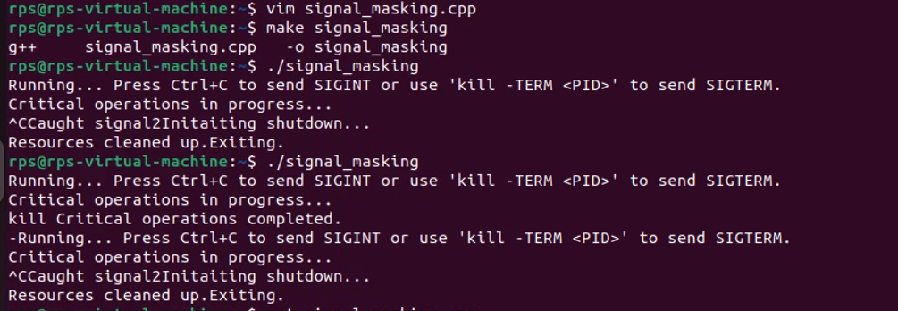

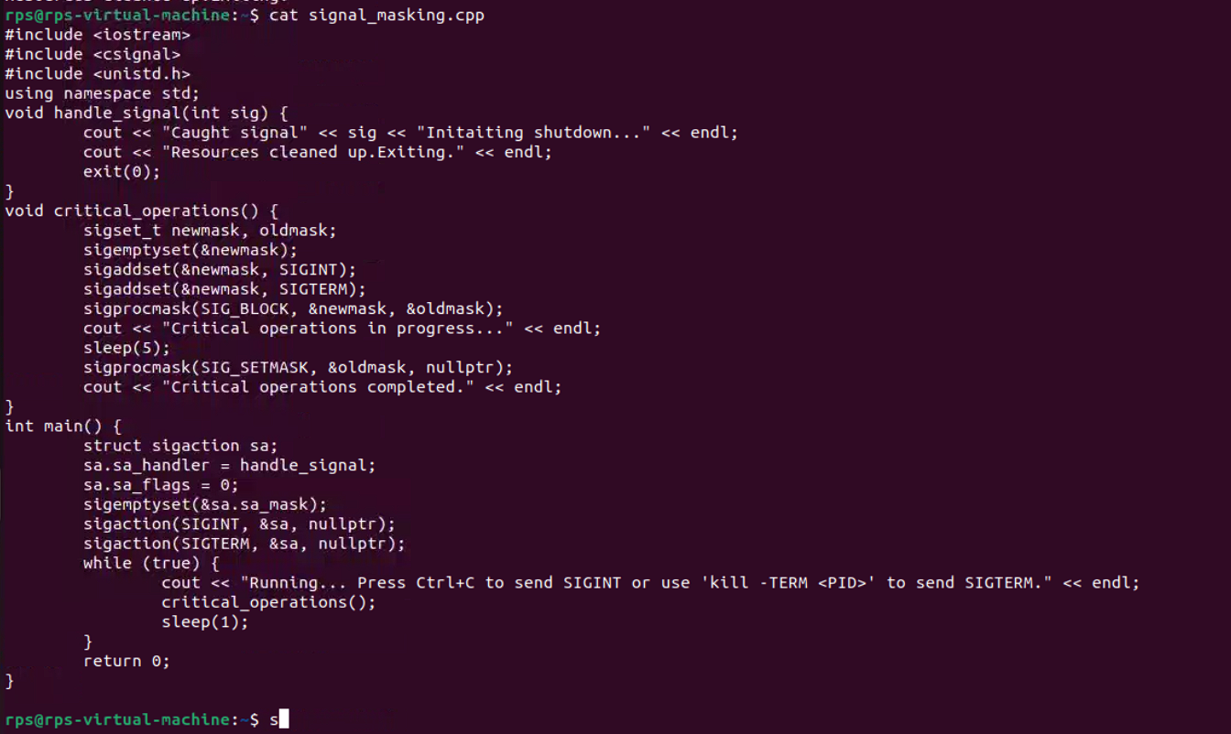

**Problem Statement 3: Signal Masking and Unmasking for Error Handling**

**Problem: Create a C++ application that uses signal masking and unmasking to handle errors gracefully. Mask specific signals during error handling routines to prevent recursive signal delivery. Implement a mechanism to log error details and perform necessary cleanup actions before re-enabling the masked signals.**

**Key Challenges:**

**Identifying the appropriate signals to mask during error handling.**

**Preventing infinite recursion of signal handlers.**

**Ensuring proper error logging and resource cleanup.**

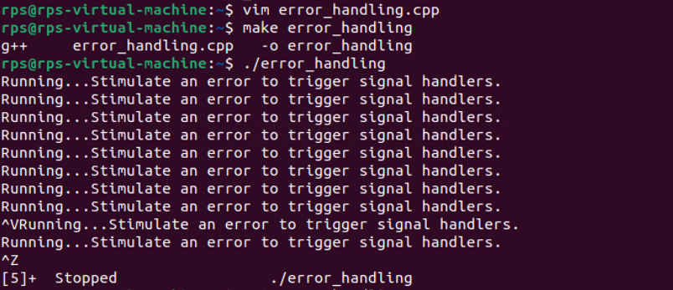

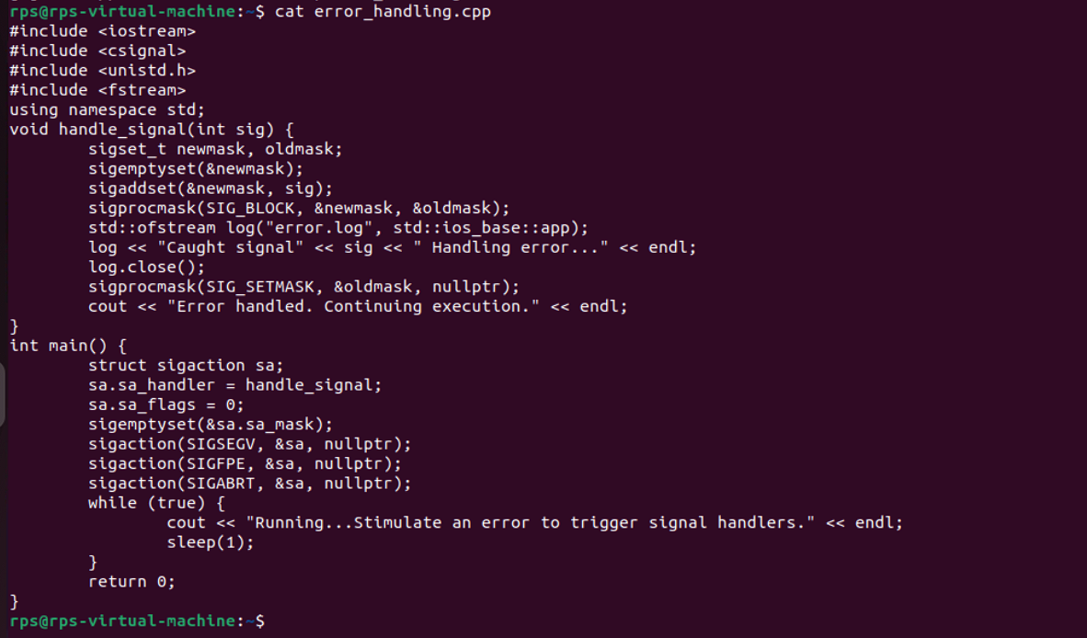

**Signal file handling:**

