PASS BY VALUE AND PASS BY REFERENCE
1.#include<iostream>
class point {
public:
double x, y;

};
void offsetpoint (point p, double x, double y) {
p.x += x;
p.y += y;
}
int main() {

point p;
p.x = 3.0;
p.y = 4.0;
offsetpoint(p, 1.0, 2.0);
std::cout << "("<< p.x << "," << p.y << ")";
}

Output:
(3,4)

2.#include<iostream>
class point {
public:
double x, y;

};
void offsetpoint (point p, double x, double y) {
p.x += x;
p.y += y;
}
int main() {

point p;
p.x = 3.0;
p.y = 4.0;
offsetpoint(p, 1.0, 2.0);
std::cout << "("<< p.x << "," << p.y << ")";
}

Output:
(4,6)

The main difference between
• The output will be (3,4).
• This is because the modifications made to p inside offsetpoint are not reflected outside due to pass by value.

• The output will be (4,6).
• Here, offsetpoint modifies p directly because it receives p by reference (point& p). Therefore, the changes to p.x and p.y inside offsetpoint are reflected in main.

CONSTRUCTORS

Constructor in C++ is a special method that is invoked automatically at the time of object creation. It is used to initialize the data members of new objects generally. The constructor in C++ has the same name as the class or structure. It constructs the values i.e. provides data for the object which is why it is known as a constructor.

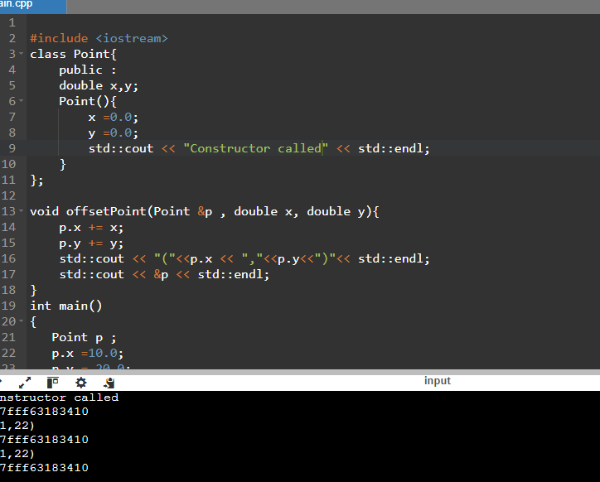

ENCAPSULATION

In normal terms, Encapsulation is defined as wrapping up of data and information under a single unit. In Object-Oriented Programming, Encapsulation is defined as binding together the data and the functions that manipulate them.(Hiding data showing functionality to user)

#include <iostream>
using namespace std;
class Rectangle {
private:
double length;
double width;
public:
void setLength(double l) {
length = l;
}
void setWidth(double w) {
width = w;
}
double getLength() {
return length;
}
double getWidth() {
return width;
}
double calculateArea() {
return length * width;
}
};

int main() {
Rectangle rect;
rect.setLength(5.0);
rect.setWidth(3.0);
cout << "Length: " << rect.getLength() << endl;
cout << "Width: " << rect.getWidth() << endl;
cout << "Area: " << rect.calculateArea() << endl;
return 0;
}

OUTPUT:
LENGTH:5
WIDTH:3
AREA:15

INHERITENCE

Acquring properties from parent to child

#include <iostream>
using namespace std;
class Animal {
public:
void eat() {
cout << "This animal is eating." << endl;
}
};
class Dog : public Animal {
public:
void bark() {
cout << "The dog is barking." << endl;
}
};
int main() {
Dog myDog;
myDog.eat(); // Inherited method
myDog.bark(); // Child class method
return 0;
}

OUTPUT:

This animal is eating
The dog is barking
CONSTRUCTORS

Constructor in C++ is a special method that is invoked automatically at the time of object creation. It is used to initialize the data members of new objects generally. The constructor in C++ has the same name as the class or structure. It constructs the values i.e. provides data for the object which is why it is known as a constructor.

1.DEFAULT CONSTRUCTOR:

A default constructor is a constructor that either has no parameters, or if it has parameters, all the parameters have default values.

Write a class Student with a default constructor that initializes the student's name to "Unknown" and age to 0. Add a method display to print the student's details

#include <iostream>
using namespace std;
class Student {
private:
string name;
int age;

public:
Student() {
name = "Unknown";
age = 0;
}

void display() {
cout << "Student Name: " << name << endl;
cout << "Student Age: " << age << endl;
}
};

int main() {
Student student;
student.display();
return 0;
}

OUTPUT:

Student Name:Unknown
Student Age:0

- PARAMETARISED CONSTRUCTOR

Parameterized constructors in C++ are constructors that accept parameters. They enable programmers to create objects with specific properties and attributes by passing arguments. Multiple parameterized constructors can be defined in a class, offering flexibility in object initialization

Write a class Rectangle with a parameterized constructor that initializes the length and width. Add a method area that returns the area of the rectangle.

#include <iostream>
using namespace std;
class Rectangle {
private:
double length;
double width;

public:
Rectangle(double l, double w) {
length = l;
width = w;
}
double area() {
return length * width;
}
};
int main() {
Rectangle rect(5.0, 3.0);
cout << "The area of the rectangle is: " << rect.area() << endl;
return 0;
}

OUTPUT:
The area of the rectangle is: 15

- MULTIPLE CONSTRUCTORS:

In C++, multiple constructors, also known as constructor overloading, allow a class to have more than one constructor with different parameters. This enables objects of the class to be initialized in different ways. Each constructor must have a unique signature, meaning the number or type of parameters must be different.

Write a class Book that has both a default constructor and a parameterized constructor. The default constructor should set the title to "Unknown" and the number of pages to 0. The parameterized constructor should initialize the title and pages with given values.

#include <iostream>
#include <string>
using namespace std;
class Book {
private:
string title;
int pages;
public:
Book() {
title = "Unknown";
pages = 0;
cout << "Default constructor called." << endl;
}
Book(string t, int p) {
title = t;
pages = p;
cout << "Parameterized constructor called." << endl;
}
void display() const {
cout << "Title: " << title << ", Pages: " << pages << endl;
}
};

int main() {
Book book1;
book1.display();
Book book2("1984", 328);
book2.display();

return 0;
}

OUTPUT:
Parameterized constructor called.
Tittle:1984,Pages:328

- CONSTRUCTOR OVERLOADING:

Constructor overloading is a feature that allows a class to have more than one constructor with different parameter lists. This enables objects of the class to be initialized in various ways, depending on the number and types of arguments passed to the constructor.
When a class has multiple constructors, they are distinguished by their signatures, which include the number and types of parameters. The compiler determines which constructor to invoke based on the arguments provided during object creation.

Write a class Complex that represents complex numbers. Implement a default constructor that sets both real and imaginary parts to 0, and a parameterized constructor that takes two arguments to initialize the real and imaginary parts.

#include <iostream>
class Complex {
private:
double real;
double imaginary;
public:
Complex() : real(0), imaginary(0) {}
Complex(double r, double i) : real(r), imaginary(i) {}
double getReal() const {
return real;
}
double getImaginary() const {
return imaginary;
}
void setReal(double r) {
real = r;
}
void setImaginary(double i) {
imaginary = i;
}
void display() const {
std::cout << real << " + " << imaginary << "i" << std::endl;
}
};
int main() {
Complex c1;
std::cout << "Complex number c1 (default constructor): ";
c1.display();
Complex c2(3.5, 2.5);
std::cout << "Complex number c2 (parameterized constructor): ";
c2.display();

return 0;
}

OUTPUT:
Complex number c1 (default constructor): 0 + 0i
Complex number c2 (parameterized constructor): 3.5 + 2.5i

- POINTER TO AN INTEGER

A pointer to an integer in C++ is a variable that stores the memory address of another variable whose data type is an integer. Pointers are used for various purposes, such as dynamic memory allocation, array manipulation, and passing large amounts of data to functions efficiently.

Write a function increment that takes a pointer to an integer and increments its value by 1. Demonstrate the function in the main program

#include <iostream>
void increment(int* ptr) {
(*ptr)++;
}
int main() {
int number = 10;
int* ptr = &number;
std::cout << "Before increment: " << number << std::endl;
increment(ptr);
std::cout << "After increment: " << number << std::endl;

return 0;
}

OUTPUT:
Before increment:10
After increment:11

- POINTES TO CLASS

A pointer to a class in C++ is a pointer that holds the address of an object of that class. This allows for dynamic allocation of objects, efficient passing of objects to functions, and the ability to work with arrays of objects.

Write a class Circle with a method area. Create a pointer to an object of this class and call the area method using the pointer

#include <iostream>
#include <cmath>
class Circle {
private:
double radius;
public:
Circle() : radius(0) {}
Circle(double r) : radius(r) {}
double area() const {
return M_PI * radius * radius;
}
void setRadius(double r) {
radius = r;
}
double getRadius() const {
return radius;
}
};
int main() {
Circle* circlePtr = new Circle(5.0);
std::cout << "Area of the circle: " << circlePtr->area() << std::endl;
delete circlePtr;
return 0;
}

OUTPUT:
Area of the circle: 78.5398

- ARRAY OF POINTER

An array of pointers is an array where each element is a pointer to another data type. This means that instead of holding actual data values, an array of pointers holds memory addresses (pointers) that point to the location of the actual data elsewhere in memory.

Write a program that creates an array of pointers to integers. Initialize the array with values and print them using the pointers.

#include <stdio.h>
int main() {
int num1 = 10, num2 = 20, num3 = 30;
int *ptrArray[3];
ptrArray[0] = &num1;
ptrArray[1] = &num2;
ptrArray[2] = &num3;
printf("Value at ptrArray[0]: %d\n", *ptrArray[0]);
printf("Value at ptrArray[1]: %d\n", *ptrArray[1]);
printf("Value at ptrArray[2]: %d\n", *ptrArray[2]);
return 0;
}

OUTPUT
Value at ptrArray[0]: 10
Value at ptrArray[1]: 20
Value at ptrArray[2]: 30

- POINTER TO AN ARRAY

a pointer to an array is a pointer that points to the first element of an array

Write a function that takes a pointer to an array of integers and the size of the array. The function should print all elements of the array.

#include <stdio.h>
void printArray(int *arr, int size) {
printf("Elements of the array:\n");
for (int i = 0; i < size; ++i) {
printf("%d ", arr[i]);
}
printf("\n");
}
int main() {
int arr[] = {1, 2, 3, 4, 5};
int size = sizeof(arr) / sizeof(arr[0]);
printArray(arr, size);
return 0;
}

OUTPUT:
Elements of the array:
1 2 3 4 5

13.DYNAMIC MEMORY ALLOCATION

Dynamic memory allocation refers to the process of allocating memory for variables or data structures at runtime (during the execution of a program) rather than at compile time. This allows programs to allocate memory as needed, based on certain conditions or requirements that may not be known until the program is running.

Write a program that dynamically allocates memory for an integer, assigns a value to it, and then frees the memory.

#include <stdio.h>
#include <stdlib.h>
int main() {
int *ptr;
ptr = (int *)malloc(sizeof(int));
if (ptr == NULL) {
printf("Memory allocation failed. Exiting...\n");
return 1;
}
*ptr = 42;
printf("Value stored in dynamically allocated memory: %d\n", *ptr);
free(ptr);
return 0;
}

OUTPUT:
Value stored in dynamically allocated memory: 42

14.REFERENCE TO AN INTEGER

A reference to an integer is an alias or alternative name for an existing integer variable. It allows you to manipulate the original variable indirectly through its reference. References provide a convenient way to pass variables to functions and to achieve more natural and readable code in certain situations compared to using pointers.

Write a function swap that takes two integer references and swaps their values. Demonstrate the function in the main program.

#include <iostream>
void swap(int &a, int &b) {
int temp = a;
a = b;
b = temp;
}
int main() {
int x = 5, y = 10;
std::cout << "Before swapping:" << std::endl;
std::cout << "x = " << x << ", y = " << y << std::endl;
swap(x, y);
std::cout << "After swapping:" << std::endl;
std::cout << "x = " << x << ", y = " << y << std::endl;
return 0;
}

OUTPUT:

Before swapping:
x = 5, y = 10
After swapping:
x = 10, y = 5

15.REFERENCE TO A CLASS OBJECT

It indicates the address where the object's variables and methods are stored

rite a class Box with a method volume. Create an object of this class and a reference to this object. Call the volume method using the reference.

#include <iostream>
class Box {
private:
double length;
double width;
double height;
public:
Box(double l, double w, double h) : length(l), width(w), height(h) {}
double volume() {
return length * width * height;
}
};
int main() {
Box myBox(3.0, 4.0, 5.0);
Box &boxRef = myBox;
double vol = boxRef.volume();
std::cout << "Volume of the box: " << vol << std::endl;
return 0;
}

OUTPUT
Volume of the box: 60

