IAM:   
Create Role:  
  
Goto EC2:  
KeyPairs 🡪create keypair  
Goto ElasticBeanstalk:  
Create new application:

Create envirnoment  
check availability:  
click next  
select VPC  
for health report let it be enhanced  
Add server_port as 5000 in environment properties  
click next -> review and click submit  
wait for few minutes to environment get create  
Environment launched successfully  
click on domain link: [DemoEBS1.us-east-1.elasticbeanstalk.com](http://DemoEBS1.us-east-1.elasticbeanstalk.com)  
you will see whitelabel error page  
just add /api/products/hello or /api/products/ to domain URL  
  
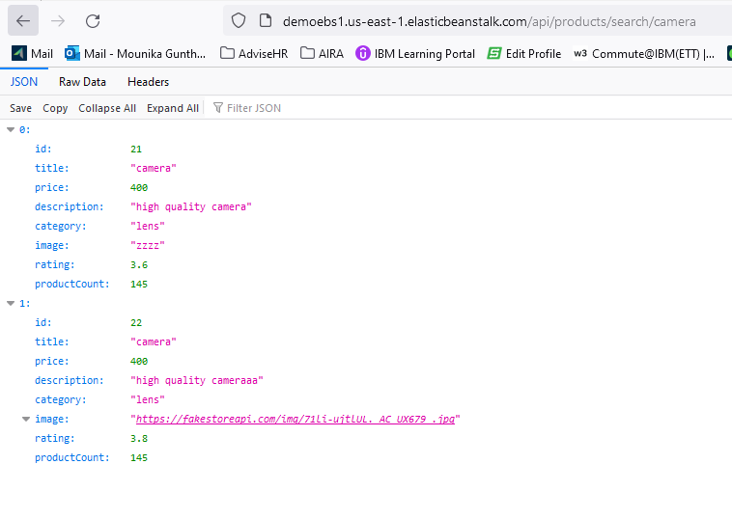  
 in health tag see the EC2 instance  
  
goto EC2 check running instances:  
go to s3: see the buckets:  
  
similar way for orders::  
  
API Gateway: Rest API Connect  
  
select Rest API Build  
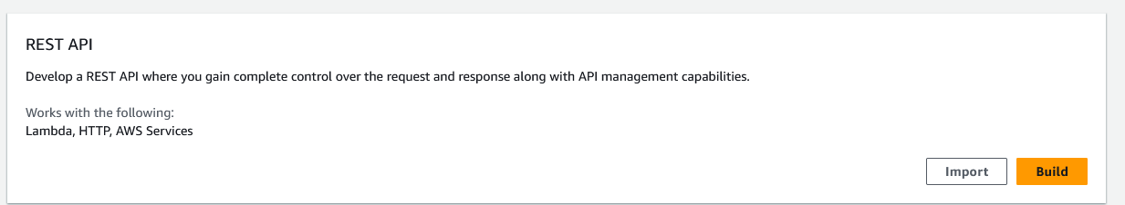

Click create API  
select Actions -> select resource  
  
Click create resource

Then on actions – click create method  
select get from dropdown  
select HTTP integration and check the box of proxy integration and provide end point URL:  
http://ebsdemo.us-east-1.elasticbeanstalk.com/api/products/hello  
click save  
same way create method post  
same way for order: <http://ebsorder.us-east-1.elasticbeanstalk.com/api/orders/hello>  
http://ebsorder.us-east-1.elasticbeanstalk.com/api/orders/  
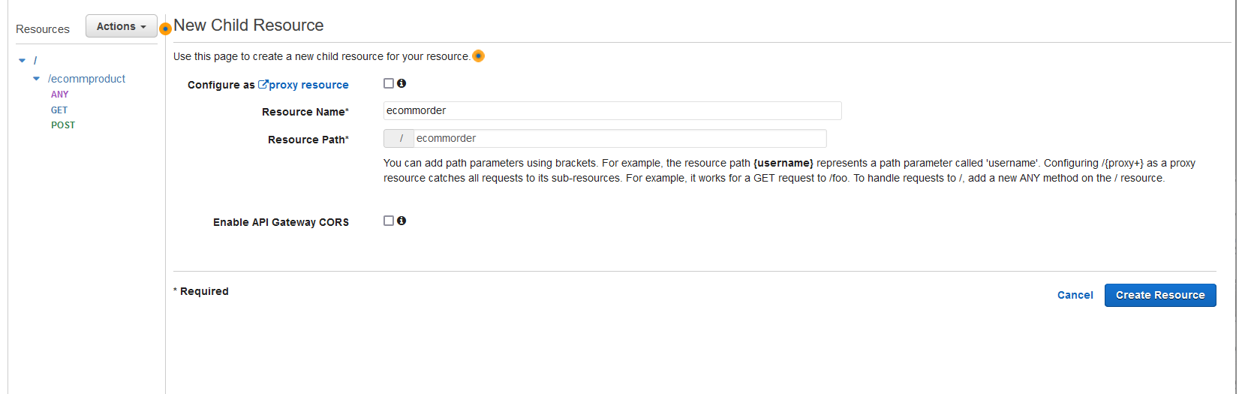

Deploy API

Click deploy  
receive a invoke URL:  
**Invoke URL:** <https://8hscdnsskd.execute-api.us-east-1.amazonaws.com/Dev>  
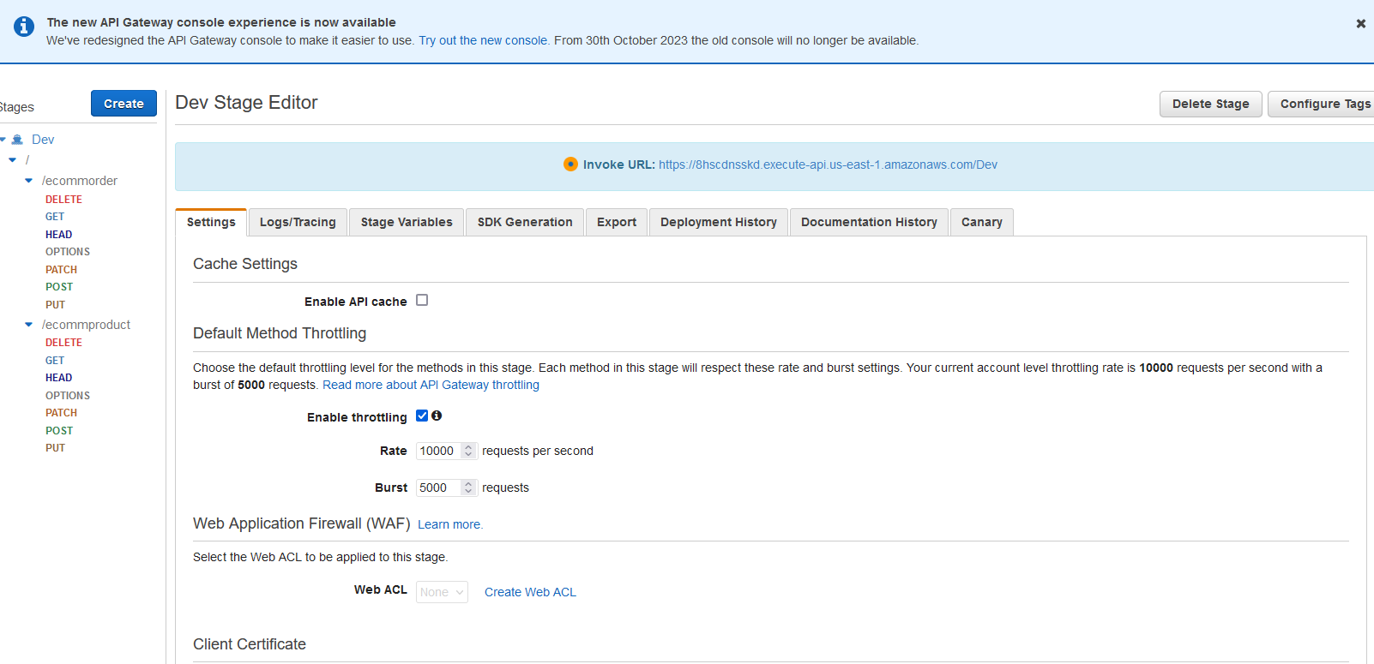

On click of order get/post url : <https://ewbgb3mp73.execute-api.us-east-1.amazonaws.com/Dev>  
  
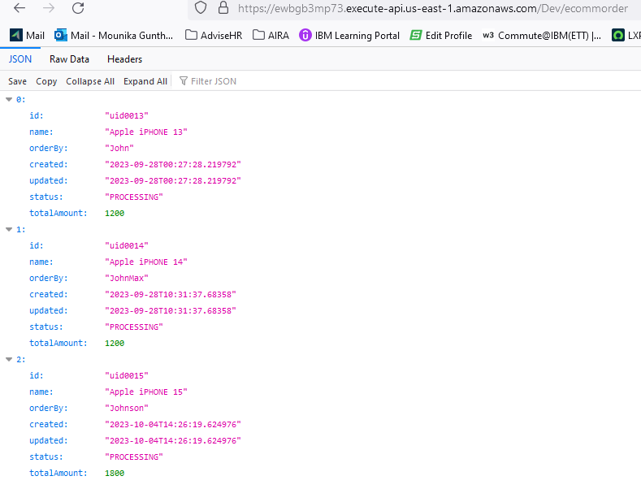

On click of Product get/post url : https://ewbgb3mp73.execute-api.us-east-1.amazonaws.com/Dev/-ecommproduct  
