Amazon web Services-POC

1. IAM settings are region specific or NOT

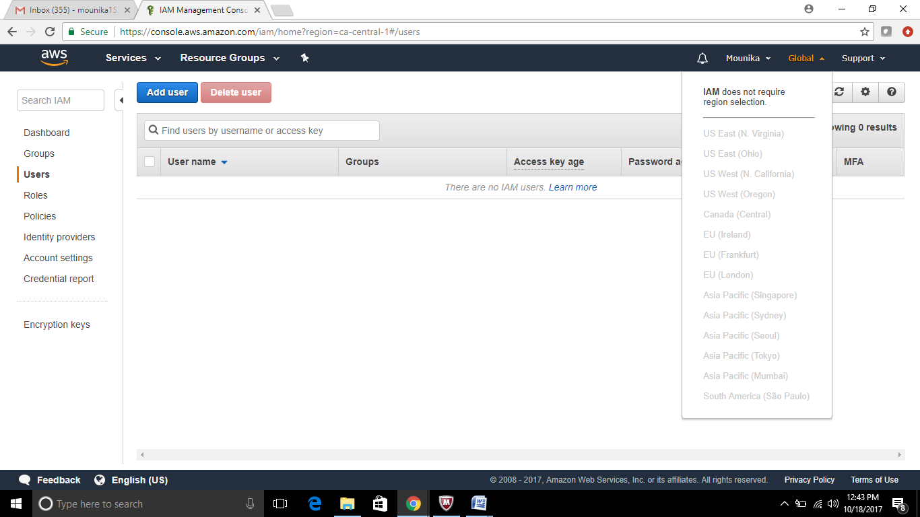

2. By default users have no permissions when first added

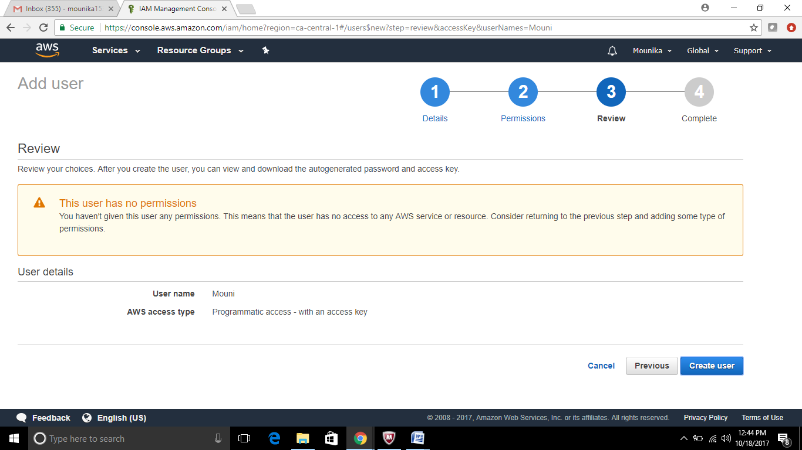

3. Active Directory Federation (AD) Can authenticate to AWS with AD using SAML

Unable to install ADFS as specified in the below link – getting error while doing it – trying to figure it out.

<https://aws.amazon.com/blogs/security/enabling-federation-to-aws-using-windows-active-directory-adfs-and-saml-2-0/>

4. Web Identity Federation to AWS via Facebook or any other social sites

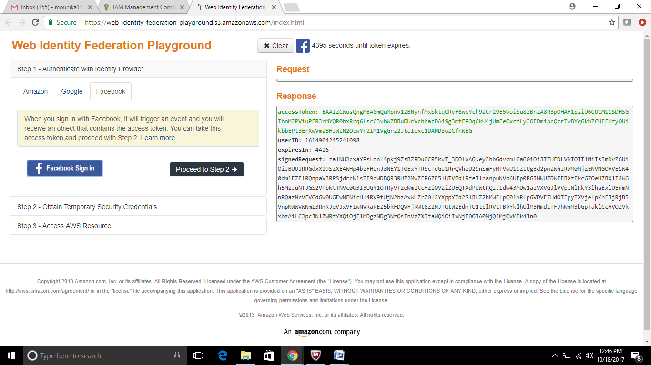

5. AssumeRoleWithWebIdentity API call used to obtain temporary security credentials when authenticating using Web Identity Federation?

