**ASSIGNMENT-5**

**Screenshots**

**Application screenshot:**

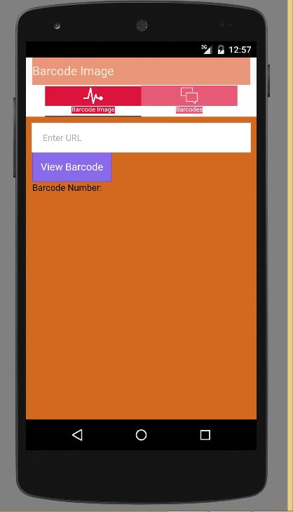

Test cases screenshots:

Showing that two test cases have failed:

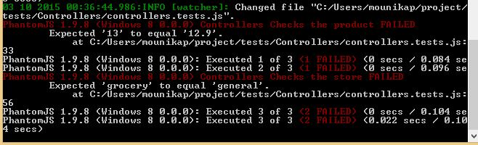

Showing that three test cases have succeeded:

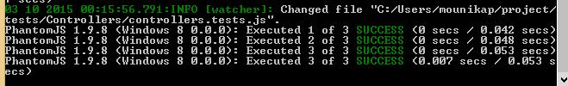

Showing that one test case has failed:

