**ASSIGNMENT-4**

**Screenshots**

**Login page:**

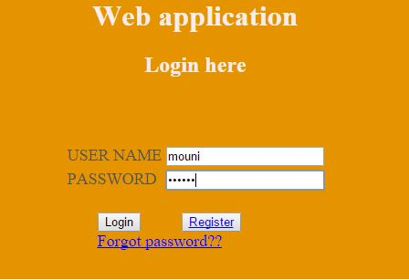

**Registration page:**

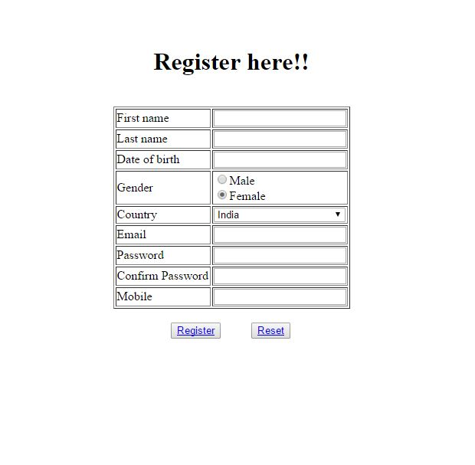

**Home page:**

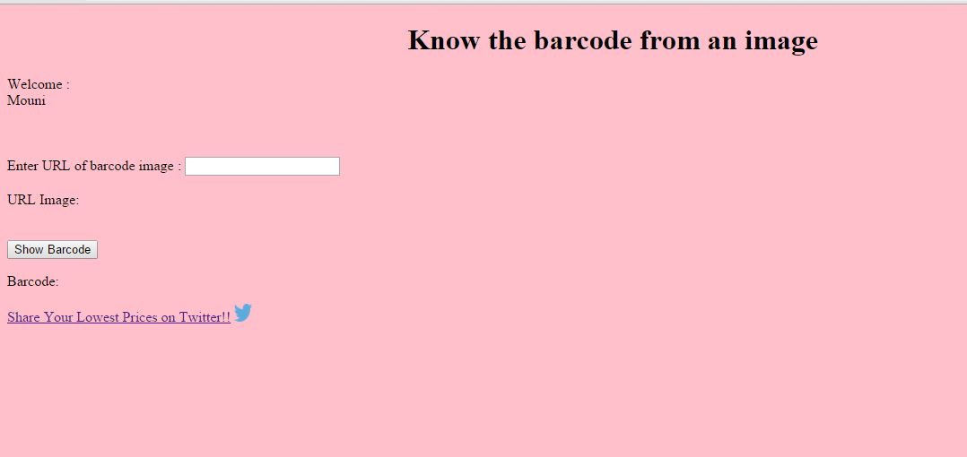

**Home page showing barcode:**

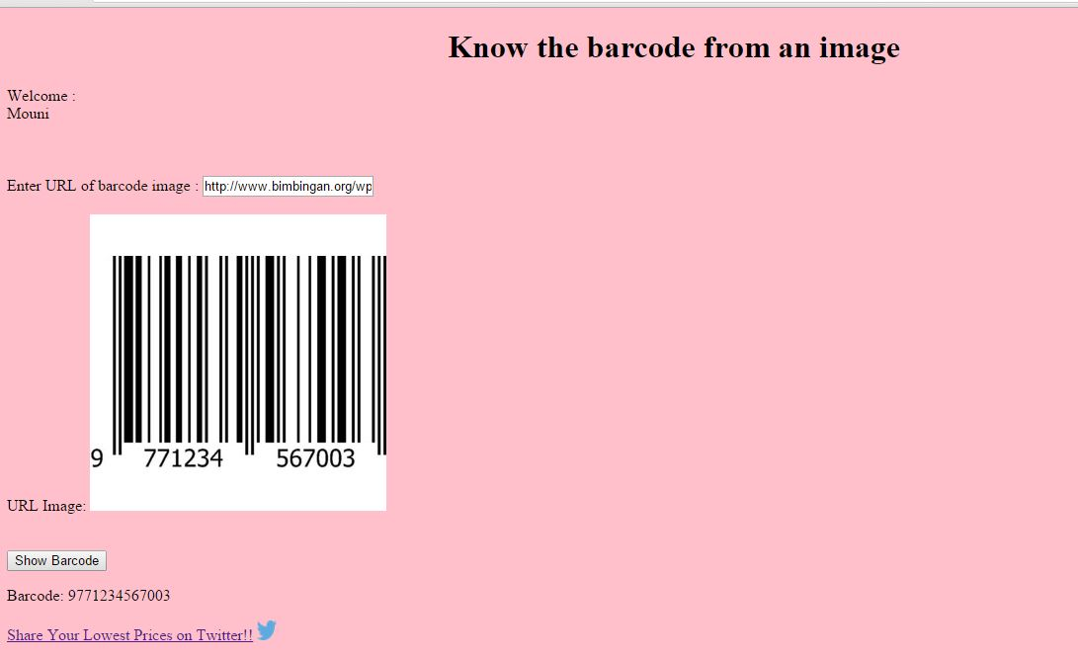

**Home page showing the tweet page:**

