**Assignment-7**

**Screenshots**

Sign Up page:

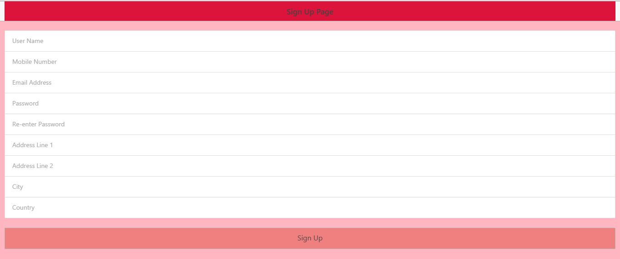

Sign Up page with user details:

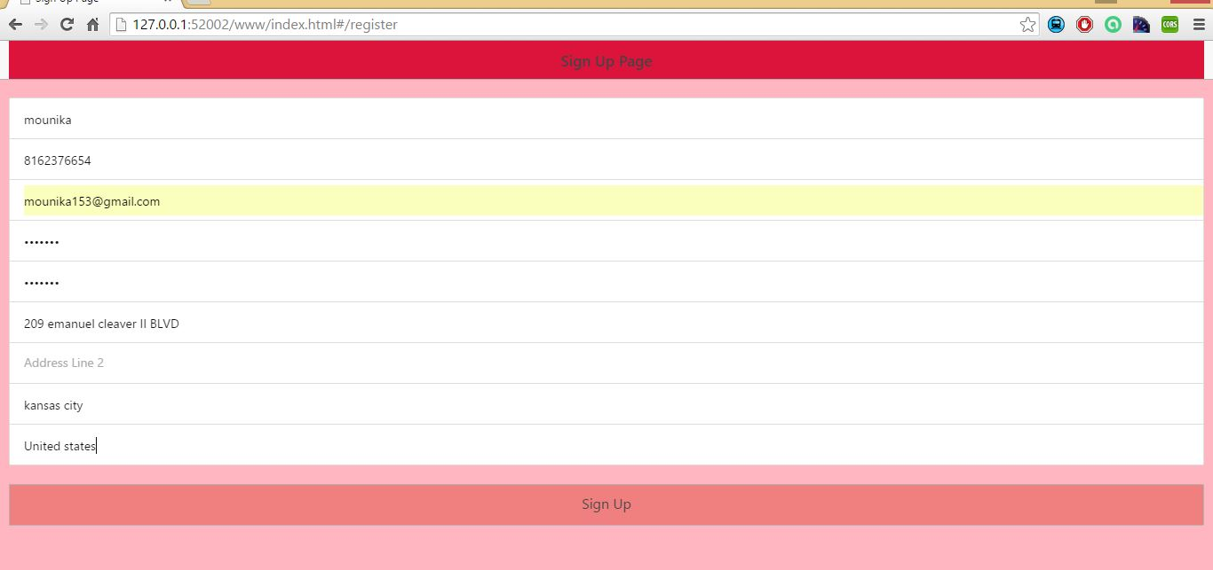

Inserted details of user:

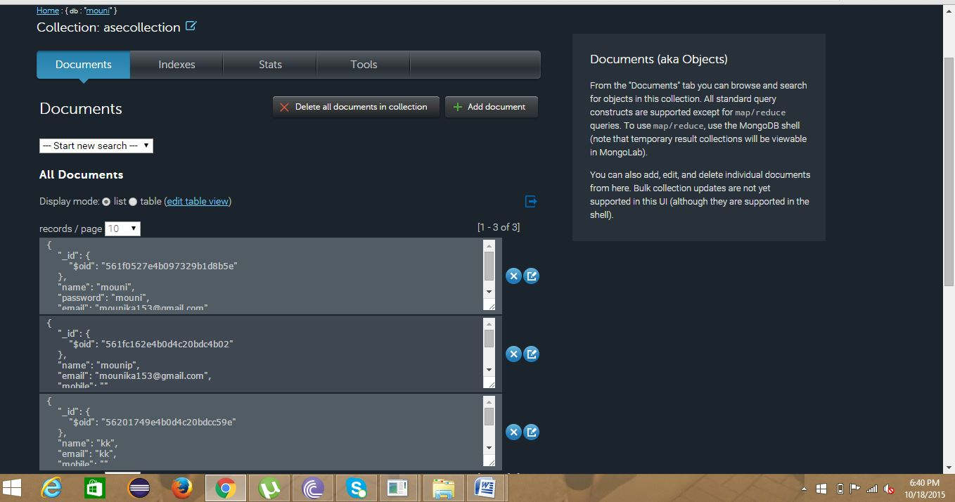

Sign In page:

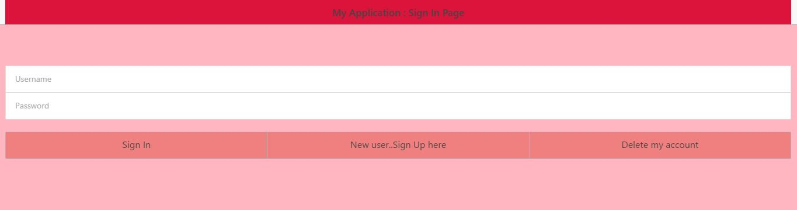

Sign In page with user details:

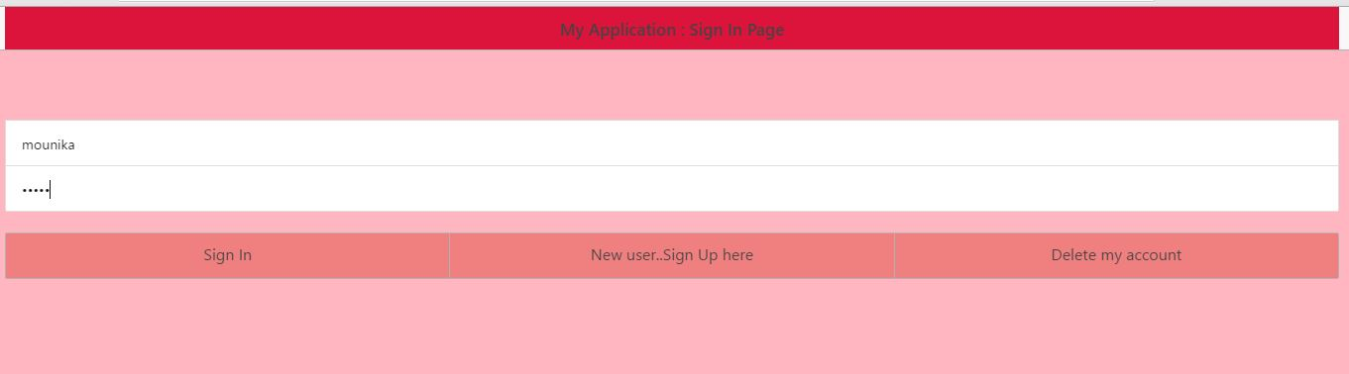

Home page:

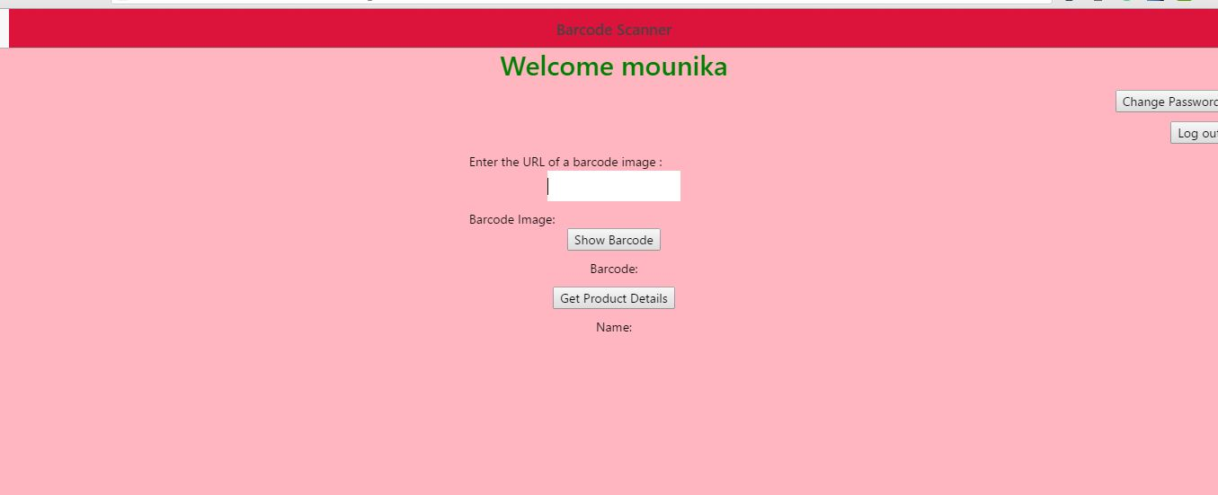

Home page showing barcode and product details:

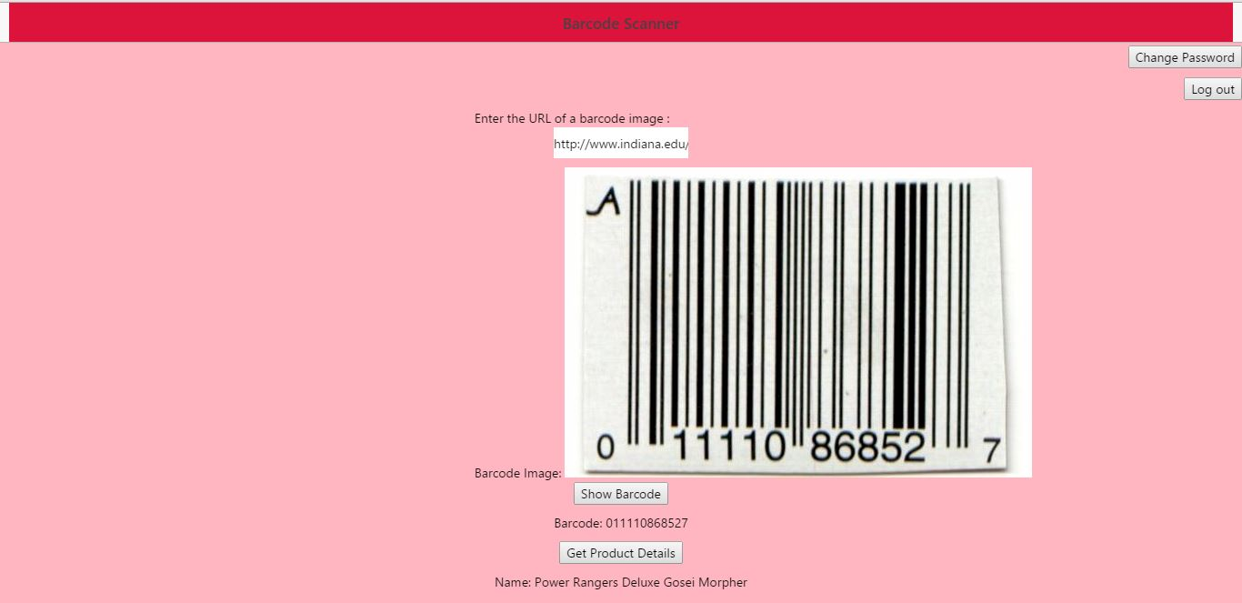

Reset password page:

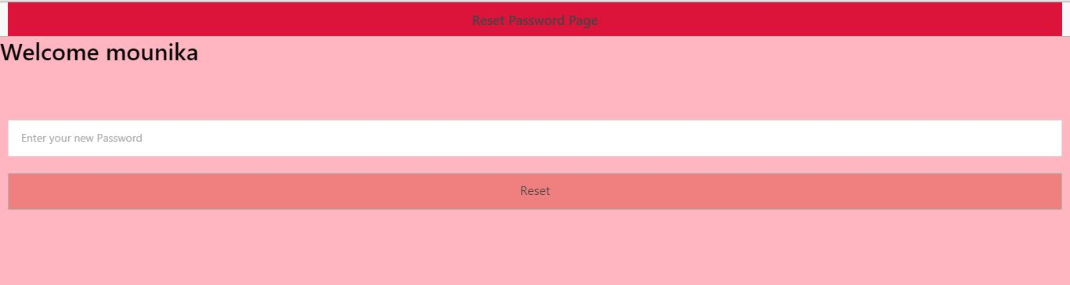

After password has changed:

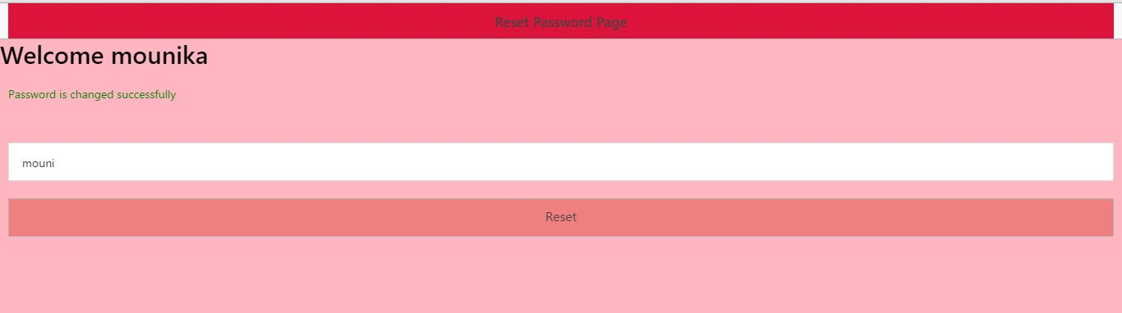

Deleting an user:

