**Assignment-8**

**Screenshots**

**Login page:**



**Sign Up page:**

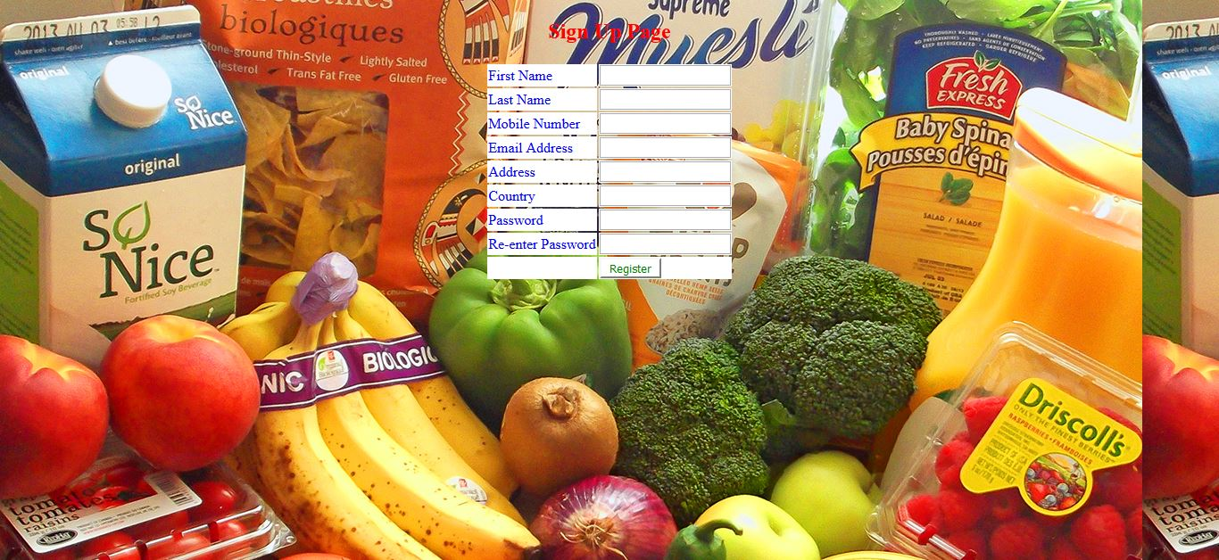

**User is signing up:**

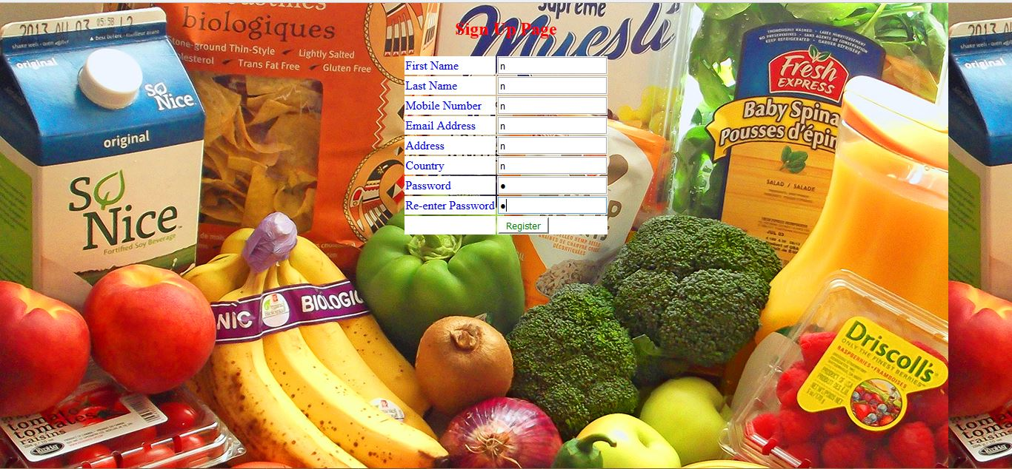

**User details inserted into MongoDB:**

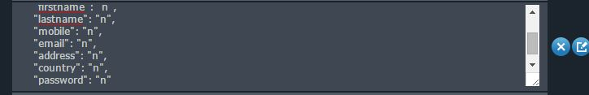

**User is signing in:**



**Retrieved user details from MongoDb in home page:**

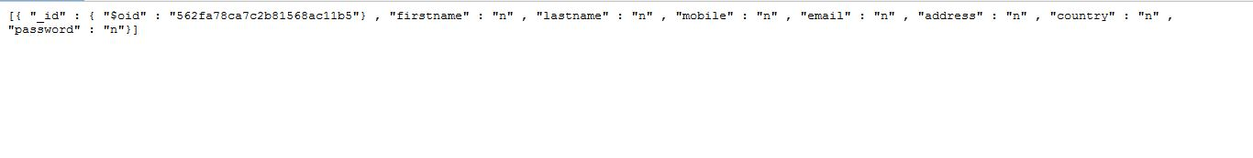

**Updating user details by changing password:**



**User details updated in MongoDB:**

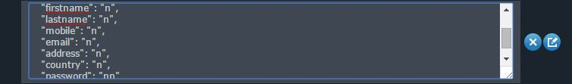

**Deleting user:**



**User deleted in MongoDB:**

