## Assembly Manual: DGMusika Assembly Guide

## LIST OF COMPONENTS

**1) Acrylic Boards (with smooth edges):** Used as the base for mounting the components like Arduino, keyboard matrix, and amplifier. Provides a durable, transparent platform with clean, smooth edges for safety and aesthetic purposes.

## ****2) Arduino UNO****: Microcontroller board that controls entire system.

## ****3) 2×6 Keyboard Matrix (PCB):** Soldered with header connectors; white and black plastic keys mounted on top.**

****4) Rubber Strips(Silicone keypad):** A 2×6 silicone rubber keypad that provides tactile feedback and completes the circuit when keys are pressed.**

****5) Screws (M2.5, M2.7, M3)****

**6) Plastic supports (sleeves)**

## ****7) Keys (Black and White Plastic Keys one octave):** 12 plastic keys mounted on the keyboard matrix for user interaction.**

## ****8) Amplifier:** Soldered with header connectors; used to amplify audio signals from the Arduino.**

## ****9) Speaker:** Outputs the audio signals as sound.**

**10) Jumper Wires:** Used to directly connect components(Arduino, Amplifier, Matrix)

* **Male-to-Female** **–** For connecting Arduino male pins to module header**s.**

**11) USB Cable (Type A to Type B):** Powers the Arduino and allows uploading code.

**COMPONENTS DESCRIPTION**

**ACRYLIC BOARDS**

Acrylic boards are lightweight, transparent plastic sheets often used as enclosures, mounting bases, or protective covers in electronics projects. In this setup, a smooth-edged acrylic board is used as the **baseplate** to mount key components such as the keyboard matrix, Arduino, and speaker module. The material is durable, easy to drill for screws and stand-offs, and offers good visibility and aesthetics for demonstration or educational kits. The smooth edges help avoid injuries and improve the overall finish of the product.

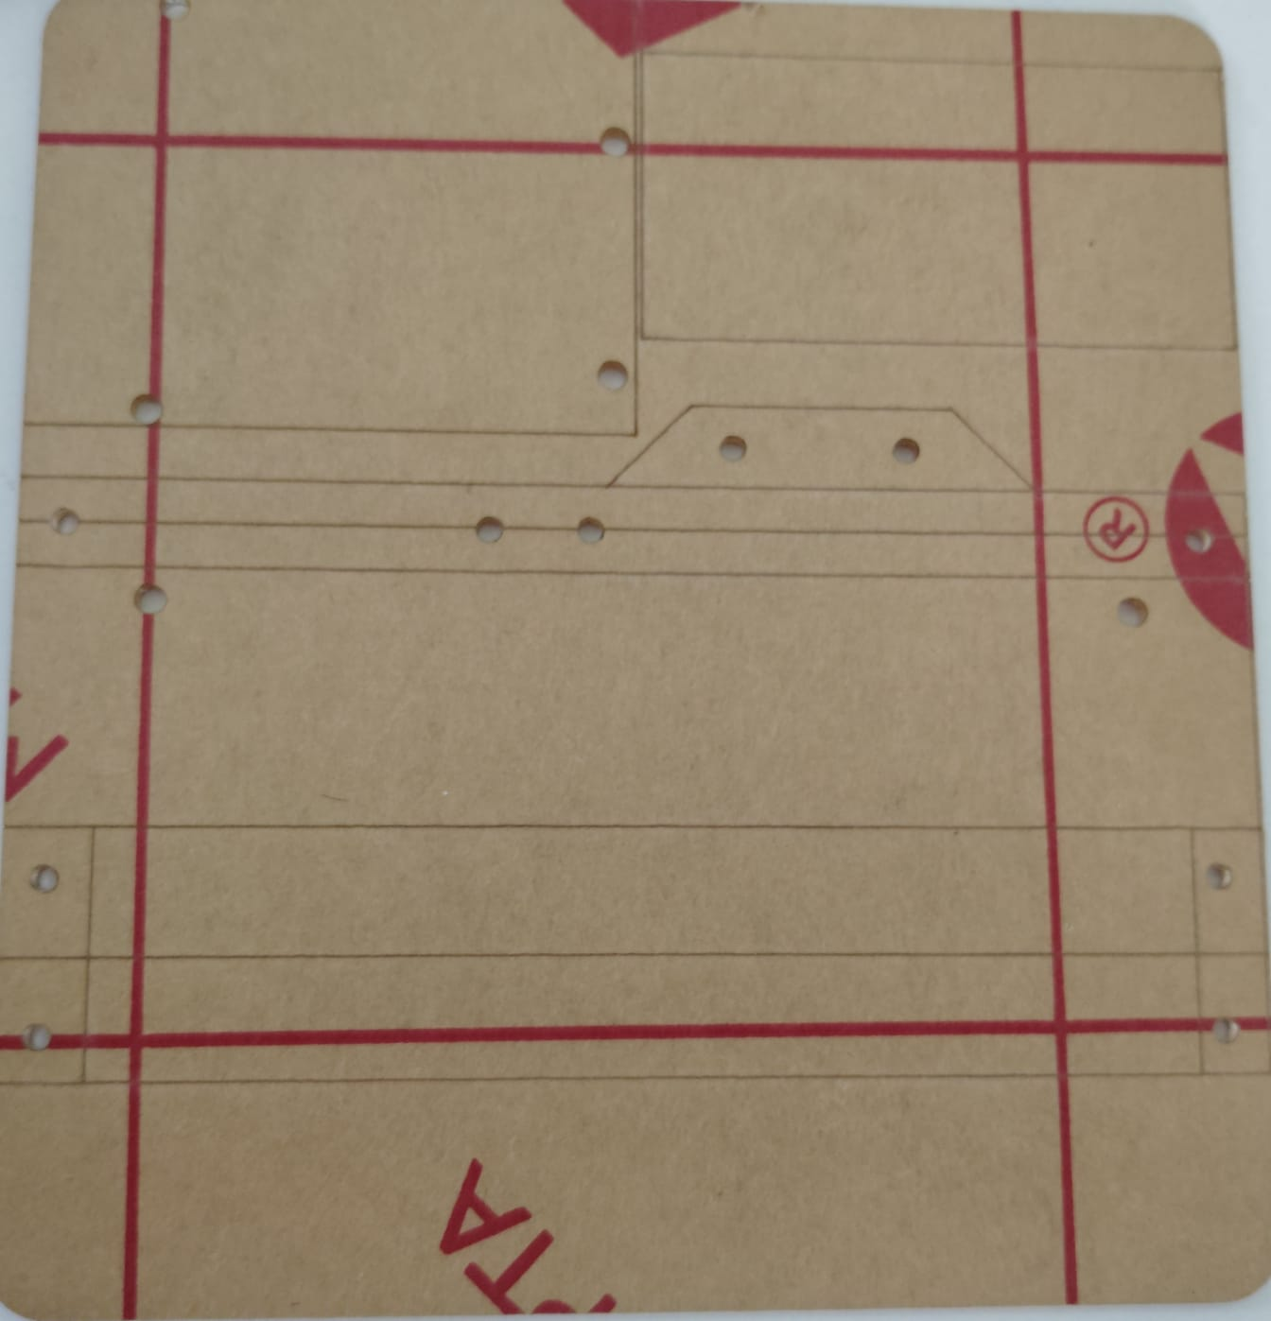

**ARDUINO UNO**

The **Arduino UNO** plays a crucial role as the **central controller** that ties together all of the components. It manages the inputs from the keyboard matrix and sends audio signals to the **PAM8403 amplifier, which then** drives the speaker.

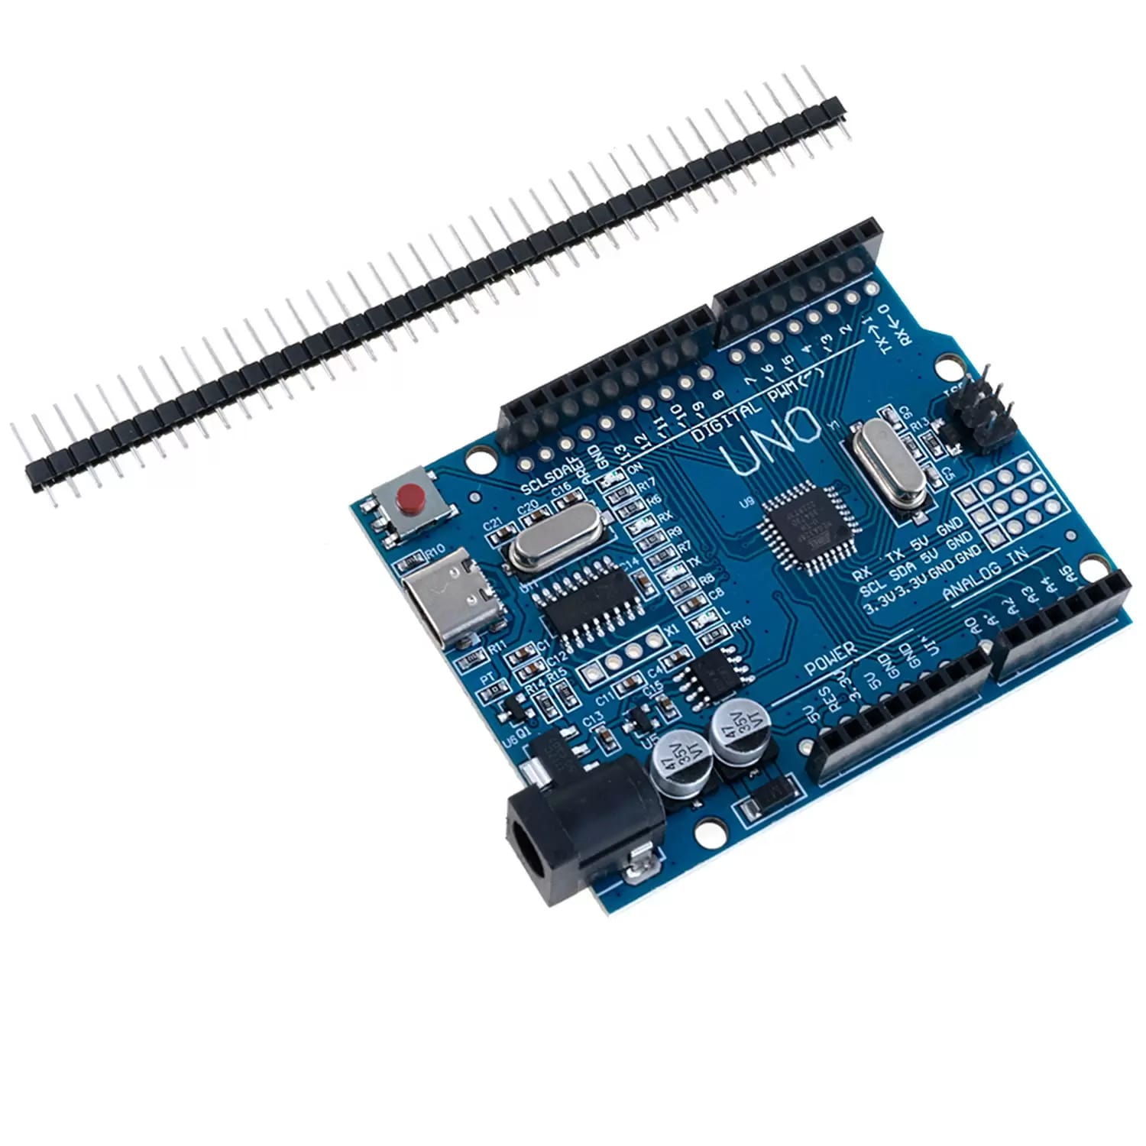

### **1.** ****Reading Input from the 2×6 Keyboard Matrix****

**Function:** The Arduino **scans** the 12 keys on the keyboard matrix (connected to pins D2 to D9) and detects which key is pressed.

**How it works:**

* + The keyboard matrix has **2 rows** and **6 columns**. Pressing a key completes a circuit between a specific row and column.
  + **The Arduino sequentially activates each row while checking the column lines for a signal.**
  + If a column reads LOW while a row is set LOW, the Arduino determines which key is pressed.

**Output: The Arduino identifies the key and triggers an action (play sound).**

**2. Controlling Audio**

**Function:** Once the Arduino knows which key was pressed, it **decides what sound to play and** sends a signal to the **PAM8403 amplifier via pin D11**.

**How it works:**

* The Arduino generates an **audio signal** on D11. It is a **PWM signal** (using the tone() function)
* To produce a tone, Arduino uses its **PWM pins** to output a square wave (for audio signals like beeps or tones).

**3. PAM8403 Audio Amplifier**

**Function:** The Arduino sends the **audio signal** to the **PAM8403 amplifier** via pin D11.

**How it works:**

* **The PAM8403 is a low-power audio amplifier that needs an audio input (typically a PWM or analog signal).**
* The Arduino outputs a **PWM signal** (which can represent the audio) to the PAM8403.
* The **PAM8403** amplifies this signal to a level that can drive a speaker.

**2×6 KEYBOARD MATRIX PCB**

It is the **user input interface**, meaning it allows us to interact with the system by pressing buttons. The Arduino reads which button is being pressed and responds accordingly (by playing a tone).The **2×6 keyboard matrix** lets the user send **commands or selections** to the Arduino by pressing one of 12 keys.

**Structure:**

* Grid of 2 rows and 6 columns (12 keys total).
* Each key lies at a row-column intersection.

**Advantage:**

* Instead of 12 separate wires, only 8 Arduino pins are used (2 for rows and 6 for columns).

**Build Note:**

* The matrix is **soldered and mounted with black and white plastic keys,** for clear visibility and durability.

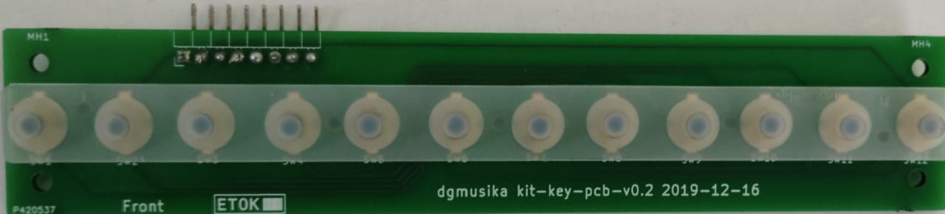

**RUBBER STRIPS:**

**A silicone rubber keypad with a 2×6 matrix layout is positioned directly over the contact pads on the PCB. Each dome on the keypad contains a conductive carbon pill that, when pressed, completes the circuit by bridging the PCB contacts. This mechanism provides both electrical connectivity and tactile feedback. For proper functionality, the keypad must be precisely aligned with the PCB layout. It can be secured in place using a plastic top cover, adhesive backing, or integrated support posts in the device enclosure. During operation, pressing a key produces a soft tactile response or sound, indicating that the input has been successfully registered.**

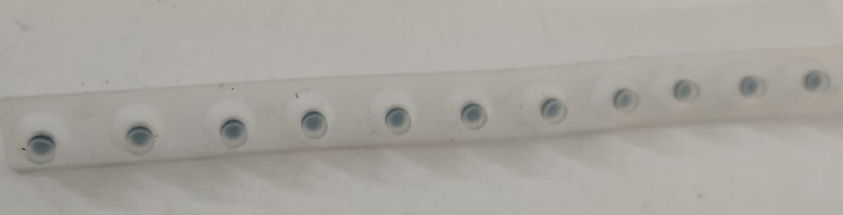

**KEYS (BLACK AND WHITE PLASTIC KEYS)**

These are the actual physical keys pressed by the user to trigger sounds.

**Function:**

* Each key makes a contact between a specific row and column on the keyboard matrix when pressed.

**Build Note:**

* All 12 keys are securely mounted on the matrix PCB for ease of use.
* White and black color differentiation improves usability.

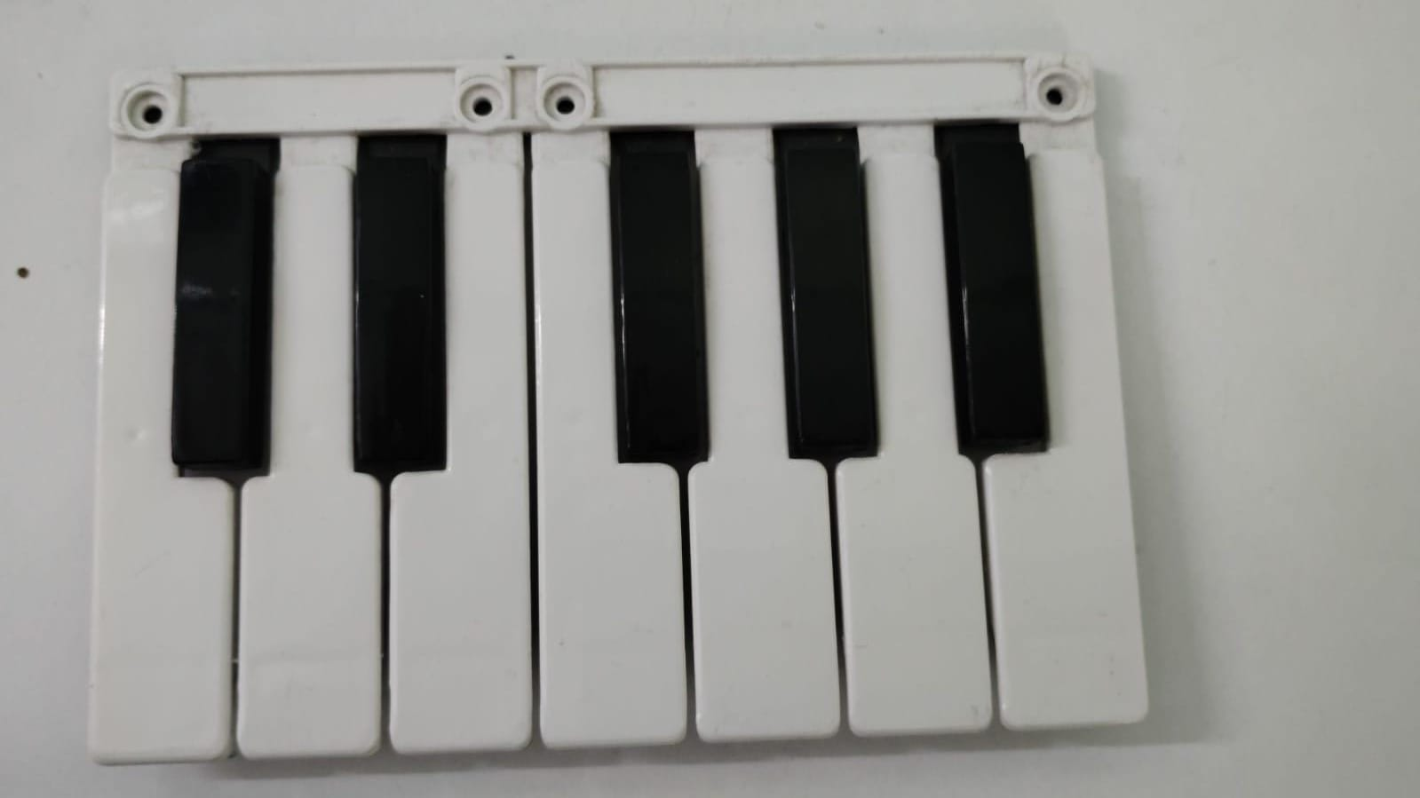

**PAM8403 AUDIO AMPLIFIER**

The **PAM8403** is a ****Class-D audio amplifier** that increases the audio signal strength from the Arduino to a level suitable for driving a speaker.**

****Note:** 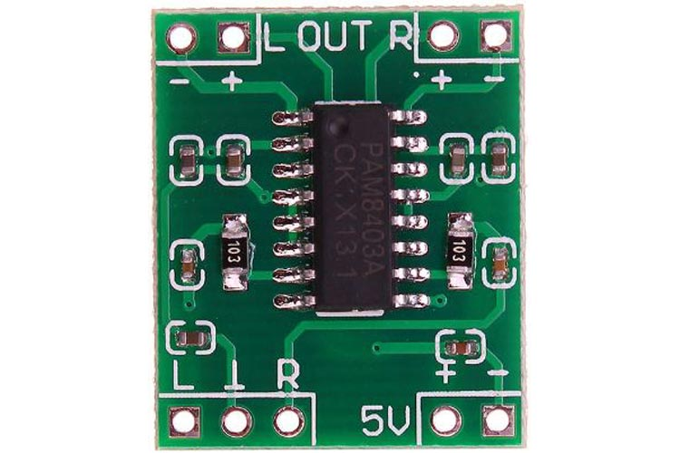The PAM8403 amplifier is soldered with connectors, making it easier to connect to other components without the need for additional soldering.**

****How it Works:****

**1.** Arduino generates a weak **audio signal on pin D11.**

**2**. This signal is **too soft** to drive a speaker directly.

**3.** The **PAM8403 amplifier** **boosts this signal to a loud, clear level.**

**4.** The amplified **output is then sent to the speaker.**

* ****Why It’s Needed:****
* The Arduino alone cannot deliver **enough current** for the speaker,resulting in a weak, distorted sound, or potentially damaging the Arduino pin. The amplifier ensures the audio is loud and clear.
* **Power Requirement:**
* Runs on **5V(same as** Arduino).
* **Current drawn:** ~ 20–30mA without a load, more when the speaker is active.

**SPEAKER**

A **speaker** is an output device that converts **electrical audio signals into sound**. In our project, the speaker plays the tones or sounds generated by the Arduino and amplified by the PAM8403 amplifier.

**Function:** The **speaker’s main job** is to produce sound loud enough to be heard clearly. The Arduino sends an audio signal (as a PWM tone), the PAM8403 amplifies it, and the **speaker plays the sound**.

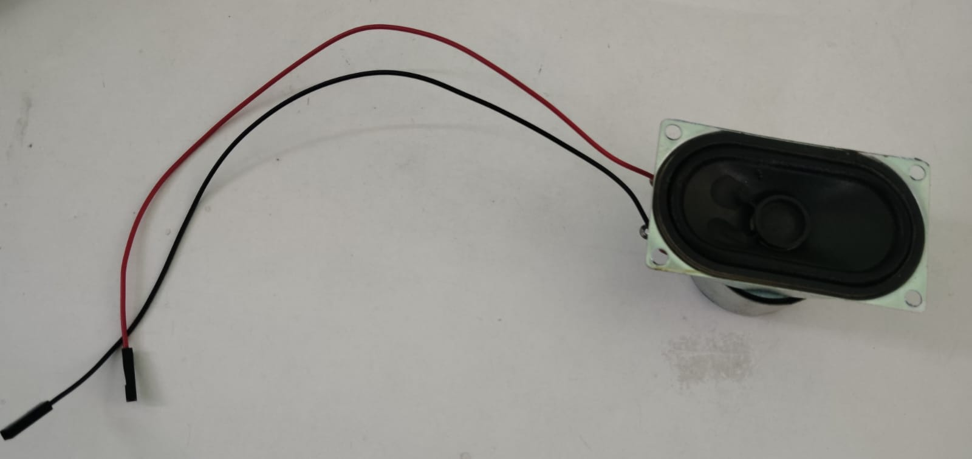

**How It Works:**

* **PWM Signal from Arduino:** The Arduino uses the tone() function to create a **PWM square wave** on pin D11. This waveform represents sound at a specific frequency (pitch).
* **Signal Amplification:** The signal is sent to the **PAM8403 amplifier**, which increases its voltage and current so it's strong enough to drive the speaker.
* **Sound Production:** The **amplified signal reaches the speaker**, causing its internal diaphragm to **vibrate rapidly**. These vibrations create sound waves in the air.

**JUMPER WIRES**

**Jumper wires** are used to connect all components. Only male-to-female jumper wires are used throughout this setup, including for the amplifier and speaker.

**Type Used:**

### Only ****Male-to-Female Jumper Wires** are used for all connections (including the amplifier and speaker),ensuring quick and stable plug-in assembly.**

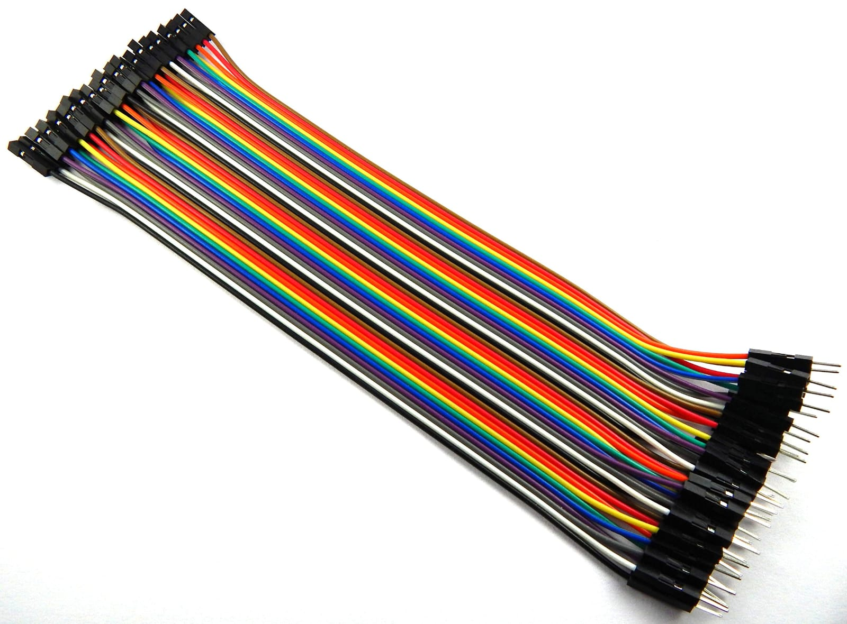

****USB CABLE (Type A to B)****

**The USB Cable serves several important purposes, primarily for powering the Arduino and for programming the Arduino.**

### ****1. Powering the Arduino:****

* The **USB cable** connects the **Arduino UNO** to the computer or a USB power source.
* It provides **5V of power** to the Arduino board, which is enough to power the board and any components that are connected to it (like the keyboard matrix, PAM8403 amplifier, and speaker).

**2.** **Uploading the Code (Programming the Arduino):**

* The **USB Cable** also allows us to **upload the program (code)** to the Arduino.
* Through the USB connection, the Arduino IDE on the computer communicates with the Arduino board and sends the code that controls the inputs from the keyboard matrix and the outputs to the amplifier and speaker.

### ****Cable Type:****

The Arduino UNO uses a **USB Type B** cable (the square connector) on the Arduino side, and a **USB Type A** (standard USB connector) on the computer or power source side.

### 

**STEP-BY-STEP ASSEMBLY INSTRUCTIONS**

### **Step 1: Prepare Acrylic Base**

* Unwrap the acrylic base and clear all holes.
* Place the Arduino UNO on the top-left section.
* Secure using **M3×12 screws** and **M3 nuts**.

### **Step 2: Mount the Keyboard Matrix PCB**

* Align the 2×6 matrix PCB to the base holes.
* Place **3 standoffs** per screw under the PCB to support it.
* Fix using **M2.5×30 screws**, **M3×25 sleeve nuts**, and **M2.5 nuts**.

### **Step 3: Mount the Plastic Keys**

* Position the black & white keys properly over the PCB.
* Ensure proper alignment for tactile feedback.
* Fix with **M2.5×35 screws**, **M3×25 sleeve nuts**, and **M2.5 nuts**.

**Step 4: Connect Arduino to 2×6 Keyboard Matrix**

* ****Type of Wire**: Male-to-Female Jumper Wires**
* **Steps:**
  + Connect the **rows** of the keyboard matrix to **D2** and **D3** on the Arduino (use male-to-female jumper wires).
  + Connect the **columns** of the keyboard matrix to **D4 to D9** on the Arduino (use male-to-female jumper wires).
  + This setup allows the Arduino to detect which key is pressed.

### ****Step 5: Connect Arduino to PAM8403 Audio Amplifier****

* **Type of Wire:** **Male-to-Female Jumper Wires**
* **Steps:**
  + Connect the Arduino’s D11 pin to the **input** pin (INR) on the **PAM8403 amplifier using a male-to-female jumper wire.**
  + This will send the audio signal (PWM signal) from the Arduino to the amplifier.

### ****Step 6: Power the PAM8403 Amplifier****

* **Type of Wire:** **Male-to-Female Jumper Wires**
* **Steps:**
* Connect the **5V pin** on the Arduino to the **VCC pin** on the PAM8403 amplifier (use male-to-female jumper wires).
  + Connect the **SGND pin** on the Arduino to the **GND pin** on the PAM8403 amplifier (use male-to-female jumper wires).
  + This will provide power to the amplifier from the Arduino.

### ****Step 7: Connect PAM8403 to Speaker****

* **Type of Wire:** **Male-to-Female Jumper Wires**
* **Steps:**
  + Connect the **output pins** on the PAM8403 amplifier to the **speaker**.
  + Ensure you connect the **positive** and **negative** terminals from the amplifier to the speaker (this may depend on your speaker's wiring, typically the red/positive wire to the positive output, and the black/negative wire to the negative output).
  + This will send the amplified audio signal to the speaker for sound output.

**NOTE: Right Channel Only**

* **Arduino D11** → **PAM8403 Right Channel Input (R IN)**
* **Speaker** → **PAM8403 Right Output (R+) and Right Ground (R-)**

### ****Explanation:****

* Since we are using **R+** and **R-** pins for the speaker, it means we are driving **mono sound** using the **right channel input (R IN)**.
* **R+** will carry the amplified audio signal from the PAM8403, and **R-** will be the ground reference for the speaker.

### ****Step 8: Power the Arduino via USB Cable****

* **Type of Wire:** **USB Type A to B cable**
* **Steps:**
  + Connect the **USB cable** (Type B) from the **Arduino** to your **computer** or a **USB power source**.
  + This will provide **5V power** to the Arduino and allow you to upload your, program.

#### **Step 5: Install Arduino IDE**

* Download from [arduino.cc/software](https://www.arduino.cc/en/software)
* Install on your laptop.

#### Step 6: Upload Code

* Connect Arduino UNO to laptop using USB.
* Open Arduino IDE.
* Load the. ino code file (see below).
* Select **Board: Arduino UNO**, choose correct **COM Port**, then **Upload**.

#### Step 7: Play!

* Once code is uploaded, pressing each key will play a tone through the speaker.

**CIRCUIT DIAGRAM:**

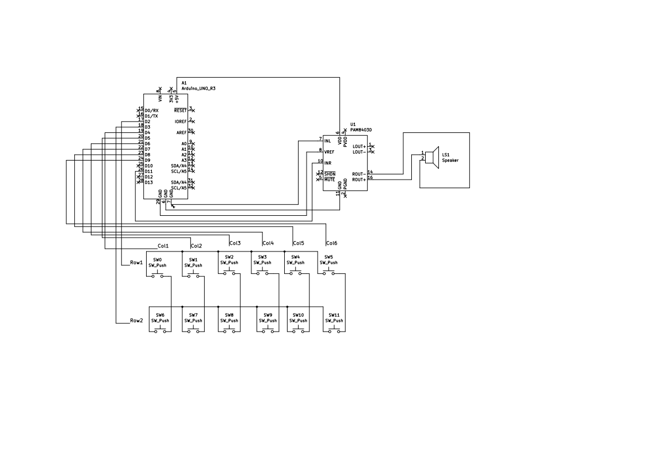

**CONCLUSION**

This project shows how to use an Arduino UNO, a 2×6 keyboard matrix, and a PAM8403 amplifier to create a simple audio system. The Arduino reads the keyboard input and generates sound signals, which the PAM8403 amplifier boosts to play through a speaker. This setup demonstrates how to combine basic components to create an interactive system that produces sound based on user input.