
Review on Embedded Systems Page|1

Review on Embedded Systems - Microwave Oven
Project Report
Prepared by
C.Mounika

Guided by
Devendra Reddy
Anjali

AP IIIT
Rajiv Gandhi University of Knowledge Technologies
RK Valley

INDUSTRY PLUS ACADEMIA Training
Date:30-04-2022

Review on Embedded Systems page|2

Index
1.Abstract .......................................................................................................3
2.Introduction ..................................................................................................4
3.Purpose..........................................................................................................5
4.Discussion......................................................................................................6
5.Findings/Results............................................................................................10
6.Conclusion....................................................................................................11
7.References ...................................................................................................12

Review on Embedded Systems page|3

Abstract
Microwave oven is an Embedded system .It is called as microwave oven because it's working is wholly based on Microwaves.
Working Principle: High powered microwaves are generated and are allowed to fall on the food stuff. These waves heat the molecules in the food particles evenly and cook the food
How the microwaves created: Magnetron plays a crucial role here .
Magnetron inside the oven produces microwaves.Through the wave guide waves are moved onto the top of the oven . The microwaves reflect off the metal interior of the oven and cause the water molecules in food to vibrate. This vibration results in friction between molecules.Due to Bipolarity of the water molecules in the food causes vibration resulting heat between molecules, that cooks the food.
Myth : Microwaves cook from the inside out.Microwave ovens do not “cook from the inside out”, as many people say. Microwaves actually heat from the outside in, very similar to other heating methods. Microwaves are actually pretty simple devices

Review on Embedded Systems page|4

Introduction

If I say a product name microwave oven,people think of it like it’s in every kitchen now a days and made cooking very simple and time saver.Isn’t it?
Obviously,we do.
Microwave ovens are everywhere now ,but what made it very simple to heat food?We need to think of it too.
As it’s name imply Microwave oven is wholly based on Microwaves of range 2.45 GHZ or wavelength 12.23cm.Although that is done by microwaves but the credit goes to he inventor .Who’s is that Engineer?
At the time of world war II (1945) when an employer of Raytheon called Percy LeBaron Spencer was working on a device called Radar ,microwaves transmitted from it ,melted a candy bar chocolate in his pocket .He figured out food can be heated using microwaves too.He then tried popping popcorn and making an egg using microwaves.
It is the starting of microwave ovens later after that invention, many addons came to it making oven more easier and comfortable to use.Like temperature ,timer etc.Sensors are being used to detect the food and calculate the time and temperature to heat food, automatically poweroutlet turnsoff after the timeduration.
Anyhow what ever the working principle and all of microwave oven it do helped a busy generation and occupied very less space like not even a counter.Which also helped to make it popular .

Review on Embedded Systems page|5
Purpose

The purpose of this project report is to let know the working principle, of a Microwave oven ,it’s parts and and their functionality,overall working of a of Microwave oven which is basically an embedded system occupied most of the kitchens now a days.
Why Microwave oven?
As Microwave oven is popular now a days ,anyone can easily do understand its functionality and parts of it .It’s a very small device with great use and cost effective.And any layman can use it if he/she know the time it takes to cook food.

And as I started just now to learn about embedded systems,it might be a great start with simple and small device .Here it is microwave oven.And it will be more useful to my fellow friend learners too to know about another useful embedded system and it’s functionality.
As a student ,my main aim is to learn something new from every individual work that I start.So,my intention and purpose of this project is know as much I can from my reserch about microwave oven

Review on Embedded Systems page|6

Discussion
Now ,let’s see how the microwave oven cooks food :
To start with first let’s know it’s components and their function in microwave oven
a.Transformer:
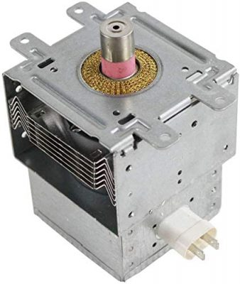

Figure 1:Transformer
Microwave ovens need high voltage of electricity to function effectively and heat food but a microwave oven actually requires more power than the normal voltage that our home's electrical wiring produces.The transformer's function is to magnify the power available to the oven from the home's wiring to the level necessary to produce microwaves.
b.Magnetron
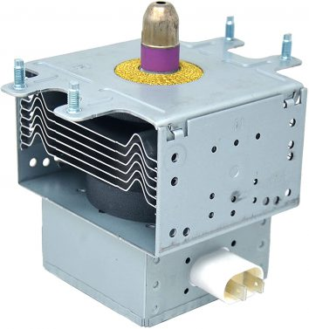

Figure 2: Magnetron
Magnetron draws in electricity and produces microwaves .The microwave’s magnetron consists of a vacum like tube and and sits on the same side as the control panel.
Like a human brain sends messages to the body,magnetrons produce microwaves that travel through the waveguide and bounce from the oven’s metal interior to the water molecules in the food.
The tiny waves cause the water molecules to vibrate. The friction of the vibrating molecules produces heat, thereby cooking the food.
c.Waveguide
The waveguide is a hollow metal tube that extends from the magnetron to the cooling fan. It directs the flow of microwaves from the magnetron to the cooking chamber.
While these waves transfer, they reflect off the inner walls and into the food, cooking it.A waveguide includes a thin plastic or cardboard-like cover to protect the internal components from food and splatters during cooking.
Review on Embedded Systems Page|7
d.Cooling fan
Cooling fan is a part of microwave ceiling.It prevents microwave from overheating ,if it is too hot in oven food may also spoil.Fan knows when to turn on and off.
e.Cooking case
Cooking case also very important in oven .The cooking cavity is the deep inner compartment that holds the food while it cooks. The inner walls consist of thick, stainless steel to absorb the waves when they leave the food
f.Rotating disc/turnable
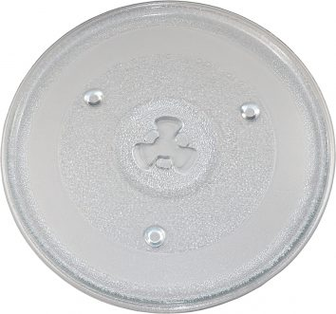

Figure 3: Turnable
You place your food on a round glass or plastic plate so that the food will rotate during cooking. The purpose of rotating your food is that heat will evenly distribute through and cook it thoroughly.
g.Control panel/Inspection window

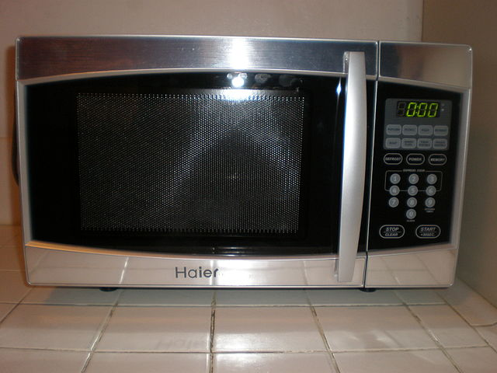

Figure 4: Inspection window
Microwaves come with a control panel that allows you to choose your settings. Use a knob or buttons to determine the cooking time, cooking power, or mode, depending on what model you have.Most appliances include a defrost setting, a timer, and a clock.
h.Few sensors
Sensors will sense food automatically and set timer to heat food .where drinks has 100% correct prediction ,solid foods with 85.6% correct prediction to set timer.
Many other sensors will also be there.
i.Capacitor
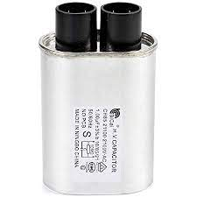

Figure 5: capacitor
Review on Embedded Systems Page|8
A capacitor stores large amounts of electricity even when your microwave is unplugged, and it must be discharged before beginning any repair. A capacitor is discharged by creating a short circuit between each of the two capacitor terminals, and between each terminal and the chassis.
j.Power cord
This component speaks for itself. It connects the microwave to electricity. You can detach the power cord from the back of the unit if you need to replace it.
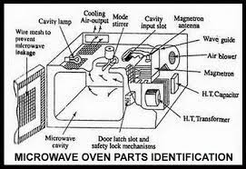

Figure 6: Parts Assembled in Microoven
Working of Microwave oven:
Inside the strong metal case there is a component called magnetron which generates microwaves.
When we turnon the oven the magnetron takes electricity from the power outlet and converts it into high-powered 12.23cm radio waves.And waves are into the channel called wave guide into food compartment .
The food sits on a turntable, spinning slowly round so the microwaves cook it,evenly.
The microwaves bounce back and forth off the reflective metal walls of the food compartment.
Microwaves penetrate inside the food. As they travel through it, they make the molecules inside it vibrate more quickly.
Vibrating molecules have heat so, the faster the molecules vibrate, the hotter the food becomes. Thus the microwaves pass their energy onto the molecules in the food, rapidly heating it up
Review on Embedded Systems page|9

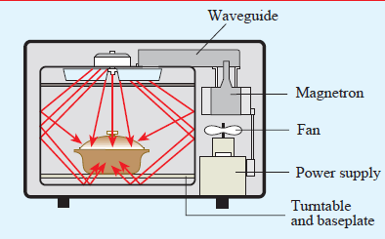

Figure 7: Reflection of microwaves in Oven

But how the timer works?
The timer is mainly composed of miniature synchronous motor and deceleration gear.
When the operator dials the timing button to set the timing between, the time switch is switched on, the microwave oven power and start to work, while the timer motor rotation. When the timer time arrives, the switch is disconnected and the microwave oven stops working.
Many timing switches also emit a sound when they are disconnected, A ringing bell to remind people to heat up the work done.
The function of the switch is to switch on and off the power supply of the magnetron periodically during the operation of the microwave oven to make the magnetron regular intermittent work, namely working time and resting time have certain proportion relation, change this proportion, make touch control tube in microwave oven The working time in the whole heating period can be changed accordingly, thus playing the role of adjusting the microwave output power. Power regulation.
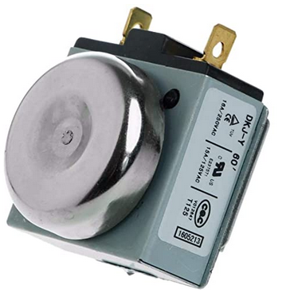
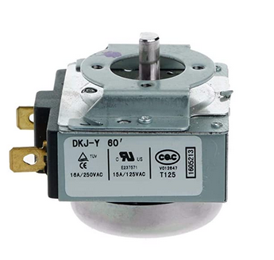

Figure 3:Mechanical Minutes timer switch with bell
Review on Embedded Systems page|10

Containers that can be used in oven :
1.Glass
2.Ceramic
3.Stoneware
4.Stainless steel
5.Aluminium vessels
Basically utensils made of thick metal (aluminium or iron)which can withstand high heat temperature.

Containers that cannot be used :
1.plastic
2.Alminium foils
Because they may melt and stick to surface .

Findings/Results
Throught the project we have gone through a lot of discussion.We came to know about a lot of things related to an embeeded system.
1.Microwave oven working principle
2.Magnetor radiation and reflection of electromagnetic waves.
3.Mechanical timer switch with bell
4.Vessels that can beand cannot be used in ovens
5.And a fan will cool down the area inside oven.
6.So oven is a easy replacement of all type of stoves and all.

Review on Embedded Systems page|11

Conclusion
In conclusion, the microwave oven has come a long way, decreased in height, weight, and price.
For any product there exists both pros and cons
Pros of microwave oven:
If it is used in a proper way, it can be considered that the microwave oven offers a great, convenient and safe method of food preparation without any harmful effects on consumer safety or nutrition.
Quick heating/Reheating. ...
- Precise Cooking Programs. ...
- Easy To Clean. ...
- It Can Be Used To Defrost Food. ...
- Safe For Children. ...
- Variable Heat Settings. ...
- Low Energy Consumption. ...
- No Change In Taste And Nutrition.
Cons of microwave oven:
Dry Food. Cooking food in a microwave might result in overcooking and drying out certain meals due to the high heat intensity. ...
- Soggy Food. ...
- Not Versatile. ...
- Needs Special Containers. ...
- Chances Of Food Poisoning.

Review on Embedded Systems page|12

References
1.https://www.jaye-heater.com/info/structure-and-principle-of-microwave-oven-time-44172298.html
2.https://www.explainthatstuff.com/microwaveovens.html
3.http://www.sfu.ca/phys/346/121/resources/physics_of_microwave_ovens.pdf
4.https://www.streetdirectory.com/food_editorials/cooking/cooking_appliances/5.a_brief_introduction_to_microwave_ovens.html
6.https://www.rcet.org.in/uploads/academics/rohini_35009643667.pdf
7.https://www.tifr.res.in/~cccf/data/InternDocs/How_to_write_a_structured_Project_Report.pdf

