Project Report
On
CAR SALES DASHBOARD
Interactive Sales Analytics using Tableau
KPIs, Weekly Trend, Body Style, Colour, Dealer Region, Company Grid

Submitted for Minor Project
MCA (AI/ML), 3rd Semester, November 2026
Submitted by:  Name: Boddu Mounika  UID: 25MCI10070  Programme: MCA (AI/ML)  Academic Session: 2025–2027 | Submitted to:  Name: Ms. Sweta  Assistant Professor  University Institute of Computing  Chandigarh University

Certificate
Certified that this project report “Car Sales Dashboard” is the Bonafide work of “Boddu Mounika (25MCI10070” who carried out the project work under my/our supervision on
02 November 2026.

Faculty Signature  Ms. Sweta  Assistant Professor  University Institute of Computing | Head of the Department  Dr. Amanpreet Kaur Sandhu  University Institute of Computing  Chandigarh University

Internal Examiner | External Examiner

Acknowledgement
We would like to express our heartfelt gratitude to all those who assisted us in preparing and completing our Data analytics Project report titled “Car sales dashboard”. We extend our sincere appreciation and thanks to Ms. Sweta for inspiring, cooperating with, and encouraging us throughout this work. With valuable suggestions and guidance, we aware able to complete our work within the allotted time frame at this institution.
We also convey our respect and gratitude to Dr. Amanpreet Kaur Sandhu, Head of the Department, University Institute of Computing, and Chandigarh University, as well as all the faculty members, for their valuable suggestions and guidance towards completing the report. Furthermore, we are grateful to all our academic mentors who provided direct or indirect assistance in successfully completing our major project report.
Last but not least, we are immensely grateful to our parents, who served as a constant source of encouragement and inspiration throughout the completion of this work at Chandigarh University, Mohali.

Boddu Mounika (UID: 25MCI10070)

Table of Content
S.No. | Content | Page No.
1. | Introduction | 1
2. | Background | 1
3. | Objective | 2-3
4. | Technology Used | 3
5. | Requirement | 3
6. | System Design | 4-6
7. | Code | 8
8. | Output | 14
9. | Future Work | 18
10. | Learning Outcomes | 18
11. | Conclusion | 19
12. | Bibliography | 19

1. Introduction
In a competitive automobile market, dealerships generate thousands of transactions every year across many brands, body styles, colours and locations. Raw transaction tables are difficult to read, and decisions based on them are usually slow. Data visualisation solves this problem by turning rows of data into charts and indicators that can be understood at a glance.
This project, the Car Sales Dashboard, is an interactive business-intelligence dashboard built in Tableau. It covers sales from 02-01-2020 to 31-12-2021 and presents three headline KPIs (Year-to-Date total sales, average price and cars sold, each with Year-over-Year growth) together with five analytical views: a weekly sales trend, sales by body style, sales by colour, sales by dealer region and a company-wise sales grid.
A filter panel (Date, Transmission, Body Style, Engine and Gender) is attached to the dashboard. Every KPI and chart is recalculated when a filter value changes, so the same dashboard can answer many different business questions.
Project Detail | Description
Project title | Car Sales Dashboard
Tool used | Tableau Desktop
Data period | 02-01-2020 to 31-12-2021
KPIs on the dashboard | 3 (Total Sales, Average Price, Cars Sold) with YoY growth
Charts on the dashboard | 5 (area, pie, donut, stacked bar, grid) plus a date-range header
Interactive filters | 5 (Date, Transmission, Body Style, Engine, Gender)

2. Background
The company is a car dealership that sells a wide range of car models from about thirty manufacturers through dealers located in seven regions: Austin, Janesville, Scottsdale, Aurora, Greenville, Pasco and Middletown. Each sale records the car, company, body style, colour, engine type, transmission, customer gender, dealer region, date and price.
Management needs to track sales performance over time, compare it with the previous year and understand which products, colours and regions drive revenue. Earlier, this information had to be prepared manually from spreadsheets, which was time consuming and could not be explored interactively.
The management therefore asked for a single, dynamic dashboard that shows real-time insight into key performance indicators, highlights trends and opportunities for growth, and allows the user to slice the data by transmission, body style, engine and gender without writing any query.

3. Objective
The objective of this project is to design and develop a dynamic and interactive Car Sales Dashboard in Tableau that visualises the critical KPIs of car sales, helps the management understand sales performance over time and supports data-driven decisions.

3.1 Specific Objectives
- Calculate Year-to-Date (YTD) total sales, average price and number of cars sold.
- Calculate Year-over-Year (YoY) growth for each of the three KPIs.
- Show the weekly trend of YTD sales to identify peaks, dips and seasonality.
- Show the contribution of body styles, colours, dealer regions and companies to total sales.
- Provide a filter panel so that all visuals change together with the selected filter values.
- Design a clean, dark-themed dashboard layout that is easy to read for non-technical users.

3.2 Problem Statement 1: KPI Requirement
KPI Group | Measures Required | Meaning
Sales Overview | YTD Total Sales; YoY Growth in Total Sales | Revenue of the current year so far, compared with the previous year
Average Price Analysis | YTD Average Price; YoY Growth in Average Price | Average selling price per car and how it has changed
Cars Sold Metrics | YTD Cars Sold; YoY Growth in Cars Sold | Sales volume and its change over the previous year

3.3 Problem Statement 2: Chart Requirement
Chart | Type | Description
YTD Sales Weekly Trend | Area / line chart | X-axis = week, Y-axis = total sales amount
YTD Total Sales by Body Style | Pie chart | Distribution of sales over body styles
YTD Total Sales by Colour | Donut chart | Contribution of each car colour
YTD Sales by Dealer Region | Stacked bar chart | Regional distribution, split by transmission
Company-wise Sales Trend | Grid (table) | Company name with cars sold, average price, total sales and % of total

3.4 Expected Outcome
At the end of the project the user should be able to open a single dashboard, see the latest YTD position of the business, compare it with the previous year, and apply any combination of filters to explore the data further. The dashboard should refresh every visual consistently and display the data period it covers.

4. Technology Used
The project is built entirely with Tableau. The table below lists the technologies and the role each of them plays.
Technology / Feature | Purpose in the Project
Tableau Desktop | Main tool for connecting to data, building worksheets and assembling the dashboard
CSV / Excel data source | Stores the car sales transactions that feed the dashboard
Calculated fields | Create CY Sales, PY Sales, YTD measures and YoY growth percentages
FIXED LOD expression | Finds the latest year in the data independent of the filters
Table calculation (TOTAL) | Calculates each company's percentage of total YTD sales
Dual-axis chart | Builds the donut chart by overlaying a pie with a smaller circle
Measure Names / Measure Values | Builds the company-wise grid with several measures in columns
Quick filters | Date range slider and drop-down filters applied to all worksheets
Dashboard containers | Arrange KPI cards, charts and the filter panel in a responsive layout
Custom number formats | Show values as $274.24M, $27.91K and #9.83K

4.1 Why Tableau?
Tableau connects directly to many data sources, creates charts by simple drag and drop and updates every sheet instantly when a filter changes. Its calculated fields and level-of-detail expressions make it possible to implement business rules such as YTD and YoY with only a few lines of code, and the finished dashboard can later be published to Tableau Public, Tableau Cloud or Tableau Server for sharing.

5. Requirement

5.1 Functional Requirements
- Display YTD total sales, YTD average price and YTD cars sold with their YoY growth.
- Display a weekly trend of YTD sales with the minimum and maximum weeks labelled.
- Display sales by body style (pie), colour (donut), dealer region (stacked bar) and company (grid).
- Show the data period (minimum date to maximum date) in the dashboard header.
- Provide filters for Date, Transmission, Body Style, Engine and Gender that affect all visuals.
- Use consistent colours, fonts and number formats across the whole dashboard.

5.2 Data Requirements
Field | Type | Used For
Car_id | Text / Number | Counting cars sold (COUNTD)
Date | Date | Year, week, date filter and date range
Price ($) | Number | Sales amount, total and average price
Company | Text | Company-wise sales grid
Body Style | Text | Pie chart and filter
Color | Text | Donut chart
Dealer_Region | Text | Regional stacked bar chart
Transmission | Text | Bar colour (Auto / Manual) and filter
Engine | Text | Filter
Gender | Text | Filter

5.3 Software and Hardware Requirements
Item | Minimum Requirement
Software | Tableau Desktop (or Tableau Public) with Excel / CSV connector
Operating system | Windows 10/11 (64-bit) or macOS
Processor and memory | Dual-core processor, 8 GB RAM (16 GB recommended)
Display | 1366 x 768 or higher; dashboard designed for a wide screen

6. System Design

6.1 Architecture and Data Flow
The data flows from the source file into Tableau, where calculated fields prepare the KPIs. The worksheets use these fields, the dashboard combines the worksheets, and the filter panel sends the user's selection back to all worksheets.
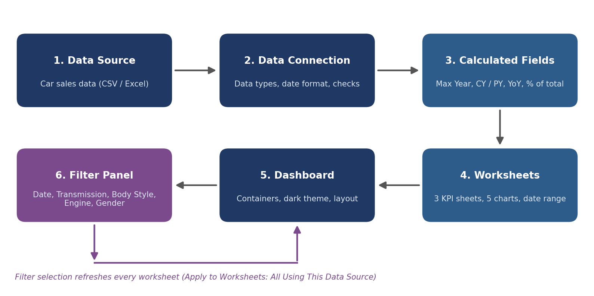
Figure 1: System architecture and data flow of the Car Sales Dashboard

6.2 Worksheet Design
Worksheet | Mark Type | Main Fields
YTD Total sales | Text | YTD Total Sales, YoY Sales Growth
YTD Cars sold | Text | YTD Cars Sold, YoY Cars Sold Growth
YTD Avg price | Text | YTD Avg Price, YoY Avg Growth
YTD Sales Weekly Trend | Area | WEEK(Date), YTD Total Sales
YTD Total Sales by Body Style | Pie | Body Style, YTD Total Sales
YTD Total sales by colour | Pie (dual axis donut) | Color, YTD Total Sales
YTD Cars sold by dealer region | Bar (stacked) | Dealer_Region, Transmission, YTD Total Sales
Company-Wise sales trend | Text table | Company, Measure Names / Values
Date range | Text | Min Date, Max Date

6.3 Dashboard Layout
The dashboard uses a dark background so that the coloured visuals stand out. It is divided into four zones:
- Header band: a car icon, the title "CAR SALES DASHBOARD" in gold and the data period on the right.
- Left filter panel ("Sales Insight"): the Date slider and the Transmission, Body Style, Engine and Gender drop-downs.
- KPI row: three cards for YTD Total sales, YTD Avg price and YTD cars sold, each with a YoY growth value.
- Chart area: weekly trend, body-style pie and colour donut in the first row; dealer-region bars and the company grid in the second row.

6.4 Colour and Formatting Scheme
Element | Design Choice
Background | Dark slate for the dashboard and panels
Title and KPI headings | Gold, teal and purple headings to separate the three KPI cards
Weekly trend | Green area with the minimum ($0.30M) and maximum labelled
Body style pie | Warm red-orange palette, one shade per body style
Colour donut | Grey (Black), purple (Pale White) and light cyan (Red)
Dealer region bars | Dark purple for Manual and light pink for Auto
Company grid | Separate colour legend for each measure (blue, orange, purple, green)

6.5 Filter Interaction Design
Filter | Control Type | Effect
Date | Range slider | Limits the period used for YTD values and the weekly trend
Transmission | Multiple-value drop-down (Auto, Manual) | Recalculates all KPIs and charts
Body Style | Multiple-value drop-down (5 values) | Recalculates all KPIs and charts
Engine | Multiple-value drop-down (2 values) | Recalculates all KPIs and charts
Gender | Multiple-value drop-down (Female, Male) | Recalculates all KPIs and charts

7. Code
Tableau does not need programming in the traditional sense, but the KPIs depend on a small set of calculated fields. This section lists the steps and formulas used in every worksheet. The blue screenshots are the worksheet (Show Me / Marks card) views from Tableau Desktop.

7.1 Connecting to the Data
- Open Tableau Desktop and choose Connect > Microsoft Excel / Text file, then select the car sales file.
- Drag the sales table to the canvas and check the data types: Date as Date, Price ($) as Number (decimal), the rest as String.
- Set the default date format of Date to dd-MM-yyyy (Default Properties > Date Format > Custom).
- Go to the first worksheet and start creating the calculated fields below.

7.2 Core Calculated Fields
These three fields are used by all KPI sheets. The FIXED expression returns the latest year in the data and is not affected by the quick filters, so the current year (2021) and previous year (2020) stay stable.

7.3 Worksheet: YTD Total sales
Filters shelf: Date, Engine, Transmission, Body Style, Gender. Marks card: Text, with the two aggregated fields below. Number format of YTD Total Sales is custom "$"#,##0.00,,"M" and YoY Sales Growth is "YoY Growth"0.00%.
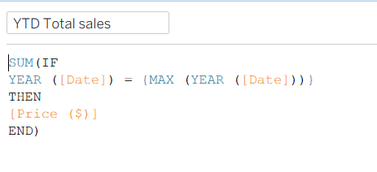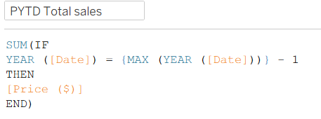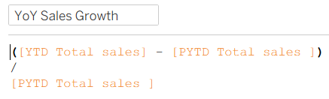

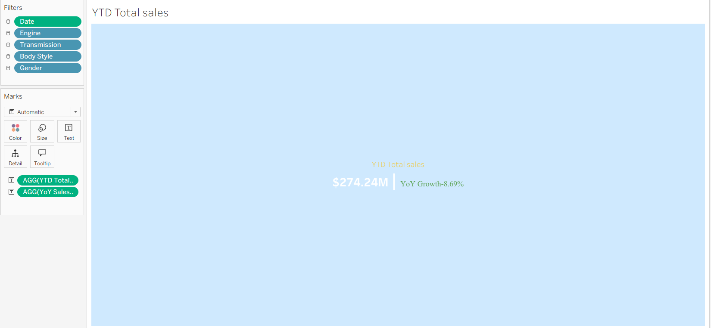
Figure 2: Worksheet "YTD Total sales" showing $274.24M and YoY growth -8.69%

7.4 Worksheet: YTD Cars sold
Cars are counted with COUNTD on the unique car id so that each car is counted once. The value is formatted as "#"0.00,"K", which displays 9,830 as #9.83K. The tooltip shows both values.
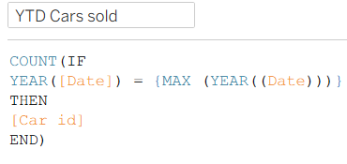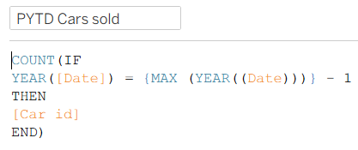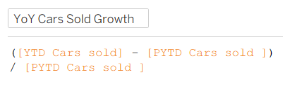

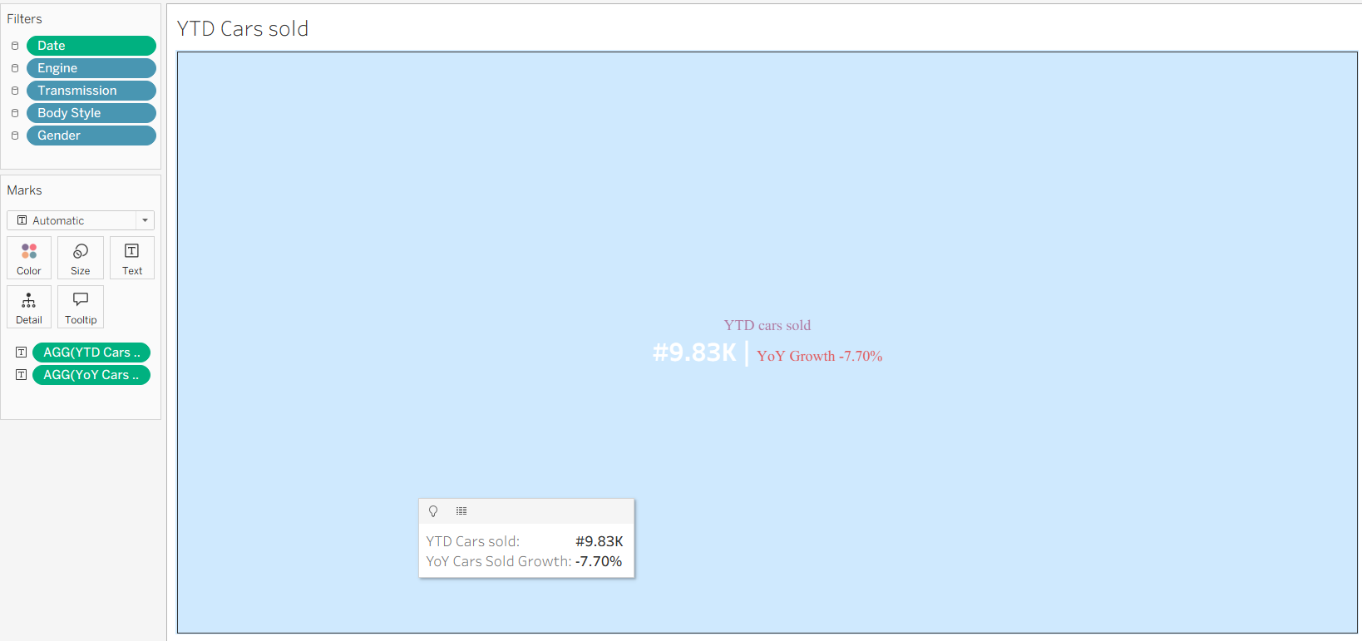
Figure 3: Worksheet "YTD Cars sold" showing #9.83K cars and a tooltip

7.5 Worksheet: YTD Avg price
The average price is the average of the current-year sales amounts. The number format is "$"#,##0.00,"K" (for example $27.91K).
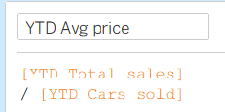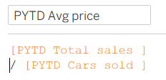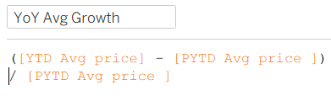

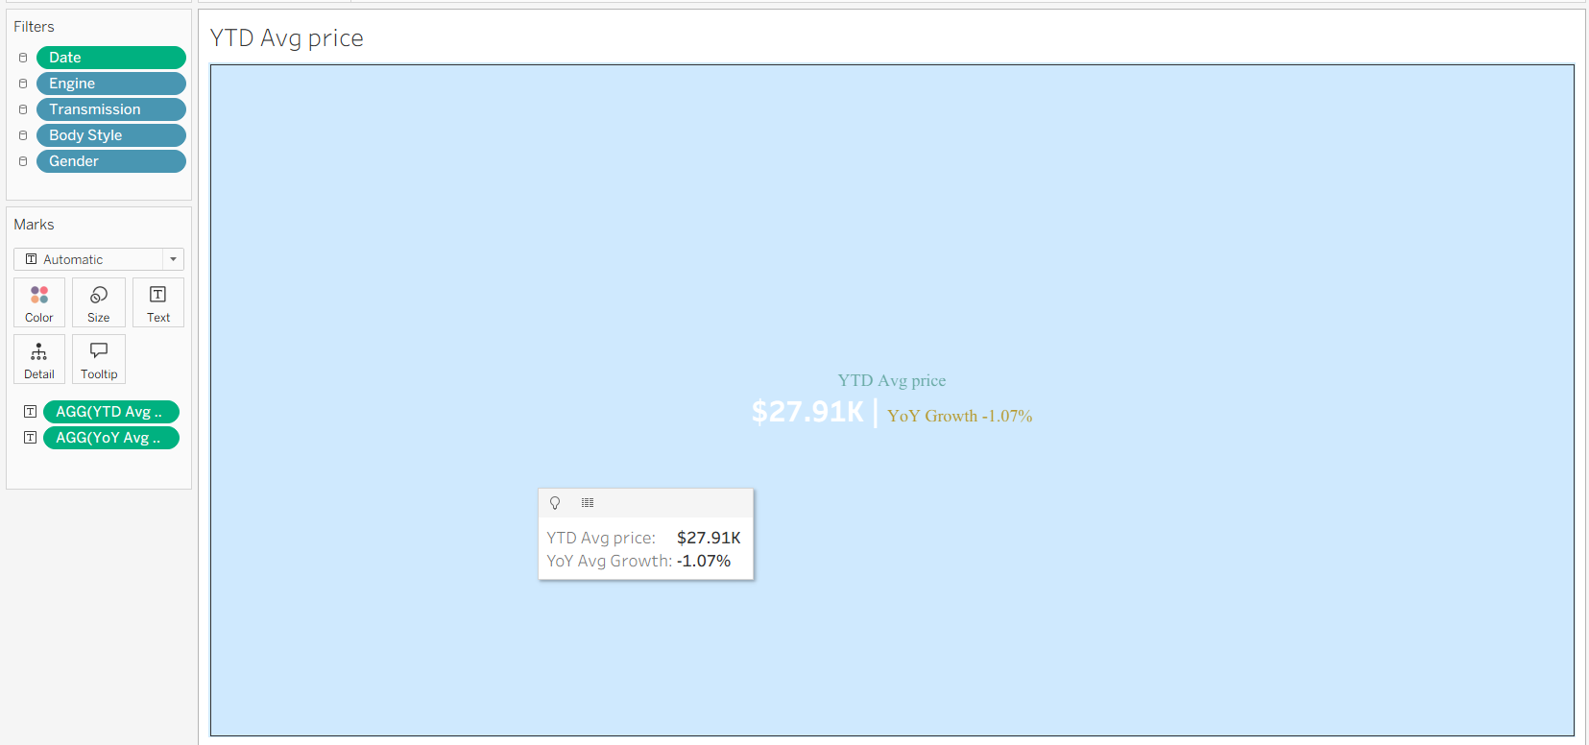
Figure 4: Worksheet "YTD Avg price" showing $27.91K and YoY growth -1.07%

7.6 Worksheet: YTD Sales Weekly Trend
- Drag Date to Columns and choose WEEK(Date) as a continuous (green) pill.
- Drag YTD Total Sales (AGG) to Rows.
- Change the mark type to Area and set the colour to green.
- Label card: show Min / Max values only, which produces the $0.30M and $14.51M labels.
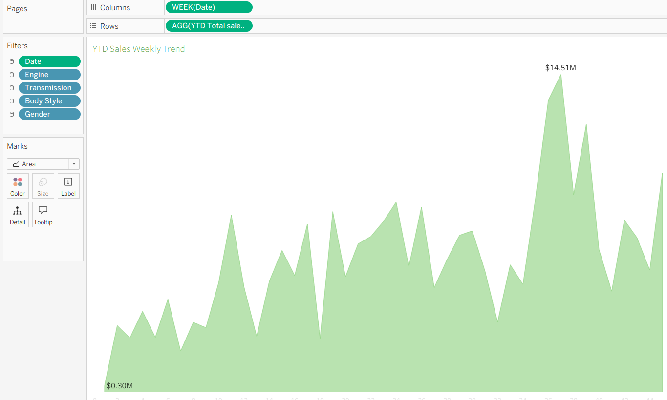
Figure 5: Worksheet "YTD Sales Weekly Trend": WEEK(Date) on Columns, YTD Total Sales on Rows

7.7 Worksheet: YTD Total Sales by Body Style (Pie)
Marks card: Pie. Body Style on Color and Label, AGG(YTD Total Sales) on Angle and Label. A warm palette (Hardtop to SUV) is assigned from the colour legend. No additional formula is needed.
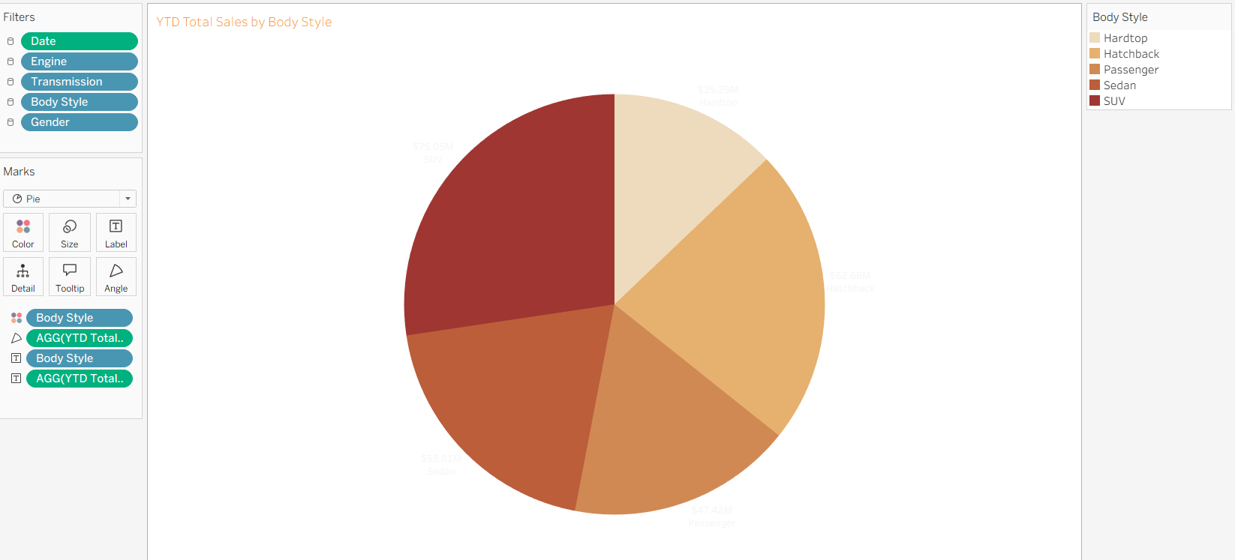
Figure 6: Worksheet "YTD Total Sales by Body Style" built as a pie chart

7.8 Worksheet: YTD Total sales by colour (Donut)
The donut is created with two copies of an ad hoc calculation AVG(0) on Rows and a dual axis:
Rows : AVG(0) AVG(0) // type 0 as an ad hoc calculation twice
Mark 1 (Pie) : Color = Color field, Angle = AGG(YTD Total Sales), Label = Color + sales
Mark 2 (Pie) : single mark, colour = dashboard background, Size reduced // the hole
Right-click the second AVG(0) > Dual Axis; Synchronise axes; hide both headers
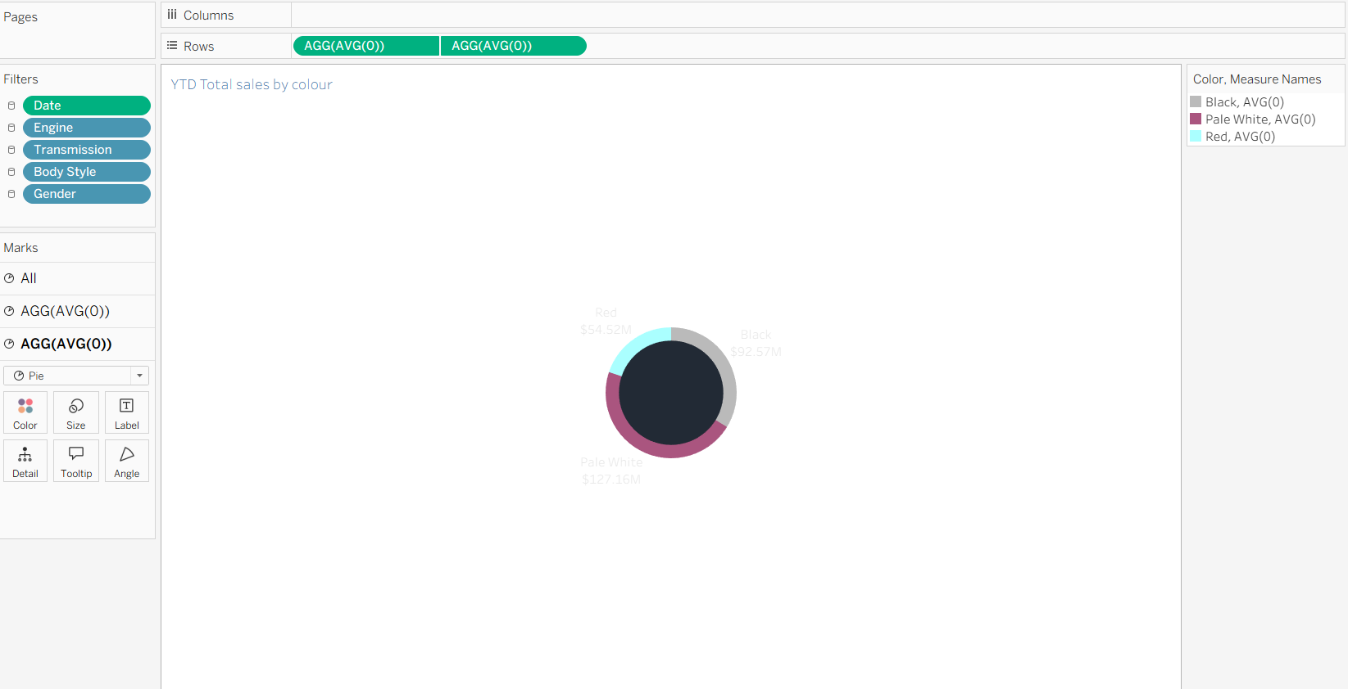
Figure 7: Worksheet "YTD Total sales by colour" built as a dual-axis donut chart

7.9 Worksheet: YTD Cars sold by dealer region (Stacked Bar)
Rows: Dealer_Region. Columns: AGG(YTD Total Sales). Color: Transmission (Manual in dark purple, Auto in light pink). Label: AGG(YTD Total Sales). The bars are sorted in descending order of total value, which puts Austin on top and Middletown at the bottom, and the legend is placed at the top right of the chart.

7.10 Worksheet: Company-Wise sales trend (Grid)
Rows: Company. Columns: Measure Names. Measure Values: YTD Cars Sold, YTD Avg Price, YTD Total Sales and the percentage field below. On the colour card Use Separate Legends is selected so every column gets its own colour scale (blue, orange, purple and green).

% of Total YTD Total Sales =
SUM([YTD Total Sales]) / TOTAL(SUM([YTD Total Sales])) // table calculation, compute using Company
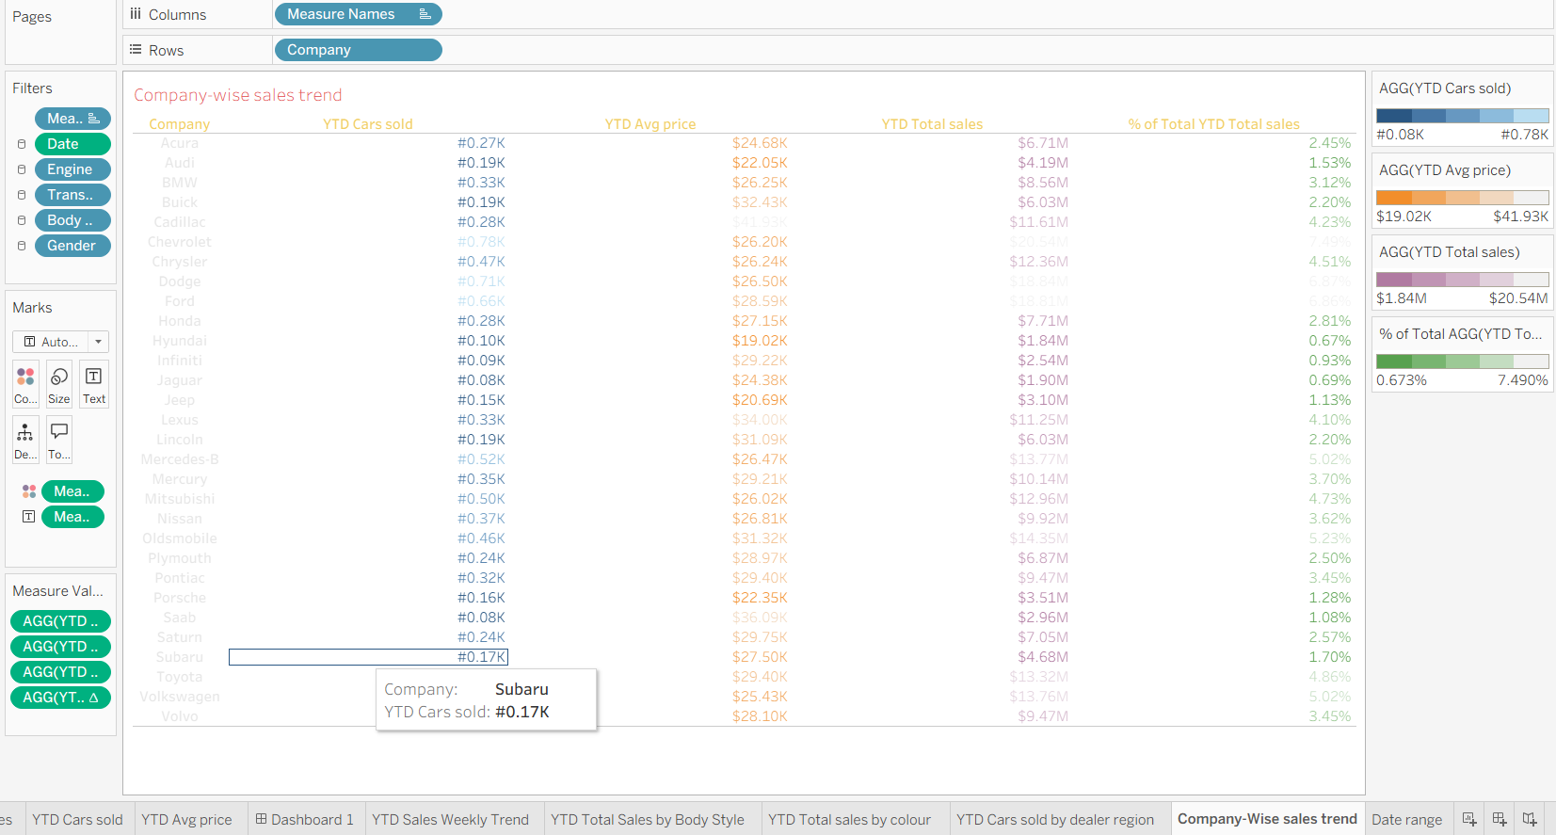
Figure 8: Worksheet "Company-Wise sales trend" with Measure Names and Measure Values

7.11 Worksheet: Date range
This small worksheet supplies the data period shown at the top right of the dashboard. Both fields are placed on Text and formatted as dd-MM-yyyy, and the text is edited to read "Min Date to Max Date".

Min Date = MIN([Date])
Max Date = MAX([Date])
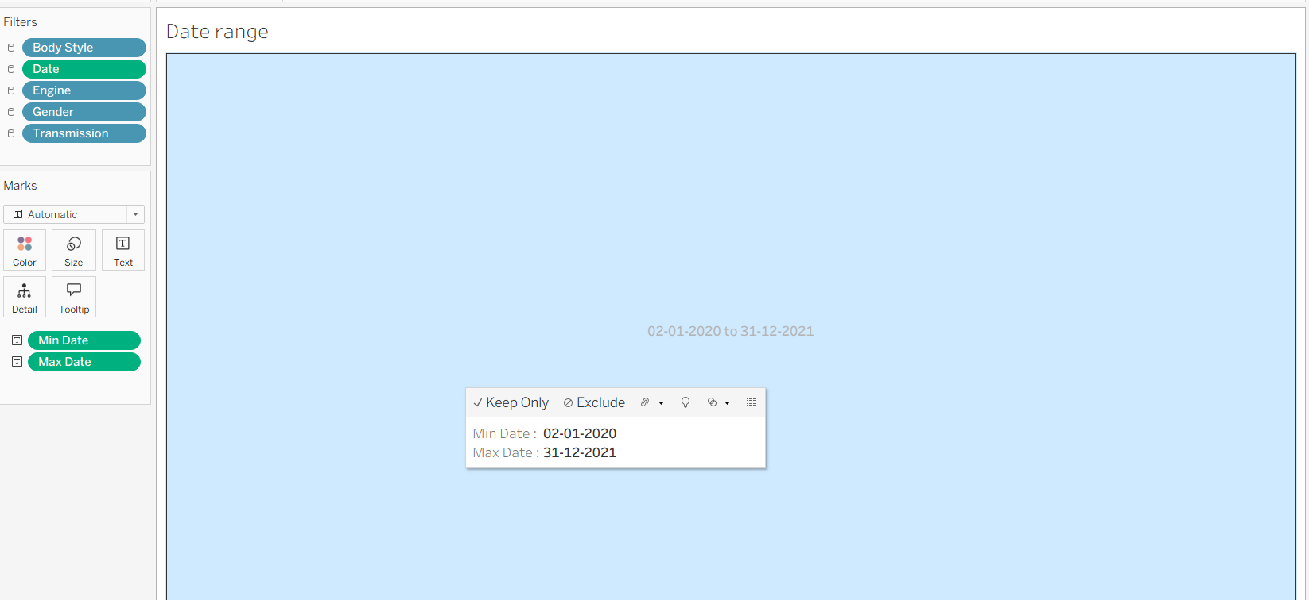
Figure 9: Worksheet "Date range" with Min Date and Max Date

7.12 Dashboard Assembly
- Create Dashboard 1, set a wide fixed size and a dark background colour.
- Add horizontal and vertical layout containers for the header, filter panel, KPI row and charts.
- Drag the nine worksheets into their zones and hide the sheet titles that are already drawn in the sheets.
- For each filter choose Show Filter, set it to *Range of dates* (Date) or *Multiple Values (dropdown)* (others) and use Apply to Worksheets > All Using This Data Source.
- Add the icons, the title text and the "Sales Insight / Filter Panel" labels, then test every filter.

8. Output
The final dashboard changes instantly when a value in the filter panel is changed. The screenshots below show the dashboard in its default state and after each filter is used.

8.1 Default Dashboard View
With the date slider set from 02-01-2020 to 05-11-2021 the dashboard reports $274.24M YTD sales, $27.91K average price and 9.83K cars sold.
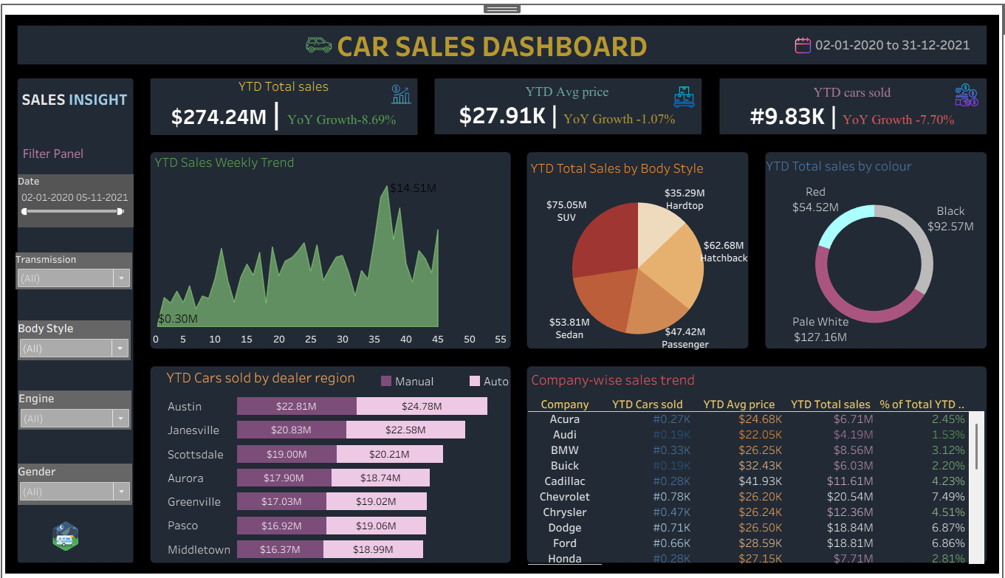
Figure 10: Final Car Sales Dashboard (default view, all filters set to All)

8.2 Output after the Date Filter
Moving the right end of the date slider to 24-04-2021 recalculates every visual: sales fall to $69.27M, cars sold to 2.52K, and the weekly trend stops at week 17.
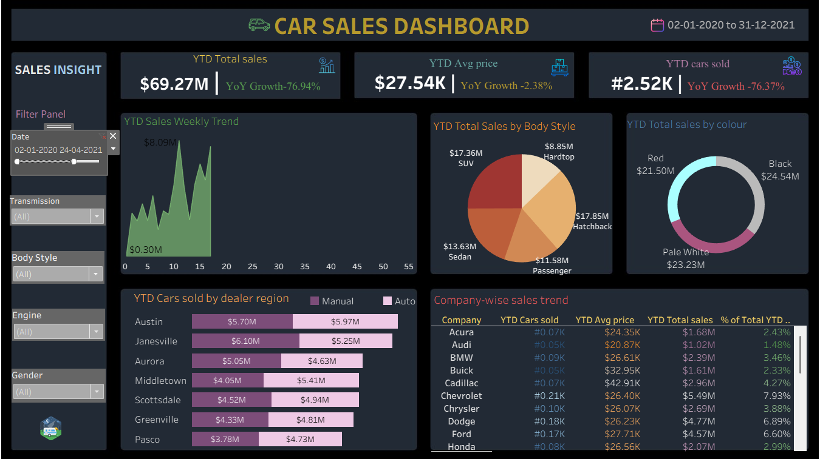
Figure 11: Dashboard after the Date filter is set to 02-01-2020 to 24-04-2021

8.3 Output after the Transmission Filter
The Transmission drop-down lists Auto and Manual. With the date slider at 08-08-2021 the KPIs show $165.43M, $27.90K and 5.93K cars. Selecting only Auto or only Manual would update all charts in the same way.
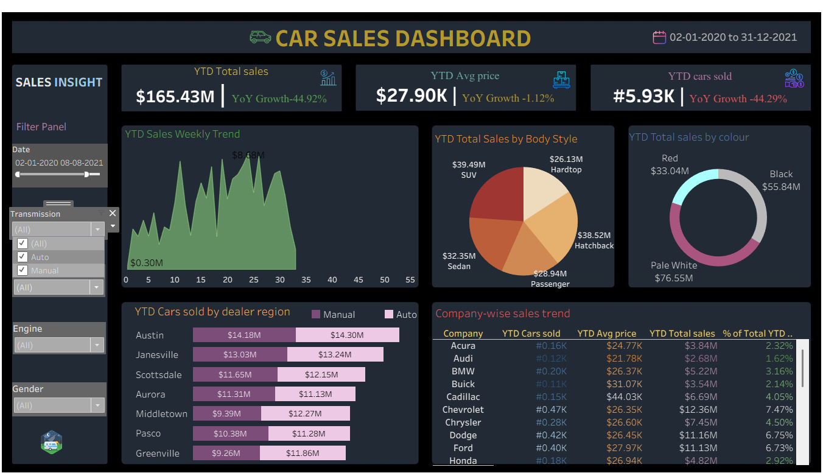
Figure 12: Transmission filter drop-down (Auto, Manual) with date range up to 08-08-2021

8.4 Output after the Body Style Filter
The Body Style filter contains Hardtop, Hatchback, Passenger, Sedan and SUV. Unchecking a body style removes it from the KPIs, pie chart, donut, regional bars and company grid.
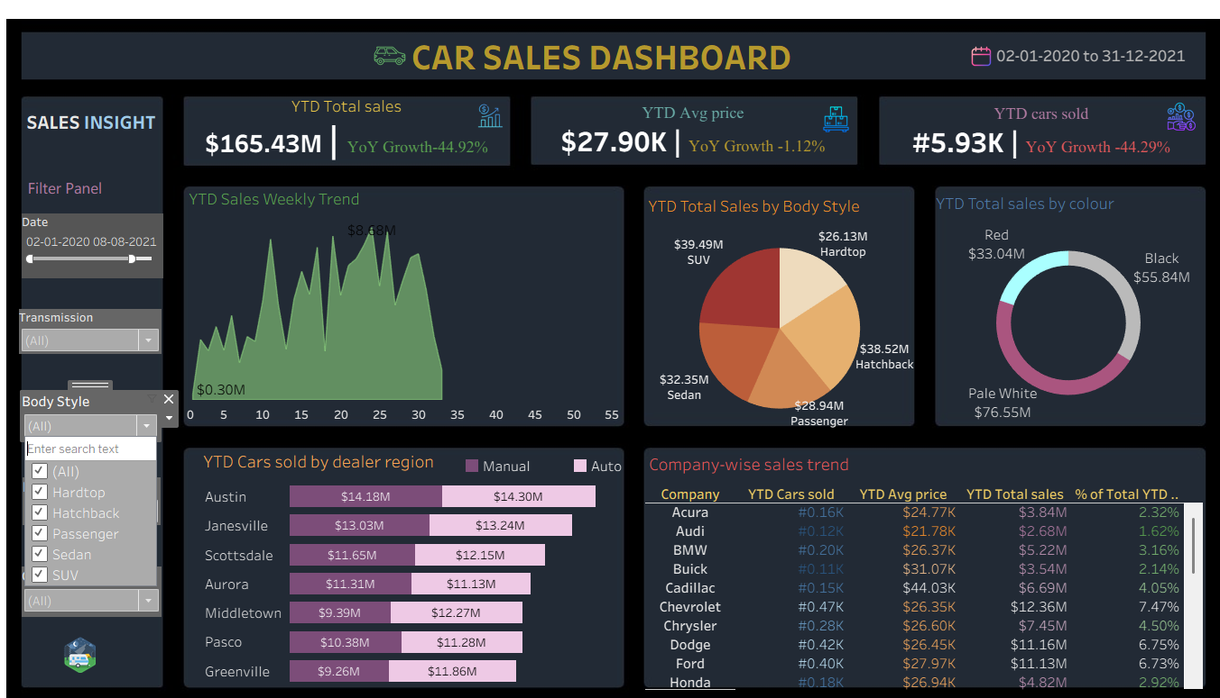
Figure 13: Body Style filter drop-down with five body styles

8.5 Output after the Engine Filter
The Engine filter has two values: Double Overhead Camshaft and Overhead Camshaft. The first value is displayed as "DoubleÂ Overhead Camshaft" because of a character-encoding issue in the source data (see Future Work).
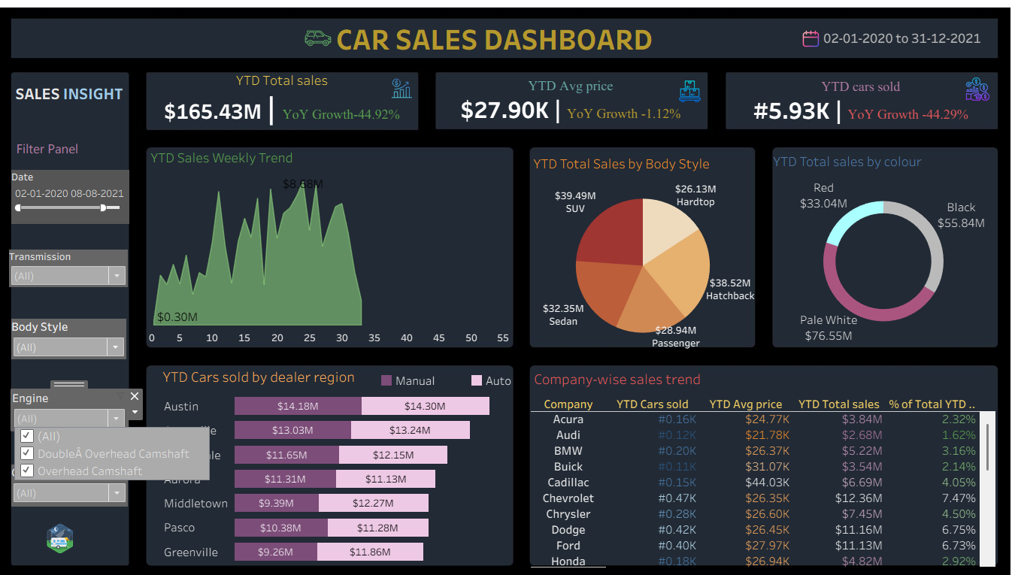
Figure 14: Engine filter drop-down
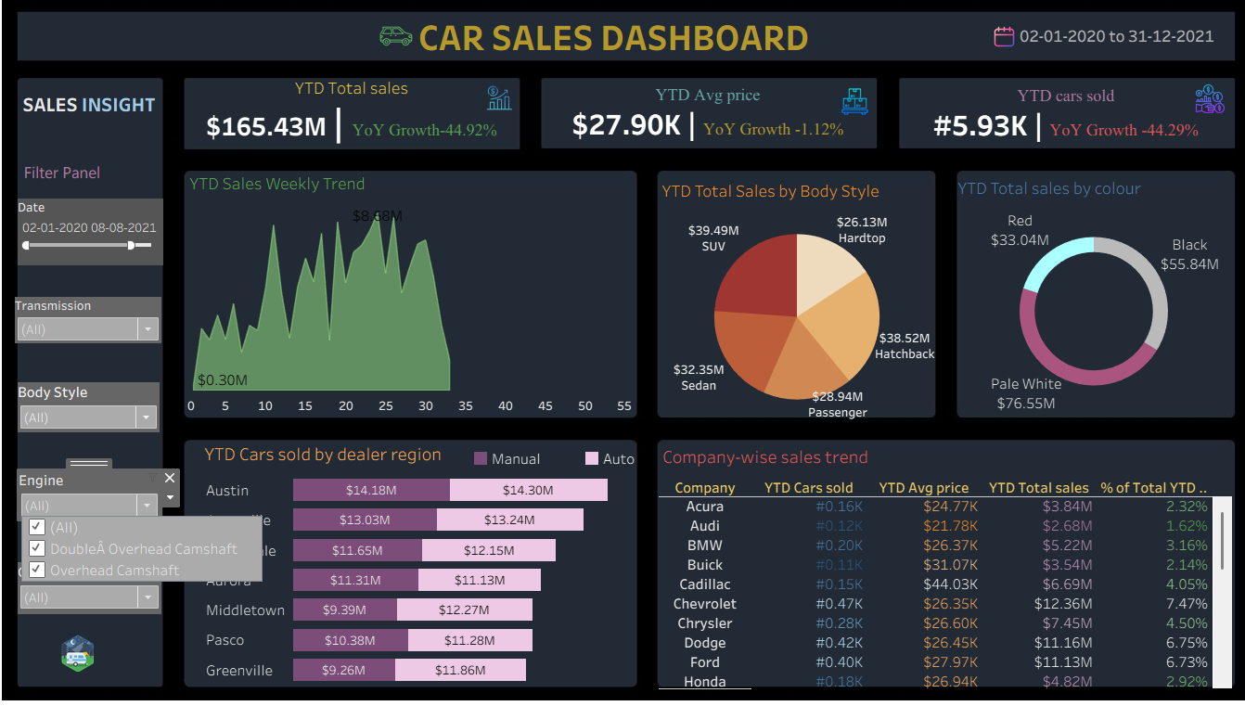
Figure 15: Engine filter drop-down (alternate dashboard size)

8.6 Output after the Gender Filter
The Gender filter lets the user compare Female and Male customers; all visuals refresh together.
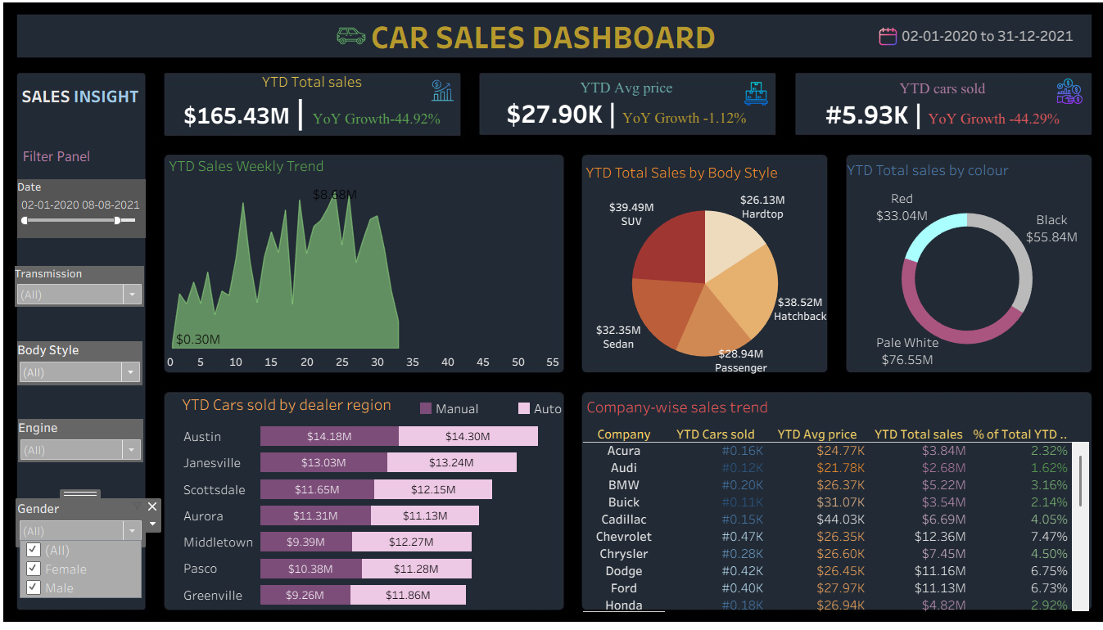
Figure 16: Gender filter drop-down (Female, Male)

8.7 KPI Values under Different Date Ranges
Date range (from 02-01-2020 to) | YTD Sales | Avg Price | Cars Sold | Sales YoY | Price YoY | Cars YoY
05-11-2021 (default) | $274.24M | $27.91K | 9.83K | -8.69% | -1.07% | -7.70%
08-08-2021 | $165.43M | $27.90K | 5.93K | -44.92% | -1.12% | -44.29%
24-04-2021 | $69.27M | $27.54K | 2.52K | -76.94% | -2.38% | -76.37%
Note: The YoY growth compares the selected part of the current year with the complete previous year, which is why the growth becomes more negative when the date slider is shortened. The average price, which is not affected by volume, stays stable at about $27.5K to $27.9K.

8.8 Breakdown Tables
Body Style | Until 05-11-2021 | Until 08-08-2021 | Until 24-04-2021
SUV | $75.05M | $39.49M | $17.36M
Hatchback | $62.68M | $38.52M | $17.85M
Sedan | $53.81M | $32.35M | $13.63M
Passenger | $47.42M | $28.94M | $11.58M
Hardtop | $35.29M | $26.13M | $8.85M

Colour | Until 05-11-2021 | Until 08-08-2021 | Until 24-04-2021
Pale White | $127.16M | $76.55M | $23.23M
Black | $92.57M | $55.84M | $24.54M
Red | $54.52M | $33.04M | $21.50M

Dealer Region | Manual | Auto | Total
Austin | $22.81M | $24.78M | $47.59M
Janesville | $20.83M | $22.58M | $43.41M
Scottsdale | $19.00M | $20.21M | $39.21M
Aurora | $17.90M | $18.74M | $36.64M
Greenville | $17.03M | $19.02M | $36.05M
Pasco | $16.92M | $19.06M | $35.98M
Middletown | $16.37M | $18.99M | $35.36M
Dealer-region values are for the default view (until 05-11-2021).

8.9 Key Insights from the Dashboard
- SUV is the best-selling body style ($75.05M, about 27.4% of sales), followed by Hatchback (22.9%) and Sedan (19.6%).
- Pale White cars contribute the most (about 46.4%), then Black (33.8%) and Red (19.9%).
- Austin is the top dealer region with $47.59M (17.4%); Auto cars account for about 52.3% of regional sales.
- Chevrolet leads the company grid with $20.54M (7.49%), followed by Dodge ($18.84M) and Ford ($18.81M).
- Cadillac has the highest average price ($41.93K) while Hyundai has the lowest ($19.02K).
- The weekly trend peaks at $14.51M around week 37, while the lowest week is $0.30M.

9. Future Work
- Same-period YoY comparison: compare the selected period with the same dates of the previous year (using DATEADD or a parameter) so that growth stays meaningful when the slider is shortened.
- Year parameter: replace the Max Year formula with a parameter so that the user can choose the year to analyse.
- Data cleaning: fix the encoding issue in the Engine values ("DoubleÂ Overhead Camshaft") and standardise company names such as Mercedes-Benz.
- Forecasting: add Tableau's forecast option to the weekly trend to predict the coming weeks.
- Geographic view: show dealer regions on a map and add drill-down from company to car model.
- Publishing: publish to Tableau Cloud / Server with scheduled extract refresh and a mobile layout.
- Customer analysis: use annual income and gender to profile the customers who buy each body style.

10. Learning Outcomes
- Understood how KPIs such as YTD, YoY growth and average price are defined and calculated.
- Learned to write calculated fields, a FIXED level-of-detail expression and a table calculation in Tableau.
- Built different chart types: area, pie, donut (dual axis), stacked bar and a text grid with Measure Names and Measure Values.
- Learned to apply a single filter to all worksheets and to design an interactive filter panel.
- Practised dashboard design: layout containers, colour themes, fonts, icons and number formatting.
- Learned to read a dashboard critically and to turn charts into business insights.

11. Conclusion
The Car Sales Dashboard fulfils the requirements of the problem statement. It delivers three KPIs with YoY growth, five charts and a five-filter panel in a single dark-themed Tableau dashboard. With the default settings it reports $274.24M of YTD sales, 9.83K cars sold at an average price of $27.91K, and the filter panel allows the user to look at any date range, transmission, body style, engine type or gender.
The dashboard shows clearly that SUVs, Pale White cars and the Austin region lead the sales, that Chevrolet is the largest company and that sales volume is the main driver of YoY change while the average price remains almost constant. The project also demonstrated how a few well-chosen calculated fields can convert a plain sales table into an interactive decision-support tool, and the dashboard can be extended further with the improvements listed under Future Work.

12. Bibliography
- Tableau Software, Tableau Help documentation: https://help.tableau.com
- Tableau Software, Tableau Training and Tutorials: https://www.tableau.com/learn/training
- Tableau Community Forums: https://community.tableau.com
- Tableau Public Gallery (reference dashboards): https://public.tableau.com
- Project Problem Statement: Car Sales Dashboard (Problem_Statement.docx).

