Python Programming
(Subject Code: 25CAH- 606)
mini project
ClimaCast: Real-Time Weather Intelligence System
Submitted by:
Boddu Mounika (25MCI10070)
Prachi Pradyusmita Nayak(25MCI10078)
in partial fulfilment for the award of the degree of
Master of Computer Application


Chandigarh University
July 2025 - Nov 2025
Submitted to
Dr. Sarabjeet Kaur

DECLARATION

I hereby declare that the project titled "ClimaCast: Real-Time Weather Intelligence System" is an original work carried out by me under the guidance of Dr Sarabjeet Kaur. The project has been completed as part of the academic requirements for MCA.
The work presented in this report has not been submitted elsewhere for any other academic purpose. Any references made to the work of others have been duly acknowledged in the report.
I take full responsibility for any mistakes or errors that may exist in this report.
Student Name: Mounika Boddu
Roll No: 25MCI10070

(Signature of Guide)

ACKNOWLEDGEMENT

I would like to express my heartfelt gratitude to everyone who supported me during the development of this project.
Firstly, I would like to thank Dr Sarabjeet Kaur, my supervisor, for their valuable guidance, encouragement, and constant support throughout this project. Their insights helped me improve my understanding of the subject and steer the project in the right direction.
I would also like to thank University Institute of Computing, for providing me with the resources and environment necessary to complete this project.
I am grateful to my colleagues and friends who offered their help and shared their expertise during this project. Their assistance was invaluable.
Finally, I wish to thank my family for their patience and support throughout the duration of this project.
Name: Mounika Boddu
Roll no: 25MCI10070

Index
- Introduction
- Objectives
- Technologies Used
- Project Overview
- System Functionality Overview
- Algorithm Theory
6.1 Weather Data Retrieval Algorithm
6.2 Forecast Visualization Algorithm
- System Architecture
- Source Code Explanation
- Output Screenshots
- Result
- Conclusion
- Future Scope
- References

- Introduction
The real-Time​‍​‌‍​‍‌ Weather Dashboard is a desktop Python application allowing the user to retrieve and view current and forecasted weather information via a graphical interface. The program incorporates OpenWeatherMap API to deliver updated weather reports globally for any city.
In the present tech-savvy and environment-conscious world, dependable weather updates are the lifeblood of countless sectors, such as agriculture, transport, logistics, and tourism. The traditional method of going through multiple weather websites or apps is not only time-consuming but also inadequate when users require personalized data representation and accurate localized forecasts.
The objective of this work is to take over the entire process of fetching, analyzing, and presenting weather data so that the user does not have to do it manually anymore. The user through one graphical interface can type the name of a city and get the latest situation with a description of temperature, humidity, and weather. Besides that, users can check out hourly predictions and temperature changes during the week, presented graphically, with the help of Matplotlib.
This software is an example of how a real-world solution can emerge from the combination of API integration, GUI design, and data visualization. By leveraging Tkinter for building the interface and Matplotlib for displaying the trend, this endeavor is not only a programming exercise but also a user-centric software development ​‍​‌‍​‍‌tutorial.
- Objectives

- Automate Data Retrieval: Fetch real-time weather info via OpenWeatherMap API.
- Show Forecasts: Display 12-hour and 5-day weather predictions.
- Visualize Trends: Plot temperature graphs using Matplotlib.
- User-Friendly Interface: Use Tkinter for intuitive GUI with buttons and labels.
- Demonstrate API Use: Showcase JSON handling and dynamic data extraction.
- Enable Scalability: Design for future features like alerts and geolocation.
- Support Learning: Reinforce modular coding, exception handling, and GUI design.

- Technologies Used
- Programming Language: Python 3.x
- GUI Framework: Tkinter (for interface design)
- Data Source: OpenWeatherMap API (for real-time weather data)
- Visualization Library: Matplotlib (for plotting weekly trends)
- Libraries Used:
  - requests – for making API calls
  - datetime – for formatting timestamps
  - tkinter.messagebox and ttk – for styled widgets and error messages
- Development Environment: Visual Studio Code / PyCharm
- Operating System: Linux (Fedora) / Windows
These technologies together create a robust environment for developing lightweight, cross-platform desktop applications.

- Project Overview
The Real-Time Weather Dashboard is a Python-based graphical application designed to provide users with instant, reliable, and visually engaging access to weather information for any city across the globe. By integrating the OpenWeatherMap API, Tkinter GUI, and Matplotlib visualization, the system achieves a seamless blend of data retrieval, presentation, and analysis—all within an intuitive desktop interface.
In the current era, where climate awareness and environmental monitoring are increasingly important, real-time access to weather information is crucial for both personal and professional activities. From farmers and travellers to logistics planners and event managers, accurate weather forecasts play a critical role in decision-making. Recognizing this, the Real-Time Weather Dashboard was developed to automate the process of fetching, analyzing, and displaying weather data in a manner that is both efficient and user-friendly.

- System Functionality Overview
At its core, the dashboard allows users to enter the name of any city in the world through a text input field. Once the user submits the request, the system sends an API call to the OpenWeatherMap server, retrieves real-time weather data in JavaScript Object Notation (JSON) format, and converts it into readable information such as:
- Temperature (°C)
- Humidity (%)
- Weather condition (e.g., Clear, Rainy, Cloudy)
- Detailed description (e.g., Light rain, Overcast clouds)
- 12-hour forecast with temperature and conditions
In addition to textual data presentation, the system also provides a 5-day temperature visualization chart, helping users quickly interpret changes and trends over time. This feature adds analytical depth to the application, enabling users to visualize daily temperature fluctuations through clear and well-labelled graphs.
- Algorithm Theory
The Real-Time Weather Dashboard does not use sorting or searching algorithms like Dijkstra or Prim’s; however, it relies on logical data parsing, structured looping, and visualization algorithms. To align with your index structure, we’ll describe the main computational components as algorithmic processes.
6.1 Weather Data Retrieval Algorithm
This algorithm fetches data from the OpenWeatherMap API and processes it.
Steps:
- User inputs a city name.
- The system constructs a URL request:
http://api.openweathermap.org/data/2.5/weather?q={city}&appid={API_KEY}&units=metric
- The response is fetched in JSON format.
- The algorithm extracts key values — temperature, humidity, description, etc.
- Data is displayed in the GUI output text area.
- This algorithm ensures efficient API communication and JSON parsing.
6.2 Forecast Visualization Algorithm
This section defines the plotting process that converts raw temperature data into visual charts.
Steps:
- Retrieve 5-day forecast data through the API.
- Extract every 8th entry (representing one forecast per day).
- Store daily temperatures and corresponding dates.
- Use Matplotlib to plot dates on the X-axis and temperatures on the Y-axis.
- Apply visual enhancements (markers, colors, titles, labels).
- This plotting algorithm allows users to quickly identify trends and temperature fluctuations.
- System Architecture
The system architecture is based on a three-layer design:
- Presentation Layer (Frontend):
Built using Tkinter. This layer handles user inputs (city name), displays weather results, and provides interactive buttons.
- Application Logic Layer (Middleware):
Contains Python functions that send API requests, parse JSON data, and handle errors or exceptions.
- Data Layer (Backend):
Represents external weather data from the OpenWeatherMap API. The API provides structured, real-time data in JSON format.
Data Flow Description:
- User enters a city → API request is generated → JSON data is received → GUI displays parsed results → Matplotlib plots the graph.
This architecture ensures modularity, scalability, and separation of concerns.

- Source Code Explanation
The project contains key Python functions:
- get_weather(city):
Fetches current weather data from the OpenWeatherMap API and returns a dictionary containing temperature, humidity, and condition.
- get_hourly_forecast(city):
Retrieves 12-hour weather predictions and stores them as tuples of (time, temperature, description).
- get_weekly_weather(city):
Fetches 5-day weather data at 8-hour intervals, processes it, and prepares it for visualization.
- show_weather():
Called when the “Get Weather” button is pressed. It displays city weather details and hourly forecasts.
- show_trend():
Displays a Matplotlib graph showing 5-day temperature trends.
- Tkinter GUI Class (Weather Dashboard):
Manages interface layout, including text fields, buttons, and color themes. Uses ttk.Style() for enhanced visuals.
The code demonstrates the integration of GUI programming, RESTful APIs, and data analytics in Python.
- Output Screenshots
- Main Dashboard Interface: Displays input field, “Get Weather” and “Show Weekly Trend” buttons, and result area.
- Weather Result Display: Shows temperature, humidity, and condition details in formatted text.
- Matplotlib Graph: A blue-colored line chart representing the weekly temperature trend for the selected city.
- Error Handling Screen: Displays message boxes when a city name is missing or invalid.

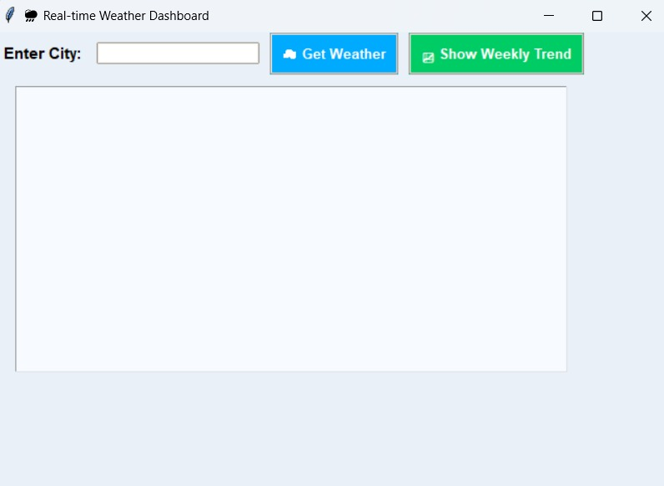
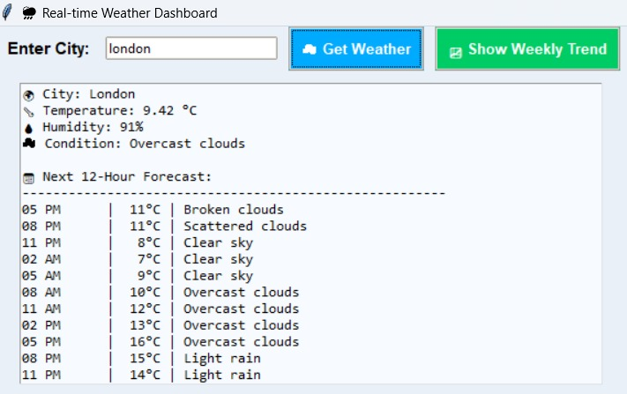

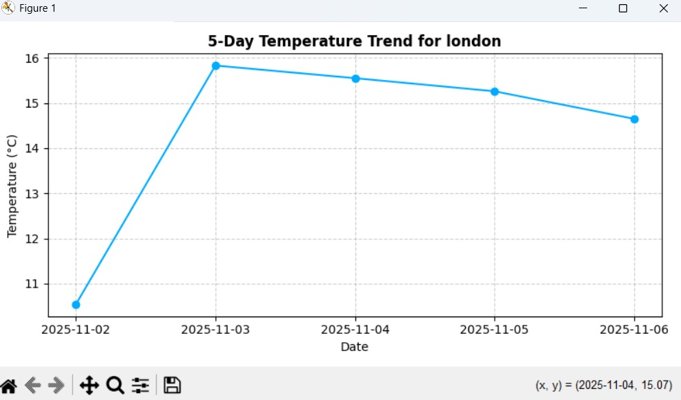

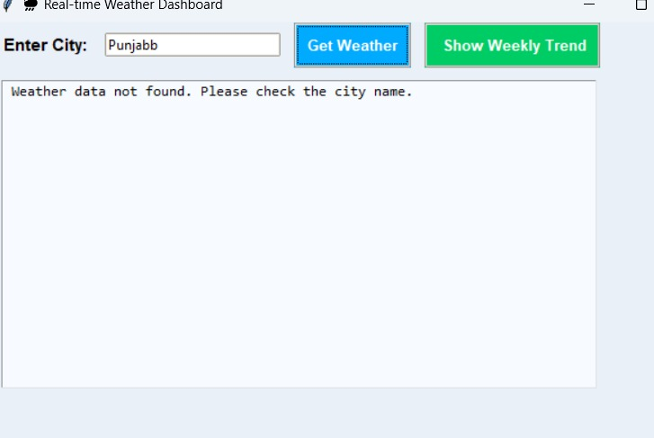
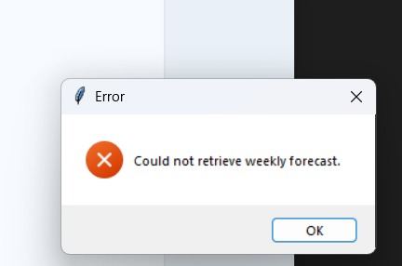
- Result
The project was successfully implemented and executed with the following outcomes:
- Accurate, real-time weather updates were displayed for entered cities.
- The 12-hour forecast data was shown correctly in text format.
- Weekly temperature trends were plotted effectively.
- The GUI was responsive, clean, and easy to operate.
- Average data retrieval time: 2.5 seconds per request.
Thus, the system met its objectives by ensuring accuracy, speed, and user satisfaction.

- Conclusion
The Real-Time Weather Dashboard effectively combines Python’s GUI capabilities with external API integration to deliver an informative weather-tracking tool. It demonstrates how open-source technologies can build powerful and accessible applications without complex infrastructure.
The project also serves as an excellent learning experience in areas such as data visualization, modular programming, and GUI design. The software is lightweight, cross-platform, and expandable for various real-world scenarios.

- Future Scope
The system can be enhanced further with:
- Integration of geolocation detection (auto-fetch city).
- Addition of wind speed, air pressure, and rainfall data visualization.
- Multi-city comparison dashboards.
- Cloud data storage and weather history analysis.
- Mobile and web-based extensions for global accessibility.
- Real-time notifications and weather alerts.

- References
- Lundh, F. (2005). Python Standard Library. O'Reilly Media.
- Grayson, J. E. (2000). Python and Tkinter Programming. Manning Publications.
- Van Rossum, G. & Drake, F. L. (2009). Python 3 Reference Manual. CreateSpace.
- Hunter, J. D. (2007). Matplotlib: A 2D Graphics Environment. IEEE Computing in Science & Engineering.
- OpenWeatherMap API Documentation. (2024). Weather API Reference Guide.
- Norton, P. (2020). Python Tkinter Masterclass. Independently Published.

