MediSync AI: A Connected Hospital Resource Visibility and Capacity-Pressure Prediction Platform
A PROJECT REPORT

Submitted by

Boddu Mounika (25MCI10070) Monika Rani (25MCI10261)
in partial fulfillment for the award of the degree of

MASTER OF COMPUTER APPLICATIONS
IN
ARTIFICIAL INTELLIGENCE AND MACHINE LEARNING

Chandigarh University
November 2026

BONAFIDE CERTIFICATE

Certified that this project report “MediSync AI” is the Bonafide work of “Boddu Mounika (25MCI10070), Monika Rani (25MCI10261)” who carried out the project work under my/our supervision.

SIGNATURE  Dr. Amanpreet Kaur Sandhu  HEAD OF THE DEPARTMENT  University Institute of Computing | SIGNATURE  Mr. Rishabh Tomar  SUPERVISOR  Assistant Professor  University Institute of Computing

Submitted for the project viva-voce examination held on 05 November 2026.

INTERNAL EXAMINER | EXTERNAL EXAMINER

TABLE OF CONTENTS
List of Figures 4
List of Tables 5
List of Standards 6
CHAPTER 1. INTRODUCTION 11
  - Identification of Client/ Need/ Relevant Contemporary issue 11
  - Identification of Problem 12
  - Identification of Tasks 13
  - Timeline 14
  - Organization of the Report 16
CHAPTER 2. LITERATURE REVIEW/BACKGROUND STUDY 17
  - Timeline of the reported problem 17
  - Existing solutions 18
  - Bibliometric analysis 19
  - Review Summary 20
  - Problem Definition 21
  - Goals/Objectives 22
CHAPTER 3. DESIGN FLOW/PROCESS 24
  - Evaluation & Selection of Specifications/Features 24
  - Design Constraints 26
  - Analysis of Features and finalization subject to constraints 28
  - Design Flow 29
  - Design selection 32
  - Implementation plan/methodology 33
CHAPTER 4. RESULTS ANALYSIS AND VALIDATION 37
  - Implementation of solution 37
CHAPTER 5. CONCLUSION AND FUTURE WORK 49
  - Conclusion 49
  - Future work 50
REFERENCES 52
APPENDIX 53
- Plagiarism Report 53
- Design Checklist 54
USER MANUAL 55

List of Figures

Figure 1.1 Gantt chart of the seven-week project timeline 15
Figure 3.1 Flow Chart of Project 29
Figure 3.2 System architecture of MediSync AI 30
Figure 3.3 Data model (MongoDB collections) 31
Figure 3.4 Sequence of a prediction request 32
Figure 3.5 Machine-learning pipeline in the Flask service 32
Figure 4.1 Network-wide totals and available units by resource 38
Figure 4.2 ICU bed availability by hospital with status thresholds 39
Figure 4.3 Distribution of facility status (ICU thresholds) 39
Figure 4.4 Projected availability for Northstar Medical Center under 8% and 25% demand increase
. 40
Figure 4.5 Feature importances of the Random Forest model 41
Figure 4.6 Heuristic ICU pressure and ML risk score for each sample hospital (dashed line: High threshold, 75; dotted line: Moderate threshold, 50) 42
Figure 4.7 Sign-in portal (patient and hospital-administrator tabs) 43
Figure 4.8 Home page with hospital cards, doctors, and appointment-request form 44
Figure 4.9 Operational dashboard 45
Figure 4.10 Hospital directory and hospital profile 45
Figure 4.11 AI-insights page with demand slider and scenario chart 46

List of Tables
Table 1.1 Project timeline 14
Table 2.1 Comparison of existing solution categories with MediSync AI 19
Table 3.1 Functional features and primary users 24
Table 3.2 Technology stack and rationale 25
Table 3.3 Feature analysis and finalization subject to constraints 28
Table 3.4 Summary of REST API endpoints 31
Table 3.5 Design alternatives and selection 32
Table 3.6 Comparison of the two candidate designs 33
Table 4.1 Sample hospital resources (available / total) 37
Table 4.2 Evaluation of the synthetic Random Forest model 40
Table 4.3 Heuristic ICU pressure vs. synthetic ML risk score (8% demand increase) 41
Table 4.4 Executed tests of the ML service (/predict and /health) 47
Table 4.5 Test plan for the API and user interface 47

List of Standards (Mandatory for Engineering Programs)

Standard | Publishing Agency | About the standard | Page no
RFC 7519 – JSON Web  Token (JWT) | IETF | A compact, URL-safe means of representing claims between two parties. Used for stateless authentication with a configurable 8-hour token lifetime. | Sections 3.3 and 3.6  (pages 28 and 33)
RFC 9110 – HTTP  Semantics | IETF | Defines the semantics of HTTP methods, status codes and headers that the REST API follows (GET, POST, PUT/PATCH,  DELETE; 2xx, 4xx and 5xx responses). | Section 3.4, Table 3.4  (page 29)
RFC 8259 – JSON Data  Interchange Format | IETF | Text format for structured data exchange. All API requests and responses, and the call from the Express API to the Flask service, use JSON. | Section 3.4 (page 29)
ECMA-262 –  ECMAScript Language Specification | Ecma International | Standard that defines the JavaScript language used in the React front end and the Node.js/Express back end. | Section 3.1, Table 3.2  (page 24)
OWASP Top 10:2021 | OWASP  Foundation | Awareness document listing the most critical web-application security risks; used as the checklist for the security review. | Section 4.1.4 (page 46)
Digital Personal Data Protection Act, 2023 | Government of India | Statute governing the processing of digital personal data in India; considered in the privacy-by-design decisions (fictional data only). | Sections 3.2 and 3.3  (pages 26 and 28)

ABSTRACT
The “MediSync AI” is a full-stack healthcare resource management platform designed to centralize hospital information, including general beds, ICU beds, ventilators, oxygen units, blood units, ambulances, doctors, appointments, and emergency records. It helps patients and hospital administrators access essential hospital resource information through a single web application.
The frontend is developed using React.js, providing a user-friendly interface with hospital directories, resource dashboards, appointment requests, emergency records, and AI insights. The backend uses Node.js and Express.js to provide REST APIs, while MongoDB stores information about users, hospitals, doctors, appointments, alerts, and emergencies.
The platform integrates a Python Flask microservice with a Random Forest Regressor to estimate hospital capacity risk based on available resources and expected demand. The model is trained on 4,096 synthetic records and achieves an MAE of 1.39 and an RZ of 0.990 on synthetic test data. Security features include JWT authentication, password hashing, input validation, and role-based access control.
MediSync AI provides capacity alerts and AI-assisted insights to support hospital resource planning. The prototype uses fictional demonstration data and is not intended for clinical decisions or emergency dispatch. It offers a foundation for future development using real hospital data and improved healthcare analytics.
Keywords: hospital resource management, healthcare analytics, capacity planning, Random Forest, MERN stack, REST API, role-based access control, decision support.

GRAPHICAL ABSTRACT
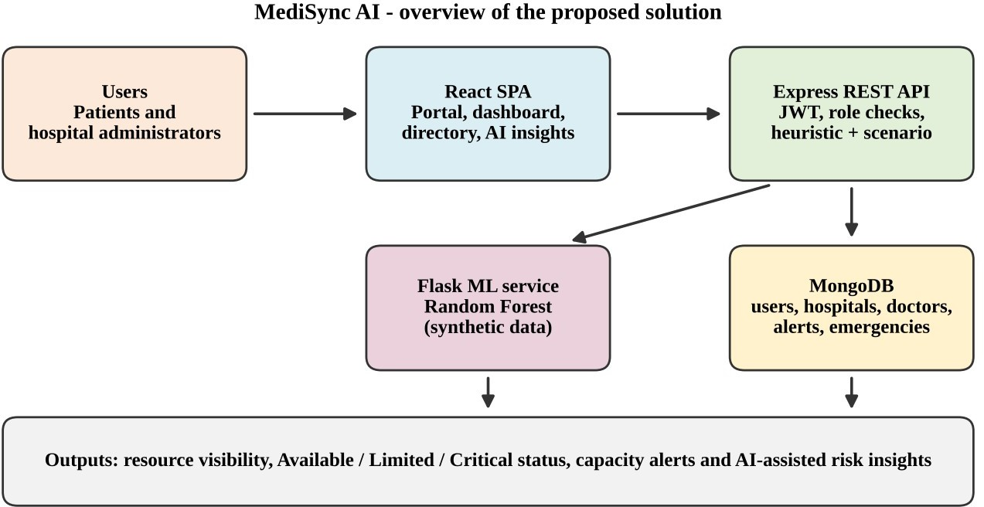

Graphical abstract of the MediSync AI platform
The graphical abstract summarises the proposed solution. Patients and hospital administrators use a React single-page application, which communicates only with a secured Express REST API. The API stores users, hospitals, doctors, alerts and emergencies in MongoDB, computes a transparent capacity-pressure heuristic and a 12-hour demand scenario, and calls a Flask microservice that hosts a Random Forest model trained on synthetic data. The combined outputs give resource visibility, facility status, capacity alerts and AI-assisted risk insights.

ABBREVIATIONS

Abbreviation | Full form
AI | Artificial Intelligence
API | Application Programming Interface
CLI | Command-Line Interface
CORS | Cross-Origin Resource Sharing
CRUD | Create, Read, Update, Delete
DoS | Denial of Service
DPDP | Digital Personal Data Protection
EHR | Electronic Health Record
HIS / HMIS | Hospital Information System / Hospital Management Information System
HTTP | Hypertext Transfer Protocol
ICU | Intensive Care Unit
IETF | Internet Engineering Task Force
JSON | JavaScript Object Notation
JWT | JSON Web Token
MAE | Mean Absolute Error
MERN | MongoDB, Express.js, React.js, Node.js
ML | Machine Learning
OWASP | Open Worldwide Application Security Project
PPE | Personal Protective Equipment
RBAC | Role-Based Access Control
REST | Representational State Transfer
SPA | Single-Page Application
UI | User Interface

SYMBOLS

Symbol | Meaning
T | Total units of a tracked resource (for example, total ICU beds)
A | Available units of a tracked resource
a = A / T | Availability ratio of a resource (0 when T = 0)
P | Pressure score of a resource, P = round((1 − a) × 100)
d | Assumed demand increase over 12 hours, expressed as a percentage (0–25 %)
h | Hour in the 12-hour scenario, h ∈ {0, 3, 6, 9, 12}
r | Pearson correlation coefficient between the heuristic and ML signals
RZ | Coefficient of determination of the regression model
MAE | Mean absolute error of the regression model
≥ , ≤ | Greater than or equal to; less than or equal to (used for status thresholds)
× ÷ | Multiplication and division
∈ | Element of a set

CHAPTER 1.
INTRODUCTION

Identification of Client/ Need/ Relevant Contemporary issue
Client:
The clients for the “MediSync AI” project are envisioned as three groups: (i) patients and caregivers who need to locate an appropriate hospital or specialist and submit an appointment request; (ii) hospital administrators and network coordinators who are responsible for keeping resource information accurate and for responding to capacity alerts; and (iii) city- or state-level health coordinators who need a consolidated, network-wide view of capacity. The platform therefore serves a spectrum of users ranging from individual citizens to institutional decision makers.
Need:
The primary need addressed by this project is the absence of an integrated and up-to-date view of hospital capacity. During peak demand, whether caused by seasonal disease surges, accidents, or public-health emergencies, people frequently cannot tell which nearby hospital has a free ICU bed, a working ventilator, or sufficient oxygen supply. Hospital staff, in turn, spend valuable time answering phone calls and compiling manual status reports. A consolidated platform with role-based editing rights, threshold-based alerts, and a simple forecast of resource pressure can shorten this search and support earlier, better-informed coordination.
Relevant Contemporary Issue:
The contemporary issue addressed by the project is resource visibility and preparedness in healthcare systems. The COVID-19 pandemic made the consequences of poor visibility highly apparent: families searched social media and phone directories for beds and oxygen, and administrators struggled to see the whole network at once. At the same time, digital health, data-driven operations, and AI-assisted decision support have become central themes in health-informatics research and policy. However, applying machine learning to healthcare operations also raises legitimate concerns about data privacy, model validity, and over-reliance on unvalidated predictions.
The project aligns with this discourse by combining a practical, user-facing information system with a deliberately cautious AI component. MediSync AI separates fictional demonstration data

from real data, labels every model output as a synthetic demonstration, and prevents patient accounts from acquiring administrative rights. By identifying the client, understanding their needs, and addressing a relevant contemporary issue, the project positions itself as a timely prototype in the domain of connected care and healthcare information systems.

Identification of Problem
The “MediSync AI” project is designed to address several interrelated problems that arise from fragmented hospital information.
Fragmented and outdated resource information. Bed, ventilator, and oxygen availability are typically maintained in separate registers, spreadsheets, or phone-based reports. This makes it difficult to answer the simple question, “Which facility can take a critical patient right now?”, and the answer may already be stale by the time it is communicated.
No early warning of capacity pressure. Without threshold-based rules or forecasting, coordinators learn about shortages only after a facility is already saturated. A facility with only 3 of 30 ICU beds free requires a very different response from one with 13 of 40 free, yet this distinction is invisible when data is scattered.
Weak separation of roles and responsibilities. Resource counts, alert resolution, and emergency assignment are sensitive operations. If every user can edit them, the integrity of the information is lost. A usable system must therefore distinguish patient accounts from administrator accounts and enforce this distinction on the server rather than only in the user interface.
Privacy and safety risks of health data. Appointment and emergency workflows tempt users to enter detailed medical information. A prototype must restrict free text, discourage sensitive entries, avoid real patient identifiers, and make clear that it is not a clinical or dispatch tool.
Unverified “AI” claims. Many student and demonstration projects present machine-learning accuracy figures that do not reflect real-world performance. A responsible solution must be transparent about the data used to train the model and about the limits of any metric it reports.
MediSync AI responds to these problems by providing a single role-controlled platform for hospital information, a rule-based alerting mechanism, a transparent scenario engine, and a clearly labelled synthetic ML model, all backed by a persistent database.

Identification of Tasks
The successful execution of the “MediSync AI” project involves a series of interrelated tasks covering analysis, design, development, integration, testing, and documentation. The tasks are grouped into the following key areas:
- Research and Requirement Analysis
  - Study existing hospital information systems, bed-availability dashboards, and appointment platforms to identify gaps.
  - Define user roles (patient, hospital administrator) and the operations each role may perform.
  - Specify the resource categories to be tracked: general beds, ICU beds, ventilators, oxygen, ambulances, blood, PPE, and medicines.
- Database Design and Seeding
  - Design six MongoDB collections (users, hospitals, doctors, appointment requests, alerts, emergencies) with validation rules and indexes using Mongoose.
  - Develop a repeatable seed script that inserts 12 fictional hospitals, 24 doctors, sample alerts, and sample emergencies without overwriting existing data.
- Backend API Development
  - Implement authentication (register, login, profile) with bcrypt hashing and JSON Web Tokens.
  - Implement protected REST endpoints for hospitals, doctors, resources, alerts, emergencies, appointments, patients, and predictions.
  - Add security middleware: Helmet, CORS allow-list, request-size limits, and rate limiting.
- Frontend Development
  - Build a React single-page application with a public landing page, sign-in portal, dashboard, hospital directory, hospital profile, emergencies page, AI-insights page, and profile page.
  - Provide filtering, charts (Recharts), responsive layout (Bootstrap and custom CSS), and clear data-classification notices.
- AI Module Development
  - Develop a Flask microservice that trains a Random Forest Regressor on generated data and exposes /predict and /health endpoints.
  - Implement a transparent capacity-pressure heuristic and a 12-hour demand scenario in the Express API, and fuse both with the ML signal in the AI-insights page.

- Alerts, Emergencies and Administration
  - Provide administrator-only functions: updating hospital resource counts, resolving alerts, creating emergencies (fictional DEMO- identifiers only), and updating emergency status.
- Testing and Evaluation
  - Verify input validation, authorization rules, error handling, and graceful degradation when the ML service is unavailable.
  - Evaluate the ML model on a held-out synthetic set and compare it with the heuristic risk signal.
- Documentation, Deployment and Tooling
  - Document setup in README files, provide a one-command PowerShell launcher (Start-MediSync.ps1) with health checks, and supply a Postman collection and environment for API testing.

Timeline
The “MediSync AI” project was organised as a structured 7-week plan with regular milestone reviews. The plan allocates sustained effort to data modelling, secure API development, and the AI module, since these determine the reliability of the final system. Table 1.1 summarises the plan.
Table 1.1 Project timeline

Week | Activity | Deliverable
Week 1 | Define project scope, objectives, user roles, and requirements; study existing solutions. | Requirement specification and scope statement
Week 2 | Design MongoDB schemas; write the seed script with fictional hospitals, doctors, alerts, and emergencies. | Six Mongoose models and repeatable seed data
Week 3 | Develop the Express API: authentication, JWT middleware, hospitals, doctors, appointments, resources. | Secured REST API with role checks
Week 4 | Build the React front end: portal, home page, dashboard, hospital directory and profile. | Responsive single-page application
Week 5 | Develop the Flask ML service, the capacity-pressure heuristic, and the AI-insights page. | Prediction endpoint, scenario charts, ML integration
Week 6 | Implement alerts, emergencies, and administrator workflows; harden security; prepare the Postman collection. | Admin features, rate limiting, API test collection
Week 7 | Conduct final testing, review, documentation, and minor adjustments. | Final report and demonstration build

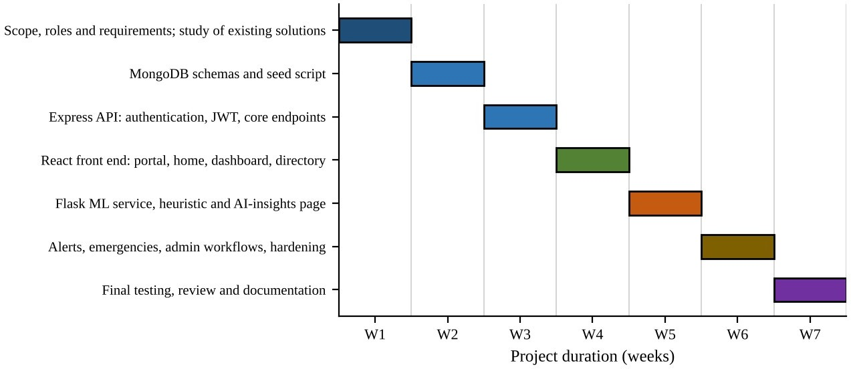
Figure 1.1 Gantt chart of the seven-week project timeline
Figure 1.1 presents the same seven-week plan as a Gantt chart. Each activity occupies one week, and the activities are sequenced so that the data model and the secured API exist before the user interface and the AI module depend on them. The week-by-week description is given below.
Week 1: Define project scope, objectives, and requirements. The first week lays the foundation: the problem is framed, the user roles are fixed, and the resource categories and alert thresholds are agreed. A clear statement that the prototype uses fictional data and is not for clinical use is recorded at this stage.
Week 2: Design the data model and seed data. Collections, relationships, and validation rules are designed, and a repeatable seed script is written so that every installation starts with the same demonstration dataset.
Week 3: Develop the secured backend. Registration, login, profile management, and JWT verification are implemented first, followed by the read and write endpoints for the main entities, each protected by authentication and, where necessary, by an administrator check.
Week 4: Build the front end. The portal, landing page, dashboard, hospital directory with filters, and hospital profile are created and connected to the API using axios.
Week 5: Develop the AI module. The Flask service and the scikit-learn model are developed, the Express prediction route is written with a fallback for an offline service, and the AI-insights page with adjustable demand and line charts is completed.

Week 6: Alerts, emergencies, and hardening. Alert and emergency workflows are added, administrator-only operations are enforced, rate limits and input checks are tightened, and the Postman collection is prepared.
Week 7: Final review. Integrated testing is performed, documentation is completed, feedback is gathered, and minor adjustments are made before the demonstration build is frozen.

Organization of the Report
The report is organised into five chapters, followed by the references, an appendix and a user manual. A brief description of what each part contains is given below.
    - Chapter 1 – Introduction. identifies the client, the need and the contemporary issue behind the project, states the problem, lists the tasks required to build and test the solution, and presents the project timeline.
    - Chapter 2 – Literature Review/Background Study. traces the timeline of the reported problem, reviews existing solutions and a bibliometric view of the field, summarises the review, defines the problem precisely, and states the goals and objectives.
    - Chapter 3 – Design Flow/Process. evaluates and selects the features, records the design constraints and standards, analyses the features against those constraints, compares alternative designs, justifies the design selection, and describes the implementation methodology.
    - Chapter 4 – Results Analysis and Validation. describes the implementation of the solution, including exploratory data analysis, model building, interface design and testing, and discusses the results obtained.
    - Chapter 5 – Conclusion and Future Work. summarises the outcome of the project, compares expected and obtained results, lists the known limitations, and suggests the way ahead.
    - References, Appendix and User Manual. list the sources consulted, provide the plagiarism report and design checklist, and give step-by-step instructions to run the project.

CHAPTER 2.
LITERATURE REVIEW/BACKGROUND STUDY

Timeline of the reported problem
The difficulty of finding available hospital capacity at the moment it is needed has been reported repeatedly in public health literature and news reporting, and it became most visible during sudden surges in demand. The milestones below summarise how the problem has been identified and addressed, based on publicly available sources.
    - 11 March 2020. The World Health Organization characterised COVID-19 as a pandemic [16]. Health systems around the world faced abrupt growth in demand for ICU beds, ventilators and medical oxygen, and the need for a real-time view of capacity became evident.
    - 2020–2021. Several state and municipal administrations in India published COVID-19 bed-availability dashboards and helplines. These depended on periodic reporting by hospitals, so the figures shown to the public were often delayed.
    - April–May 2021. During the second wave in India, widespread public and media reporting documented shortages of hospital beds, ICU capacity and oxygen, and described families searching social media and telephone directories to locate resources.
    - September 2021. The Government of India launched the Ayushman Bharat Digital Mission to build a digital health ecosystem with interoperable health data [17], reflecting the policy recognition that fragmented health information is a national problem.
    - August 2023. The Digital Personal Data Protection Act, 2023 was enacted [8], placing legal responsibilities on any system that processes personal data and strengthening the case for privacy-by-design in health applications.
    - Present. Seasonal diseases, accidents and local emergencies continue to create periodic pressure on hospital resources. The need for timely, accurate and role-controlled capacity information therefore persists beyond the pandemic period.
This timeline shows that the problem is neither new nor limited to one region: it recurs whenever demand rises faster than information can be shared. MediSync AI is positioned as a small, transparent prototype that addresses this information gap while respecting privacy and safety constraints.

Existing solutions
Existing approaches to hospital resource visibility, patient access, and demand forecasting can be grouped into the following categories. Each has strengths that informed the design of this project, and limitations that it tries to address.
- Hospital Information Systems (HIS/HMIS)
  - Description: Enterprise software that manages admissions, billing, clinical workflows, and internal bed management within a single hospital or hospital group.
  - Pros: Comprehensive, integrated with clinical records, authoritative for internal operations.
  - Cons: Typically closed, expensive, and focused on a single institution; rarely exposes a public, cross-hospital view of capacity.
- Government and Regional Bed-Availability Dashboards
  - Description: Web portals that publish aggregated bed, oxygen, or ventilator availability for a city or state, often introduced during public-health emergencies.
  - Pros: Provide a network-wide picture and public transparency.
  - Cons: Depend on manual or periodic updates by facilities, so data can be stale; usually lack forecasting, roles, and appointment workflows.
- Online Appointment and Doctor-Discovery Platforms
  - Description: Consumer platforms that list doctors and clinics and allow appointment booking.
  - Pros: User-friendly search and booking experience.
  - Cons: Focus on outpatient convenience, not on hospital resource capacity or emergency readiness.
- Electronic Health Record (EHR) Systems
  - Description: Systems that store longitudinal patient histories and support clinical documentation.
  - Pros: Rich clinical data; foundation for analytics.
  - Cons: Contain highly sensitive personal data, require strict compliance, and are not designed as public capacity dashboards.
- Rule-Based Threshold Alerts
  - Description: Systems that raise warnings when a resource falls below a fixed threshold (for example, ICU availability below a percentage).
  - Pros: Simple, transparent, easy to audit.
  - Cons: Reactive; do not anticipate how pressure will evolve.

- Statistical Time-Series Forecasting (e.g., ARIMA, exponential smoothing)
  - Description: Models that forecast admissions or occupancy from historical time series.
  - Pros: Interpretable, effective for stable seasonal patterns.
  - Cons: Require long, high-quality historical data; struggle with sudden regime changes.
- Machine-Learning Forecasting (Random Forests, gradient boosting, LSTM)
  - Description: Models that learn non-linear relationships between operational features and demand or occupancy.
  - Pros: Capture complex interactions; Random Forests are robust and need little tuning.
  - Cons: Need substantial real data and validation; risk of over-confident outputs if trained on unrepresentative data.
The approach taken by MediSync AI is to combine the capacity-dashboard idea (category 2), the doctor-discovery and appointment idea (category 3), the threshold-alert idea (category 5), and an ML-based risk signal (category 7) in one role-controlled platform, while keeping the first four elements transparent and rule-based and flagging the ML element as a synthetic demonstration.
Table 2.1 Comparison of existing solution categories with MediSync AI

Capability | HIS / HMIS | Public bed dashboards | Appointment platforms | MediSync AI
Cross-hospital resource view | No | Yes | No | Yes
Role-based editing of resources | Yes (internal) | Limited | No | Yes (admin only)
Doctor directory and requests | Partial | No | Yes | Yes
Threshold alerts | Partial | Rare | No | Yes
What-if capacity scenario | Rare | Rare | No | Yes (0–25%  demand)
ML risk signal | Rare | Rare | No | Yes (synthetic demo)
Open, low-cost stack | No | Varies | No | Yes

Bibliometric analysis
A bibliometric analysis of the field “Hospital Resource Management and Healthcare Demand Forecasting Using Machine Learning” investigates the scholarly output and impact of research in this domain. The following steps describe how such an analysis is carried out and the themes it reveals.
Identification of key publications. The first step is to compile influential papers published in reputable journals and conferences that address hospital capacity planning, bed and ICU demand forecasting, patient-flow modelling, and clinical decision support. Typical venues for this literature include the Journal of Medical Systems, BMC Medical Informatics and Decision

Making, Health Care Management Science, the Journal of the American Medical Informatics Association, and IEEE Access.
Authorship and venue analysis. Authorship analysis identifies prolific authors and research groups and shows collaboration patterns between hospitals, universities, and public-health agencies. Venue analysis assesses impact factors and citation metrics to determine which journals and conferences are most influential for the topic.
Citation and co-citation analysis. Citation analysis highlights highly cited papers and the networks that connect them. Co-citation analysis reveals intellectual clusters, for example one cluster around queueing and simulation models of patient flow, another around statistical time-series forecasting of admissions, and a third around machine-learning approaches such as Random Forests, gradient boosting, and recurrent networks.
Keyword and trend analysis. Recurring keywords in titles and abstracts, such as “bed occupancy,” “length of stay,” “emergency department crowding,” “forecasting,” “decision support,” and “interpretability,” show how the field has moved from purely statistical models toward machine learning, and more recently toward explainable and privacy-preserving methods. Publication counts typically rise after major public-health events, reflecting renewed interest in surge preparedness.
Geographical analysis. Examining the geographic distribution of contributions shows which countries lead the research and highlights the relative scarcity of studies and open datasets from low- and middle-income settings, which motivates locally relevant prototypes such as this one.
Gaps and challenges. Analysis of recent publications points to recurring challenges: limited availability of high-quality, shareable operational data; privacy and regulatory barriers; difficulty of integrating prediction tools into clinical workflows; and the need for transparent, interpretable models. These gaps directly shape the design principles of this project: use of synthetic data for demonstration, explicit labelling of model limits, role-based access control, and an interpretable heuristic that runs alongside the ML model.

Review Summary
The “MediSync AI” project is a timely and well-structured initiative aimed at improving visibility of hospital resources and access to care. With a client base that includes patients,

hospital administrators, and network coordinators, the project recognises the pressing need for a consolidated, role-controlled solution.
The identified problem of fragmented, stale resource information is analysed in terms of its impact on patient access, coordinator workload, and safety. The project’s focus on a unified data model, threshold-based alerts, transparent scenario analysis, and a cautious AI component reflects a strategic response to the multi-faceted challenge.
The review of existing solutions shows that hospital information systems, public dashboards, appointment platforms, and forecasting models each solve part of the problem but none combines cross-hospital visibility, role-based editing, alerts, and scenario-based risk signals in an open, low-cost stack. The delineation of tasks reveals a systematic approach covering research, database design, backend and frontend development, AI integration, testing, and documentation. Noteworthy is the emphasis on security and honest labelling of data and model limitations, which aligns with current discourse on trustworthy AI in healthcare.
The proposed seven-week timeline is concise and structured, with milestones for data modelling, API development, front-end construction, AI integration, administrator workflows, and final testing. In summary, the project stands as a promising prototype, strategically positioned to contribute to the broader discussion of connected, data-informed healthcare operations.
In summary, the literature review links directly to the project at hand: existing hospital systems are comprehensive but closed, public dashboards are open but stale, and machine-learning forecasting is promising but demands real data and validation. The review therefore supports building a role-controlled, transparent and clearly labelled prototype rather than claiming a production-ready predictive system.

Problem Definition
Hospitals, patients and network coordinators lack a single, role-controlled and up-to-date view of hospital resources, and they lack a transparent early-warning indication of capacity pressure. The problem to be solved in this project is to design, implement and evaluate a prototype that closes this gap without compromising security, privacy or honesty about what the model can predict.

What is to be done
    - Build a full-stack web application that centralises hospital profiles, doctors, resource inventories (eight categories), alerts, emergency records and appointment requests.
    - Provide role-based access so that patients can view and request, while only administrators can change resource counts, resolve alerts and manage emergencies.
    - Classify each facility as Available, Limited or Critical and present a transparent capacity-pressure score with a 12-hour demand scenario.
    - Integrate a Random Forest model as a secondary, clearly labelled risk signal and evaluate it against the heuristic.
How it is to be done
    - Use the MERN stack (MongoDB, Express.js, React.js, Node.js) for the application and a Python Flask microservice with scikit-learn for the model.
    - Secure the API with JWT authentication, bcrypt password hashing, input validation, rate limiting and server-side role checks.
    - Use fictional demonstration data and a seeded synthetic data set, and verify behaviour through scripted tests and a documented test plan.
What is not to be done
    - The prototype must not use or store real patient records or real hospital capacity data.
    - It must not be used for clinical decisions, triage or emergency dispatch.
    - It must not present synthetic-data accuracy figures as evidence of real-world predictive performance.

Goals/Objectives
The “MediSync AI” project encompasses a set of well-defined goals and objectives:
- Unified resource visibility: provide a single application in which hospital profiles and eight resource categories (general beds, ICU beds, ventilators, oxygen, ambulances, blood, PPE, and medicines) are stored, searched, and displayed with availability indicators.
- Secure, role-based access: implement registration, login, and JWT-based sessions with separate patient and administrator roles, ensuring that only administrators can change resource counts, resolve alerts, and manage emergencies.
- Patient-facing services: offer a doctor directory linked to hospitals and an appointment-request workflow that stores a brief, non-sensitive request in the database without implying a confirmed booking.

- Early-warning alerts: classify each facility as Available, Limited, or Critical using ICU availability thresholds (≤ 12% Critical, ≤ 25% Limited) and surface active alerts and recent emergencies on the dashboard.
- Transparent capacity-pressure analysis: compute a per-resource pressure score and a 12-hour what-if projection controlled by an adjustable demand-increase assumption (0–25%).
- Machine-learning integration: develop and integrate a Random Forest regression service that returns a 0–100 risk score, and report its evaluation metrics honestly as applying to synthetic data only.
- Resilience and responsible use: ensure the platform keeps working when the ML service is offline, validates all inputs, labels all data as fictional, and discourages entry of sensitive health information.
- Maintainability and reproducibility: provide a repeatable seed script, environment-based configuration, a one-command launcher, and a Postman collection to support testing and future extension.
Collectively, these goals position the project as a comprehensive and adaptive prototype addressing contemporary challenges in hospital resource visibility and decision support.

CHAPTER 3.
DESIGN FLOW/PROCESS

Evaluation & Selection of Specifications/Features
Developing a hospital resource-visibility platform requires a systematic evaluation of the features that users need, of the technologies that can deliver them, and of the data features that the prediction module will consume. The evaluation started with a clear definition of the problem: users must be able to find a facility and see its capacity, administrators must be able to maintain that information, and the system must provide an early indication of resource pressure.
Functional features
Table 3.1 Functional features and primary users

Feature | Description | Primary user
Registration and sign-in | Patient self-registration; administrator accounts are provisioned by a command-line script; JWT session in the browser tab. | Patient, Admin
Hospital directory | Search by name, city, state, or specialty; filter by city, type, and status (Available/Limited/Critical). | Patient, Admin
Hospital profile | Facility details, specialties, doctors, and inventory of eight resource categories. | Patient, Admin
Resource update | Edit total and available counts for all eight resources with validation (0 ≤ available ≤ total). | Admin
Doctor directory | Specialist profiles linked to hospitals with credentials, experience, rating, and availability. | Patient
Appointment request | Stores name, phone, city, brief reason (≤ 240 characters), specialty, and preferred date (not in the past). | Patient
Dashboard | Network totals, active alerts, recent emergencies, bed-capacity chart, and hospital cards. | Patient, Admin
Alerts | Active/resolved alerts filtered by severity, hospital, or city; administrators can resolve alerts. | Admin
Emergencies | Fictional incident records with required resources and status workflow (pending → hospital-assigned → response-in-progress → resolved). | Admin
AI insights | Capacity-pressure heuristic, 12-hour scenario chart, and synthetic ML risk score for a selected hospital. | Patient, Admin
Patient list | Paginated, searchable list of patient accounts without password hashes. | Admin

Technology selection
Table 3.2 Technology stack and rationale

Layer | Technology | Rationale
Front end | React with Vite, React Router, Bootstrap 5, Recharts, lucide-react, axios | Component-based UI, fast development server, rich charting, and a familiar HTTP client.
Back end | Node.js, Express 4, Mongoose 8 | Lightweight REST API with a mature middleware ecosystem and schema validation.
Database | MongoDB | Flexible documents suit nested resource inventories ({total, available} per resource) and rapid iteration.
Security | jsonwebtoken, bcryptjs (cost 12), helmet, cors, express-rate-limit | Stateless authentication, salted password hashing, secure HTTP headers, origin allow-list, and  brute-force protection.
AI service | Python, Flask, NumPy, scikit-learn (RandomForestRegressor) | Simple HTTP microservice; Random Forest is robust, non-linear, and needs little tuning.
Tooling | Postman, PowerShell launcher, nodemon, dotenv | API verification, one-command start-up with health checks, and environment-based configuration.

Data features for the prediction module
The machine-learning model uses five numeric input features: the availability ratio (available ÷ total) of ICU beds, general beds, oxygen units, and ventilators, and the assumed demand increase expressed as a fraction (0–0.25). The output is a single continuous risk score between 0 and 100, which the service converts into a level (High ≥ 75, Moderate ≥ 50, otherwise Low). Only four of the eight tracked resources are used by the ML model; the heuristic scenario uses five (general beds, ICU beds, oxygen, ventilators, and blood units). Features such as patient identity or free-text reasons are deliberately excluded to protect privacy and avoid bias.
Throughout the evaluation, the balance between interpretability and sophistication remained central. A heuristic that a coordinator can verify by hand, paired with a more flexible model, gives both transparency and an opportunity to demonstrate AI integration. Ethical considerations (fairness, privacy, and honest reporting of accuracy) were applied at every stage and are documented in the following sections.

Design Constraints
    - Standards:
The design was guided by the standards listed in the List of Standards at the beginning of this report (JWT, HTTP, JSON, ECMAScript and the OWASP Top 10) and by the regulations, economic, environmental, health, safety, professional, ethical, social and political considerations summarised below.
Regulations. Real deployment would be subject to India’s Digital Personal Data Protection Act, 2023 and to health-sector rules on patient data. The prototype avoids these obligations by using only fictional data and by never returning password hashes.
Economic and cost. All technologies (React, Node.js, Express, MongoDB, Flask and scikit-learn) are open source and run on a single ordinary computer, so the solution carries no licence cost and can be reproduced at negligible expense.
Environmental. The system is lightweight: the Random Forest has 64 trees and trains in seconds, so energy use is small, and no specialised hardware is required.
Health and safety. Wrong capacity information can affect decisions about care. The platform therefore labels every figure as demonstration data, is not a clinical or dispatch tool, and keeps the interpretable heuristic as the primary signal.
Manufacturability / reproducibility. The seed script, one-command launcher and README files allow the whole system to be rebuilt and started consistently on another machine.
Professional and ethical. The project is transparent about its limits, does not claim real-world accuracy for a model trained on synthetic data, and excludes patient identity and free-text medical details to protect privacy and avoid bias.
Social and political. The system is intended to improve equitable access to information about hospital capacity for patients, caregivers and public-health coordinators; it must not be used to rank or exclude patients, and any future use with real data would need institutional and regulatory approval.

    - Project-specific design constraints
Designing a hospital-resource platform with an AI component involves several constraints that profoundly influence its architecture and functionality.
Data availability and privacy. Real hospital capacity data and patient records are confidential and not available for an academic prototype. The system therefore uses fictional hospitals, doctors, and incidents (patient identifiers must begin with DEMO-), stores only brief non-sensitive appointment information, and never returns password hashes. Compliance with data-protection regulations, such as India’s Digital Personal Data Protection Act, 2023, would be mandatory before any real deployment.
Absence of real training data. Because no historical admissions or occupancy data were available, the ML model can only be trained on generated data. This constrains the claims that can be made: the model demonstrates integration and workflow, not clinical predictive power.
Security constraints. The application handles credentials and role-restricted operations, requiring password hashing, token-based authentication, server-side authorization, request-rate limiting, input validation, restricted CORS, and secure HTTP headers.
Real-time and latency constraints. The prediction page recalculates as the user moves the demand slider. The front end therefore debounces requests (180 ms), the client timeout is 3.5 seconds, and the API allows the ML service only 1.8 seconds before falling back to the heuristic.
Computational and deployment constraints. The system must run on a single developer machine with free tools. The ML model is small (64 trees, depth 9) so that it trains in about two seconds at service start-up and answers requests in a few milliseconds.
Ethical and safety constraints. The platform must not be used for clinical decisions, dispatch, or real bookings. Every page that shows sample data carries a notice, and API responses include a data-classification field and a clinicalUse flag set to false.
Integration and compatibility constraints. The front end, API, and ML service communicate over HTTP/JSON and must tolerate the absence of the optional ML service. Browsers on desktop and mobile must be supported through a responsive layout.
Budgetary constraints. All technologies are open source and run locally, keeping the project within a student budget.

Analysis of Features and finalization subject to constraints
Features were analysed against the constraints above, and the final feature set was fixed according to the decisions summarised in Table 3.3.
Table 3.3 Feature analysis and finalization subject to constraints

Feature / concern | Constraint considered | Final decision
Account roles | Privilege escalation risk | Registration creates patients only; the role field is immutable in the schema; administrators are created by a CLI script; the built-in demo admin is disabled unless DEMO_AUTH=true.
Passwords | Credential theft | Length 8–128 characters; bcrypt with cost factor 12; hash excluded from queries by default.
Sessions | Token exposure | JWT valid for 8 hours (configurable); stored in sessionStorage so it is cleared when the tab closes; legacy localStorage keys removed on start-up.
Resource editing | Data integrity | Admin-only; every one of eight resources must be present; counts must be finite, non-negative, and available ≤ total.
Appointment text | Privacy of health information | Short reason (3–240 characters) with an on-screen warning not to enter medical records; date must not be in the past; doctor must belong to the chosen hospital.
Emergencies | Real patient data risk | Patient identifier must match DEMO-[A-Z0-9-]+; only administrators may create or update records.
Abuse / DoS | Availability | Global limit of 120 API requests per minute; 10 login/registration attempts per 15 minutes; JSON body limited to 100 KB; ML payload limited to 16 KB.
Search filters | Injection | User input is escaped before being used in regular expressions; ObjectIds are validated before queries on most routes.
ML model | No real data | Train on synthetic data only; label output “synthetic-demo”; return metrics with an explicit description; clinicalUse = false.
ML availability | Optional dependency | If the Flask service is unreachable, the API returns the heuristic result and mlModel.available = false.
Production start-up | Weak secrets | In production mode, the server refuses to start unless JWT_SECRET is private and at least 32 characters.

The analysis also confirmed that an interpretable heuristic must remain the primary indicator, since it can be verified manually, while the ML score is presented as a secondary, clearly labelled signal.

Design Flow
Two alternative designs were considered for the system. Both satisfy the functional requirements, but they differ in how the prediction capability is organised and in how failures are handled.
Alternative Design 1 – Monolithic MERN application. In this design the React front end calls a single Express/Node.js application that performs all processing: authentication, database access, the capacity-pressure heuristic and a simple rule-based or statistical risk estimate coded in JavaScript. There is only one back-end process to run, which keeps deployment simple. However, JavaScript offers fewer mature machine-learning libraries, model code and API code are tightly coupled, and a defect in the prediction code could disturb the whole API.
Alternative Design 2 – Three-service architecture (React, Express, Flask). Here the React front end talks only to the Express API, the API is the only component that accesses MongoDB, and a separate Python Flask microservice hosts the scikit-learn Random Forest. The Express API computes the interpretable heuristic itself and calls the Flask service for the secondary ML signal. This design isolates the Python machine-learning stack, allows the model to be replaced independently, and lets the system keep working when the ML service is stopped, at the cost of running three processes.
Design 2 was selected after the comparison given in Section 3.5. The remainder of this section describes the selected design: its process flow, architecture, data model, REST API and prediction workflow.
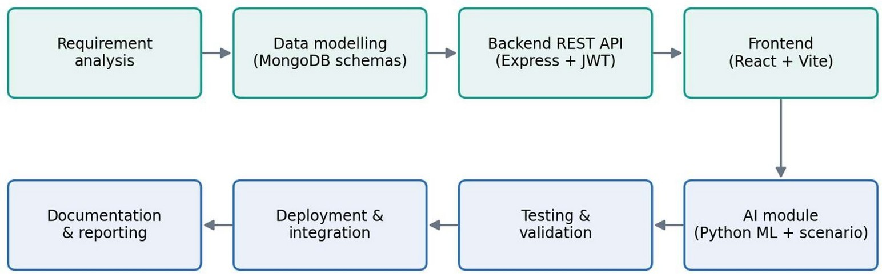
Figure 3.1 Flow Chart of Project
The project follows the sequence shown in Figure 3.1: requirement analysis, data modelling, backend API construction, front-end development, AI-module integration, testing and validation,

deployment and integration, and finally documentation and reporting. Monitoring and maintenance continue after deployment through health-check endpoints.
System architecture
The system uses a three-service, four-tier architecture, illustrated in Figure 3.2. The browser communicates only with the Express API; the API is the only component that talks to MongoDB, and it calls the Flask service on behalf of the user.
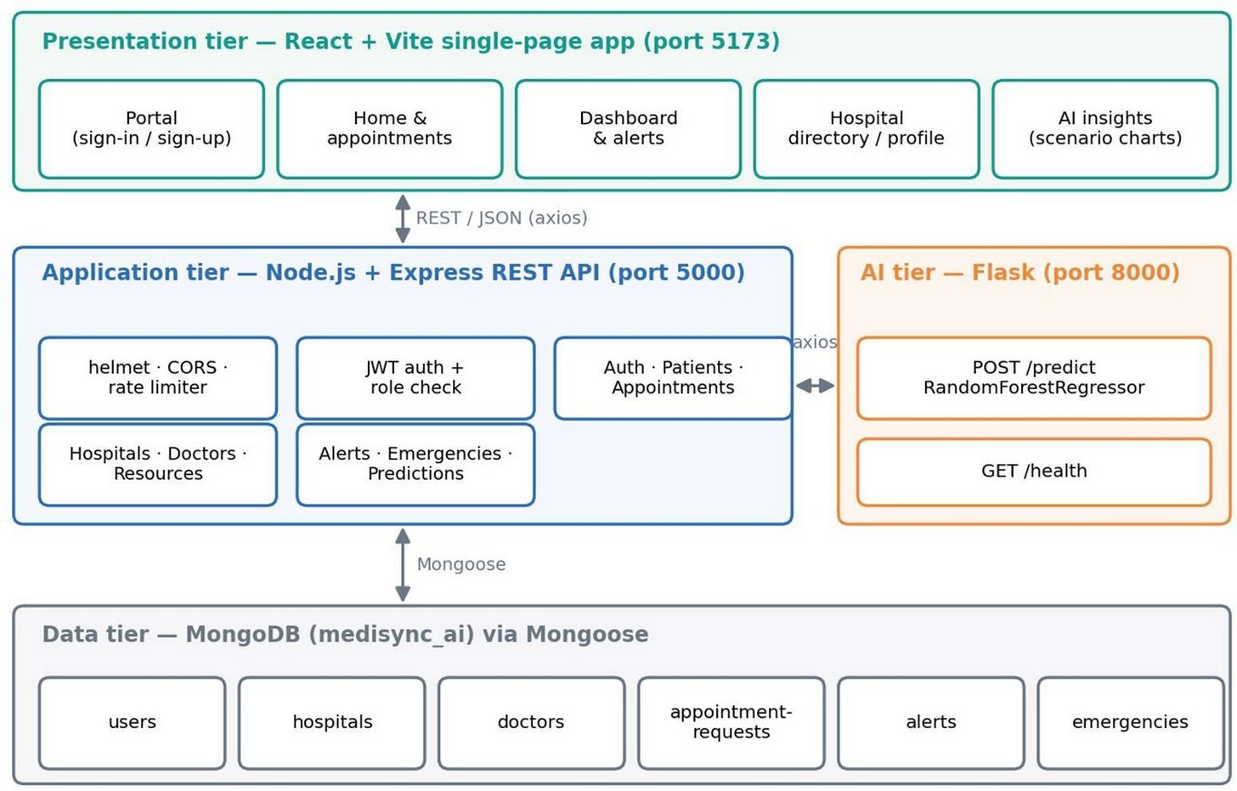
Figure 3.2 System architecture of MediSync AI
Data model
Figure 3.3 shows the six MongoDB collections and their relationships. Doctors, alerts, and emergencies refer to hospitals through hospitalId; appointment requests may refer to a user, a hospital, and a doctor. Each hospital stores its eight resource categories as nested {total, available} pairs.

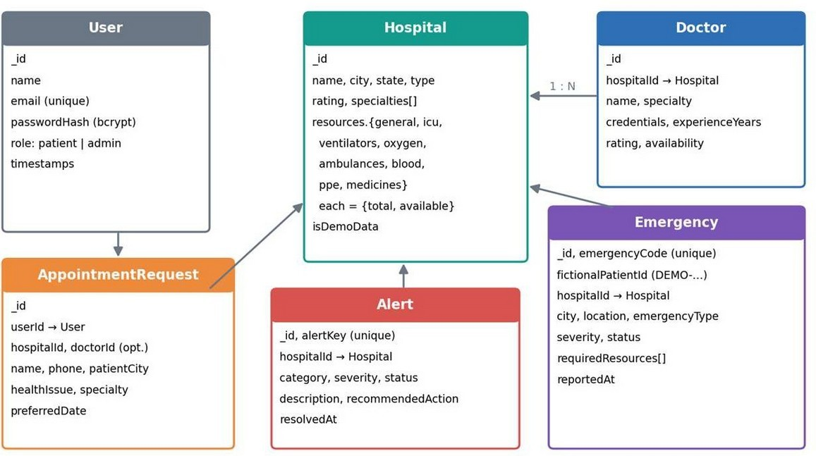

REST API design
Figure 3.3 Data model (MongoDB collections)

Table 3.4 Summary of REST API endpoints

Method | Endpoint | Access | Purpose
GET | /api/health | Public | Service and database health
POST | /api/auth/register | Public (rate-limited) | Create a patient account and return a JWT
POST | /api/auth/login | Public (rate-limited) | Authenticate and return a JWT
GET / PATCH | /api/auth/me | Signed-in | Read or update own name and email
GET | /api/patients | Admin | Paginated, searchable patient list
POST | /api/appointments | Signed-in | Create an appointment request
GET | /api/hospitals, /api/hospitals/:id | Signed-in | List (q, city, type, status filters) or read a hospital
PATCH | /api/hospitals/:id/resources | Admin | Update the eight resource counts
GET | /api/doctors | Signed-in | List doctors by hospital, specialty, or text
GET | /api/summary,  /api/resources/summary | Signed-in | Network totals and critical-facility count
GET | /api/alerts | Signed-in | Paginated alerts (severity, status, hospital, city)
PATCH | /api/alerts/:id/resolve | Admin | Resolve an alert
GET | /api/emergencies,  /api/emergencies/:id | Signed-in | List/filter or read emergency records
POST / PATCH | /api/emergencies,  /api/emergencies/:id/status | Admin | Create a fictional emergency or change its status
GET | /api/predictions/:id | Signed-in | Heuristic risk, scenario series, and ML signal

Prediction workflow
When the user opens the AI-insights page, the browser requests /api/predictions/:id with the chosen demand-increase percentage. The API reads the hospital from MongoDB, computes the

heuristic metrics and the scenario series, calls the Flask /predict endpoint, and returns all results together (Figure 3.4).
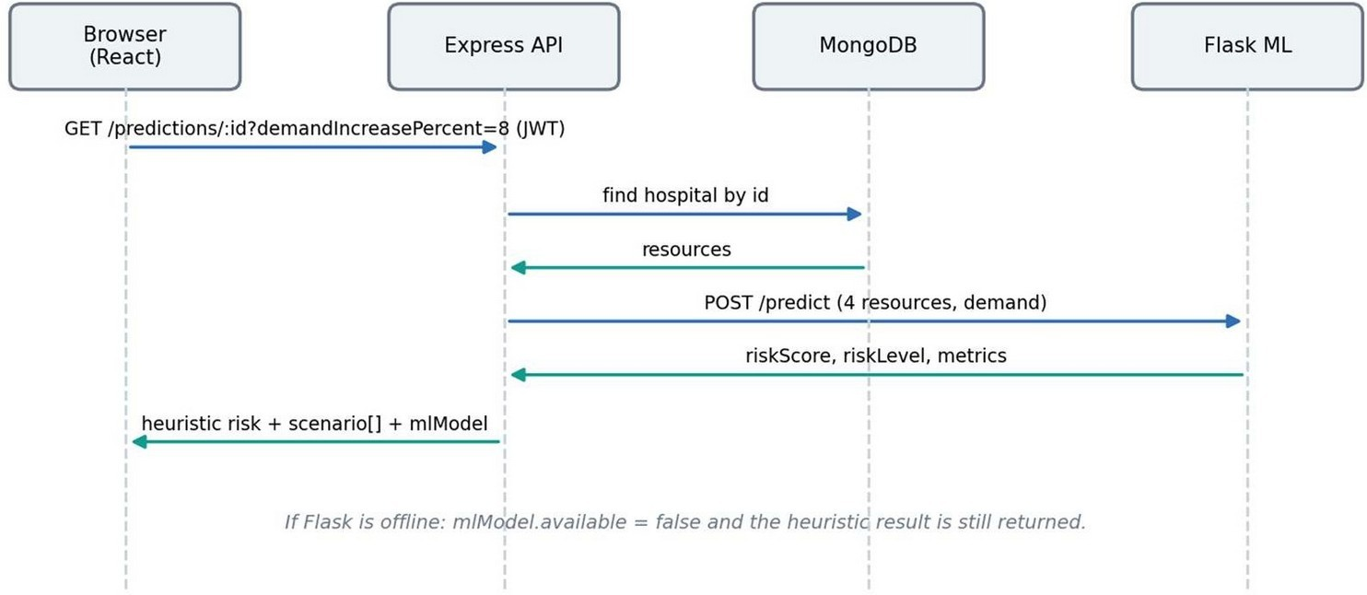
Figure 3.4 Sequence of a prediction request
The machine-learning pipeline inside the Flask service is shown in Figure 3.5: synthetic data are generated with a fixed random seed, split 80/20, used to train the Random Forest, evaluated on the held-out portion, and then served through the /predict endpoint.
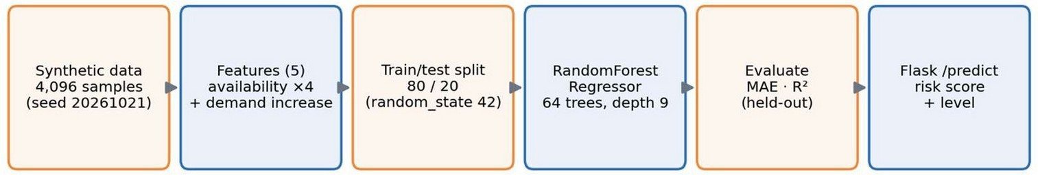
Figure 3.5 Machine-learning pipeline in the Flask service

Design selection
Several design alternatives were considered, and the final choices reflect the constraints discussed above.
Table 3.5 Design alternatives and selection

Design question | Alternatives | Selected and why
Overall architecture | Single monolith vs. separate services | Three services (React, Express, Flask): the Python ML stack stays isolated from the Node API, and the system keeps working if the ML service is stopped.
Database | Relational (SQL) vs. document (MongoDB) | MongoDB: nested resource inventories map naturally to documents; schema validation is provided by Mongoose.
Authentication | Server sessions vs. JWT | JWT: stateless and simple for a single-page application; role carried in the token and re-checked in route handlers.

Design question | Alternatives | Selected and why
Token storage | localStorage vs. sessionStorage | sessionStorage: limits persistence to the browser tab; legacy localStorage entries are deleted.
Risk indicator | ML only vs. heuristic only vs. both | Both: the interpretable heuristic is the primary signal; the ML score is secondary and clearly labelled as synthetic.
ML algorithm | Linear regression, Gradient Boosting, Random Forest, neural network | Random Forest Regressor: robust to non-linearity, minimal tuning, quick to train, and provides feature importances for explanation.
Failure handling | Fail whole request vs. degrade | Graceful degradation: connection errors from the ML service produce mlModel.available = false while the rest of the response is returned.
UI framework | Server-rendered pages vs. SPA | React SPA with client-side routing and protected routes for a dashboard-style experience.

Table 3.6 Comparison of the two candidate designs

Criterion | Design 1: Monolithic MERN | Design 2: Three-service (selected)
Separation of concerns | Model and API code share one runtime | Python ML stack isolated in its own service
Failure isolation | A fault in prediction code can affect the API | API degrades gracefully (mlModel.available = false)
Machine-learning ecosystem | Limited JavaScript libraries | scikit-learn, NumPy and mature Python tooling
Interpretability | Heuristic only | Heuristic as primary signal plus labelled ML signal
Deployment effort | One back-end process | Three processes, handled by the one-command launcher
Extensibility | Changing the model means changing the API | Model can be retrained or replaced independently
Overall decision | Not selected | Selected

Design 2 scores better on isolation, tooling and extensibility, which matter most for an AI-enabled system whose model may change. Its only disadvantage, the extra deployment effort, is removed by the PowerShell launcher and the health checks. The comparison therefore supports selecting the three-service architecture.

Implementation plan/methodology
- Project Kickoff and Planning
  - Define objectives, user roles, and constraints; decide that all data will be fictional.

  - Allocate responsibilities among team members for front end, back end, and AI/ML.
  - Set up the development environment: Node.js, MongoDB, Python virtual environment, Git, and Postman.
- Data Modelling and Seeding
  - Create Mongoose schemas for User, Hospital, Doctor, AppointmentRequest, Alert, and Emergency with validation rules and indexes (for example, a unique email, and a unique
{hospitalId, name} pair for doctors).
  - Write seed.js to insert 12 fictional hospitals across six cities (New Delhi, Chandigarh, Ludhiana, Jaipur, Amritsar, Gurugram), 24 doctors, six alerts, and six emergencies using idempotent upserts. Blood, PPE, and medicine counts are derived from bed totals.
- Backend Development
  - Implement the auth middleware that verifies the bearer token and attaches the user to the request.
  - Implement route modules and validation for every endpoint listed in Table 3.4; return consistent JSON responses with success and message fields.
  - Add Helmet, CORS allow-list, JSON size limit, global and authentication-specific rate limits, and a central error handler that converts validation and duplicate-key errors into clean responses.
- Capacity-Pressure Heuristic
For each tracked resource r with total T and available A, the availability ratio is a = A / T (0 when T = 0), and the pressure score is P = round((1 − a) × 100). The overall risk score reported by the API is the ICU pressure, with the level High if ≥ 75, Moderate if ≥ 50, and Low otherwise. For the scenario, if the assumed demand increase is d percent over 12 hours, the
projected availability at hour h ∈ {0, 3, 6, 9, 12} is max(0, A − round(T × d/100 × h/12)). The
facility status used in the directory is derived from the ICU ratio: Critical if ≤ 0.12, Limited if ≤ 0.25, otherwise Available.
- AI Service Development
  - Generate 4,096 synthetic samples with a fixed seed: four availability ratios drawn uniformly from 0.02–1.0 and a demand increase from 0–0.25.
  - Define the synthetic target as a weighted pressure: 100 × [0.55(1 − a_ICU) + 0.15(1 − a_general) + 0.15(1 − a_oxygen) + 0.10(1 − a_ventilators) + 0.05 × demand], clipped to 0–100.

  - Train a RandomForestRegressor (64 trees, maximum depth 9, minimum leaf size 3, random_state 42) on 80% of the data and evaluate on the remaining 20% using mean absolute error and RZ.
  - Expose POST /predict (with strict input validation) and GET /health; limit payload size to 16 KB.
- Frontend Development
  - Create the React application with protected routes (/, /dashboard/*), the sign-in portal, and an authentication context that verifies the stored token against /api/auth/me.
  - Build the dashboard, hospital directory and profile, emergencies, AI-insights (with a demand slider and line chart), and profile pages.
- Testing and Validation
  - Verify validation rules, authorization, and error handling with Postman and manual UI tests; verify ML-service input validation and performance with scripted requests.
- Deployment, Monitoring and Documentation
  - Provide Start-MediSync.ps1, which checks the health of the API (port 5000, database connected), the ML service (port 8000, mode synthetic-demo), and the client (port 5173), reuses services that are already running, and opens each in its own window.
  - Maintain README and Postman documentation, and prepare this report summarising design, methodology, and findings.
Algorithm for processing a prediction request
Input: hospital identifier id, demand increase d (0–25 %)
    - Verify the JWT; reject the request with 401 if it is missing or invalid.
    - Validate the ObjectId and load the hospital from MongoDB.
    - For every tracked resource r: a ← A_r / T_r (0 if T_r = 0); P_r ← round((1 − a) × 100).
    - Set status: Critical if a_ICU ≤ 0.12; Limited if a_ICU ≤ 0.25; otherwise Available.
    - For h in {0, 3, 6, 9, 12}: A_r(h) ← max(0, A_r − round(T_r × d/100 × h/12)).
    - Build the ML payload (four availability ratios and d) and POST it to /predict.
    - If the Flask service responds, attach the risk score and level; otherwise set mlModel.available = false.
    - Return the heuristic metrics, the scenario series and the ML result in one response.

The flow of this algorithm corresponds to the process flow chart in Figure 3.1, the architecture in Figure 3.2, the sequence in Figure 3.4 and the machine-learning pipeline in Figure 3.5.

CHAPTER 4.
RESULTS ANALYSIS AND VALIDATION

Implementation of solution
The solution was implemented with modern, open-source tools used consistently across the analysis, design, reporting, project-management and testing activities of the project:
- Analysis. Python with scikit-learn for model training and evaluation, a transparent heuristic implemented in the Express API, and Recharts for plotting resource and scenario charts in the interface.
- Design drawings and schematics. The process flow chart, system architecture, MongoDB data model, prediction sequence diagram and machine-learning pipeline (Figures 3.1 to 3.5) were drawn before development and used as the implementation reference.
- Report preparation. Microsoft Word was used for this report, with figures, tables and captions numbered by chapter.
- Project management and communication. A seven-week plan with weekly milestones (Table 1.1 and Figure 1.1), README files for setup instructions and a Postman collection with its environment for communicating the API behaviour.
- Testing, characterization and data validation. Scripted checks with the Flask test client, a documented test plan for the API and interface, and a held-out synthetic test set for evaluating the model (Section 4.1.4).
    - Exploratory data analysis of the dataset
The demonstration dataset shipped with the prototype contains 12 fictional hospitals in six cities, 24 doctors (two per hospital), six alerts (five active and one resolved), and six emergency records. Each hospital stores totals and available units for eight resource categories. All records are flagged isDemoData = true and must not be interpreted as real capacity.
Table 4.1 Sample hospital resources (available / total)

Hospital | City | General beds | ICU beds | ICU avail.  % | Status
Northstar Medical Center | New Delhi | 58 / 240 | 9 / 48 | 18.8% | Limited
Riverbend Institute of Health | Chandigarh | 31 / 180 | 4 / 36 | 11.1% | Critical
Greenway Community Hospital | Ludhiana | 46 / 120 | 8 / 20 | 40.0% | Available
Sunrise Advanced Care | Jaipur | 17 / 150 | 3 / 30 | 10.0% | Critical
Lakeside Multispeciality | Amritsar | 72 / 200 | 12 / 28 | 42.9% | Available
MetroCare Hospital | Gurugram | 29 / 160 | 7 / 32 | 21.9% | Limited

Hospital | City | General beds | ICU beds | ICU avail.  % | Status
Aster Grove Medical Centre | New Delhi | 52 / 220 | 11 / 42 | 26.2% | Available
Harborview Specialist Hospital | Chandigarh | 37 / 190 | 8 / 38 | 21.1% | Limited
Cedarfield Regional Hospital | Ludhiana | 43 / 170 | 9 / 34 | 26.5% | Available
Meadowlands Medical Institute | Jaipur | 61 / 210 | 13 / 40 | 32.5% | Available
Silverline Emergency and Trauma Centre | Amritsar | 24 / 145 | 5 / 29 | 17.2% | Limited
Pinecrest Women and Children Hospital | Gurugram | 39 / 130 | 8 / 24 | 33.3% | Available

Network totals. Across the 12 facilities, 509 of 2,115 general beds (24.1%), 97 of 401 ICU beds
(24.2%), 70 of 265 ventilators (26.4%), 223 of 719 oxygen units (31.0%), and 43 of 111 ambulances (38.7%) are available. Figure 4.1 compares totals and available units.
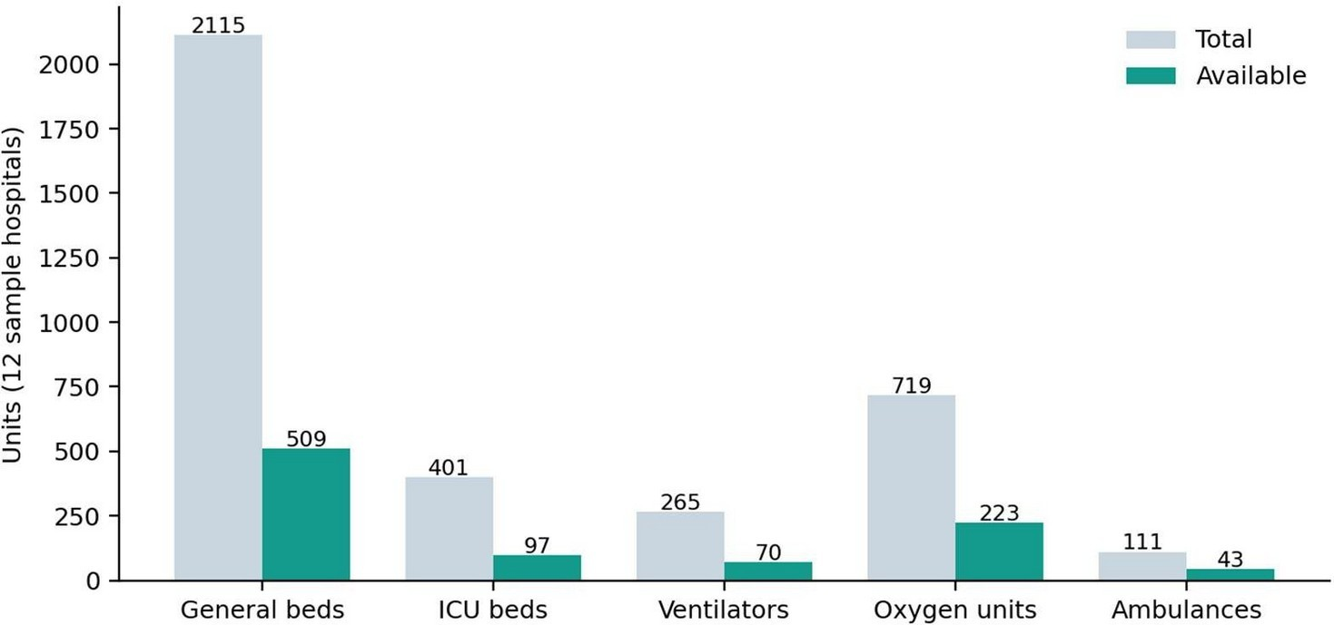
Figure 4.1 Network-wide totals and available units by resource
ICU availability and status. Figure 4.2 ranks the facilities by the percentage of free ICU beds and shows the 12% (Critical) and 25% (Limited) thresholds. Sunrise Advanced Care (3 of 30, 10.0%) and Riverbend Institute of Health (4 of 36, 11.1%) fall below the Critical threshold, whereas Lakeside Multispeciality (12 of 28, 42.9%) has the most headroom.

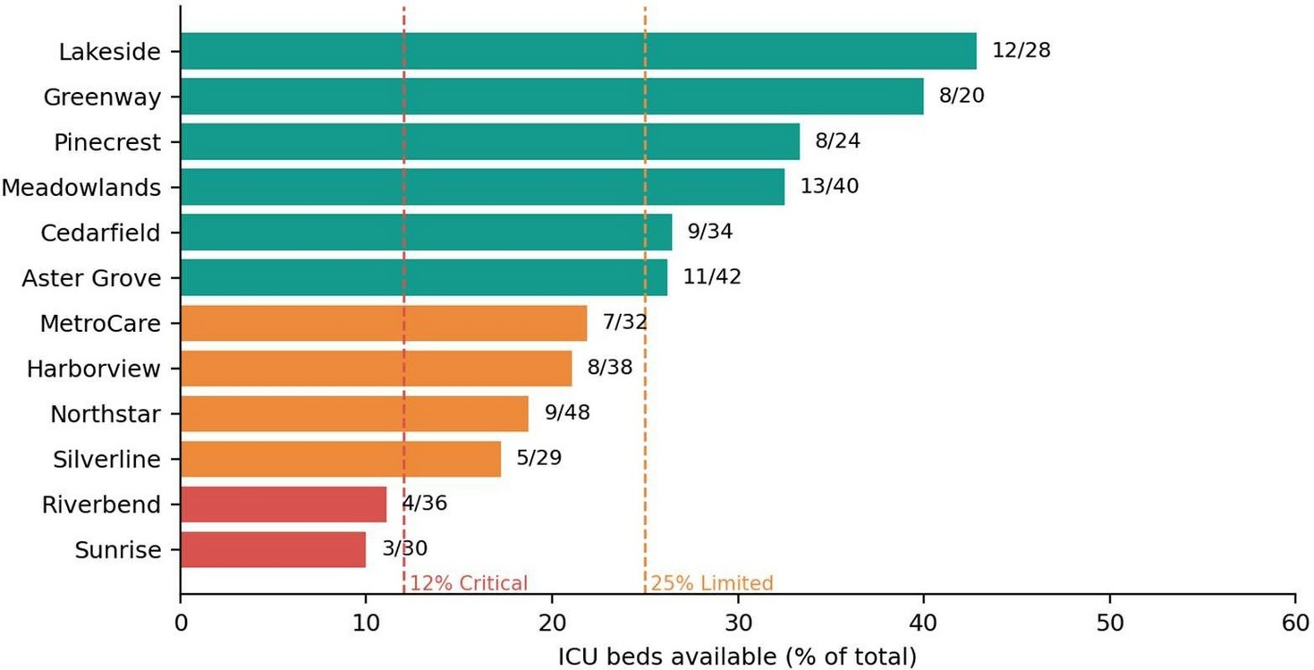
Figure 4.2 ICU bed availability by hospital with status thresholds
Figure 4.3 shows the distribution of facility status: six facilities (50.0%) are Available, four (33.3%) are Limited, and two (16.7%) are Critical. The five active alerts in the sample data (two critical ICU shortages, two high-severity alerts, and one medium-severity oxygen warning) are consistent with these low-availability facilities.
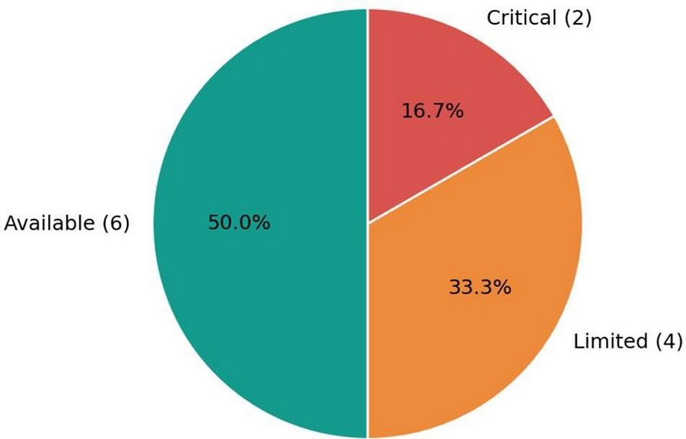
Figure 4.3 Distribution of facility status (ICU thresholds)

    - Model building
The prediction module has two components, which are described below and evaluated together.
- Transparent capacity-pressure heuristic
The heuristic described in Section 3.6 is evaluated for every facility. For example, Northstar Medical Center has 9 of 48 ICU beds free (18.8% available), so its ICU pressure is round(81.25)
= 81%, which is High. Figure 4.4 shows how the projected availability of its resources declines over 12 hours under demand-increase assumptions of 8% and 25%.

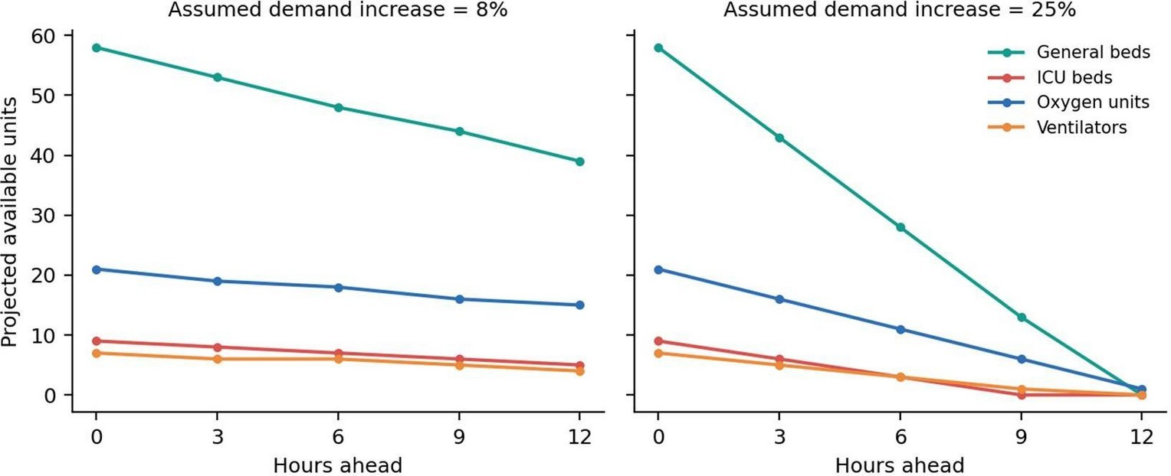
Figure 4.4 Projected availability for Northstar Medical Center under 8% and 25% demand increase
- Synthetic Random Forest model
The Flask service trains a RandomForestRegressor on 4,096 generated records (3,276 for training and 820 for testing). It has 64 trees, a maximum depth of 9, and a minimum leaf size of
3. Training takes about 1.8 seconds at service start-up in the development environment, and the model reproduces the held-out synthetic target with the results shown in Table 4.2.
Table 4.2 Evaluation of the synthetic Random Forest model

Metric | Value | Interpretation
Mean absolute error (held-out synthetic data) | 1.393 points | Average deviation on the 0–100 risk scale
RZ (held-out synthetic data) | 0.990 | Share of variance in the synthetic target explained
Median prediction latency (in-process) | ≈ 5.2 ms | 300 repeated /predict calls; 95th percentile ≈  8.0 ms
Training time at start-up | ≈ 1.8 s | Model is rebuilt each time the service starts

Important interpretation. The high RZ arises because the model is trained to reproduce a deterministic formula that is itself a function of the same features. The result therefore confirms that the integration works and that the model has learnt the synthetic rule, but it says nothing about how well the model would forecast real hospital demand. This limitation is stated in the API response (metricsDescription) and in the user interface.

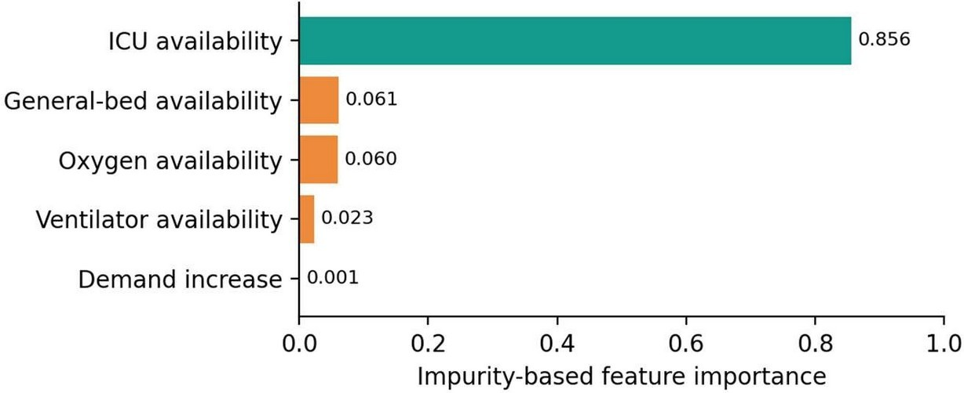
Figure 4.5 Feature importances of the Random Forest model
As Figure 4.5 shows, ICU availability accounts for about 85.6% of the importance, followed by general-bed (6.1%) and oxygen availability (6.0%), ventilators (2.3%), and the demand increase (0.1%). The demand feature contributes at most about 1.25 points to the synthetic score (0.05 × 0.25 × 100), so changing the demand slider barely changes the ML score. This is a known property of the demonstration model; the demand-sensitive information is provided by the heuristic scenario chart instead.
- Comparison of the two signals
Table 4.3 and Figure 4.6 compare the heuristic ICU pressure with the ML risk score for each facility at the default 8% demand increase. The two signals are strongly correlated (Pearson r = 0.989), and the ML score is on average 4.6 points lower than the heuristic because it spreads weight over four resources rather than relying on ICU alone. The two signals place 10 of the 12 facilities in the same level (High or Moderate); the only differences are MetroCare Hospital (heuristic 78%, ML 74%) and Harborview Specialist Hospital (heuristic 79%, ML 74%), where the heuristic is just above the 75% High threshold and the ML score is just below it. Such borderline cases illustrate why both signals are displayed side by side rather than merged into one number.
Table 4.3 Heuristic ICU pressure vs. synthetic ML risk score (8% demand increase)

Hospital | ICU pressure (heuristic) | Level (heuristic) | ML risk score | Level (ML)
Northstar Medical Center | 81% | High | 75% | High
Riverbend Institute of Health | 89% | High | 80% | High
Greenway Community Hospital | 60% | Moderate | 59% | Moderate
Sunrise Advanced Care | 90% | High | 81% | High
Lakeside Multispeciality | 57% | Moderate | 55% | Moderate
MetroCare Hospital | 78% | High | 74% | Moderate
Aster Grove Medical Centre | 74% | Moderate | 72% | Moderate

Hospital | ICU pressure (heuristic) | Level (heuristic) | ML risk score | Level (ML)
Harborview Specialist Hospital | 79% | High | 74% | Moderate
Cedarfield Regional Hospital | 74% | Moderate | 71% | Moderate
Meadowlands Medical Institute | 68% | Moderate | 64% | Moderate
Silverline Emergency and Trauma Centre | 83% | High | 76% | High
Pinecrest Women and Children Hospital | 67% | Moderate | 64% | Moderate
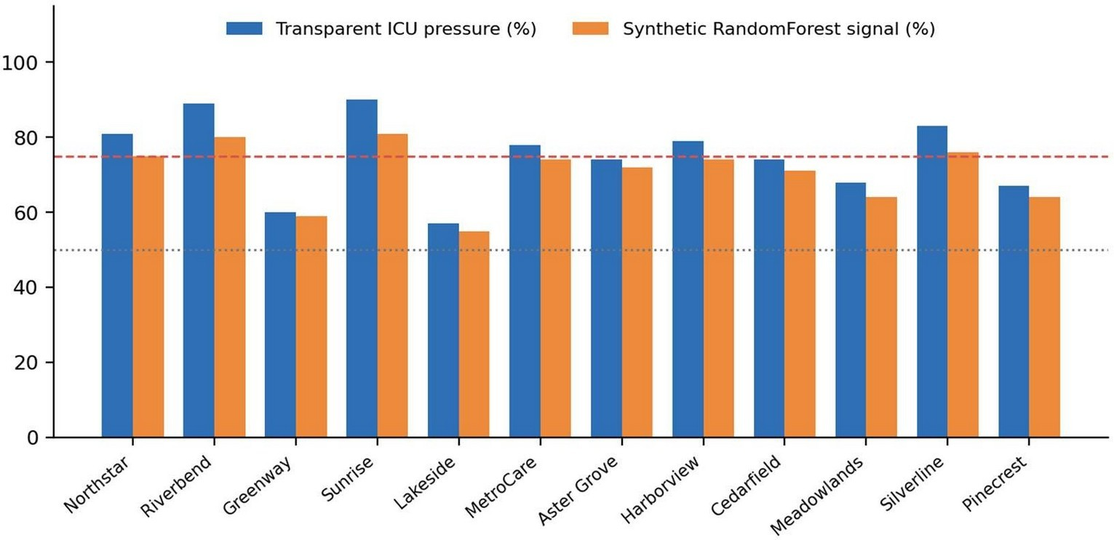
Figure 4.6 Heuristic ICU pressure and ML risk score for each sample hospital (dashed line: High threshold, 75; dotted line: Moderate threshold, 50)
    - Interface designing
The user interface is a React single-page application served on port 5173. Access to every page except the sign-in portal requires authentication; unauthenticated visitors are redirected to /portal and returned to their intended page after signing in. The main pages are described below.
Portal (sign-in / sign-up). A two-tab form (“Patient sign in” and “Hospital admin”) with a registration option for patients. Registration asks for name, email, password, and confirmation (minimum 8 characters). The administrator tab rejects accounts that do not have the admin role. A notice reminds users not to enter real patient health information.

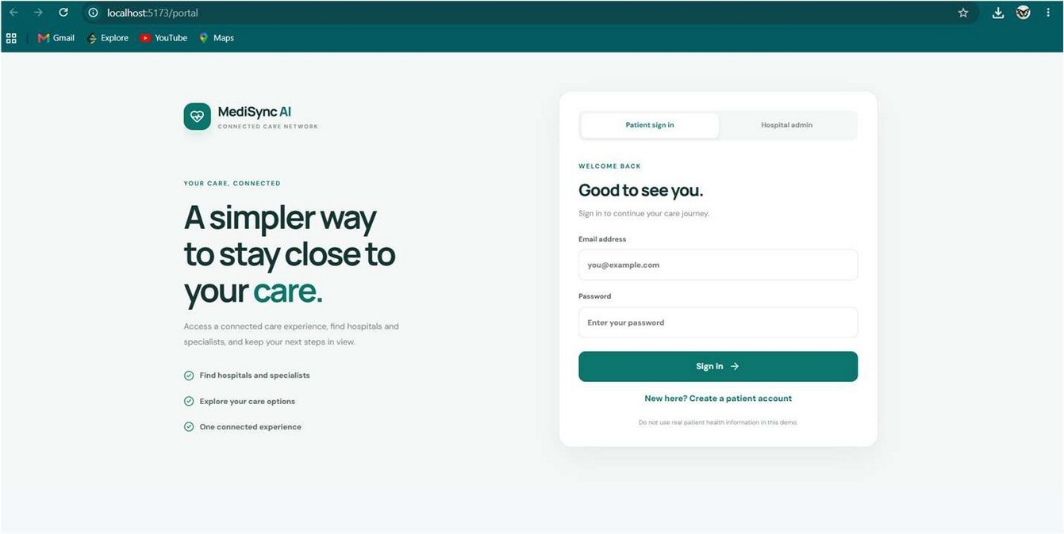
Figure 4.7 Sign-in portal (patient and hospital-administrator tabs)
Home page. A landing page with a hero section, six specialty cards (Cardiology, Neurology, Women & children, Orthopaedics, Pulmonology, Diagnostics), three featured hospital cards with general-bed and ICU-bed availability bars and a status badge, a grid of doctors loaded from the database, and the appointment-request form (name, city, brief reason, phone, preferred date, specialty). A footer states that the data is sample data and that the system is not for emergency dispatch.

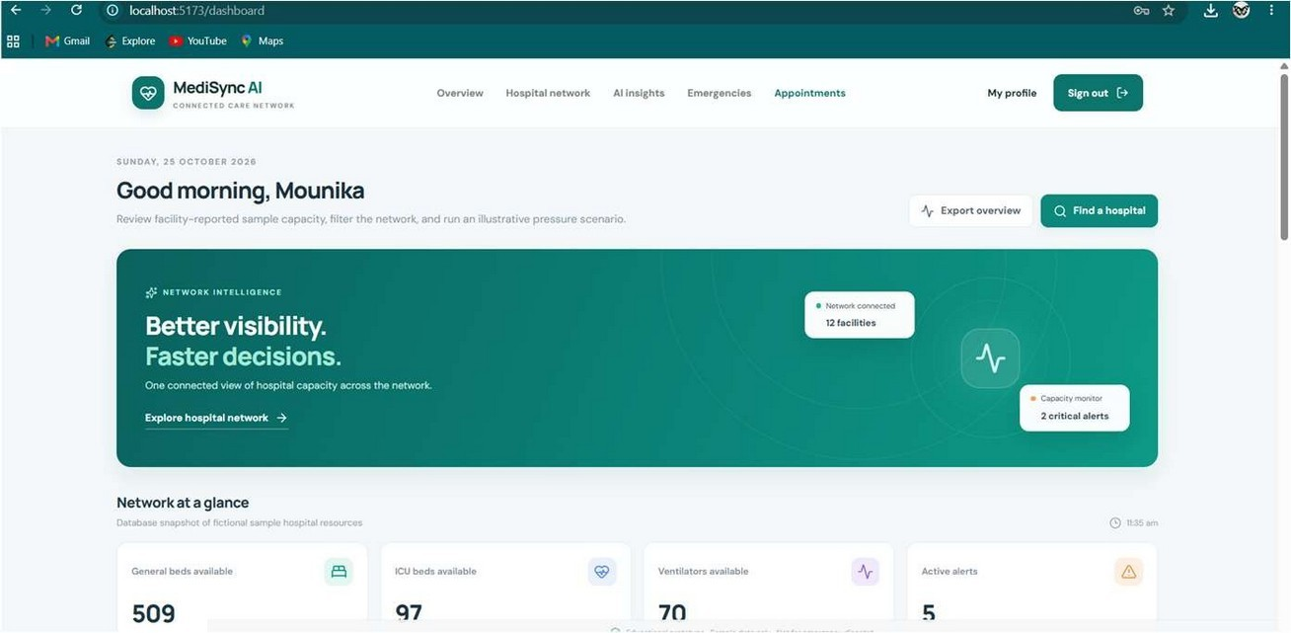
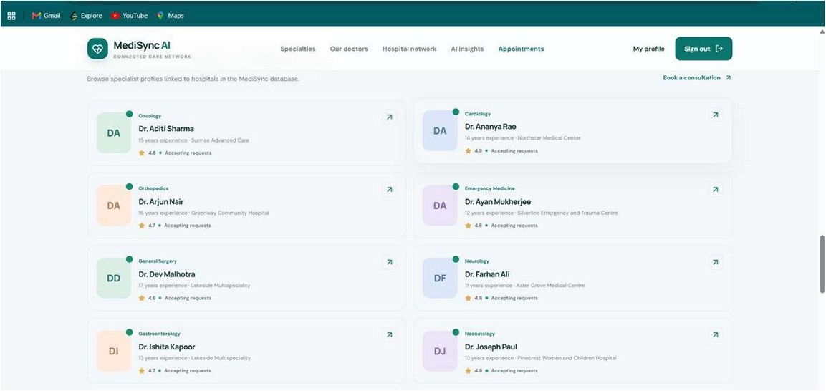
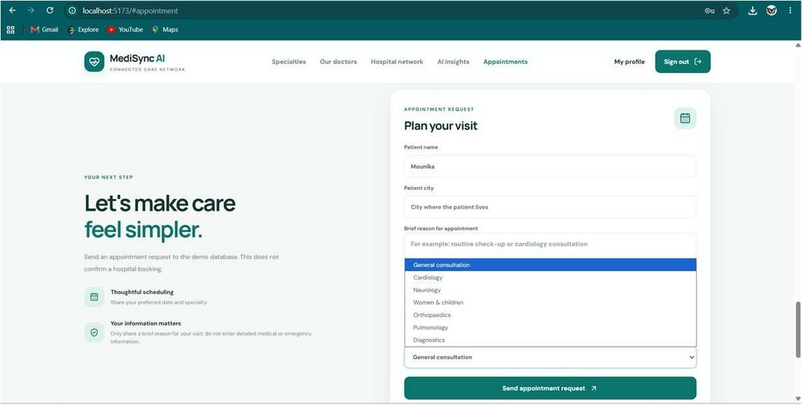

Figure 4.8 Home page with hospital cards, doctors, and appointment-request form
Dashboard. Shows a greeting, four metric cards (general beds, ICU beds, ventilators, and active alerts), a network-resources panel (oxygen, blood, PPE, and medicines), an illustrative availability-trend chart, a donut chart of bed capacity, a critical-alerts panel (administrators can resolve alerts), a recent-emergencies panel, and hospital cards.

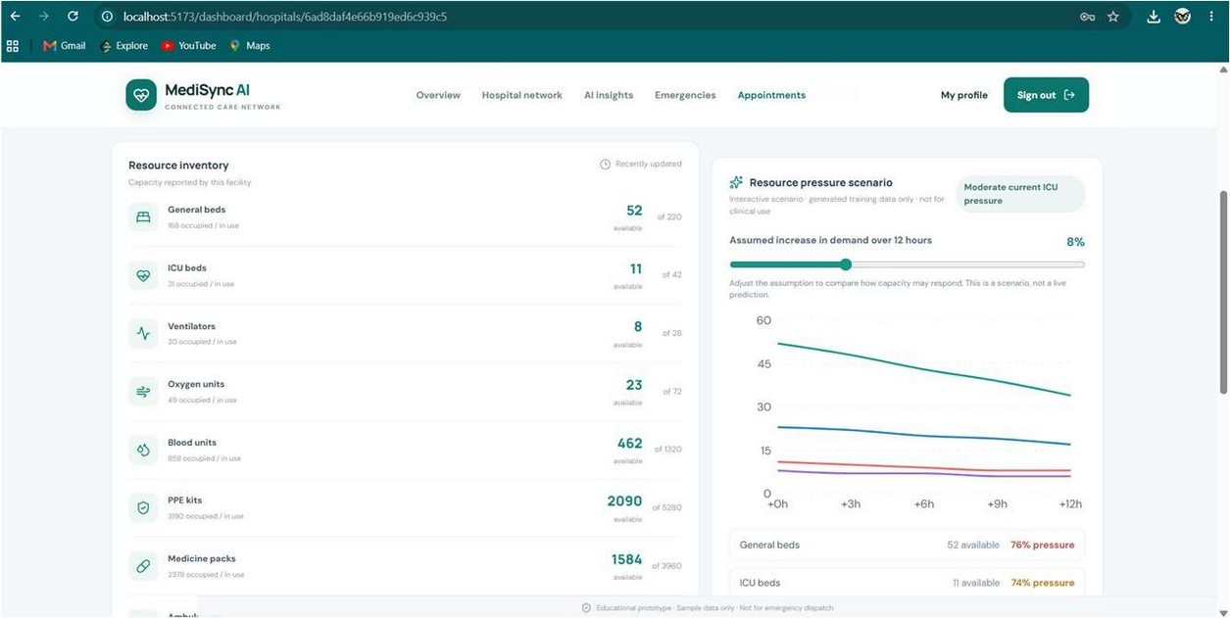
Figure 4.9 Operational dashboard
Hospital directory and profile. The directory supports free-text search and filters for city, hospital type, and status. A hospital profile shows facility information, specialties, doctors, and an inventory of the eight resource categories. Administrators can edit totals and available units; invalid values are rejected by the server.
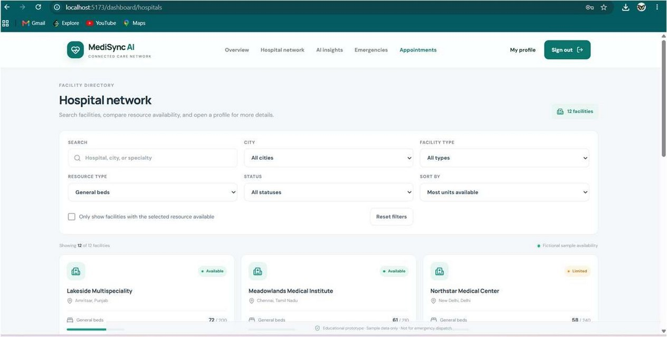
Figure 4.10 Hospital directory and hospital profile
AI insights. The user selects a sample facility and moves a slider from 0% to 25% to set the assumed 12-hour demand increase. The page shows three summary cards (synthetic model signal, current ICU pressure, and 12-hour horizon) and a line chart of projected availability for general beds, ICU beds, oxygen, ventilators, and blood. A banner states that the model is trained only on synthetic data. If the ML service is offline, the card shows “Offline” and the heuristic scenario is still displayed.

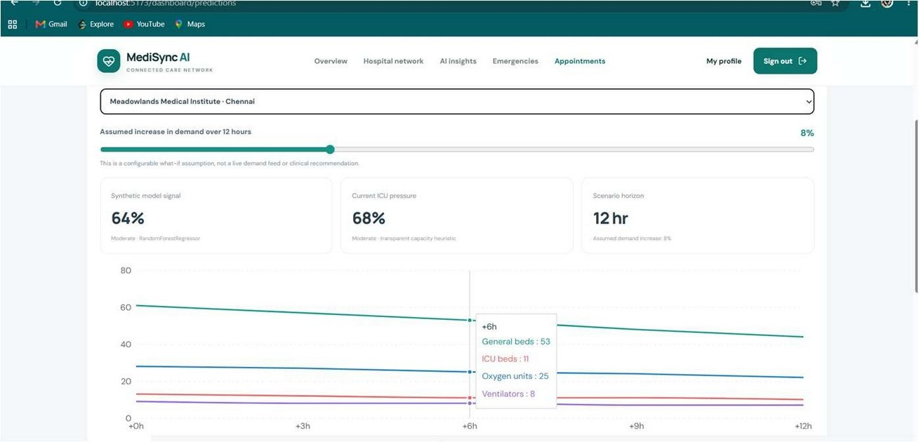
Figure 4.11 AI-insights page with demand slider and scenario chart
Emergencies and profile. The emergencies page lists fictional incidents with severity and status filters, and administrators can update status or assign a hospital. The profile page lets any signed-in user update their name and email.
Running the application
After starting MongoDB, the command “powershell -ExecutionPolicy Bypass -File .\Start-MediSync.ps1” launches the backend, the optional ML service, and the front end, and opens http://localhost:5173/portal. The API health endpoint (http://localhost:5000/api/health) reports whether the database connection is ready, and the ML service health endpoint (http://127.0.0.1:8000/health) reports its mode. The database is populated with “npm run seed”, and an administrator is created with “npm run create-admin” after setting ADMIN_NAME, ADMIN_EMAIL, and ADMIN_PASSWORD (at least 12 characters) in the .env file.
    - Testing
Testing combined scripted checks of the Python service, which were executed during the preparation of this report, with a test plan for the API and user interface, which is provided as a checklist to be executed against a running installation (Postman collection included in the project).
- Executed tests: ML service validation
The Flask application was exercised with its built-in test client. Table 4.4 lists the cases and the observed outcomes.

Table 4.4 Executed tests of the ML service (/predict and /health)

ID | Test case | Input | Observed result | Status
M1 | Valid request | All four resources 10/50; demand 8% | HTTP 200; riskScore 77, level High | Pass
M2 | Body is not a JSON object | [1, 2] | HTTP 400 “A JSON object is required” | Pass
M3 | Missing resource | Only ICU supplied | HTTP 400 “Resource ‘general’ must include total and available” | Pass
M4 | Available greater than total | ICU available 99, total 50 | HTTP 400 “counts are outside the valid range” | Pass
M5 | Non-numeric count | ICU total = "x" | HTTP 400 “counts must be finite numbers” | Pass
M6 | Demand out of range | demandIncreasePercent = 40 | HTTP 400 “must be between 0 and 25” | Pass
M7 | Lower boundary | demandIncreasePercent = 0 | HTTP 200; riskScore 77 | Pass
M8 | Upper boundary | demandIncreasePercent = 25 | HTTP 200; riskScore 77 | Pass
M9 | Zero total capacity | ICU total 0, available 0 | HTTP 200; availability treated as 0;  riskScore 83 | Pass
M10 | Health check | GET /health | HTTP 200; mode synthetic-demo; clinicalUse false | Pass

Cases M7 and M8 also confirm the observation in Section 4.1.2 that the ML score is almost insensitive to the demand feature.
- Test plan for the API and user interface
The cases in Table 4.5 follow the same categories used in the reference report: input validation, user interaction, edge cases, model accuracy, error handling, performance, security, usability, and integration. The “Expected result” column is derived from the implemented validation and authorization rules; the final column is to be completed when the plan is run against a live installation.
Table 4.5 Test plan for the API and user interface

ID | Category | Test case | Expected result | Status
T1 | Input validation | Register with a 5-character password | HTTP 400 “Password must be between 8 and 128 characters” | ☐
T2 | Input validation | Register with an existing email | HTTP 409 “An account with this email already exists” | ☐
T3 | Security | Call /api/hospitals without a token | HTTP 401 “Sign in required” | ☐
T4 | Security | Patient token calls PATCH  /api/hospitals/:id/resources | HTTP 403 “Hospital administrator access is required” | ☐
T5 | Security | Patient token calls GET /api/patients | HTTP 403 | ☐
T6 | Security | More than 10 login attempts in 15 minutes | Further attempts are rate-limited | ☐
T7 | Input validation | Appointment with a past date | HTTP 400 “Appointment date cannot be in the past” | ☐
T8 | Input validation | Appointment with a doctor from another hospital | HTTP 400 “The selected doctor does not belong to this hospital” | ☐
T9 | Edge case | Update resources with available > total | HTTP 400 “Invalid counts for <resource>” | ☐

ID | Category | Test case | Expected result | Status
T10 | Input validation | Create emergency with patient id “P-1” | HTTP 400 “Use a fictional patient identifier beginning with DEMO-” | ☐
T11 | Edge case | Prediction with demandIncreasePercent = 30 | HTTP 400 “must be between 0 and 25 percent” | ☐
T12 | Error handling | Stop the Flask service and open AI insights | Heuristic scenario shown; ML card displays “Offline” | ☐
T13 | Error handling | Stop MongoDB and call  /api/auth/login | HTTP 503 “Database is unavailable” | ☐
T14 | Model accuracy | Compare heuristic pressure with hand calculation for three hospitals | Values equal round((1 − A/T) × 100) | ☐
T15 | User interaction | Move the demand slider from 0% to 25% | Chart updates after about 180 ms; values decrease monotonically over time | ☐
T16 | User interaction | Sign in, refresh the page, close the tab, reopen | Session survives a refresh; sign-in is required after the tab is closed | ☐
T17 | Usability | Use the site on a phone-sized viewport | Menu collapses; cards and tables remain readable | ☐
T18 | Cross-browser | Open the application in Chrome, Edge, and Firefox | Layout and functions are consistent | ☐
T19 | Integration | Import the Postman collection and run all requests | Responses match the documented status codes | ☐
T20 | Performance | Measure /api/predictions/:id response time | Below the 1.8 s ML timeout in normal operation | ☐

- Security review
The implemented controls were reviewed against the common web-application risks listed by the OWASP Top 10: broken access control is addressed by server-side role checks and an immutable role field; cryptographic failures by bcrypt hashing and a required strong JWT secret in production; injection by input validation, ObjectId checks, and escaping of user-provided text before it is used in regular expressions; security misconfiguration by Helmet headers, a CORS allow-list, and request-size limits; and identification and authentication failures by rate limiting of sign-in attempts and short token lifetime.

CHAPTER 5.
CONCLUSION AND FUTURE WORK

Conclusion
The “MediSync AI” project has delivered a working, full-stack prototype that unifies hospital profiles, doctor directories, resource inventories, alerts, emergency records, and appointment requests in one role-controlled web platform. The project began with a careful analysis of the problem of fragmented hospital information and progressed through data modelling, secure API development, front-end construction, AI integration, and testing.
On the technical side, the Express API enforces authentication, authorization, validation, and rate limiting across all endpoints; MongoDB stores eight resource categories per hospital together with doctors, alerts, emergencies, and appointment requests; and the React interface provides a dashboard, directory, profile, emergencies view, and AI-insights page. The sample data classify 6 of 12 facilities as Available, 4 as Limited, and 2 as Critical, and the system raises alerts accordingly.
The AI component was designed with deliberate caution. A transparent capacity-pressure heuristic and a 12-hour what-if scenario provide an interpretable baseline, while a Random Forest regressor served by a Flask microservice provides a complementary 0–100 risk score. The model achieved a mean absolute error of 1.39 and an RZ of 0.990 on held-out synthetic data, with predictions in about 5 ms; the heuristic and ML signals are strongly correlated (r = 0.989). However, because the model learns a rule that was itself generated from the same features, these metrics demonstrate correct integration, not real-world predictive power, and the application states this clearly. The analysis also revealed that the demand feature has negligible influence on the ML output, which is why the scenario chart remains the primary tool for demand sensitivity.
In conclusion, the project demonstrates how a connected hospital-resource platform can be built with modern open-source tools, how security and privacy constraints can be built into a student prototype, and how AI can be added in an honest and fail-safe way. It provides a practical foundation that could be connected to real, facility-reported data in the future.

Known limitations
    - All hospital, doctor, alert, and emergency data are fictional; the system is not validated for clinical use, emergency dispatch, or real bookings.
    - The ML model is trained on synthetic data, and its demand feature has almost no influence; its metrics must not be read as real accuracy.
    - The project has no automated unit or integration test suite; testing relied on Postman, scripted checks, and manual verification.
    - If JWT_SECRET is not set outside production, the server falls back to a development secret; the token is kept in sessionStorage, which is accessible to scripts if a cross-site-scripting flaw were present.
    - Some routes (for example, GET /api/hospitals/:id) do not validate the ObjectId before querying, and there is no audit log of administrative changes.
    - The availability-trend chart on the dashboard is illustrative rather than computed from historical records.
Expected results, obtained results and deviations
The expected outcome of the project was a working prototype that centralises hospital resource information, protects it through role-based access, raises threshold-based capacity indications and offers an AI-assisted risk signal. All of these were delivered and demonstrated with the fictional data set. The Random Forest model reached an MAE of 1.39 and an RZ of 0.990 on its synthetic test set, and its score correlated strongly with the heuristic (r = 0.989).
Some results deviated from what a production system would require. The model metrics are high because the model learns a rule that was used to generate its own training data, so they describe agreement with that rule and not real-world forecasting accuracy; real hospital data were not available for privacy reasons. Automated unit and integration tests were not written within the seven-week schedule, so API and interface testing relies on a documented plan to be executed against a live installation. The dashboard availability trend is illustrative, and alerts are created by administrators instead of being generated automatically. These deviations are stated openly so that the prototype is not mistaken for a validated clinical tool.

Future work
The way ahead for the project covers required modifications to the solution, a possible change in approach, and suggestions for extending it.

Required modifications. Before any real use, the prototype needs automated test suites, a mandatory strong JWT secret in every environment, input validation on all routes, and replacement of the illustrative trend chart with measured data.
Change in approach. The synthetic-data model should be replaced by a model trained and validated on historical occupancy and admission data supplied by participating hospitals, evaluated with time-based splits and monitored after deployment.
Extending the solution. The directions below describe how the platform can grow once real data and approvals are available.
    - Real data integration: connect to facility-reported feeds or standards-based interfaces (for example, HL7 FHIR) with proper consent, auditing, and regulatory compliance, replacing the fictional dataset.
    - Real predictive modelling: collect historical occupancy and admission data and train time-series or gradient-boosting/LSTM models, with proper temporal cross-validation, calibration, and drift monitoring before presenting any forecast to users.
    - Explainability: show per-prediction explanations (for example, SHAP values) so coordinators can see which resources drive a risk score.
    - Real-time updates and notifications: use WebSockets or server-sent events for live resource updates, and send e-mail or SMS notifications when alerts are raised.
    - Automated alert generation: derive alerts directly from resource updates and thresholds instead of seeded records, with escalation rules.
    - Appointment workflow: add confirmation, rescheduling, and reminders, and integrate doctor calendars.
    - Emergency routing: use geospatial queries and travel-time estimates to suggest the nearest suitable facility and ambulance.
    - Security hardening: multi-factor authentication for administrators, HttpOnly cookie sessions, token refresh and revocation, audit logging, and uniform ObjectId validation.
    - Quality and operations: add Jest/Supertest and pytest suites, continuous integration, Docker-based deployment, centralised logging, and accessibility and multi-language support.
By combining these enhancements with validated real-world data, MediSync AI could evolve from a demonstration prototype into a dependable decision-support tool for hospital networks.

REFERENCES
- Breiman, L. (2001). Random Forests. Machine Learning, 45(1), 5–32.
- Pedregosa, F., et al. (2011). Scikit-learn: Machine Learning in Python. Journal of Machine Learning Research, 12, 2825–2830.
- Hastie, T., Tibshirani, R., and Friedman, J. (2009). The Elements of Statistical Learning: Data Mining, Inference, and Prediction (2nd ed.). Springer.
- Jones, M., Bradley, J., and Sakimura, N. (2015). JSON Web Token (JWT). RFC 7519, Internet Engineering Task Force.
- Provos, N., and Mazières, D. (1999). A Future-Adaptable Password Scheme. Proceedings of the USENIX Annual Technical Conference.
- Fielding, R. T. (2000). Architectural Styles and the Design of Network-based Software Architectures. Doctoral dissertation, University of California, Irvine.
- OWASP Foundation. (2021). OWASP Top 10: 2021. https://owasp.org/Top10/
- Government of India. (2023). The Digital Personal Data Protection Act, 2023.
- MongoDB, Inc. MongoDB Documentation. https://www.mongodb.com/docs/
- Mongoose. Mongoose Documentation. https://mongoosejs.com/docs/
- OpenJS Foundation. Express – Node.js web application framework. https://expressjs.com/
- Meta Platforms, Inc. React Documentation. https://react.dev/
- Pallets Projects. Flask Documentation. https://flask.palletsprojects.com/
- Recharts. Recharts: A composable charting library built on React components. https://recharts.org/
- Postman, Inc. Postman Learning Center. https://learning.postman.com/
- World Health Organization. (2020, March 11). WHO Director-General’s opening remarks at the media briefing on COVID-19. https://www.who.int/director-general/speeches
- National Health Authority, Government of India. Ayushman Bharat Digital Mission. https://abdm.gov.in/
- Fielding, R., Nottingham, M., and Reschke, J. (2022). HTTP Semantics. RFC 9110,
Internet Engineering Task Force. https://www.rfc-editor.org/info/rfc9110
- Bray, T. (Ed.). (2017). The JavaScript Object Notation (JSON) Data Interchange Format.
RFC 8259, Internet Engineering Task Force. https://www.rfc-editor.org/info/rfc8259
- Ecma International. ECMA-262: ECMAScript Language Specification. https://ecma-international.org/publications-and-standards/standards/ecma-262/

APPENDIX
- Plagiarism Report
The plagiarism report generated by the institution’s similarity-checking service for this project report is to be attached below before final submission.

[ Insert the plagiarism report here ]

- Design Checklist
The checklist below confirms that the design considerations expected of the project report have been addressed and shows where each is documented.

S. No. | Design consideration | Addressed | Where documented
1 | Client, need and contemporary issue identified and justified | Yes | Section 1.1
2 | Problem and tasks identified; timeline defined | Yes | Sections 1.2 to 1.4
3 | Literature review and existing solutions analysed | Yes | Sections 2.1 to 2.4
4 | Problem definition and measurable goals stated | Yes | Sections 2.5 and 2.6
5 | Features evaluated and selected | Yes | Section 3.1
6 | Standards, regulations, ethical and social constraints considered | Yes | Section 3.2, List of Standards
7 | Features finalised subject to constraints | Yes | Section 3.3
8 | At least two alternative designs presented | Yes | Section 3.4
9 | Design selected with comparison and reasons | Yes | Section 3.5, Tables 3.5  and 3.6
10 | Implementation methodology, flowchart and algorithm given | Yes | Section 3.6, Figures 3.1 to  3.5
11 | Modern tools used for analysis, design, reporting and testing | Yes | Section 4.1
12 | Results analysed and validated | Yes | Sections 4.1.1 to 4.1.4
13 | Conclusion, deviations and future work stated | Yes | Chapter 5
14 | References listed | Yes | References
15 | User manual provided | Yes | User Manual

USER MANUAL
(Complete step-by-step instructions along with pictures necessary to run the project)

Prerequisites
  - A Windows computer with PowerShell, Node.js, Python and MongoDB installed, and the project dependencies installed as described in the README files.
  - A .env file in the back-end folder containing the database connection and a private JWT_SECRET (at least 32 characters in production mode).
  - Ports 5173 (front end), 5000 (API) and 8000 (ML service) free on the machine.
Steps to run the project
    - Start MongoDB. Make sure the MongoDB service is running on the machine before starting the application.
    - Load the demonstration data. In the back-end folder run “npm run seed”. This inserts
12 fictional hospitals, 24 doctors, sample alerts and sample emergencies without overwriting existing data.
    - Create an administrator. Set ADMIN_NAME, ADMIN_EMAIL and ADMIN_PASSWORD (at least 12 characters) in the .env file and run “npm run create-admin”. Patients can register themselves from the portal; administrators can only be created in this way.
    - Launch all services. From the project folder run “powershell -ExecutionPolicy Bypass - File .\Start-MediSync.ps1”. The script starts the backend, the optional ML service and the front end, and opens http://localhost:5173/portal.
    - Check service health. Open http://localhost:5000/api/health to confirm that the database connection is ready, and http://127.0.0.1:8000/health to confirm that the ML service is running.
    - Sign in. On the portal choose the “Patient sign in” tab (or register a new patient account) or the “Hospital administrator sign in” tab (Screenshot U1).
    - Explore the dashboard. After signing in, the dashboard shows metric cards, charts and active alerts for general beds, ICU beds, ventilators, oxygen units and other resources (Screenshot U2).
    - Browse hospitals and doctors. Use the hospital directory to search and filter facilities, open a hospital profile and send an appointment request. Keep the reason short and never enter real medical details (Screenshot U3).

    - View AI insights. Open the AI-insights page, select a sample hospital and move the demand slider between 0 and 25 %. The scenario chart, heuristic pressure and ML risk score update (Screenshot U4).
    - Administrator tasks. Administrators can update resource counts, resolve alerts and create or update fictional emergency records (patient identifiers must start with DEMO-). These controls are not shown to patients.
    - Stop the application. Close the PowerShell windows opened by the launcher. If only the ML service is stopped, the application continues to work and shows the heuristic result with the ML signal marked unavailable.
Screenshot U1: Sign-in portal
Screenshot U2: Operational dashboard

Screenshot U3: Hospital directory and profile
Screenshot U4: AI-insights page

