Gauge

------------------------------------------------------------------------------------------------------------------------------

Gauge:

>Gauge is a lightweight cross platform test automation tool.It provides the ability to author test cases in the **business language**.

>Gauge is an open source project,sponsored by ThoughtWorks Inc.under GPL Licence version 3.0.0.

Why ThoughtWorks built Gauge?

ThoughtWorks, creator of Selenium and Twist,has been a key innovator in the automated testing eco system for more than a decade.

------------------------------------------------------------------------------------------------------------------------------**Twist:**

Twist is a test automation and functional testing solution built by ThoughtWorks Studios,the software division of ThoughtWorks.It uses BDD and TDD for functional testing of the application.

**Test-driven development** (**TDD**):

TDD is a s/w development process that relies on the repetition of a very short development cycle: first the developer writes an (initially failing) automated test case that defines a desired improvement or new function, then produces the minimum amount of code to pass that test, and finally refactors the new code to acceptable standards.**Kent Beck**, who is credited with having developed or 'rediscovered the technique, stated in 2003 that TDD encourages simple designs and inspires confidence.

**TDD Cycle:**

1.Add a test 2.Run all tests and see,if the new one fails 3.Write some code

4.Run tests 5.Refractor code.

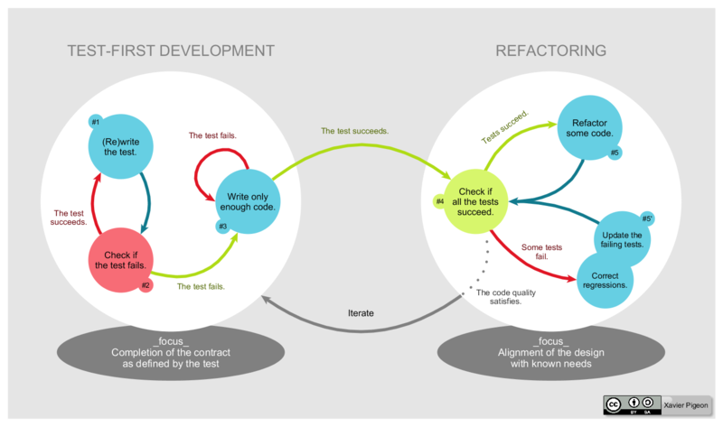

**BDD:**

In software engineering, **behavior-driven development** (**BDD**) is a software development process that emerged from TTD.Behavior-driven development combines the general techniques and principles of TDD with ideas from domain-driven design and object oriented analysis and design to provide software development and management teams with shared tools and a shared process to collaborate on software development.

Although BDD is principally an idea about how software development should be managed by both business interests and technical insight, the practice of BDD does assume the use of specialized software tools to support the development process. Although these tools are often developed specifically for use in BDD projects, they can be seen as specialized forms of the tooling that supports test-driven development. The tools serve to add automation to the ubiquitous language that is a central theme of BDD.

BDD is largely facilitated through the use of a simple domain specific language (DSL) using natural language constructs (e.g., English-like sentences) that can express the behavior and the expected outcomes. Test scripts have long been a popular application of DSLs with varying degrees of sophistication.

It includes the practice of writing tests first, but focuses on tests which describe behavior, rather than tests which test a unit of implementation. Tools such as Mspec and Specflow provide a syntax which allow non-programmers to define the behaviors which developers can then translate into automated tests.

**BDD focuses on:**

* Where to start in the process
* What to test and what not to test
* How much to test in one go
* What to call the tests
* How to understand why a test fails

--------------------------------------------------------------------------------------------------------------------------------

>To solve the hardest problems people face in the testing and automation world.

>They care about solving problems for all,not just those on a specific platform.

>Gauge is built with a plugin architecture so that you can use it with any language IDE & ecosystem you want.

>They support all testers regardless of automation experience.

**Why Gauge is better for testers?**

**1.Simple syntax:**

>We can write test specifications in markdown.

--------------------------------------------------------------------------------------------------------------------------------

**Markdown:**

Markdown is a lightweight markup language with plain text formatting syntax designed, so that it can be converted to HTML and many other formats using a tool by the same name. Markdown is often used to format readme files, for writing messages in online discussion forums, and to create rich text using a plain text editor.

|  |  |  |
| --- | --- | --- |
| **text using Markdown syntax** | **the corresponding HTML produced by a Markdown processor** | **the text viewed in a browser** |
| Heading =======  Sub-heading -----------   ### Another deeper heading   Paragraphs are separated by a blank line.  Leave 2 spaces at the end of a line to do a  line break  Text attributes *italic*, **bold**,  `monospace`, ~~strikethrough~~ .  Shopping list:   * apples  * oranges  * pears  Numbered list:   1. apples  2. oranges  3. pears  The rain---not the reign---in Spain.  A [link](http://example.com).  [[28]](https://en.wikipedia.org/wiki/Markdown#cite_note-28) | **<h1>**Heading**</h1>**  **<h2>**Sub-heading**</h2>**  **<h3>**Another deeper heading**</h3>**  **<p>**Paragraphs are separated by a blank line.**</p>**  **<p>**Leave 2 spaces at the end of a line to do a**<br** **/>** line break**</p>**  **<p>**Text attributes **<em>**italic**</em>**, **<strong>**bold**</strong>**, **<code>**monospace**</code>**, **<s>**strikethrough**</s>**.**</p>**  **<p>**Shopping list:**</p>**  **<ul>** **<li>**apples**</li>** **<li>**oranges**</li>** **<li>**pears**</li>** **</ul>**  **<p>**Numbered list:**</p>**  **<ol>** **<li>**apples**</li>** **<li>**oranges**</li>** **<li>**pears**</li>** **</ol>**  **<p>**The rain**&mdash;**not the reign**&mdash;**in Spain.**</p>**  **<p>**A **<a** href="http://example.com"**>**link**</a>**.**</p>** | Heading  **Sub-heading**  **Another deeper heading**  Paragraphs are separated by a blank line.  Leave 2 spaces at the end of a line to do a  line break  Text attributes *italic*, **bold**, monospace,strikethrough.  Shopping list:   * apples * oranges * pears   Numbered list:   1. apples 2. oranges 3. pears   The rain—not the reign—in Spain.  A [link](http://example.com/). |

--------------------------------------------------------------------------------------------------------------------------------

>Gauge won’t enforce a structure,write in a way that works for you.Generate readable documentation in the format of your choice.

**2.Get started fast:**

>Gauge is lightweight and easy to get started

>Install and initialize with a single command

**3.Your environment Your tools:**

>Automate in your favourite programming language and work in the IDE of your choice across platforms.

>Gauge supports C#,Java and Ruby,Intellij,Visual box and Eclipse.

**4.Data driven execution:**

>Easily test with large data sets,while keeping specifications highly readable.Gauge reads test data from text,CSV and more.

**Gauge Supported plugins:**

**Language Runners:**

Java

C#

Ruby

Javascript

Golang

**IDE Plugins:**

Intellij

Visual Studio

Eclipse

**Reports:**

Html

Xml

**Build Tools:**

Maven

Gradle