1.Git
1.1.Version control system
1.2.Localized or Centralized version control systems
1.3.Distributed version control systems
1.4.Git
2.Tools
2.1.Git command line tools
3.Important terminology used in Git
4.Summary of Git terminology
4.1.Reference
4.2.File states in the working tree
5.Git commands
>git version
>git config
>git init
>git clone
>git add
>git commit
>git push
>Synchronization with remote repositories
>Working Tree
>git status
>git log
>git fetch
>git pull
>git rm
>git diff
>git show
>git remote
>git branch

1.Git:

1.1. Version control system:
A version control system (VCS) allows you to track the history of a collection of files. It supports creating different versions of this collection. These versions are stored in a specific place, called a repository.The process of creating different versions (snapshots) in the repository is depicted in the following graphic..
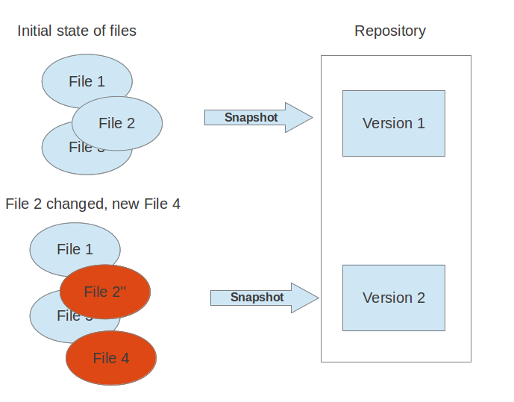VCS are typically used to track changes in source code for a programming language or other text files, like HTML code or configuration files. But a typical version control system can put any type of file under version control, e.g., you may use a VCS to track the different versions of your company logo.

1.2. Localized and centralized version control systems:
A localized version control system keeps local copies of the files.A centralized version control system provides a server software component which stores and manages the different versions of the files and let developer copy (checkout) a certain version onto their individual computer.Both approaches have the drawback that they have only one single point of failure, e.g., in localized version control systems the individual computer and in a centralized version control systems the server machine. Both system makes it also harder to work in parallel on different features.

1.3. Distributed version control system:
In a distributed version control system each user has a complete local copy of a repository on his individual computer. The user can copy an existing repository. This copying process is typically called cloning and the resulting repository can be referred to as a clone.Every clone contains the full history of the collection of files and a cloned repository has the same functionality as the original repository.Every repository can exchange versions of the files with other repositories by transporting these changes. This is typically done via a repository running on a server which is, unlike the local machine of a developer, always online. Typically there is a central server for keeping a repository but each cloned repository is a full copy of this repository.
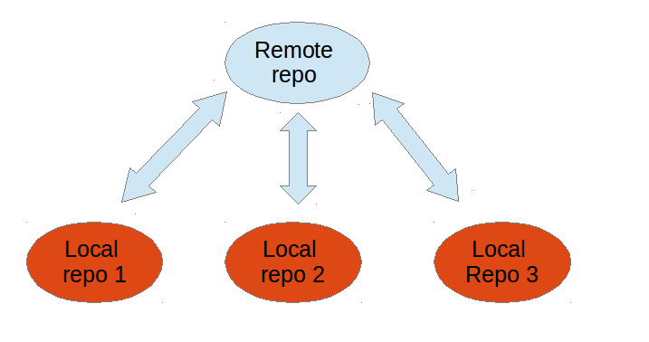

1.4. Git:
Git is currently the most popular implementation of a distributed version control system.Git originates from the Linux kernel development and was founded in 2005 by Linus Torvalds. Nowadays it is used by many popular open source projects, e.g., the Android or the Eclipse developer teams, as well as many commercial organizations.
The core of Git was originally written in the programming language C, but Git has also been re-implemented in other languages, e.g., Java, Ruby and Python.

2. Tools:

2.1.Git command line tools:

The original tooling for Git is based on the command line, i.e., the Git development team provides only tooling for the command line. Most of the following examples are based on the Git command line tooling which offers all capabilities of Git.
Other Tools:

>Eclipse plugin (EGit)

>Git4Idea

>KDevelop

> NetBeans plugin

>Padre

>PIDA

>TextMate

>Vim

>Visual Studio...etc.

Important terminology used in Git:
>Local Repository
>Remote Repository
>Concept of Branches
>Cloning
>Creating
>Deleting
>Synchronization with Remote Repositories
>Staging
>Operations(push,pull,add file,log,version,status,clear,delete,merge,fetch..etc)

4. Summary of Git Terminology:
4.1.Reference:

>Branch:
A branch is a named pointer to a commit. Selecting a branch in Git terminology is called to checkout a branch. If you are working in a certain branch, the creation of a new commit advances this pointer to the newly created commit.You can create a new branch from an existing one and change the code independently from other branches. One of the branches is the default (typically named master). The default branch is the one for which a local branch is automatically created when cloning the repository.
>Commit:
When you commit your changes into a repository this creates a new commit object in the Git repository. This commit object uniquely identifies a new revision of the content of the repository.This revision can be retrieved later, for example, if you want to see the source code of an older version. Each commit object contains the author and the committer, thus making it possible to identify who did the change. The author and committer might be different people. The author did the change and the committer applied the change to the Git repository. This is common for contributions to open source projects.
>Repository:
A repository contains the history, the different versions over time and all different branches and tags. In Git each copy of the repository is a complete repository. If the repository is not a bare repository, it allows you to checkout revisions into your working tree and to capture changes by creating new commits. Bare repositories are only changed by transporting changes from other repositories.
>Staging:
The staging area is the place to store changes in the working tree before the commit. The staging area contains a snapshot of the changes in the working tree (changed or new files) relevant to create the next commit and stores their mode (file type, executable bit).
>Working Tree:
The working tree contains the set of working files for the repository. You can modify the content and commit the changes as new commits to the repository.
>Cloning,Creating and Deleting:
The process of copying an existing Git repository is called cloning. After cloning a repository the user has the complete repository with its history on his local machine. Of course, Git also supports the creation of new repositories.If you want to delete a Git repository, you can simply delete the folder which contains the repository.

4.2. File states in the working tree:
A file in the working tree of a Git repository can have different states. These states are the following:
- Untracked: The file is not tracked by the Git repository. This means that the file never staged nor committed.
- Tracked: Committed and not staged
- Staged: Staged to be included in the next commit
- Dirty / Modified: The file has changed but the change is not staged

- Git Commands:
>git version:
Note:To know the version of git
Commands Used:
git --version
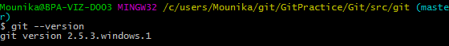
>git config:
Task:Tell Git who you are
Note:Configure the author name and email address to be used with your commits.You
have to configure at least your user and email address to be able to commit to a Git repository because this information is stored in each commit.Configure your user and email for Git via the following command.
Commands Used:
git config --global user.name “MounikaReddyDuvoori”
git config --global user.email “mounikaduvoori@gmail.com”

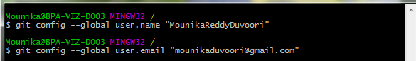

>git init:
Task:To Create a new local Repository
Note: Create an empty Git repository or reinitialize an existing one.
Commands Used:
git init

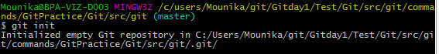

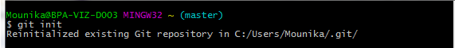
>git clone:
Task:Check out a repository
Note:Creating a working copy of a local repository.
Commands Used:
Local : git clone /path/to/repository
Remote: git clone username@host:/path/to/repository

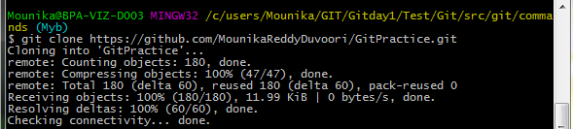

>git add,git commit,git push:
git add:
Task: Add files
Note:Add one or more files to staging(index)
Commands used:
git add <filename>
git add *
git commit:
Task:Commit
Note:Commit changes to head (but not yet to the remote repository)
Commit any files you've added with git add, and also commit any files you've changed since then
Commands used:
git commit -m “commit message”
git commit -a
git push:
Task:Push
Note:Send changes to the master branch of your remote repository
Commands used:
git push origin master

Adding an existing project to GitHub using the command line:
>>Add the files in your new local repository. This stages them for the first commit.
>>Commit the files that you've staged in your local repository.
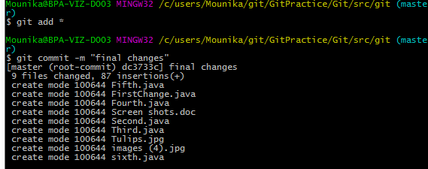
>>At the top of your GitHub repository's Quick Setup page, click to copy the remote repository URL.
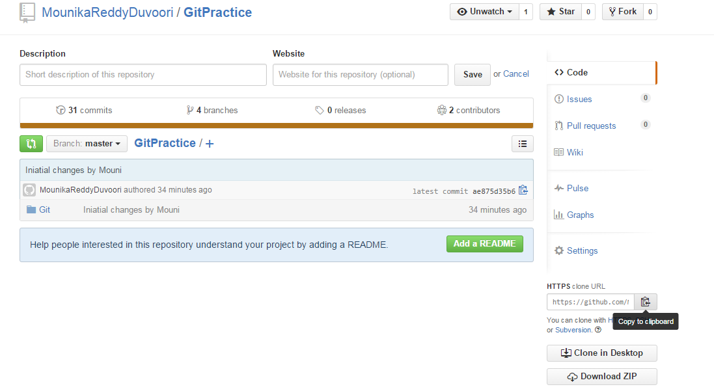
>>In the Command prompt, add the URL for the remote repository where your local repository will be pushed.
>>Push the changes in your local repository to GitHub.

>>Synchronization with remote repositories:
Git allows the user to synchronize the local repository with other (remote) repositories.Users with sufficient authorization can send new version in their local repository to to remote repositories via the push operation. They can also integrate changes from other repositories into their local repository via the fetch and pull operation.
>>Working Tree:
A local repository provides at least one collection of files which originate from a certain version of the repository. This collection of files is called the working tree. It corresponds to a checkout of one version of the repository with potential changes done by the user.

>git status:
Task:Status
Note:List the files you've changed and those you still need to add or commit:
Commands Used:
git status
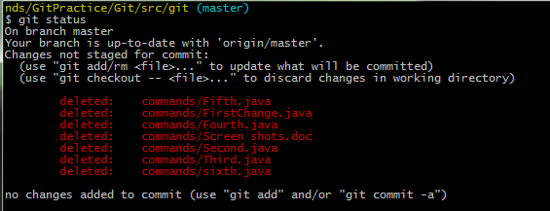

Shows you the status of files in the index versus the working directory. It will list out files that are Untracked (only in your working directory), modified (tracked but not yet updated in your index), and staged (added to your index and ready for committing).
>git log:
Task:
Note:Shows a listing of commits on a branch including the corresponding details.
Commands Used:
git log

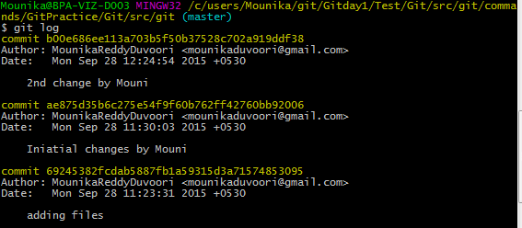

>git fetch:
Tasks:Fetches all the objects from the remote repository that are not present in the local one.Instead, to drop all your local changes and commits, fetch the latest history from the server and point your local master branch at it.
Commands Used:
>git fetch

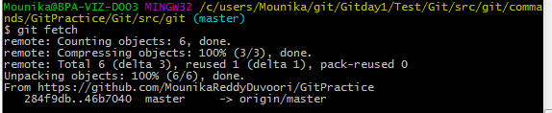
>git fetch origin

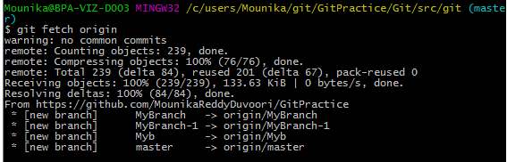

>git pull:
Task:Fetches the files from the remote repository and merges it with your local one.
This command is equal to the git fetch and the git merge sequence.
Commands Used:
>git pull

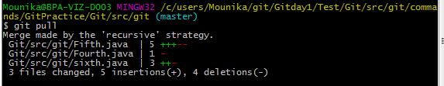

>git pull origin Myb
Note:Myb is my branch name
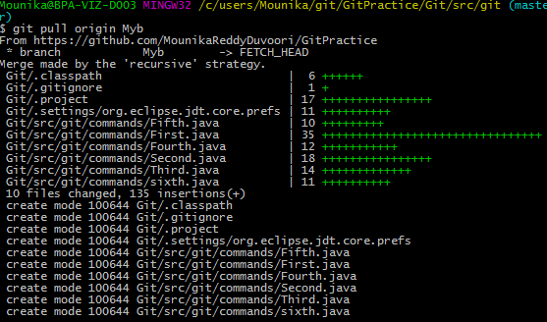

>git rm:
Task:Remove
Note:Removes files from your index and your working directory so they will not be tracked.
Commands Used:
>git rm filename

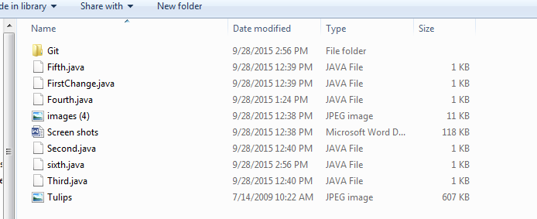

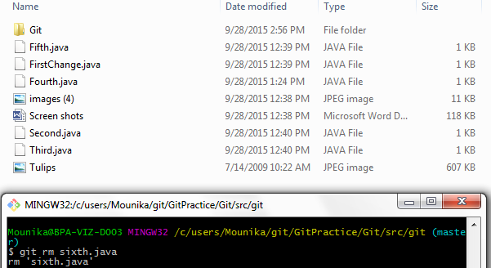
>git diff:
Task:Generates patch files or statistics of differences between paths or files in your git repository, or your index or your working directory.
Commands Used:
>git diff
>gitk

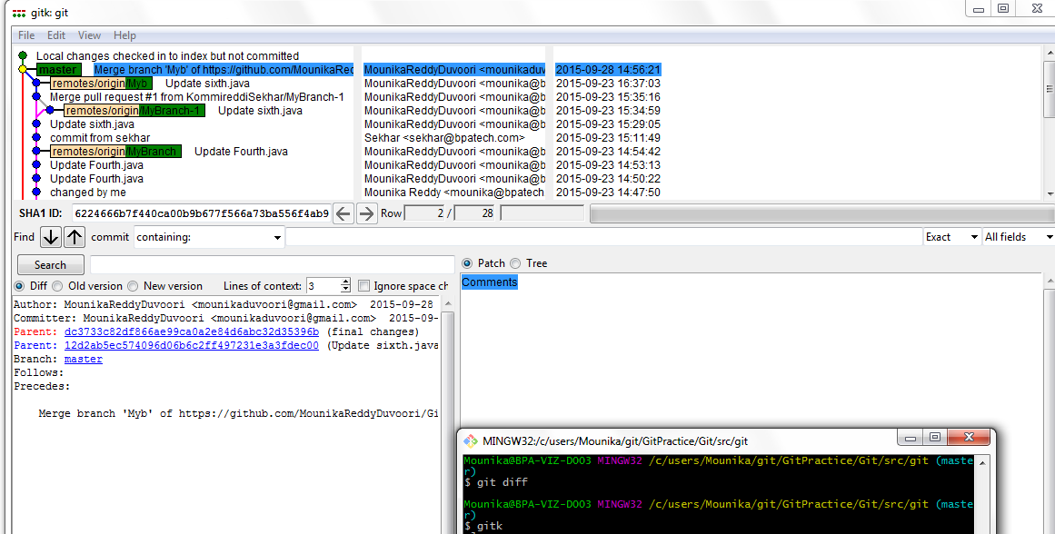

>git show:
Task:Shows information about a git object.
Commands Used:
>git show
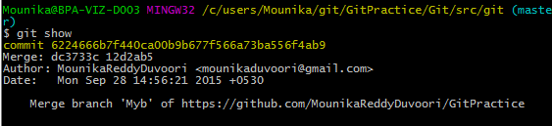

>git remote:
Task:Shows all the remote versions of the repository
Commands Used:
>git remote

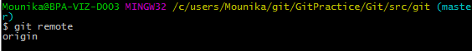

>git branch:
Task:List all the branches in your repo, and also tell you what branch you're currently in
Commands Used:
>git branch
>git checkout -b <BranchName>
>git branch -d <BranchName>

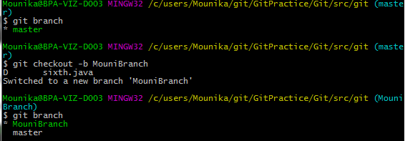
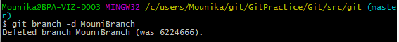

>git merge:
Task:Merges one or more branches into your current branch and automatically creates a new commit if there are no conflicts.
Commands Used:
>git merge <BranchName>

\

