**DIAGRAMS IN THE UML:**

A diagram is the graphical presentation of a set of elements, most often rendered as a connected graph of vectors and arcs.

There are 9 diagrams in the UML. These are

• Class Diagram

• Object Diagram

• Use-Case Diagram

• Sequence Diagram

• Collaboration Diagram

• State-Chart Diagram

• Activity Diagram

• Component Diagram

• Deployment Diagram

In our project we designed our system by using the following Diagrams.

**4.4.1 CLASS DIAGRAMS**

The purpose of the class diagram is to show the static structure of the system being modeled. The diagram specifically shows the entities in the system-along with each entity's internal structure and relationships with other entities in the system. Because class diagrams only model the static structure of a system, only types of entities are shown on a class diagram; specific instances are not shown.

A class is an abstraction of the things that are a part of your vocabulary. A class is not an individual object, but rather represents a whole set of objects. A *class* is a description of a set of objects that share the same attributes, operations, relationships, and semantics. Graphically, a class is rendered as a rectangle.

#### Names: A class name must be unique within its enclosing package.

#### Attributes: Attributes are related to the semantics of aggregation. An attribute is therefore an abstraction of the kind of data or state an object of the class might encompass.

#### Operations: An operation is the implementation of a service that can be requested from any object of the class to affect behavior. A class may have any number of operations or no operations at all.

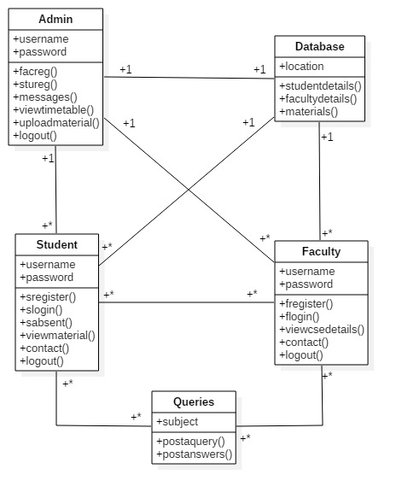

Fig: Class Diagram

**4.4.2. Use case diagrams**

The first step in the analysis is to define the use-cases, which describe what the system provides in terms of functionality- the functional requirement of the system. A use-case analysis involves reading and analyzing the specifications as well as discussing the system with potential users of the system.

The use case diagrams describe the functionality of the system and users of the system. A use case is a description of a system's behavior from user's stand point. For system developers this is valuable tool: its tried-and-true technique for gathering system requirements from a user's point of view.

The main elements of this type of diagrams are:

**Actors**: represents the users of a system including human users and other systems.

**UseCases:** represent the functionality or services provided by the system to Actors.

**Student:**

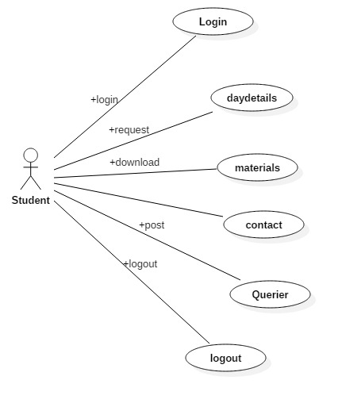

**Faculty:**

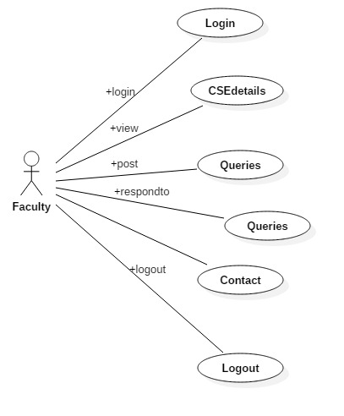

**Admin:**

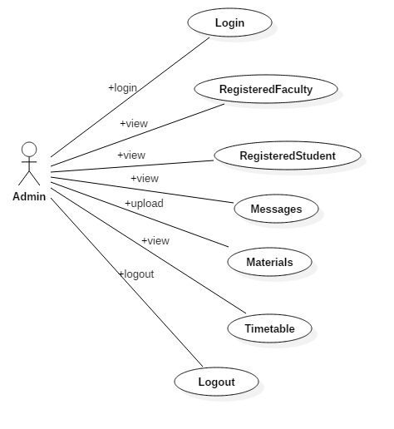

**4.4.3 Sequence diagram**

Sequence diagramsare Interaction diagrams that are ordered by time; you read the diagram from the top to the bottom. Each use case will have a number of alternate flows. Each Sequence diagram represents one of the flows through a use case.

A sequence diagram displays an interaction as a two-dimensional chart. The vertical dimension is the time axis; time proceeds down the page. The horizontal dimension shows the classifier roles that represent individual objects in the collaboration. Each classifier role is represented by a vertical column- the lifeline. During the time object exists, the role is shown by a dashed line. During the time an activation of a procedure on the object is active, the lifeline is drawn as a double line. A message is shown as an arrow from the lifeline of one object to that of another.

Admin:

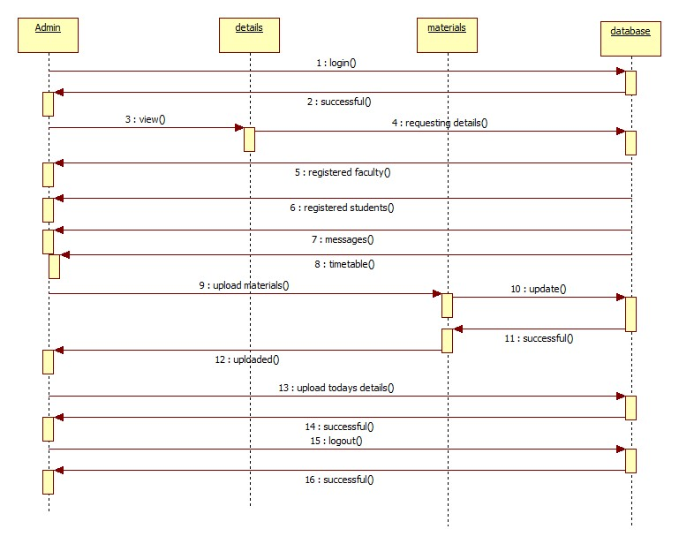

Student:

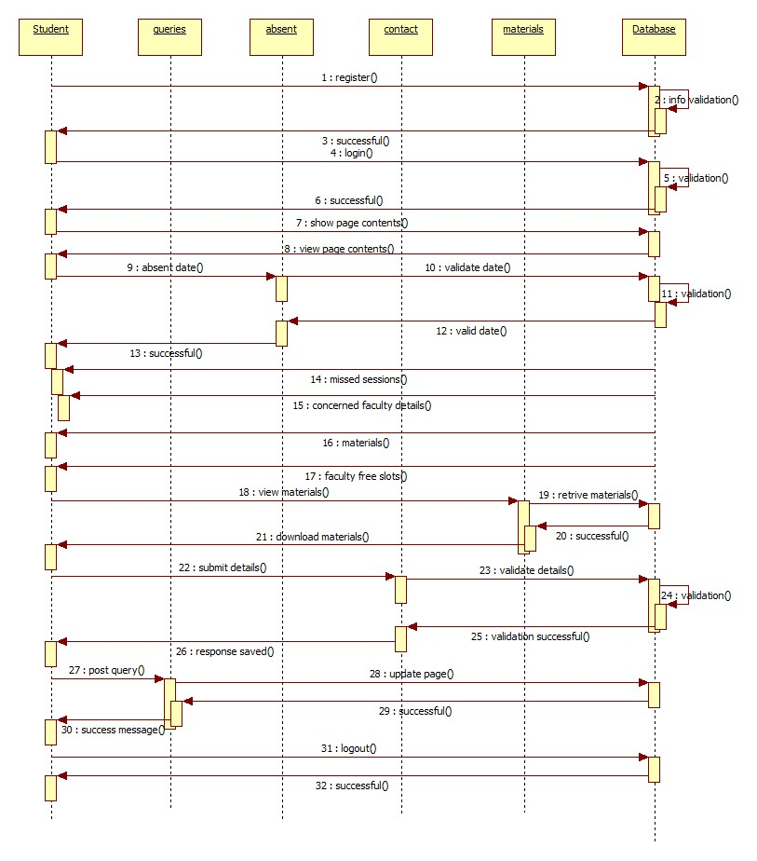

Faculty:

