1. Download the Kali 2017.2 VMware 64-bit custom image from Offensive-Security: <https://www.offensive-security.com/kali-linux-vmware-virtualbox-image-download/>
2. 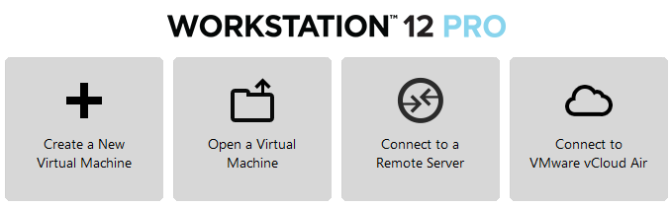Once the download is completed, In VMware workstation or fusion, click the Open a Virtual Machine option and navigate to you downloaded kali Image.
3. Once the image is loaded, click Edit Virtual Machine Settings to edit the machines resources and change per the image below. The initial setup will create a bridged networked machine in order to fully update Kali.   
   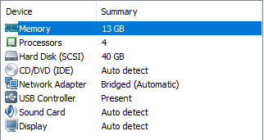
4. Power on the machine and login with the default credentials of **root/toor**. Update with the following syntax: **apt-get** install update && **apt-get** upgrade -y && **apt-get** dist-upgrade -y
5. 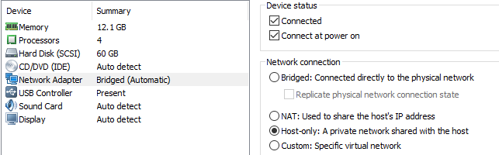After the updates are completed, go to VM 🡪 Settings 🡪 network Adapter and click the Host-Only network connection option.
6. Go to the Kali terminal and type: **reboot**
7. 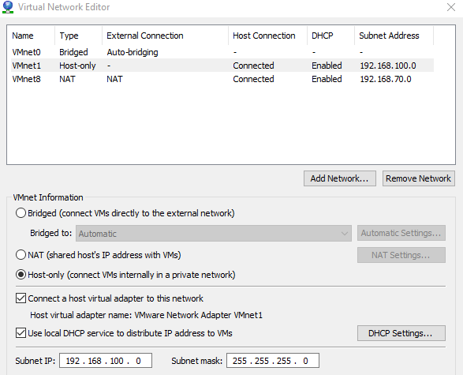While Kali is rebooting, navigate to the Edit menu is VMware workstation and click Virtual Network Editor. Click on the host only network interface and verify its subnet IP address. In my case, it is 192.168.100.0 and I will use this subnet to conduct the rest of the set-up. If your subnet is different, you need to make sure to set your ip-addresses up accordingly or change your subnet range in VMware.
8. After successful reboot, login with the default credentials (root/toor), open a terminal and navigate to /etc/network. Edit the interfaces file with either vim or nano and add the following information:

auto eth0   
iface eth0 inet static

address 192.168.100.50

netmask 255.255.255.0

broadcast 192.168.100.255

gateway 192.168.100.255

1. Save the interfaces file and run the following commands to reset the network interface:

/etc/init.d/network-manager restart

services networking restart

**ifconfig** eth0 down

**ifconfig** eth0 up

1. Verify that your IP addresses has changed to the static IP added to the interfaces file in /etc/network by running **ifconfig**
2. Setup completed.