Steps to assign static IP in windows system:
1. Press Win + R, type ncpa.cpl, and hit Enter.
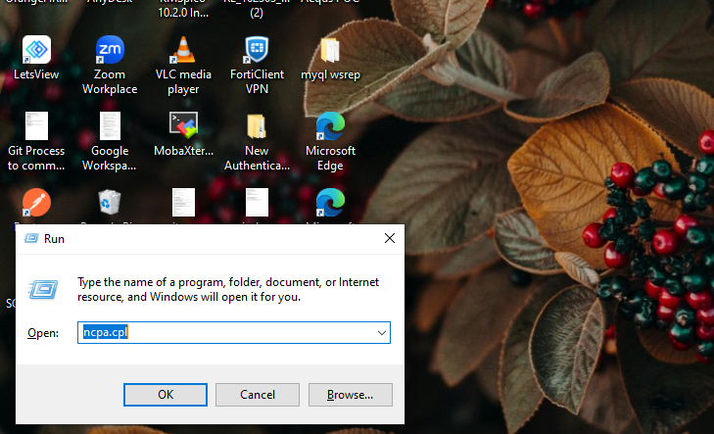

2. Right-click on your active network adapter → choose Properties.
Here my active network adapter is Wi-Fi.

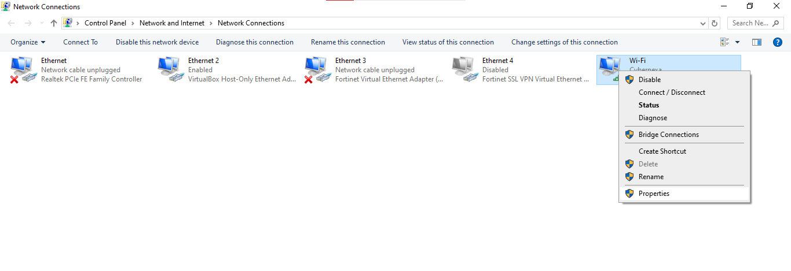

3. Here double click on Internet Protocol Version 4 (TCP/IPv4)
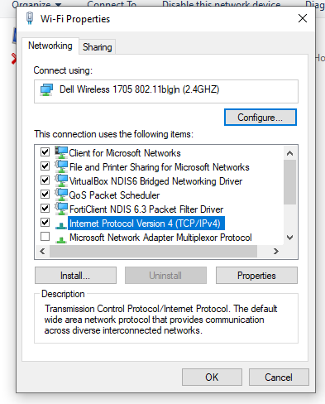
This opens Internet Protocol Version 4 (TCP/IPv4) properties screen as shown in the figure below.
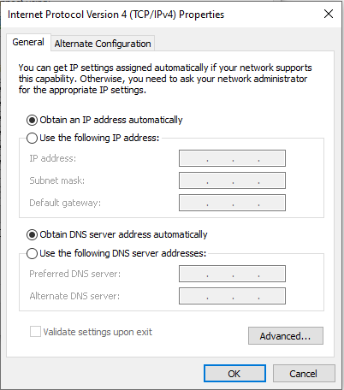
4. Here Choose Use the following IP address and fill in:
- IP address (e.g., 192.168.1.50)
- Subnet mask (255.255.255.0)
- Default gateway (e.g., 192.168.1.1)

In DNS server addresses, enter:
- Preferred: 8.8.8.8
- Alternate: 8.8.4.4
5. Click OK → Close.
