Steps to assign Static IP in Ubuntu Server using CLI
- Identify your network interface name using the below command :

ip link show
Here enp0s3 is the network interface.
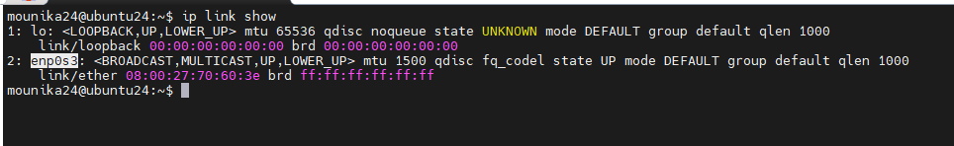
- To assign a static IP address, you need to edit the Netplan configuration file.
- Netplan files are usually located in /etc/netplan/, commonly named 50-cloud-init.yaml.
- To edit the file, use the command:
sudo nano /etc/netplan/50-cloud-init.yaml
The netplan file contents usually looks like below with dhcp config.
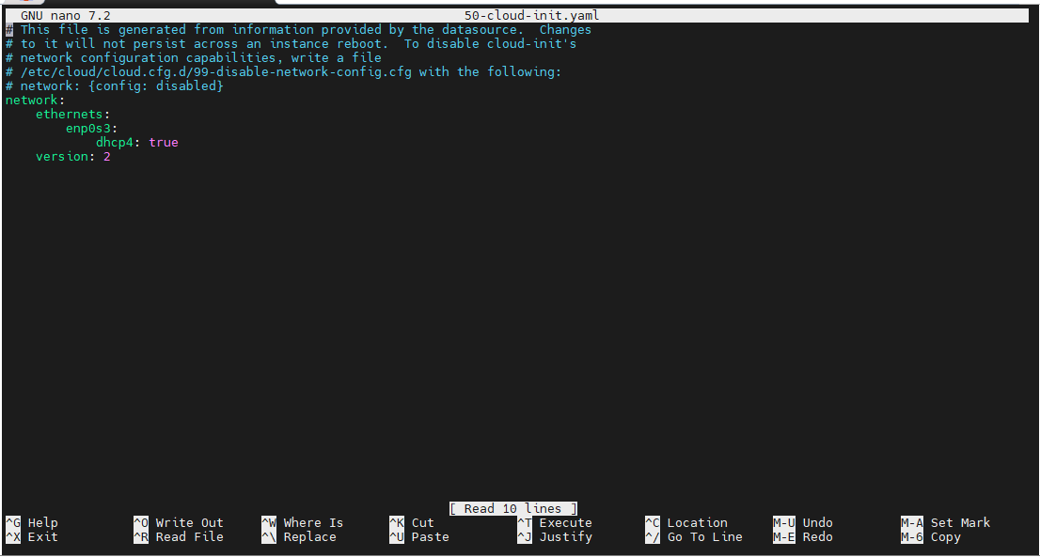
- Replace the existing content with your static IP configuration as shown below, and update the IP address, gateway, and DNS according to your network settings.

network:
version: 2
renderer: networkd
ethernets:
enp0s3:
dhcp4: false
addresses:
- 192.168.0.100/24
routes:
- to: default
via: 192.168.0.1
nameservers:
addresses: [1.1.1.1, 8.8.8.8]
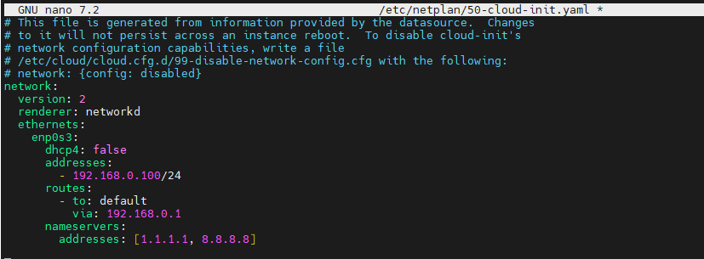
- Now safely apply the changes using below command
sudo netplan try
It gives you 2 minutes to confirm, press Enter to accept. Once it’s done, configuration is accepted. Refer the figure below.
- Then apply the changes using the below command:
sudo netplan apply
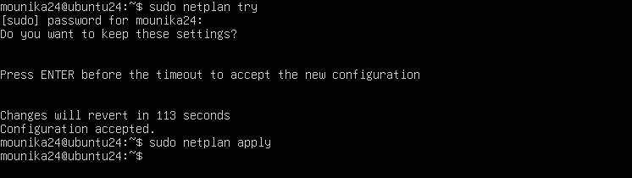
- Verify the assigned static IP by running the following command:
ip addr
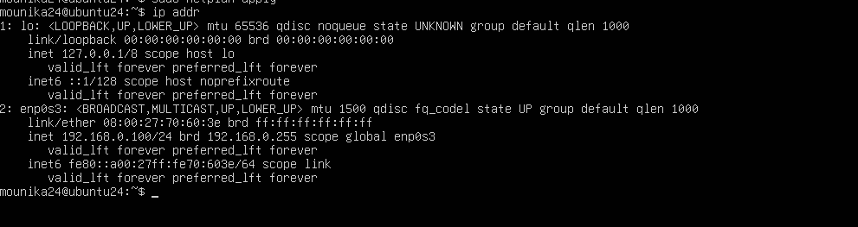
- Test SSH access to your server using the newly assigned static IP.
- Use an SSH client like MobaXterm or putty.
- Enter the assigned IP and your username as shown in the figure below.
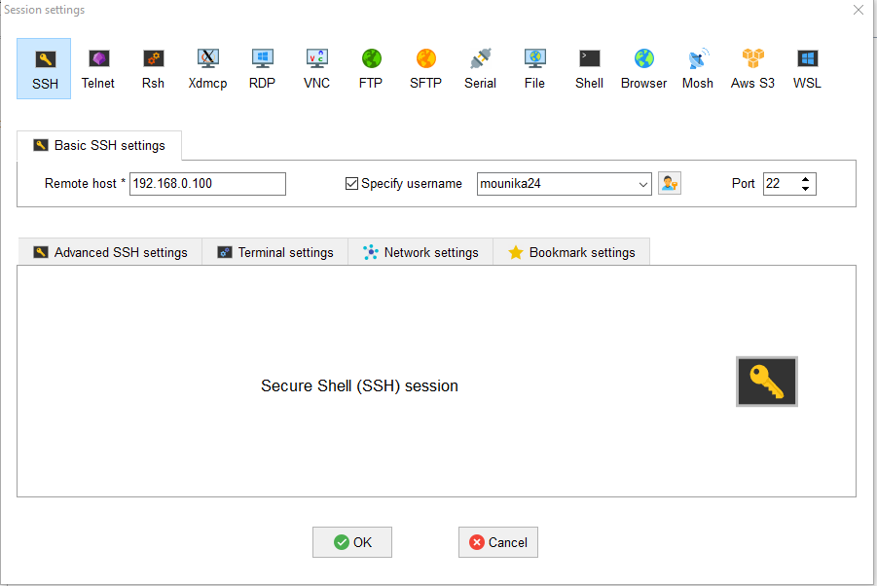
- Then enter the password.
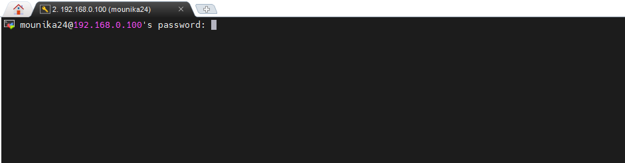
- You should be able to successfully log in to the server using the new IP.
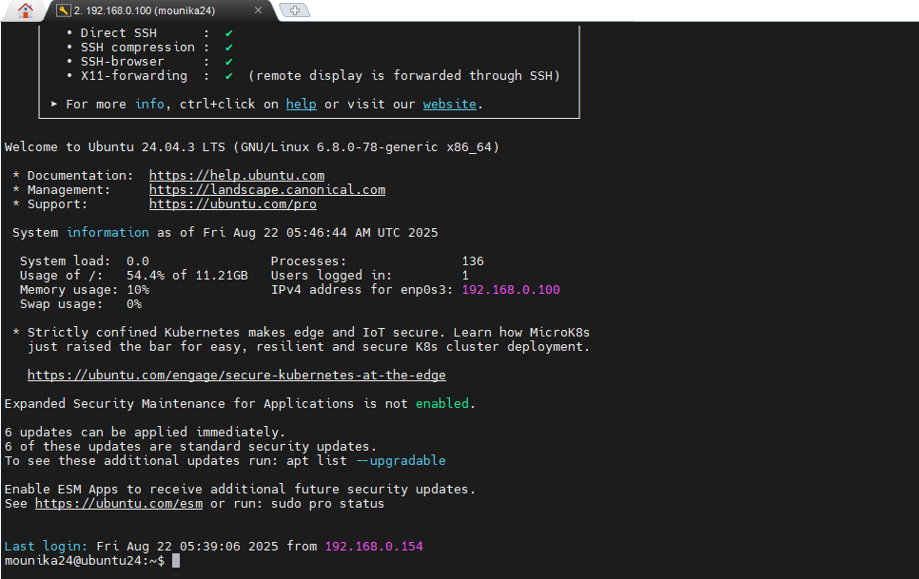
Steps to assign Static IP in RedHat (Fedora) Server using CLI
- View the list of network connections using below command:
nmcli con show
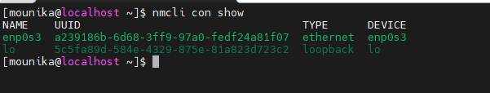
- Assign a static IP using following commands:

# Set static IP + method
sudo nmcli con mod enp0s3 ipv4.addresses 192.168.0.50/24 ipv4.method manual

# Set gateway
sudo nmcli con mod enp0s3 ipv4.gateway 192.168.0.1

# Set DNS servers
sudo nmcli con mod enp0s3 ipv4.dns "1.1.1.1 8.8.8.8"

# Bring the connection back up
sudo nmcli con up enp0s3

- Verify the assigned static IP by running the following command:
ip addr show
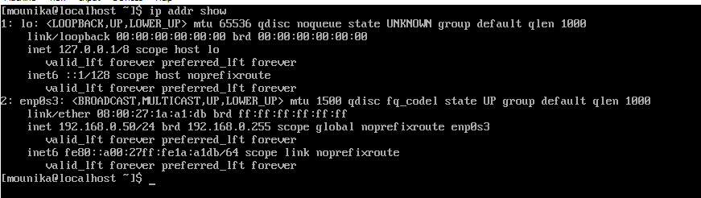
- Test SSH access to your server using the newly assigned static IP.
- Use an SSH client like MobaXterm or putty.
- Enter the assigned IP and your username as shown in the figure below.
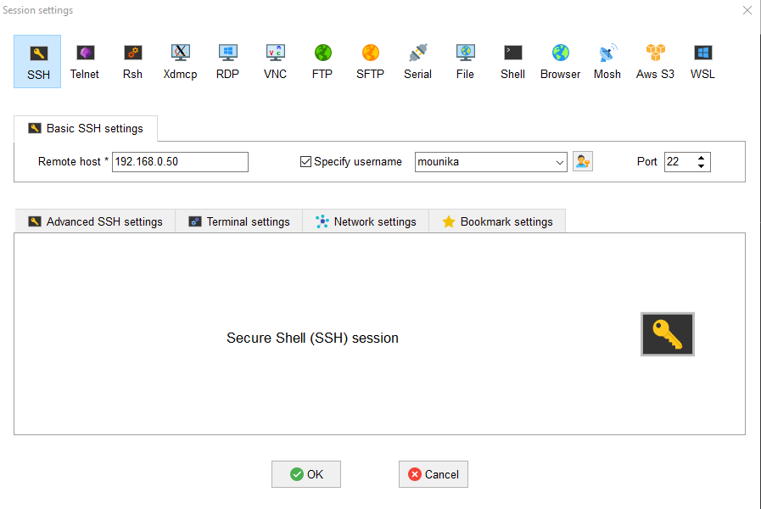
- Then enter the password.
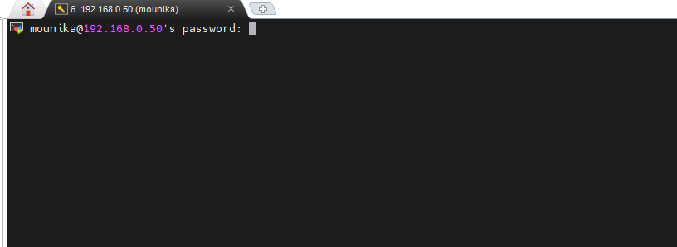
- You should be able to successfully log in to the server using the new IP.
