Steps to Join a Windows System to a Domain
1. Press Win + R, type ncpa.cpl, and press Enter.
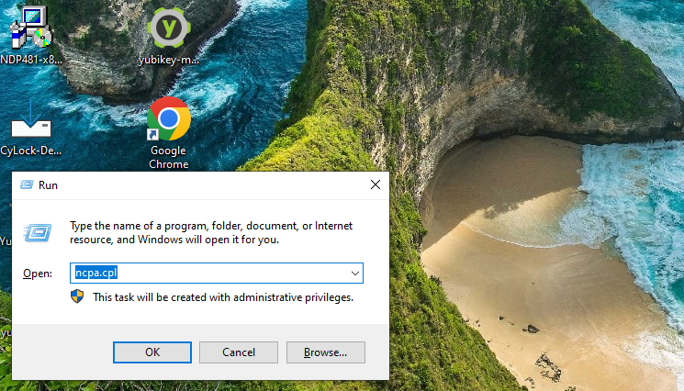
2. Right-click on your active network adapter → select Properties.
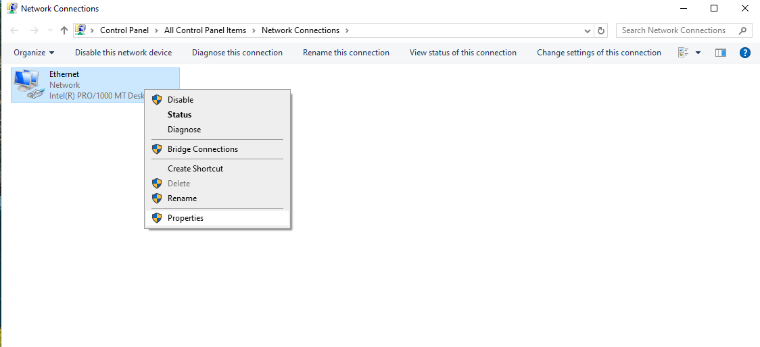
3. Double-click on Internet Protocol Version 4 (TCP/IPv4).
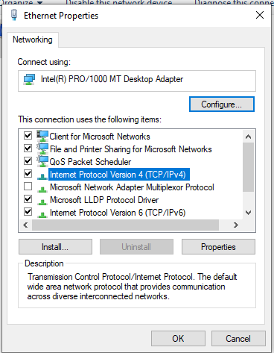
4. Select Use the following DNS server addresses.
Enter the IP address of your Active Directory (AD) server (e.g., 192.168.0.75) as shown in the figure below → click OK.
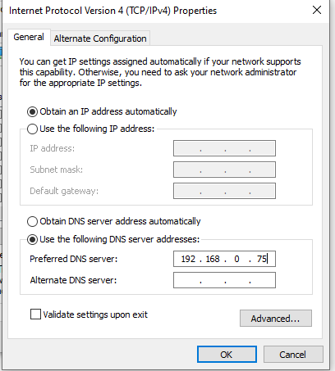

5. Right-click on This PC → select Properties.
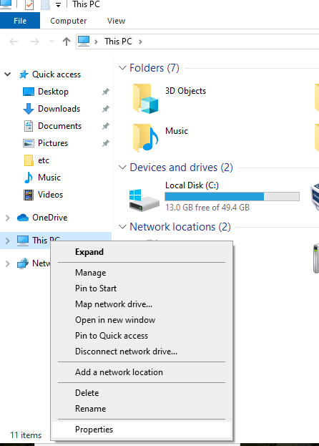

6. Click on Rename this PC (advanced).

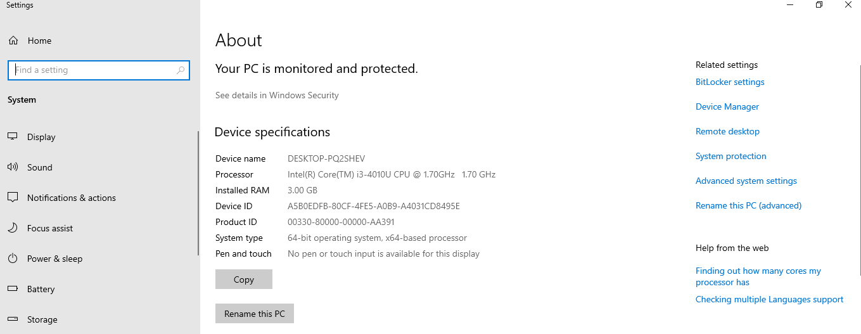
7. In the System Properties window, click Change next to “To rename this computer or change its domain or workgroup. click Change”. Refer figure below.
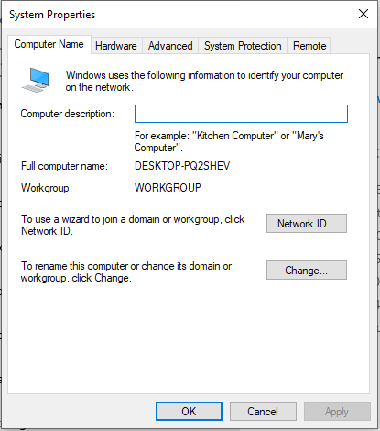
8. Under Member of, select Domain.
Enter the Domain Name (e.g., cylock.com) and click OK

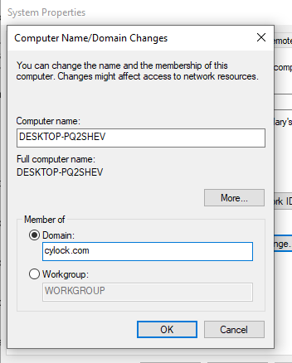
9. When prompted, enter Domain Admin credentials (e.g. Username: Administrator, Password: admin@123).
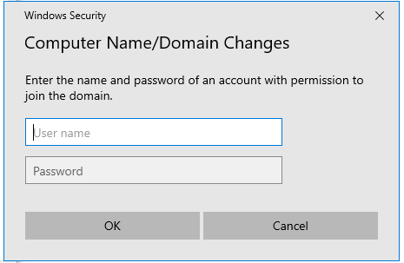
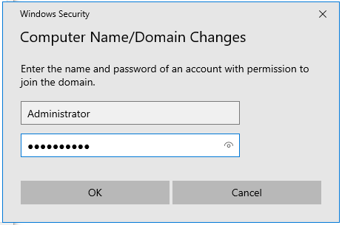
A success message will appear confirming that the computer has joined the domain as shown in the figure below. Click OK
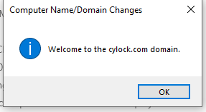
10. Click OK when prompted to restart your system.
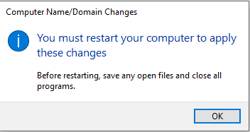
11. Then Click on Close in System properties page. Refer figure below.
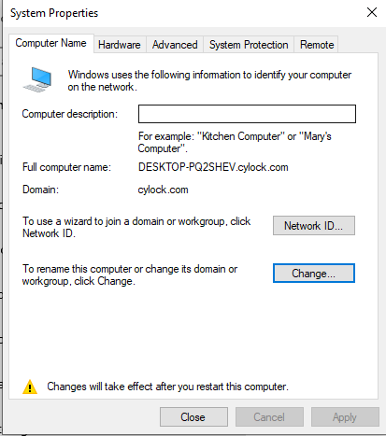
12. Now system will prompt for restart as shown in the figure below. Click on Restart Now.

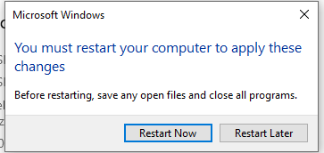
The system will restart to complete the domain join process.

13. Now on the login screen, select Other user. You can observe the domain name on the login screen which means your Windows system is successfully joined to the domain
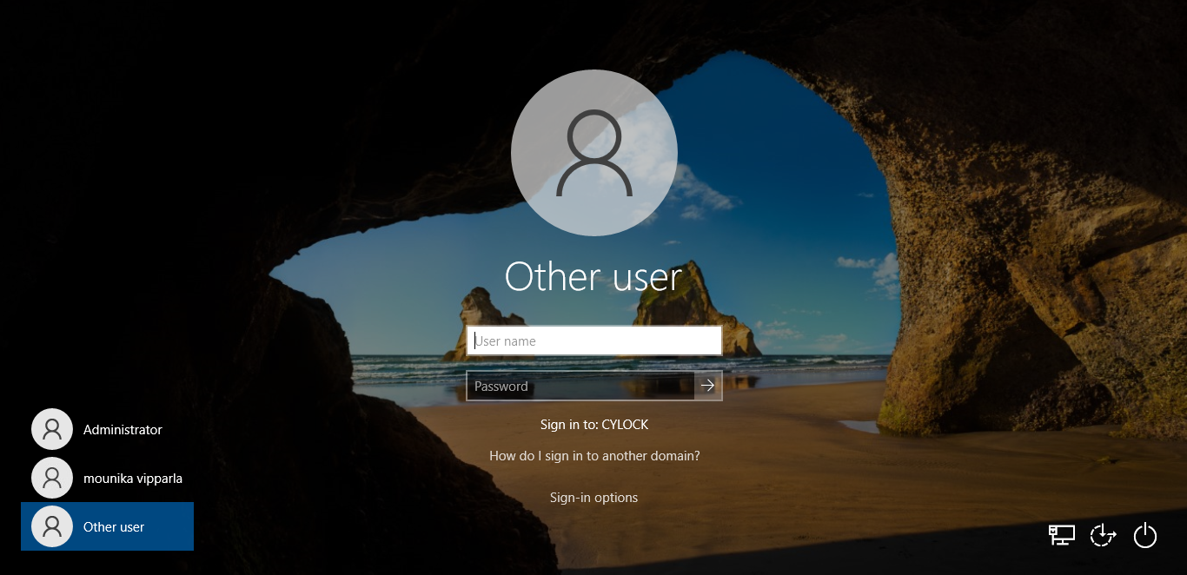
You can log in using your Active Directory credentials in any of the following formats:
- cylock\username
- username@cylock.com
- Just the username (if the domain is already selected by default)
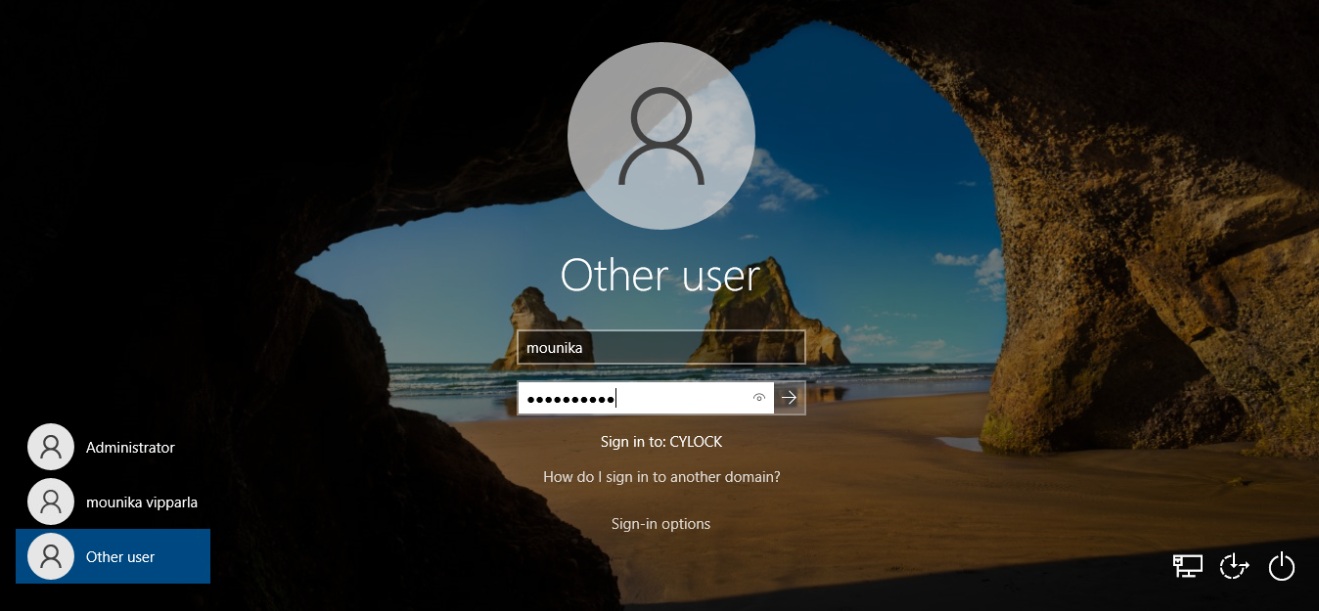

After logging in with your domain user account, you can verify that the system is successfully joined to the domain:
- Click on the network (Wi-Fi/Ethernet) icon in the taskbar.
- In the network connection details, you will see the domain name associated with the system.
This confirms that the system is now part of the domain.
