WEEK 2 TASK REPORT
Creating Financial Forecasts
Reliance Industries Limited
Forecasting the Closing Stock Price Using ARIMA

Dataset | Reliance Industries Historical Daily Stock Prices
Historical period | 01 January 1996 – 28 February 2025
Analytical records | 7,324
Forecast indicator | Closing stock price (close)
Final model | ARIMA(5,1,0)

1. Introduction
Financial forecasting uses historical financial observations to estimate future values and support planning and decision-making. This Week 2 task extends the previous analysis of Reliance Industries historical stock-price data by developing and evaluating a basic forecasting model for one financial indicator.
The selected indicator is the daily closing stock price. Because the dataset contains ordered observations across many years, the analysis treats the data as a time series. Several simple approaches were considered, and ARIMA was selected as the preferred model after model evaluation.

2. Objective
The objective of this task is to develop a basic financial forecast model using historical Reliance Industries stock-price data, evaluate its performance on unseen recent observations, generate a short-term future forecast, and analyze the forecast results and model limitations.

3. Dataset Description
The dataset is the same Reliance Industries historical stock-price dataset used for the previous analysis. The earlier report identifies the source as Kaggle and describes it as daily historical stock-market data. The workbook contains the fields date, open, high, low, close, adj_close, and volume.
Item | Details
Source | Kaggle dataset used in the previous analysis
Company | Reliance Industries
Raw imported rows | 7,329
Clean analytical records | 7,324
Columns | 7
Date range | 01-01-1996 to 28-02-2025
Forecast indicator | close

3.1 Dataset Variables
Variable | Description
date | Trading date
open | Opening stock price
high | Highest price of the day
low | Lowest price of the day
close | Closing stock price
adj_close | Adjusted closing price
volume | Number of shares traded

4. Data Preparation and Cleaning
The imported workbook contained several non-observation rows at the bottom, including a blank row, a repeated header-like row, and summary rows labelled AVERAGE, MINIMUM, and MAXIMUM. These rows were not valid daily observations and were removed before modelling.
Cleaning step | Action / Result
Date conversion | Converted the date field to a proper datetime format
Invalid date rows | Removed rows where date could not be interpreted as a date
Closing price | Converted close to numeric and removed invalid closing-price rows
Sorting | Sorted observations chronologically
Result | 7,324 valid trading observations retained

5. Selection of Financial Indicator
The closing stock price (close) was selected as the forecasting indicator. It is a direct market-based financial measure, is available for every trading day in the cleaned dataset, and forms a naturally ordered time series. Forecasting the closing price also provides a clear numerical output that can be compared with actual future observations.

6. Historical Closing Price Trend
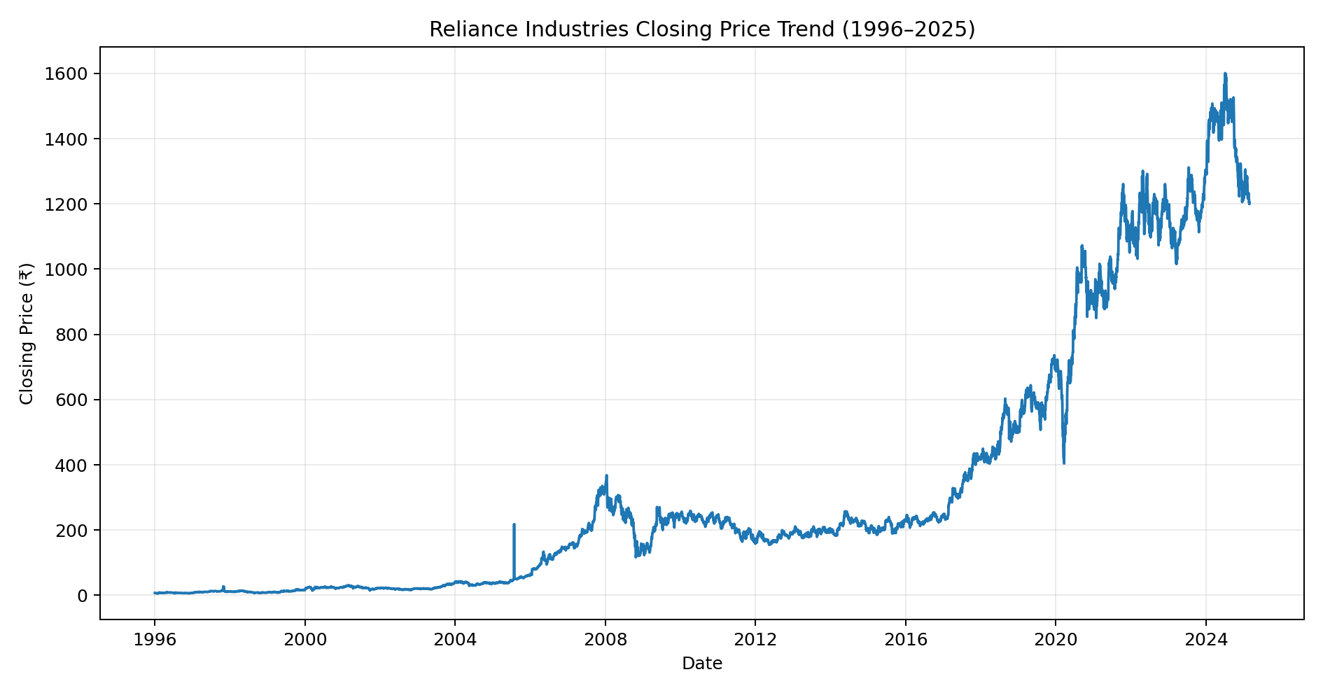
Figure 1. Historical closing-price trend of Reliance Industries, 1996–2025.
The historical series shows substantial long-term movement and periods of pronounced volatility. The wide range of price levels across the 1996–2025 period is one reason why a model trained on the entire historical period with a simple linear trend is not sufficient for short-term forecasting.

7. Forecast Model Design
The forecasting process used a chronological train-test design rather than a random split. Recent observations were selected so that the model was trained on a market regime closer to the testing period.
Stage | Period | Observations
Training period | 2020–2024 | 1,238 observations
Testing period | 2025 available observations | 43 observations
Final forecast input | 2020–2025 available observations | 1,281 observations
Future horizon | 30 future trading periods | 30 forecasts

7.1 Model Selection
A simple Linear Regression model was first tested as a baseline. It produced substantial underprediction during the testing period, showing that a single straight-line trend did not represent the changing stock-price series adequately.
Exponential Smoothing was then evaluated. Although it was able to produce a forecast, its long testing-period errors were high. ARIMA was subsequently tested because it is designed for sequential time-series observations and can model temporal dependence in the series.
The selected ARIMA specification was ARIMA(5,1,0). The model uses five autoregressive terms and one order of differencing. It was selected as the preferred approach among the tested models based on substantially lower MAE and RMSE on the 2025 test observations.

8. Model Implementation
- Load the cleaned Reliance Industries dataset.
- Select the date and closing-price fields for the forecasting workflow.
- Use 2020–2024 observations as training data.
- Reserve the available 2025 observations as unseen test data.
- Fit an ARIMA(5,1,0) model to the training closing-price series.
- Generate forecasts for the 2025 testing period.
- Compare forecasts with actual 2025 closing prices using MAE, RMSE, and R².
- Retrain the final ARIMA model using all available observations from 2020 through February 2025.
- Generate a 30-period future closing-price forecast.

9. Forecast Evaluation
Metric | Result | Interpretation
Mean Absolute Error (MAE) | 31.55 | Average absolute difference between actual and forecast price
Root Mean Squared Error (RMSE) | 39.19 | Penalizes larger forecast errors more strongly
R² | -1.3921 | Measures explained variation relative to a baseline

The ARIMA model produced an MAE of ₹31.55 and an RMSE of ₹39.19 on the 2025 test observations. Its R² was -1.3921, which is negative. Therefore, the model should not be described as highly accurate or as explaining most of the variation in the test-period prices. Its main advantage in this exercise is that it produced much lower MAE and RMSE than the earlier Exponential Smoothing model.

10. Actual vs ARIMA Forecast
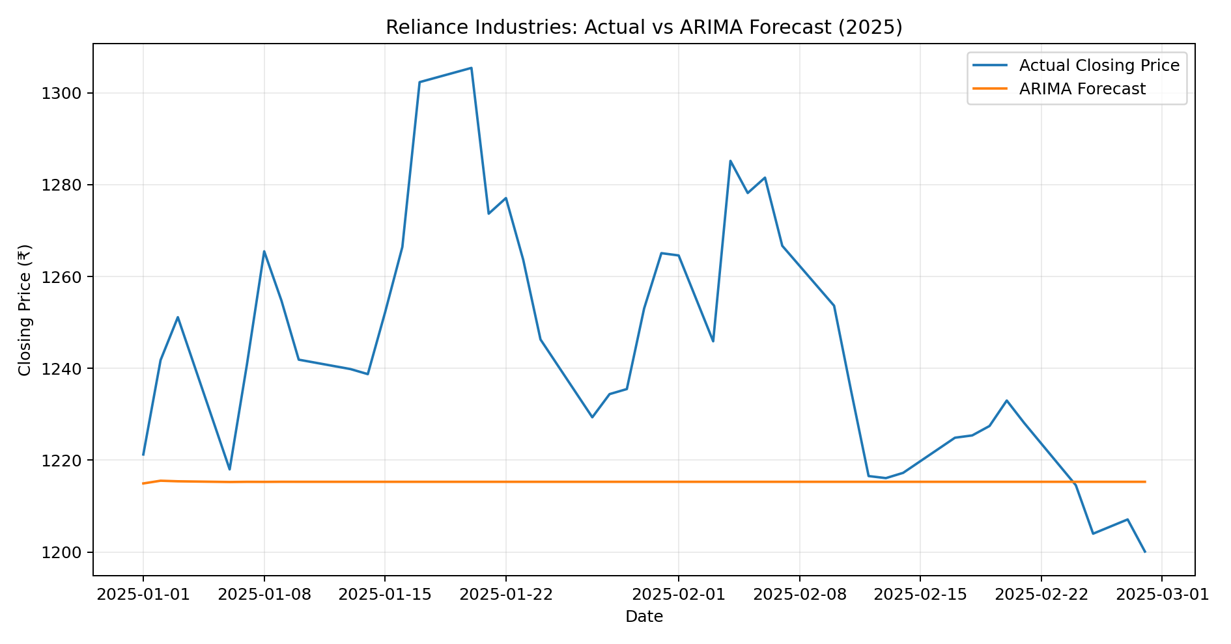
Figure 2. Actual versus ARIMA forecast for the available 2025 test period.
The chart shows that actual closing prices moved considerably during the 2025 testing period, while the ARIMA forecasts were comparatively stable. This visual difference explains why the model still has a negative R² even though its MAE and RMSE are substantially lower than those from the earlier Exponential Smoothing experiment.

10.1 Sample Test-Period Forecasts
Date | Actual (₹) | ARIMA Forecast (₹) | Absolute Error (₹)
01-01-2025 | 1221.25 | 1214.94 | 6.31
02-01-2025 | 1241.80 | 1215.53 | 26.27
03-01-2025 | 1251.15 | 1215.41 | 35.74
06-01-2025 | 1218.00 | 1215.25 | 2.75
07-01-2025 | 1240.85 | 1215.29 | 25.56
08-01-2025 | 1265.50 | 1215.28 | 50.22
09-01-2025 | 1254.75 | 1215.30 | 39.45
10-01-2025 | 1241.90 | 1215.30 | 26.60
13-01-2025 | 1239.85 | 1215.30 | 24.55
14-01-2025 | 1238.75 | 1215.30 | 23.45

11. 30-Period Future Forecast
After evaluation, the final ARIMA(5,1,0) model was fitted using all available recent observations from 2020 through 28 February 2025. The model was then used to generate forecasts for the next 30 future trading periods.
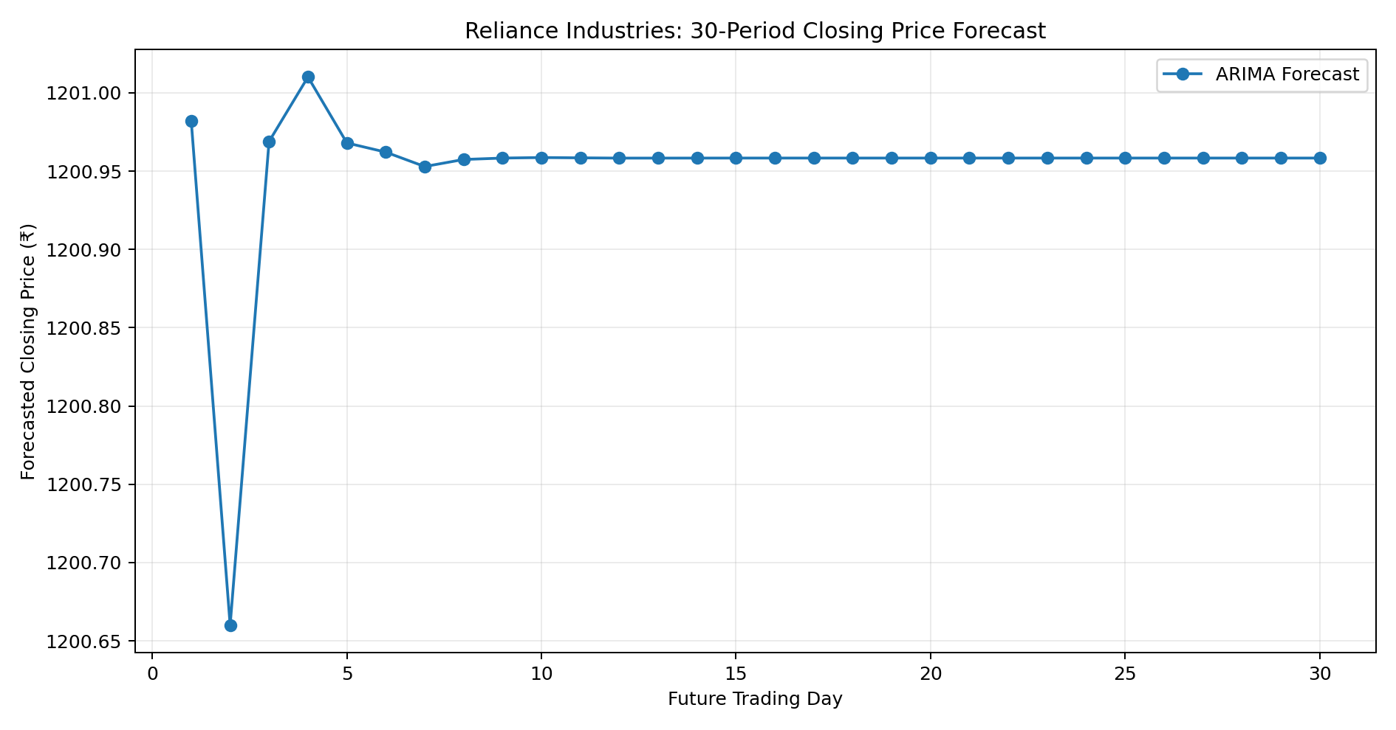
Figure 3. ARIMA forecast for the next 30 future trading periods.
Period | Forecast (₹) | Period | Forecast (₹)
1 | 1200.98 | 16 | 1200.96
2 | 1200.66 | 17 | 1200.96
3 | 1200.97 | 18 | 1200.96
4 | 1201.01 | 19 | 1200.96
5 | 1200.97 | 20 | 1200.96
6 | 1200.96 | 21 | 1200.96
7 | 1200.95 | 22 | 1200.96
8 | 1200.96 | 23 | 1200.96
9 | 1200.96 | 24 | 1200.96
10 | 1200.96 | 25 | 1200.96
11 | 1200.96 | 26 | 1200.96
12 | 1200.96 | 27 | 1200.96
13 | 1200.96 | 28 | 1200.96
14 | 1200.96 | 29 | 1200.96
15 | 1200.96 | 30 | 1200.96

12. Analysis of Forecast Results
The 30-period forecast begins at approximately ₹1200.98. The lowest forecast among the 30 periods is approximately ₹1200.66, while the highest is approximately ₹1201.01. After the small initial movement, the forecast converges to a nearly stable level around ₹1200.96.
This flat pattern is a model output rather than a guarantee about the market. It indicates that the fitted ARIMA specification does not project strong directional movement beyond the recent information contained in the series. Actual market prices can move substantially due to news, earnings, macroeconomic conditions, sector developments, investor sentiment, and other factors that are not explicitly included in this univariate model.

13. Model Limitations
- The model uses only historical closing prices and does not include external explanatory variables.
- Stock prices are affected by unpredictable market events and can change rapidly.
- The negative R² on the 2025 test period indicates limited explanatory power for price variation.
- The nearly flat future forecast should be interpreted as a statistical baseline, not a guaranteed market outcome.
- A more advanced production forecasting system could incorporate returns, volatility, market indices, trading volume, macroeconomic variables, and event information.

14. Conclusion
This task developed a basic financial forecasting workflow for Reliance Industries using historical daily closing prices. The dataset was cleaned, a chronological training and testing strategy was applied, and multiple forecasting approaches were considered. ARIMA(5,1,0) was selected as the preferred model because it achieved substantially lower MAE and RMSE than the earlier Exponential Smoothing approach on the available 2025 test data.
The selected model achieved an MAE of ₹31.55, an RMSE of ₹39.19, and an R² of -1.3921. The final model was then used to produce a 30-period future forecast. The results demonstrate the complete forecasting process—indicator selection, model design, implementation, evaluation, forecasting, and interpretation—while also recognizing the limitations of a simple univariate stock-price model.

15. Appendix: Key Python Workflow
# Clean the data
df["date"] = pd.to_datetime(df["date"], errors="coerce")
df = df.dropna(subset=["date"]).sort_values("date").reset_index(drop=True)
# Train/test split
train_recent = df[df["date"].dt.year < 2025]
test_recent = df[df["date"].dt.year == 2025]
# ARIMA model
model = ARIMA(train_recent["close"].astype(float), order=(5, 1, 0))
fit = model.fit()
# Forecast
forecast = fit.forecast(steps=len(test_recent))

