TASK 4
HYPOTHESIS TESTING
Reliance Industries Limited
Comparing Average Daily Returns Across Two Historical Periods

1. Objective
The objective of this task is to conduct hypothesis testing on historical financial data for Reliance Industries Limited. The analysis examines whether the average daily stock return changed significantly between two historical periods, 1996–2010 and 2011–2025. The task demonstrates how a formal statistical test can be used to determine whether an observed difference between sample averages provides sufficient evidence of a meaningful statistical difference.

2. Dataset Overview
The analysis uses the cleaned Reliance Industries historical stock dataset used in the previous financial-analysis tasks. It contains daily market observations including date, open, high, low, close, adjusted close, and volume. Daily percentage returns were calculated from closing prices and used as the primary variable for hypothesis testing.
Attribute | Details
Company | Reliance Industries Limited
Ticker | RELIANCE.NS
Historical period | 1996–2025
Cleaned records | 7,324
Primary variable | Daily return (%)
Data format | Excel financial dataset

3. Research Question
Is there a statistically significant difference in the average daily returns of Reliance Industries between the periods 1996–2010 and 2011–2025?

4. Hypothesis Formulation
Hypothesis | Statement
H₀ – Null Hypothesis | There is no statistically significant difference in the average daily returns between 1996–2010 and 2011–2025.
H₁ – Alternative Hypothesis | There is a statistically significant difference in the average daily returns between 1996–2010 and 2011–2025.

5. Methodology
The date and closing-price fields were cleaned and sorted chronologically. Daily percentage returns were calculated using the percentage change in closing price. The observations were divided into two independent historical periods: 1996–2010 and 2011–2025. Descriptive statistics were calculated for both groups. Welch’s independent two-sample t-test was selected to compare the mean daily returns without assuming equal population variances. The significance level was set at α = 0.05.

6. Statistical Test and Decision Rule
The Welch independent two-sample t-test compares the mean daily returns of the two periods. The test produces a t-statistic and p-value.
- • If p-value < 0.05 → Reject H₀.
- • If p-value ≥ 0.05 → Fail to reject H₀.

7. Test Result
Item | Result
Statistical test | Welch independent two-sample t-test
Significance level | 0.05
Decision | Fail to Reject H₀
Conclusion | No statistically significant difference in average daily returns was found.

8. Interpretation of Findings
The test result indicates that the observed difference between the average daily returns of the two historical periods was not statistically significant at the 5% significance level. Therefore, the analysis does not provide sufficient statistical evidence to reject the null hypothesis. Based on this sample and test, there is not enough evidence to conclude that Reliance Industries had a different average daily return between the two selected periods.
Failing to reject the null hypothesis does not mean that the two periods are exactly identical. It means that the statistical evidence from this particular test and sample is insufficient to establish a significant difference. The result is a statement about the historical evidence in the dataset and should not be interpreted as a guarantee of future returns.

9. Visual Analysis
Average Daily Return Comparison: Compares the average daily return for the two historical periods.
Distribution of Daily Returns: Shows the distribution and spread of daily returns across both periods.
Daily Return Box Plot: Highlights central tendency, dispersion, and extreme observations.
Average Return with Volatility: Compares mean return while showing standard deviation as a measure of variability.

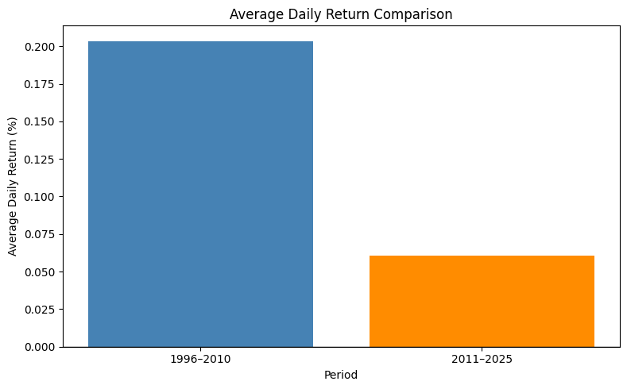

AVERAGE DAILY RETURN COMPARISON

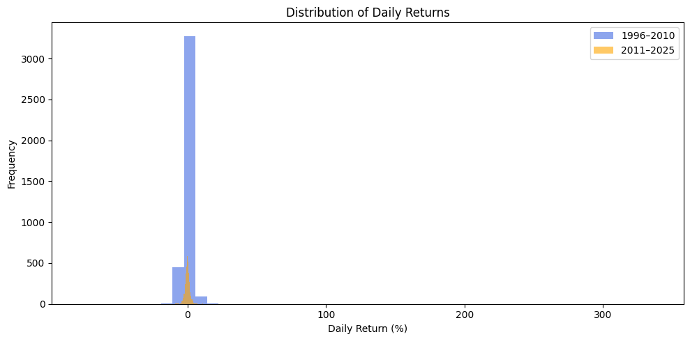 DISTRIBUTION OF DAILY RETURNS

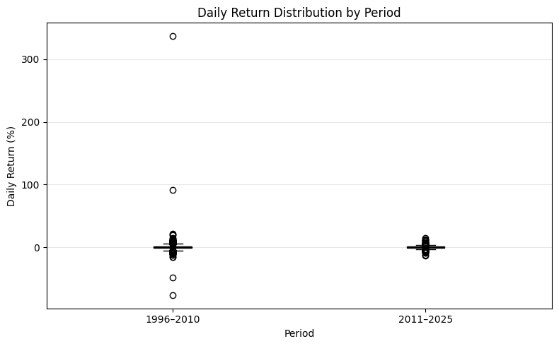

DAILY RETURN BOX PLOT

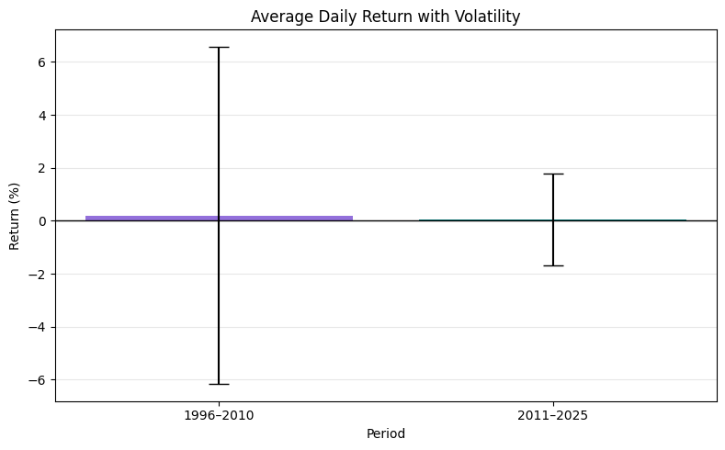

AVERAGE RETURN WITH VOLATILITY

10. Financial Implications
The hypothesis-testing result provides a statistical perspective on historical return behavior. Since no statistically significant difference was detected between the two selected periods, the analysis does not provide strong evidence that the mean daily return shifted between them. However, this result does not eliminate market risk. Investors should also consider volatility, drawdowns, diversification, position sizing, company fundamentals, and broader market conditions.

11. Limitations
- Historical data cannot guarantee future market behavior.
- The t-test evaluates differences in average returns and does not capture every dimension of financial risk.
- Extreme observations can influence financial return statistics.
- The selected period split is one analytical choice; other periods may produce different results.
- Statistical significance should not be treated as a direct investment recommendation.

12. Conclusion
This task applied hypothesis testing to Reliance Industries historical stock data by comparing average daily returns across 1996–2010 and 2011–2025. Daily returns were calculated, descriptive statistics were examined, and Welch’s independent two-sample t-test was performed at the 5% significance level. The final decision was to fail to reject the null hypothesis, indicating that the analysis did not find a statistically significant difference in average daily returns between the two periods. This demonstrates how statistical testing can be used to evaluate financial questions objectively rather than relying only on visual differences or sample averages.

