TASK 5
DATA VISUALIZATION
Reliance Industries Limited (RELIANCE)
Financial Dataset Visualization and Interpretation

1. Objective
The objective of this task is to create meaningful and insightful visualizations using the historical financial dataset of Reliance Industries Limited. The analysis uses charts to reveal patterns in stock prices, trading activity, daily returns, yearly performance, and changing volatility. Visualization makes long-term trends and unusual movements easier to identify and interpret than raw numerical tables alone.

2. Dataset Overview
The dataset contains historical daily market information for Reliance Industries, including date, opening price, highest price, lowest price, closing price, adjusted closing price, and trading volume. The cleaned dataset used in the previous tasks contained 7,324 valid records covering the historical period from 1996 to 2025. Daily returns were calculated from closing prices and were used for return and volatility visualizations.

3. Visualization Approach
Six visualizations were selected to provide different perspectives on the financial dataset. Line charts were used for time-series movements, histograms for return distributions, and bar charts for yearly comparisons. Rolling standard deviation was used to visualize changing 30-day volatility. Together, the charts provide a balanced view of price movement, market activity, return behavior, and financial risk.
Attribute | Details
Company | Reliance Industries Limited
Ticker | RELIANCE.NS
Historical period | 1996–2025
Cleaned records | 7,324
Main variables | Date, Open, High, Low, Close, Adjusted Close, Volume
Tools | Python, Pandas, Matplotlib, Google Colab

4. Visualization 1 – Closing Price Trend
The closing-price trend chart displays Reliance Industries' daily closing price across the historical period. It provides a long-term view of how the market value represented by the closing price changed over time. Major upward and downward movements are easier to observe than in a raw table. Sustained rises indicate periods of upward movement, while sharp declines indicate periods of substantial price correction or market stress. The chart is useful for understanding the overall historical price trajectory.

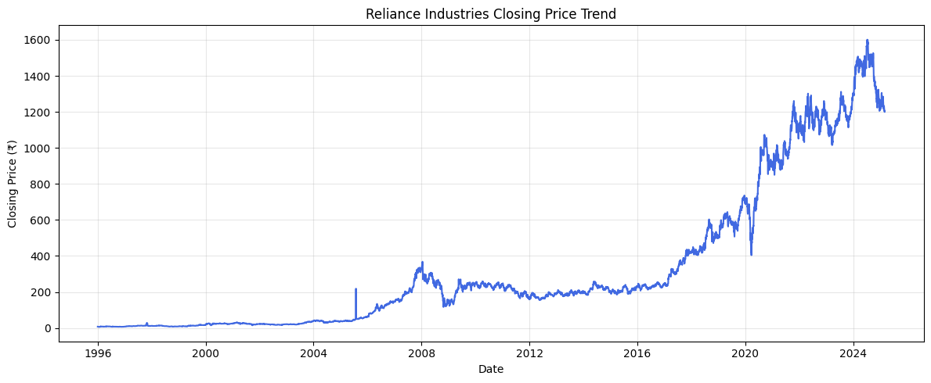

5. Visualization 2 – Trading Volume Over Time
The trading-volume chart shows the number of shares traded over time. Unusually high trading volume can indicate periods of increased investor participation or strong buying and selling activity, while lower values indicate quieter trading conditions. Examining volume together with price movement provides additional context for significant market changes.

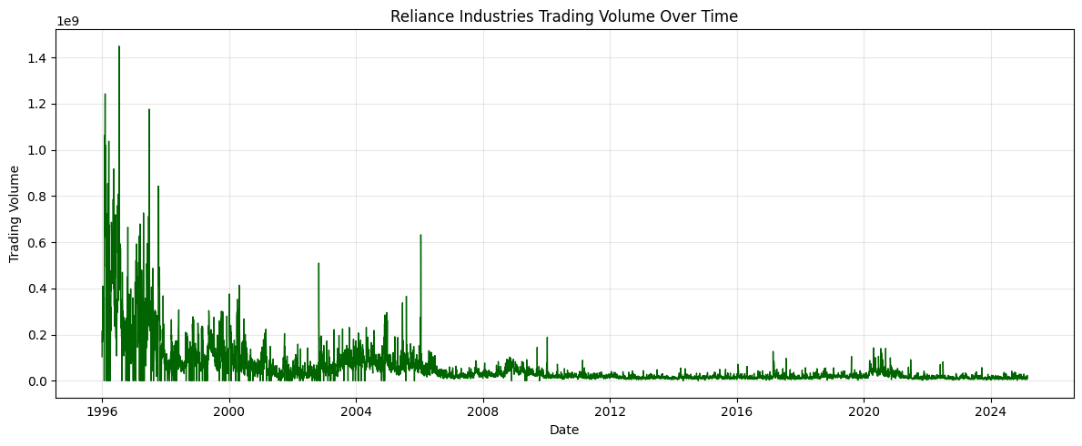

6. Visualization 3 – Distribution of Daily Returns
The daily-return distribution chart shows how frequently different daily percentage returns occurred. Most observations are generally concentrated around smaller movements, while the tails represent unusually large gains or losses. The spread of the distribution provides an indication of return variability and the presence of extreme observations.

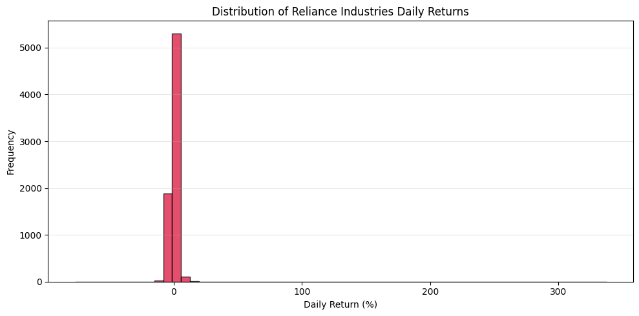

7. Visualization 4 – Average Daily Return by Year
The yearly average-return chart compares the mean daily return for each calendar year. Bars above zero represent positive average daily returns, while bars below zero represent negative averages. This visualization makes it easier to identify years with relatively stronger or weaker average daily performance.

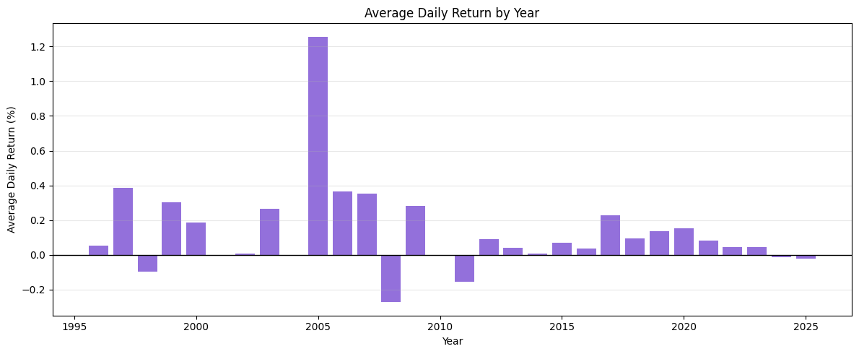

8. Visualization 5 – 30-Day Rolling Volatility
The 30-day rolling-volatility chart shows how the variability of daily returns changed over time. Peaks indicate periods of elevated short-term uncertainty, while lower values indicate comparatively stable return behavior. This visualization connects directly with the financial risk analysis performed in Task 3.

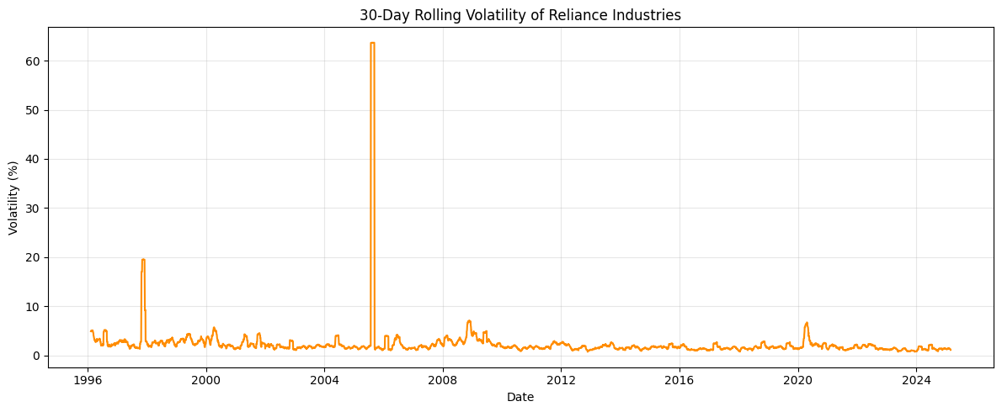

9. Visualization 6 – Average Trading Volume by Year
The yearly average-trading-volume chart compares average trading activity across calendar years. It identifies years with relatively higher or lower market participation and provides a longer-term view than the daily volume chart.

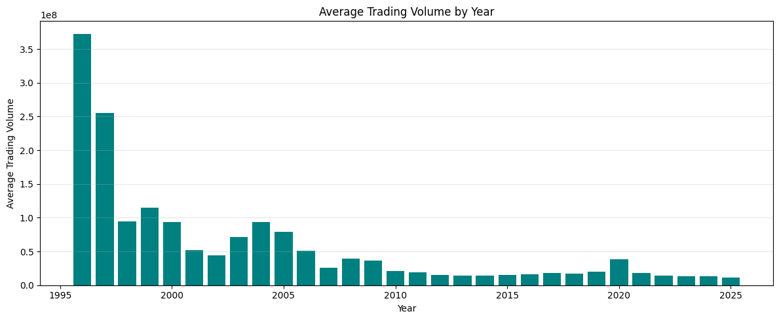

10. Key Insights
- The closing-price visualization provides a clear view of the long-term movement in Reliance Industries' stock price.
- Trading volume varies across the historical period, indicating changing levels of market activity.
- Daily returns contain both positive and negative observations, with extreme movements visible in the distribution tails.
- Yearly average returns provide a compact comparison of performance across calendar years.
- Rolling volatility demonstrates that market risk changes over time rather than remaining constant.
- Annual trading-volume comparisons provide a higher-level view of changes in market participation.

11. Financial Interpretation
The visualizations demonstrate why data visualization is valuable in financial analysis. Price trends help identify long-term movement, volume charts provide context about market activity, return distributions reveal the frequency and magnitude of daily price changes, and rolling volatility highlights changing risk conditions. No single chart is sufficient to describe financial performance. Combining several complementary visualizations provides a more complete understanding of historical market behavior.

12. Conclusion
This task applies data visualization techniques to the historical financial dataset of Reliance Industries Limited. Six complementary visualizations were developed to examine closing-price trends, trading volume, daily-return distribution, yearly average returns, rolling volatility, and yearly trading activity. The charts make complex historical information easier to understand and help reveal patterns that may not be obvious from raw numerical data. Overall, the task demonstrates practical skills in financial data analysis, visualization, and interpretation using Python.

