9/10/2025

ROCK PAPER SCISSORSCISSOR GAME

**BESANT TECHNOLOGIES**

**SUBMITTED TO**: iGOWTHAMI MADAM

co-ordinator:DHOORIKA MADAM

**SUBMITTED BY**: mounika k

**ACKNOWLEDGEMENT:**

I would like to express my sincere gratitude to “GOWTHAMI MADAM”,”DHOORIKA MADAM” who provided me with the valuable guidance and encouragement to successfully complete this project. Their continuous support and constructive suggestions were essential in shaping the rock-paper -scissor game into its final form.

I am also thankful to my institution , “BESANT TECHNOLOGIES” , for giving me the opportunity and resources to work on this project.

Table of content

|  |  |  |
| --- | --- | --- |
| Si.no | topic | Page.no |
| 1 | Introduction to python | 1 |
| 2 | Introduction about project | 2 |
| 3 | Concept used in the project | 3-4 |
| 4 | Source code | 5 |
| 5 | Description about the code | 6 |
| 6 | output | 7-8 |
| 7 | conclusion | 9 |
| 8 | Bibliography | 10 |
| 9 | Github link | 11 |

INTRODUCTION TO PYTHON

Python is a high level general purpose programming language, python is an interpreted programming language.

Python was created by “GUIDO VAN ROSSUM” , and released in 1991.

**Python is used for the following reasons:**

Python works on different platforms(windows , Mac, Linux , Raspberry Pi, etc .

Python has simple syntax similar to the English language

Python has syntax that allows developers to write programs with fewer lines than some other programming languages.

Python runs on an interpreter system,meaning that code can be executed as soon as it is written. this means that prototyping can be very quick.

Python can be treated in a procedural way ,an object -oriented way or a functional way.

**APPLICATIONS OF PYTHON:**

**Web and Internet Development:**

* frameworks such as Django and Pyramid.
* micro-frameworks such as Flask and Bottle.

**Scientific and Numeric:**

* **SciPy** is a collection of package for mathematics , science , and engineering.
* **pandas** is a data analytics and modeling library

**Desktop GUIs:**

WxWidgets

Kivy,for writing multitouch applications

**INTRODUCTION ABOUT PROJECT:**

Rock, paper, scissor is a simple classic game that is commonly played between two people (here between user and computer) .

In this game each can choose one of three possible moves :rock ,paper or scissor

**THE RULES ARE SIMPLE:**

Rock beats scissor

Scissors beats paper

Paper beats rock

the game type is a turn- based,two -players game,typically between player vs computer in our concept.

**CONCEPT USED IN THE PROJECT:**

**random module:**

The random module is used to generate a random values.

In the source code, we are using a choice() function to randomly select the computer choice among the given list of values. so in order to use choice(), we are importing a random module.

**input():**

The input() is used to read the data from the user at the run time.

In order to read the user choice at the run time ,in python language we are using input(). it always return the string data type, we can typecast it as per our requirements.

**print():**

print() is a output function, it displays the output on the screen.

In the code, print is used to the user , computer choice and display the winner .

**while():**

The while loop is used to execute a set of statements repeatedly as long as the given condition is true.

**break:**

break statement is a command that interrupts the normal flow of a loop ,immediately exiting the loop and continuing execution with the next statement after the loop.

**if-else:**

if statement is the most simple decision making statement.if the condition evaluates to True ,the block of code inside the if statement is executed.

**if-elif-else:**

with the if-elif statements, only the code block associated with the clause that evaluates to True will execute.

All the remaining clauses which are False will never execute.

**else:**

the else statement in python will execute when all the given condition is are not evaluated as True.

**SOURCE CODE:**

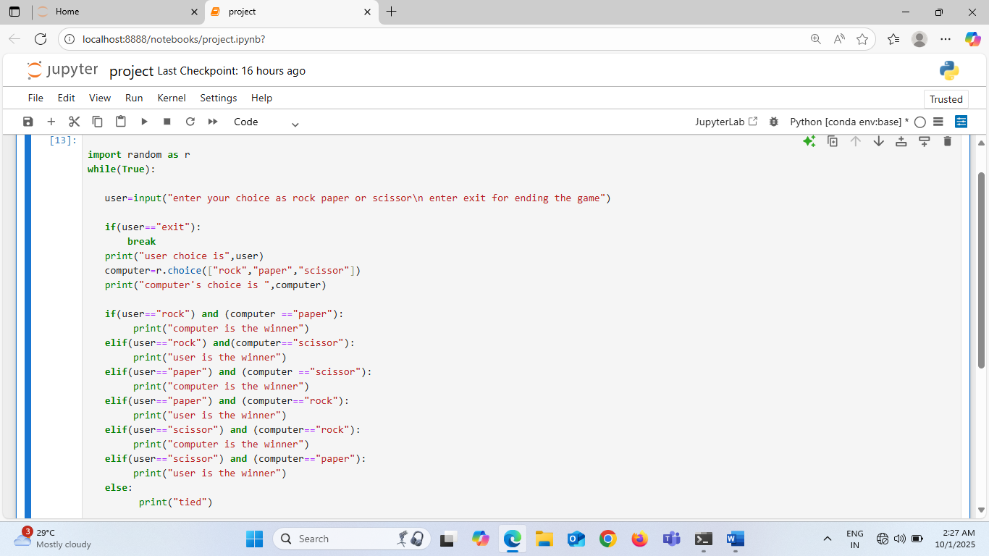

DECRIPTION ABOUT CODE:

The code consist of

* random module ,is used to generate a random numbers or pick the random items from a list,in this case random module is used to let the computer randomly pick rock, apaper or scissor.
* infinite loop for game ,the game runs continuously ,this is useful because we want the game to be played multiple times without restarting the program every time.the game will be running until the user type “exit”.
* user inpit(), asks the player to choose rock, paper, or scissor .if the player types “exit, the game stops.
* exit condition , breaks out the loop if the user types “exit”.
* computer’s choice , the computer randomly selects one of the three options.
* display the user and computer choice using print ().
* check all possible conditions in the game using conditional statements.
* rock vs paper 🡪paper wins

paper covers rock so paper is winner.

* rock vs scissor 🡪rock wins

rock crushes scissor so rock is winner.

* paper vs scissor 🡪scissor wins

scissor cuts paper so scissor is the winner

* paper vs rock 🡪paper wins

paper covers rock so paper is the winner

* scissor vs rock 🡪rock wins

rock crushes the scissor ,rock is the winner

* scissor vs paper🡪scissor wins
* if both choose the same 🡪tied
* as we are using conditional statements in the code it will checks all the conditions which are mentioned above and execute the statements which are associated with the True block and skip the remaining statements in the loop

**OUTPUT:**

case 1: rock vs paper

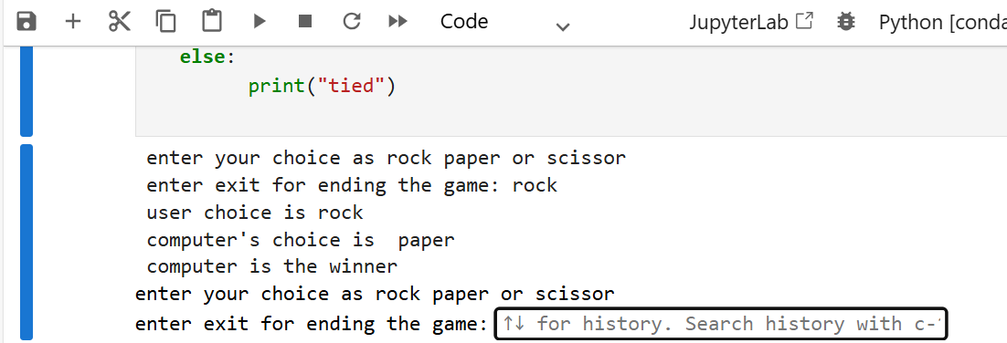

case 2: rock vs scissor

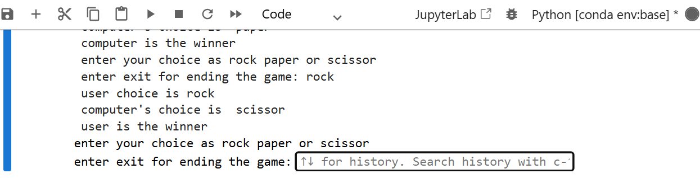

case 3: tie

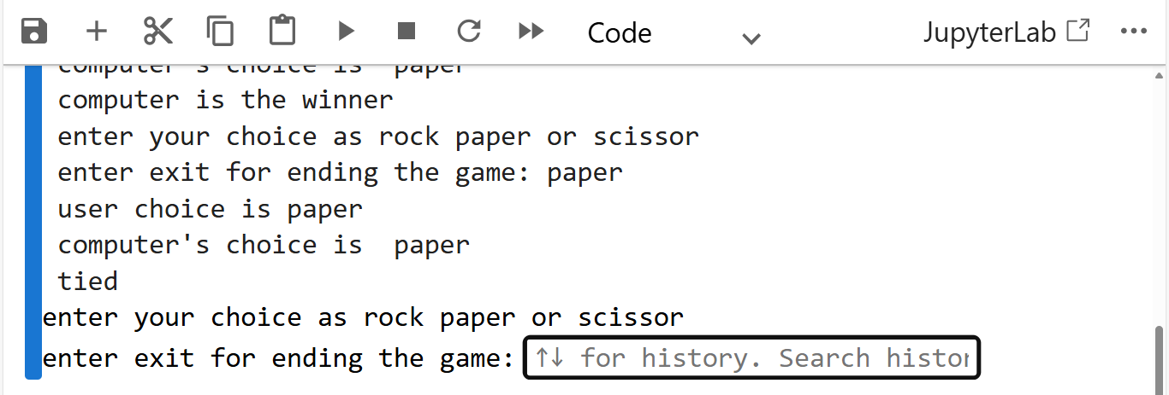

case 4: paper vs rock

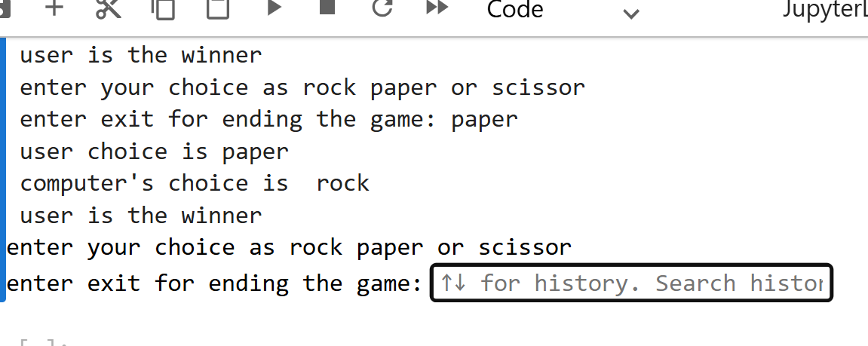case 5: paper vs scissor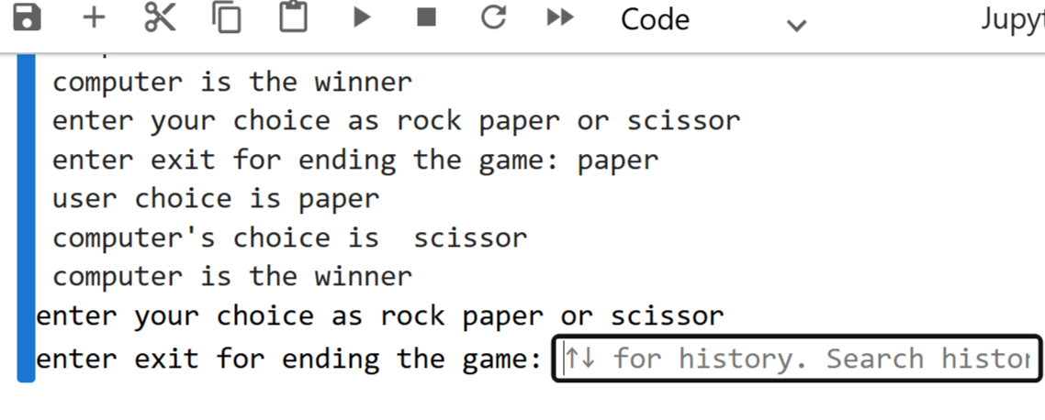case 6: scissor vs rock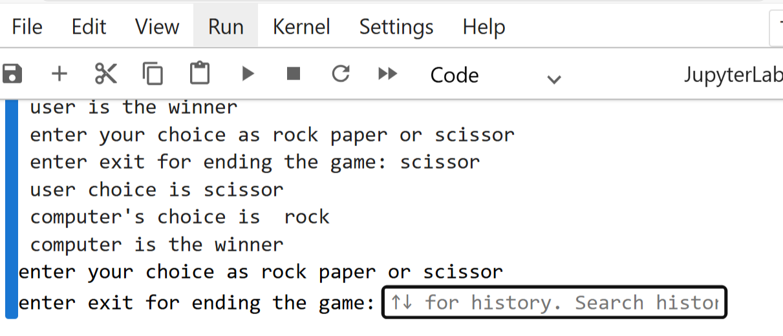

**CONCLUSION:**

In this project ,we successfully developed a rock- paper-scissor game using python .the program allow the user to input their choice while the computer generates a random choice.By applying conditional statements ,the program compares both choices and displays the winner.

This project enhanced the understanding of python fundamentals such as input/output handling ,the use of the “random” module and decision making with “if-else “statements.

The implementation demonstrates how simple logic can be transformed into an interactive application .

overall ,this project not only strengthened programming skills but also showcased how basic concepts can be applied to design fun and interactive applications

**BIBLIOGRAPHY:**

<https://www.python.org>

<https://www.geeksforgeeks.org>

**GITHUB LINK:**

[**https://github.com/mounikakamepalli85-star**](https://github.com/mounikakamepalli85-star)