**LAB-1**

Task1 Report

Subtask 1 : TI Sensor Tag with Android Sensor Tag

Downloaded the BLE Sensor tag app from the Google play. The BLE sensor tag is connected to the sensor tag via blue tooth to see the reading in the app 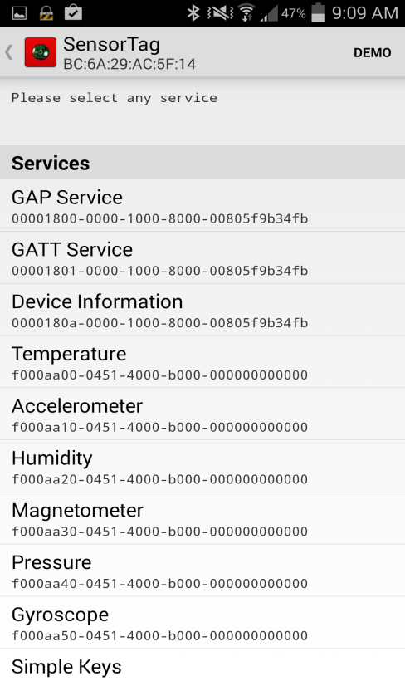

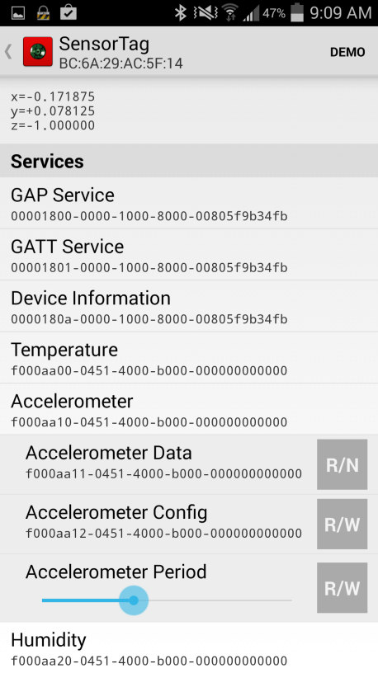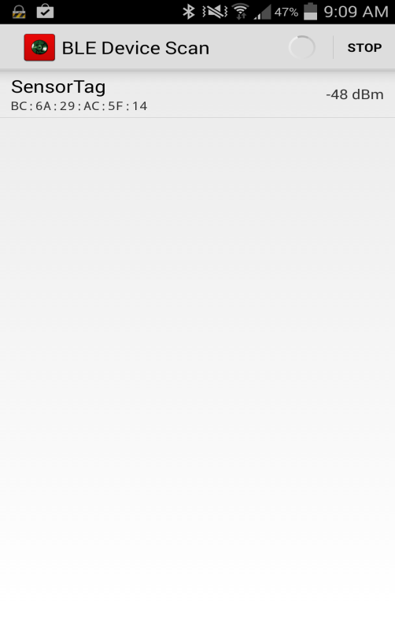

After downloading and open the source code file Android-Sensortag, connected to the device via wire and install the app in the device

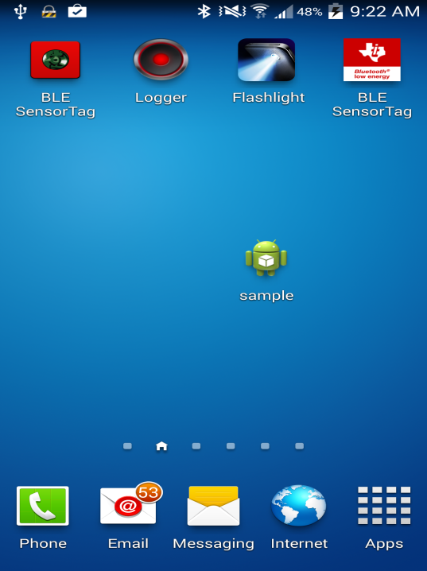

The given source code file is opened and the device is connected to sensor tag via blue tooth the, the data is read from the device via Bluetooth and can be seen in the log file of the ap in ADT.

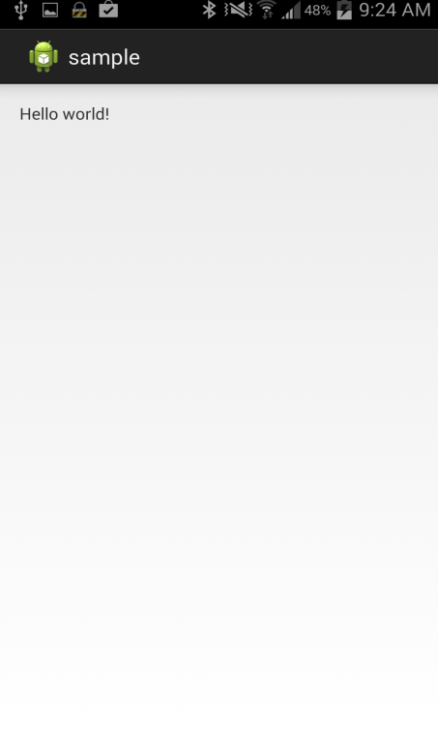

The Sensor tag reading from the log file

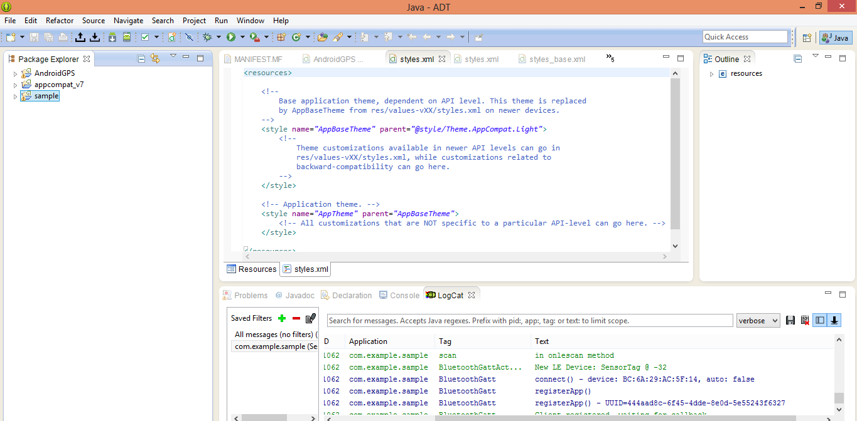

Subtask2. Mobile sensor with Android App.

The source is downloaded from blackboard and is opened in Eclipse ADT, the app is installed into the device and when it is opened it reads the data from the inbuild sensors, which we can see the color change in the screens when the device is shaken

initially the screen is green and due to changes in the internal gyroscope data the screen changes to color red and leaves a toast that is device is shuffled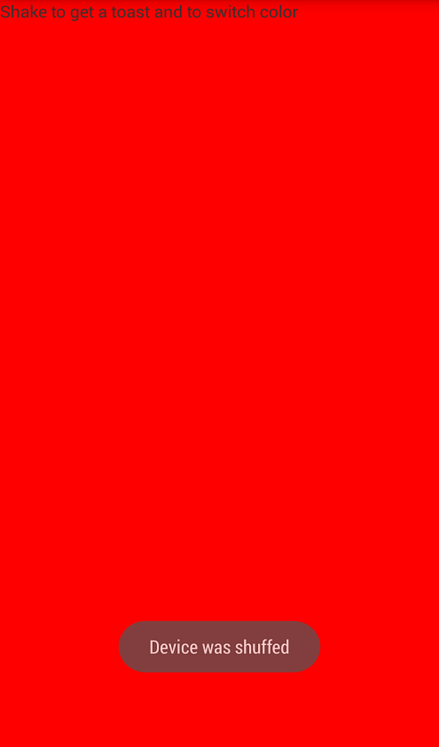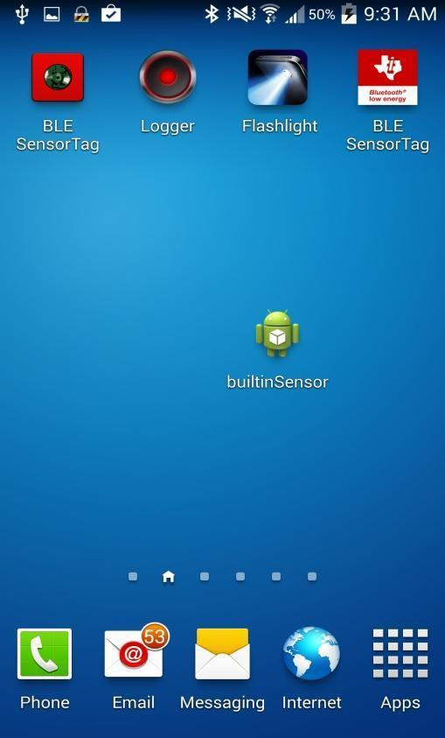

Subtask 3: GPS Feature with Android Smart phone.

The given source code is downloaded from the black board and opened in Eclipse ADT, to make the necessary required changes.

This app collects the data from the in built device GPS of android device and mentions the latitude and longitude and the Address of the location

Initial Location of the device

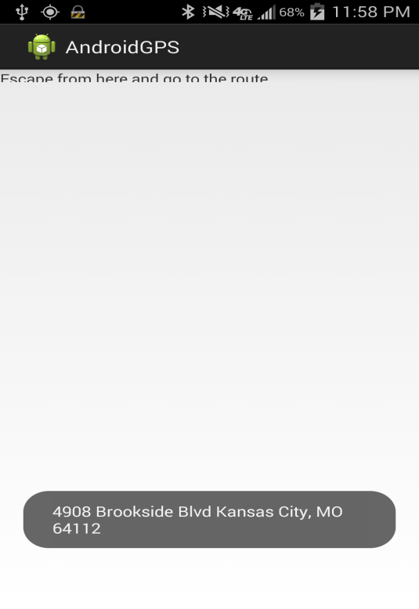

Upon the change of location

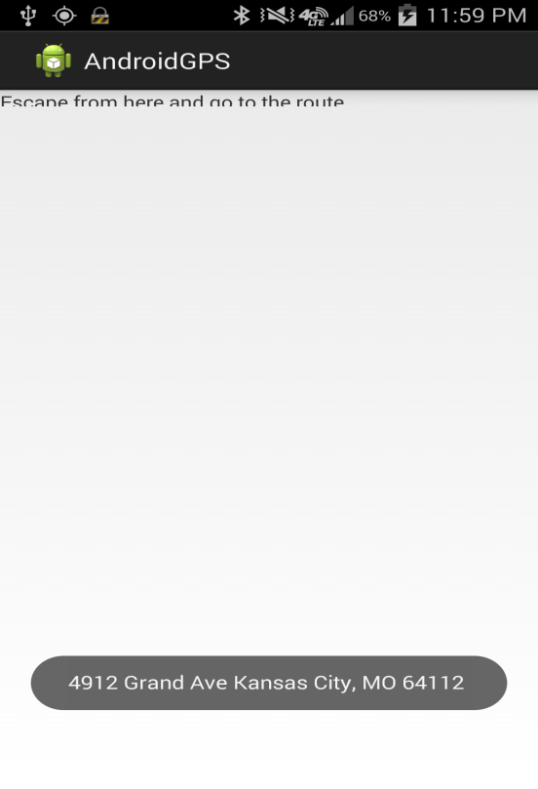

The latitude and longitude of the device location

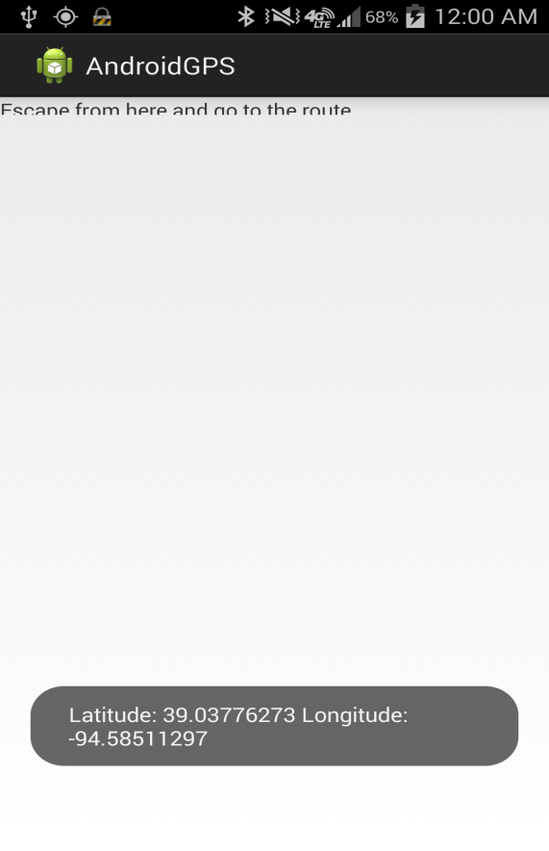

Sub Task 4:

Wiigee app with android smart phone

Subtask 5: TI Chronos watch with JAVA App

After downloading and installing the control center from the CD, the chronoswatch is connected to the control center in ACC mode via a RF receiver. The changes in the orientation and movement of device is recorded in all the three dimensional axes

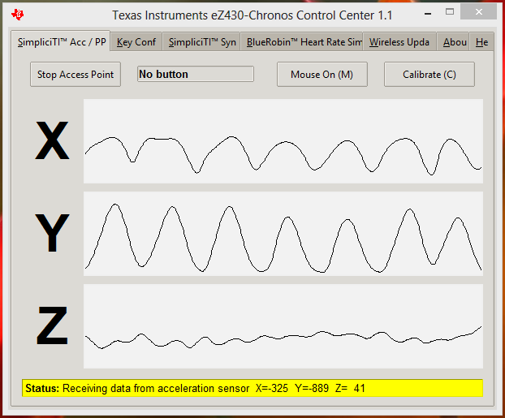

The Punch game is installed into PC and is connected to the Chronos watch via RF receiver which takes the readings

Due to RF connector problem we are unable to play the game but however we are ble to get the readings from the device

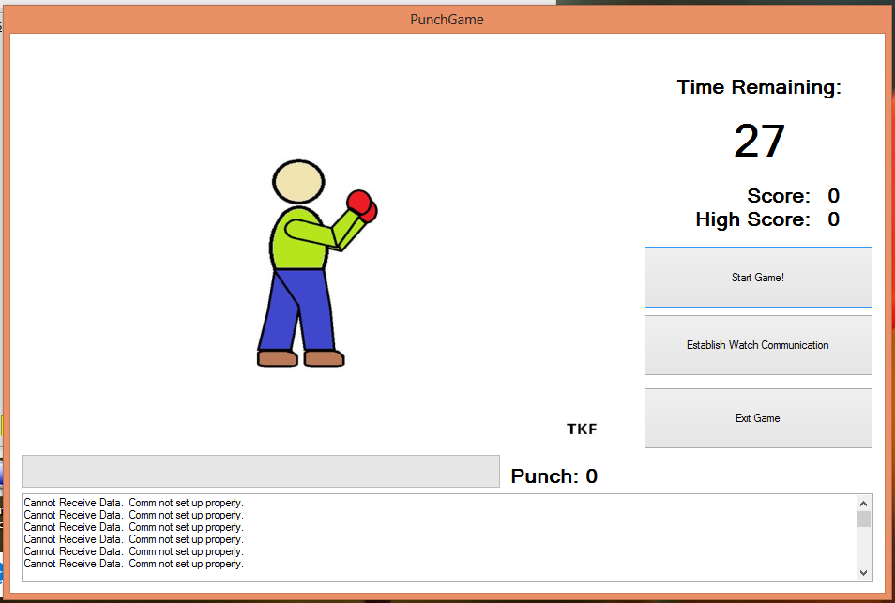

**TASK#2(CLOUDERA):**

**Step1:**Connect to umkc VPN. Login to cloudera manager using [http://134.193.136.147:7180](http://134.193.136.147:7180/).

**Step2:**download putty and enter the hostname as shown below.

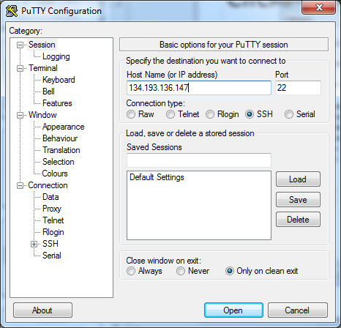

**Step3:**enter username and password as group9 in putty

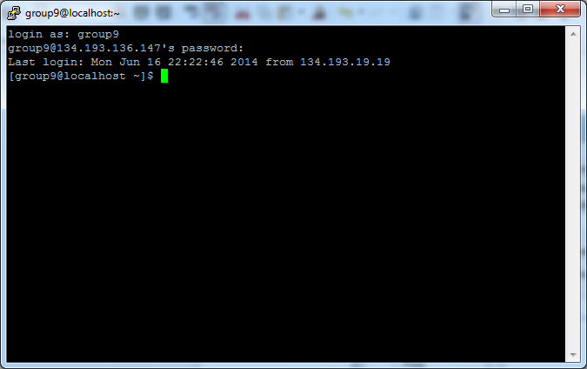

**step4:** download Winscp and enter host name as shown below and enter the username and password as group9

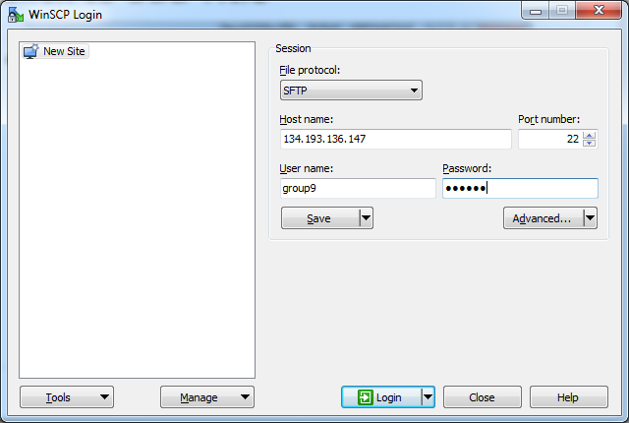

Download the word count file from the link provided and

Drag and drop the word count file from local machine to virtual machine as shown below:

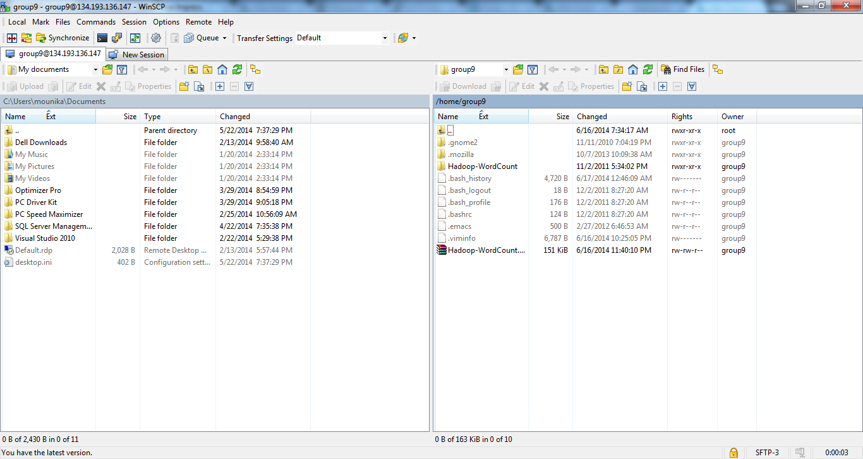

open putty and type in 'cd $Hadoop_Home',type commands 'unzip Hadoop-WordCount.zip'

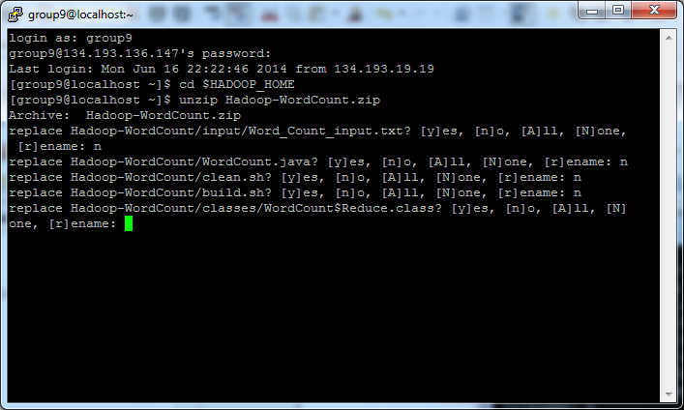

when we type a command 'hadoop fs -put input input', it is showing no such file or directory exists.Hadoop commannds are not working.

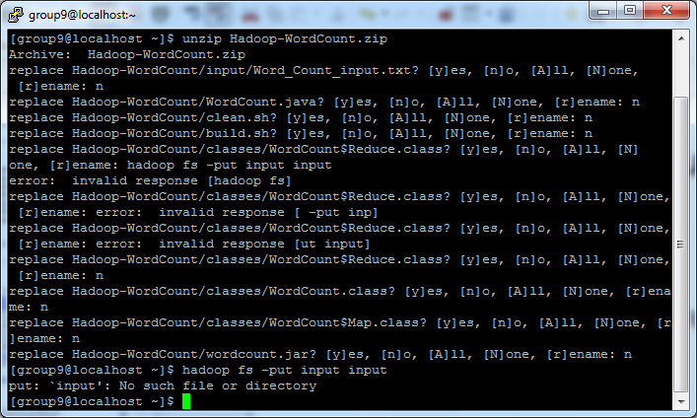

Installed the vmware player using that I created my own cloudera and then did wordcount commands the below is the screen shot for word count.

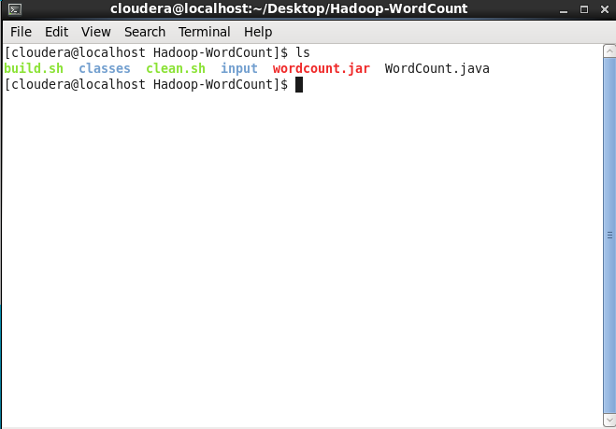

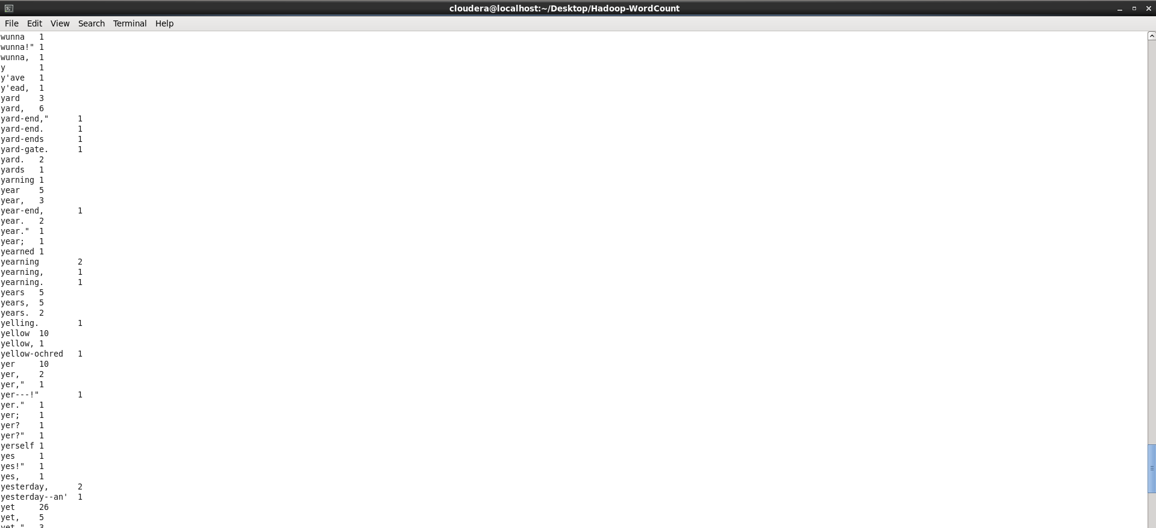

**TASK#3:**

**SCRUMBDO:**

After creating an account:

Creating an organization as UMKC and project as BIG DATA

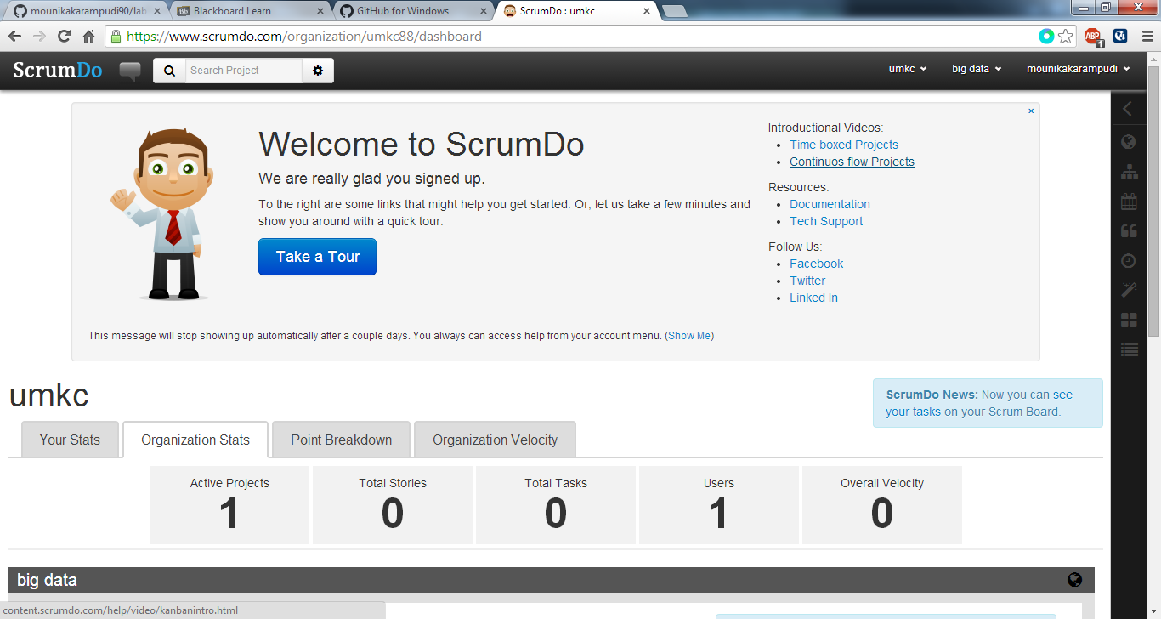

To add a story in project Big Data.select Add story option and enter the story.

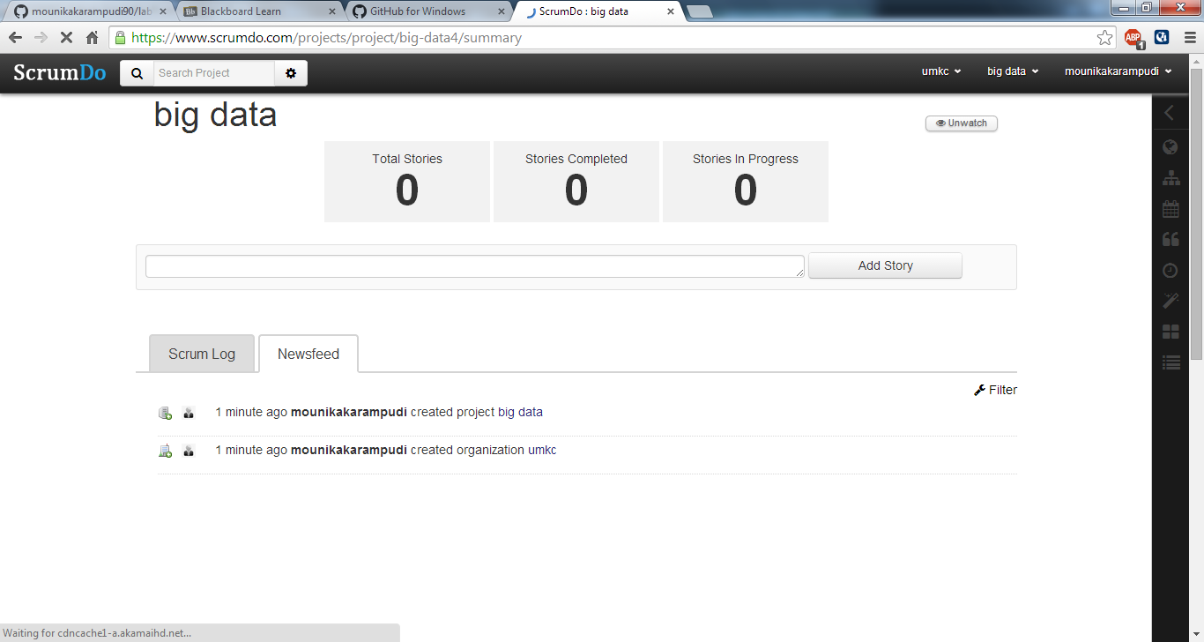

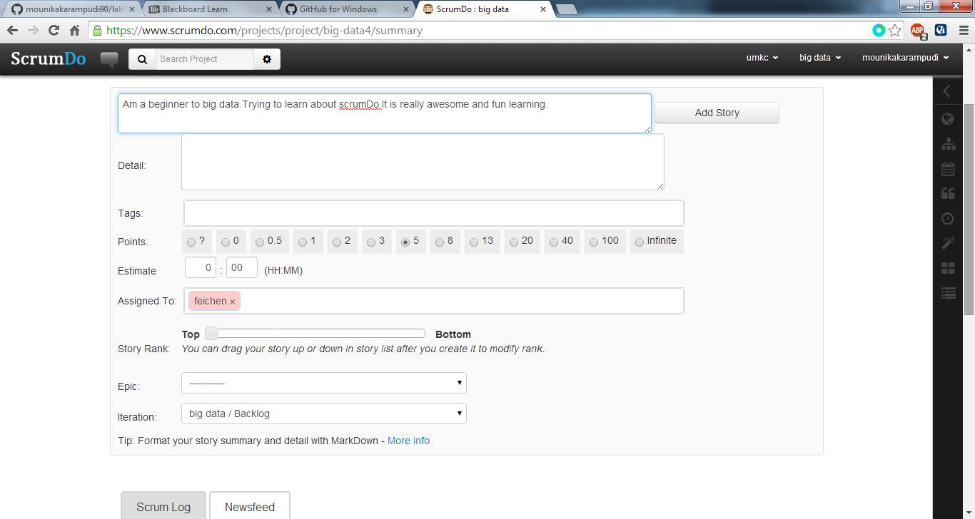

A story one is created on clicking Add story button.

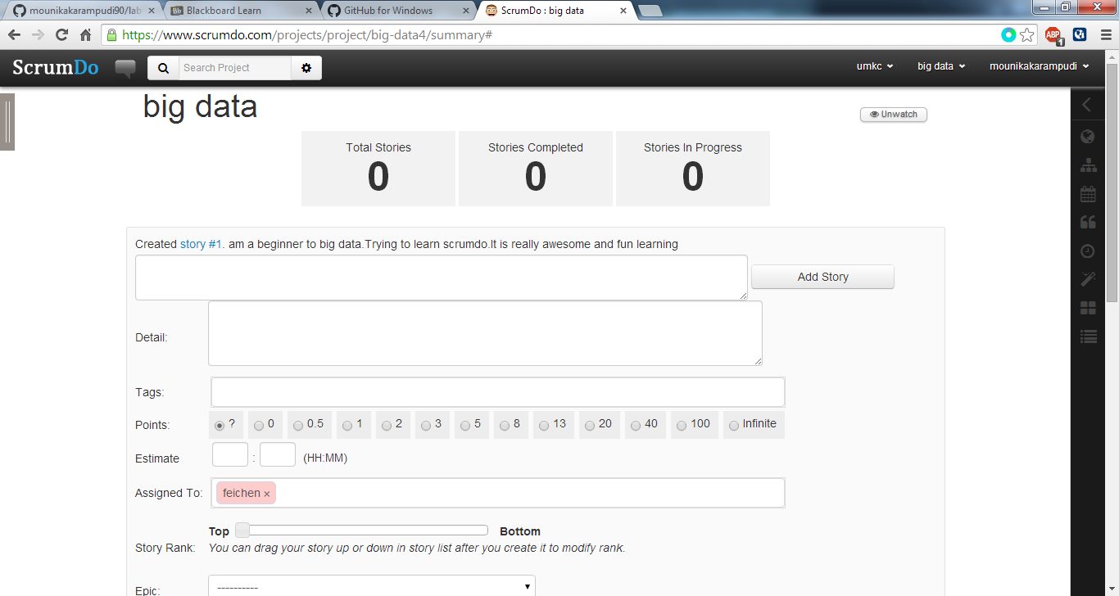

The story is displayed in Backlog folder,as shown below

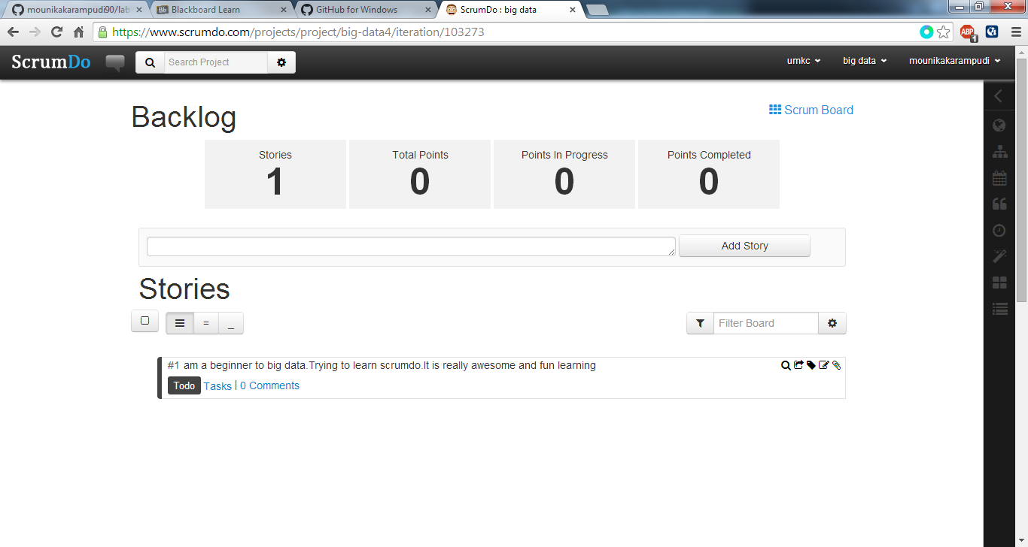

Creating a new iteration,go to big data,in the drop down select iteration and enter the new iteration as below.

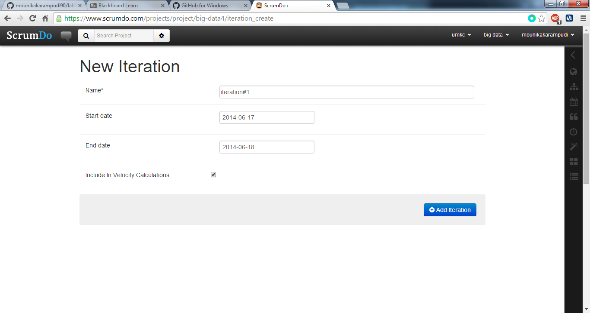

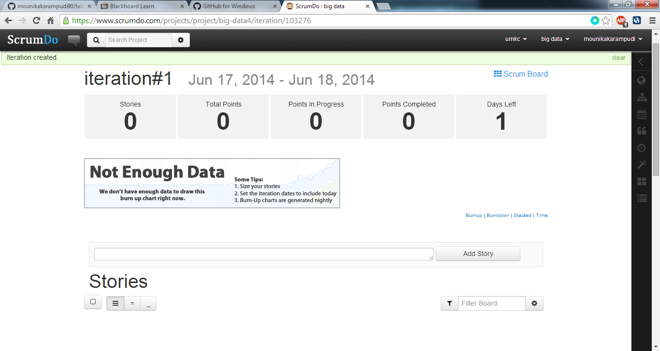

Creating a new Epic.Go to Big data select epic and enter the summary,we can create epic as shown below

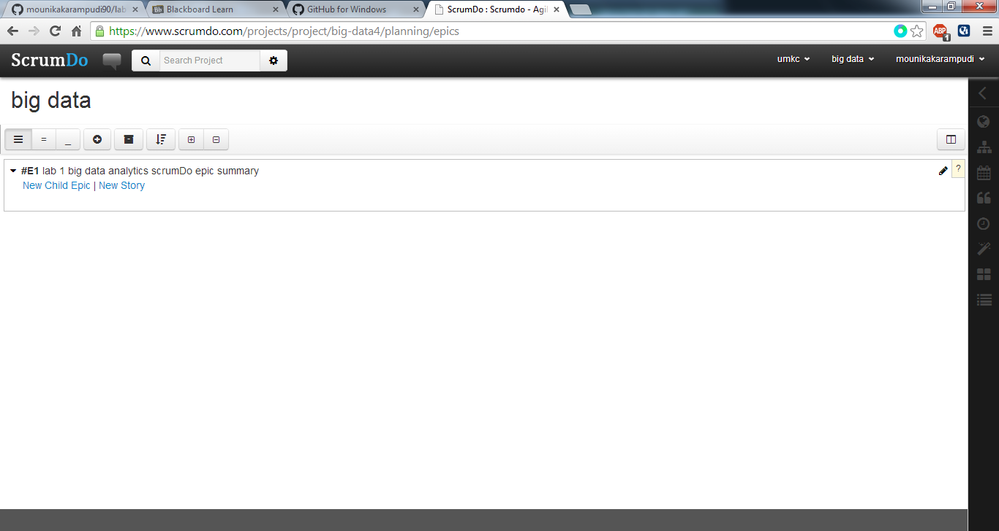

**GITHUB:**

Create account in Git hub .Create a repository with name bigdata-lab1

download git gui to local machine

clone the github url with the local machine,using existing repository.

Open the file and stage it.Commit the changes and push the file to git hub webservice

