**Lab2 Assignment**

Mounika Karampudi

16158193

generated a sensor text file as shown below,ny changing the conenction service.java class

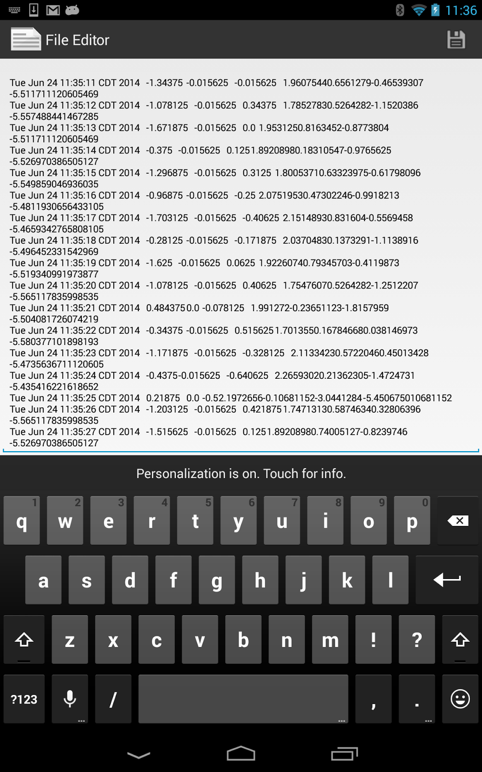

The values of X,Y,Z are generated as shown below.

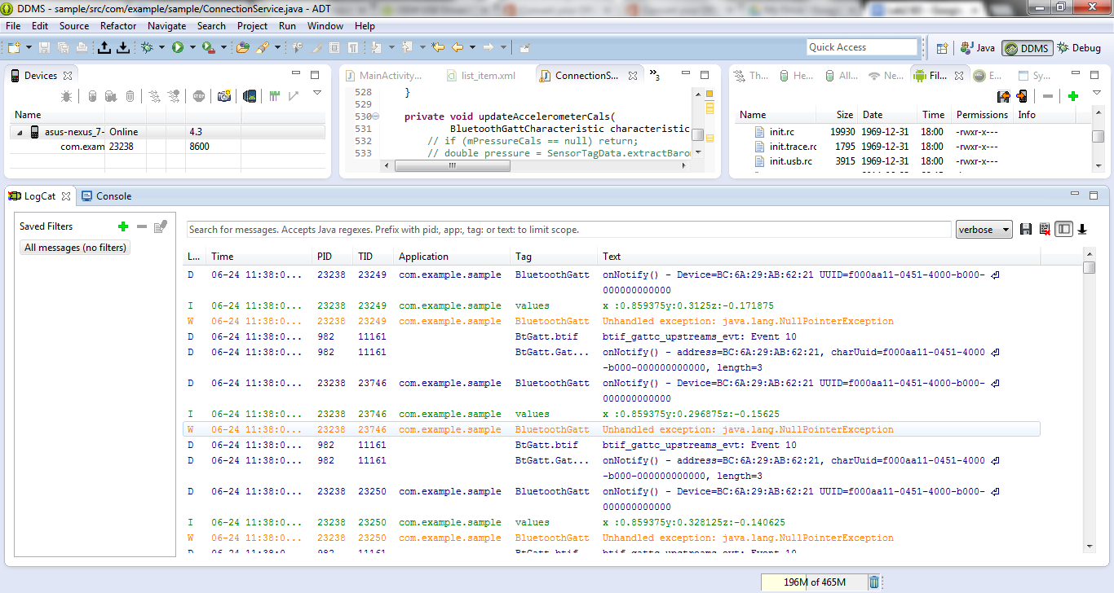

changes are made in connectionservice.java as shown below:

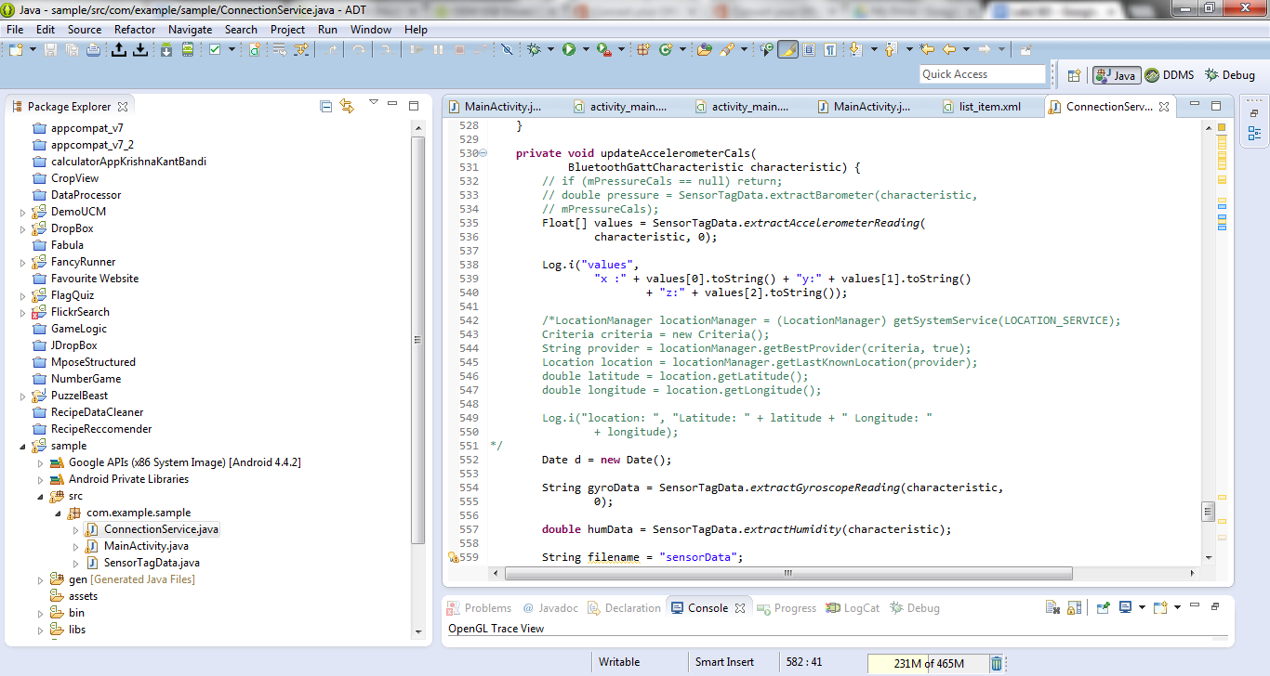

Now,in Hbasestart.java we have to add gyroscope and humidity values and run.we have to create and insert table values in hbase.We get the output as shown below.And we can see our respective sensor tables in hbase.

