**Ideation Phase**

**Empathize & Discover**

|  |  |
| --- | --- |
| Team ID | LTVIP2025TMID29763 |
| Project Name | Airline Manageent System |
| Maximum Marks | 4 Marks |

**Empathy Map :**

An empathy map is a simple, easy-to-digest visual that captures knowledge about a user’s behaviours and attitudes.

An **Empathy Map** is a collaborative tool used to gain deeper insight into users' needs and experiences. For the **Salesforce-based Airline Management System project**, it helps understand the pain points, thoughts, and behaviors of stakeholders like passengers, customer support agents, and operations staff. **Example:**

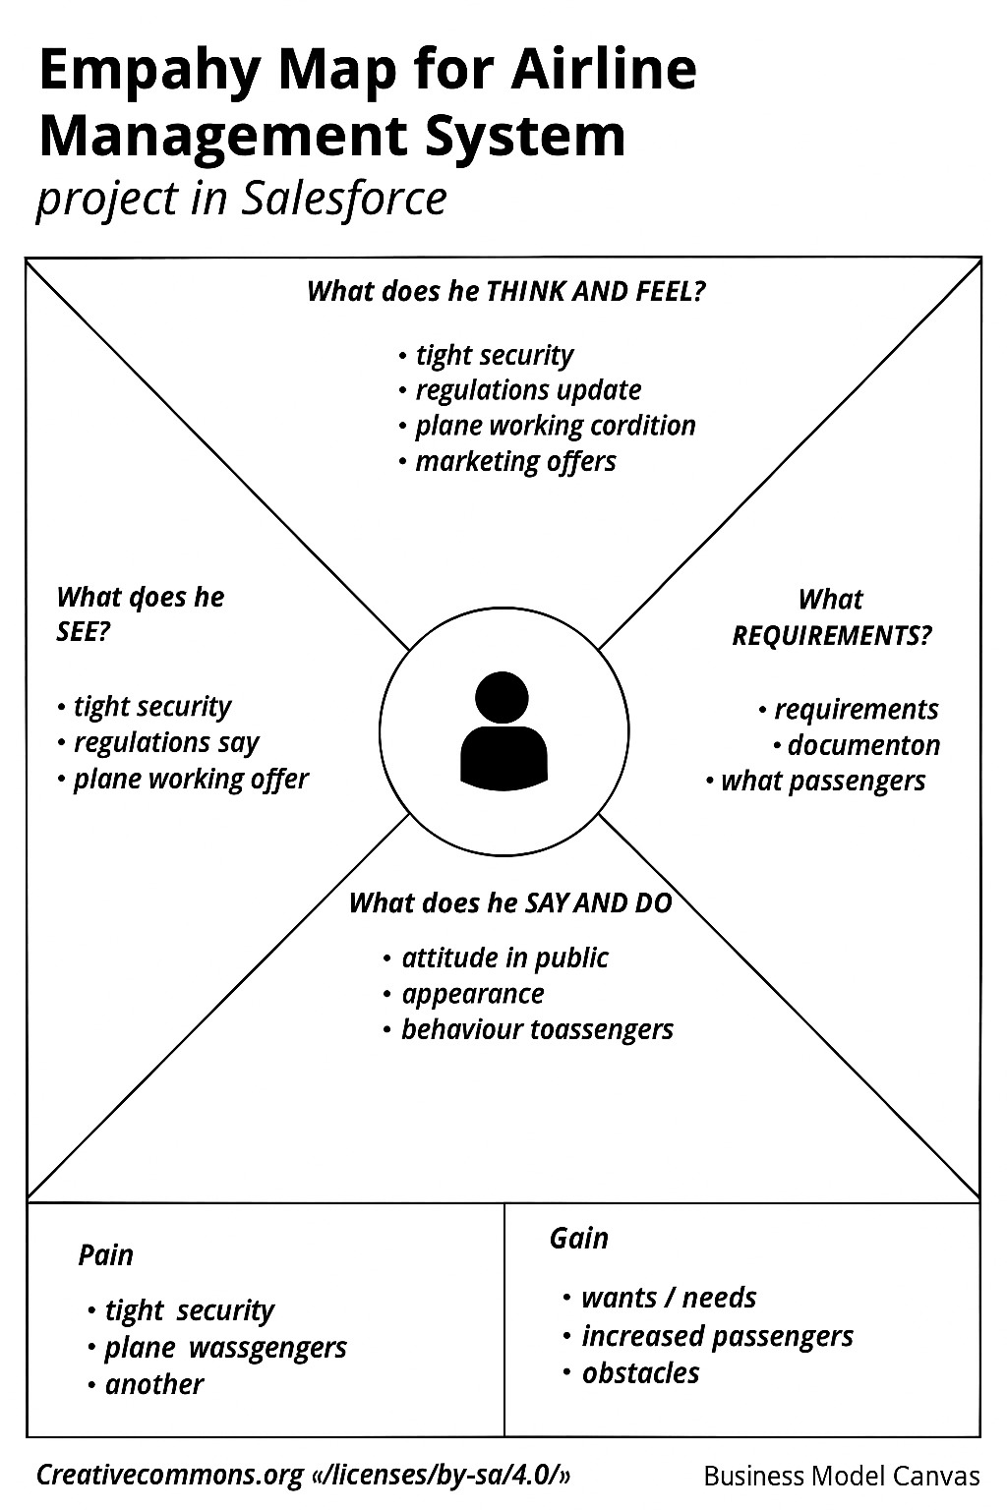

Reference: <https://www.mural.co/templates/empathy-map-canvas>

**Example: Journey Experiencing**

