**Ideation Phase**

**Brainstorm & Idea Prioritization**

|  |  |
| --- | --- |
| Team ID | LTVIP2025TMID29763 |
| Project Name | Airline Management System |
| Maximum Marks |  |

**Brainstorm & Idea Prioritization**

**✅ 1. Project Overview**

**Goal:** Build a centralized Salesforce-based system to manage airline operations focusing on sales, customer service, ticketing, and loyalty programs.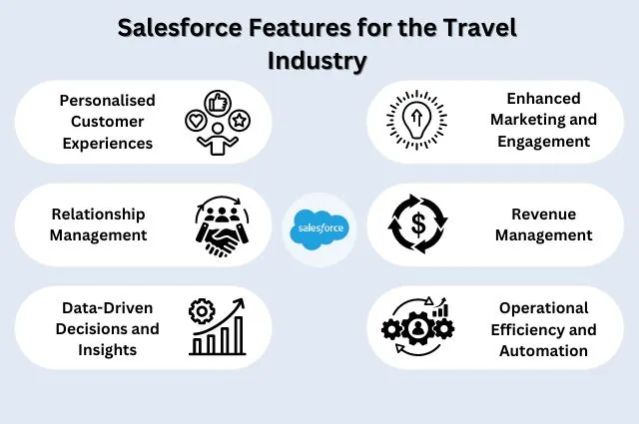

**🧠 Brainstorming: Key Modules & Ideas**

| **Module** | **Ideas / Features** | **Priority** | **Salesforce Tools** |
| --- | --- | --- | --- |
| **Customer Management** | 360° customer profile, frequent flyer data, preferences | 🔥 High | Sales Cloud, Service Cloud |
| **Ticket Booking System** | Integrate online booking, PNR management | 🔥 High | Custom Objects, Flows |
| **Flight Scheduling** | Aircraft rotation, crew schedule, delay management | 🟡 Medium | Custom Apps |
| **Revenue Management** | Dynamic pricing, demand forecasting | 🔥 High | Einstein Analytics |
| **Loyalty Program (Miles)** | Miles tracking, tier levels, redemption | 🔥 High | Loyalty Management |
| **Customer Service (Support)** | Omnichannel support, chatbot, case routing | 🔥 High | Service Cloud, Einstein Bot |
| **Marketing Automation** | Email campaigns, offers, segmentation | 🟢 Low | Marketing Cloud |
| **Mobile App Integration** | Ticket alerts, QR boarding passes | 🟡 Medium | Mobile SDK, API Integration |
| **B2B Corporate Accounts** | Manage travel agent/enterprise bookings | 🟡 Medium | Account Hierarchies |
| **Feedback & Surveys** | In-flight and post-travel survey automation | 🟢 Low | Survey Tool, Flow Builder |

**📊 Prioritization Matrix**

| **Priority** | **Features** |
| --- | --- |
| **High** | Customer Management, Booking System, Revenue Mgmt, Loyalty, Support |
| **Medium** | Flight Scheduling, B2B Bookings, Mobile App |
| **Low** | Feedback System, Marketing Campaigns |

**🖼️ Visual: Salesforce Airline Project Architecture**

Here's a conceptual diagram (created below) to help illustrate how the system might connect.

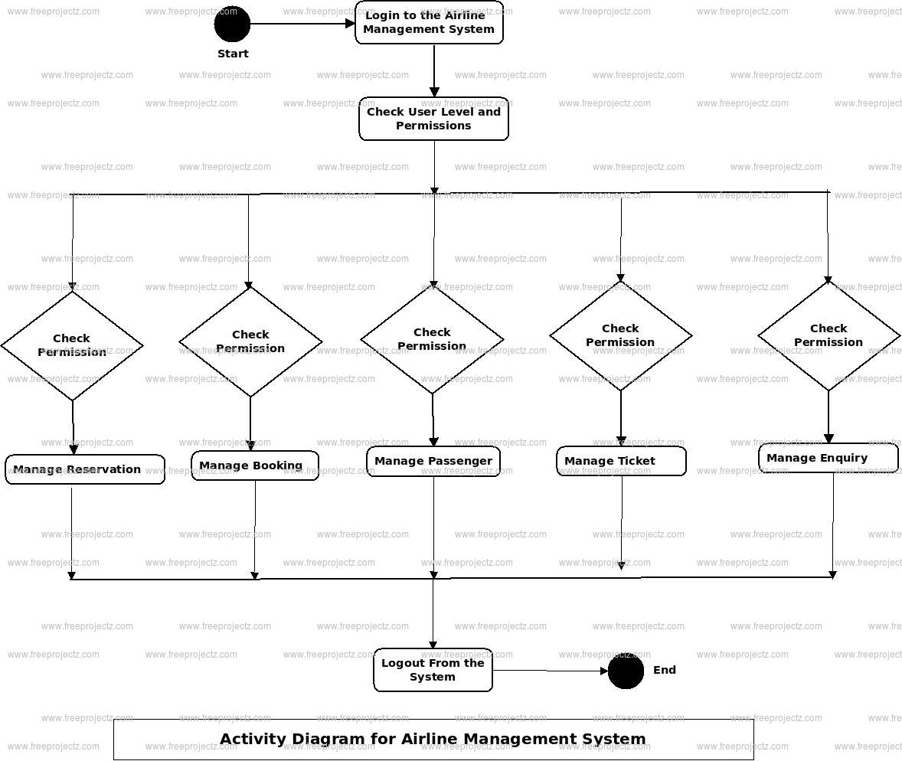

**📌 Suggested Project Flow (with visual stages)**

1. Discovery & Requirement Gathering

↓

2. Data Model Design (Flights, Tickets, Customers)

↓

3. Custom App Development (Booking, Loyalty, etc.)

↓

4. Integration (Payment Gateway, Mobile App, APIs)

↓

5. Testing (UAT, Load, Security)

↓

6. Deployment on Salesforce

↓

7. Training & Go-Live

**🛠️ Tools for Implementation**

* **Salesforce Clouds**: Sales Cloud, Service Cloud, Marketing Cloud, Loyalty Management
* **Integration**: REST APIs, MuleSoft, Mobile SDK
* **Automation**: Flow Builder, Apex, Process Builder
* **Analytics**: Tableau CRM (Einstein)