**Project Design Phase-II**

**Technology Stack (Architecture & Stack)**

|  |  |
| --- | --- |
| Team ID | LTVIP2025TMID29763 |
| Project Name | Airline Management System |
| Maximum Marks | 4 Marks |

**Technical Architecture:**

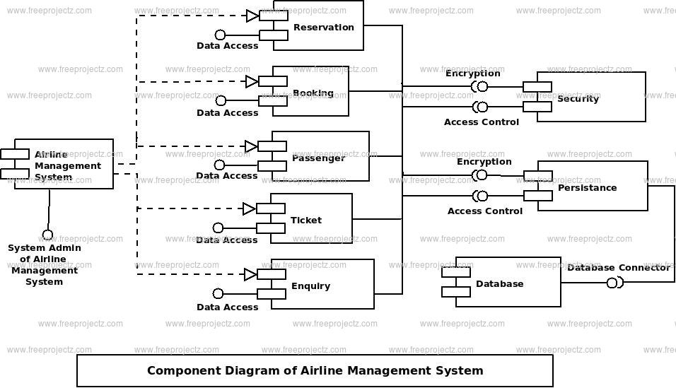

**Example: Order processing during pandemics for offline mode**

**Reference:** **https://www.mdpi.com/2673-8112/3/1/1**

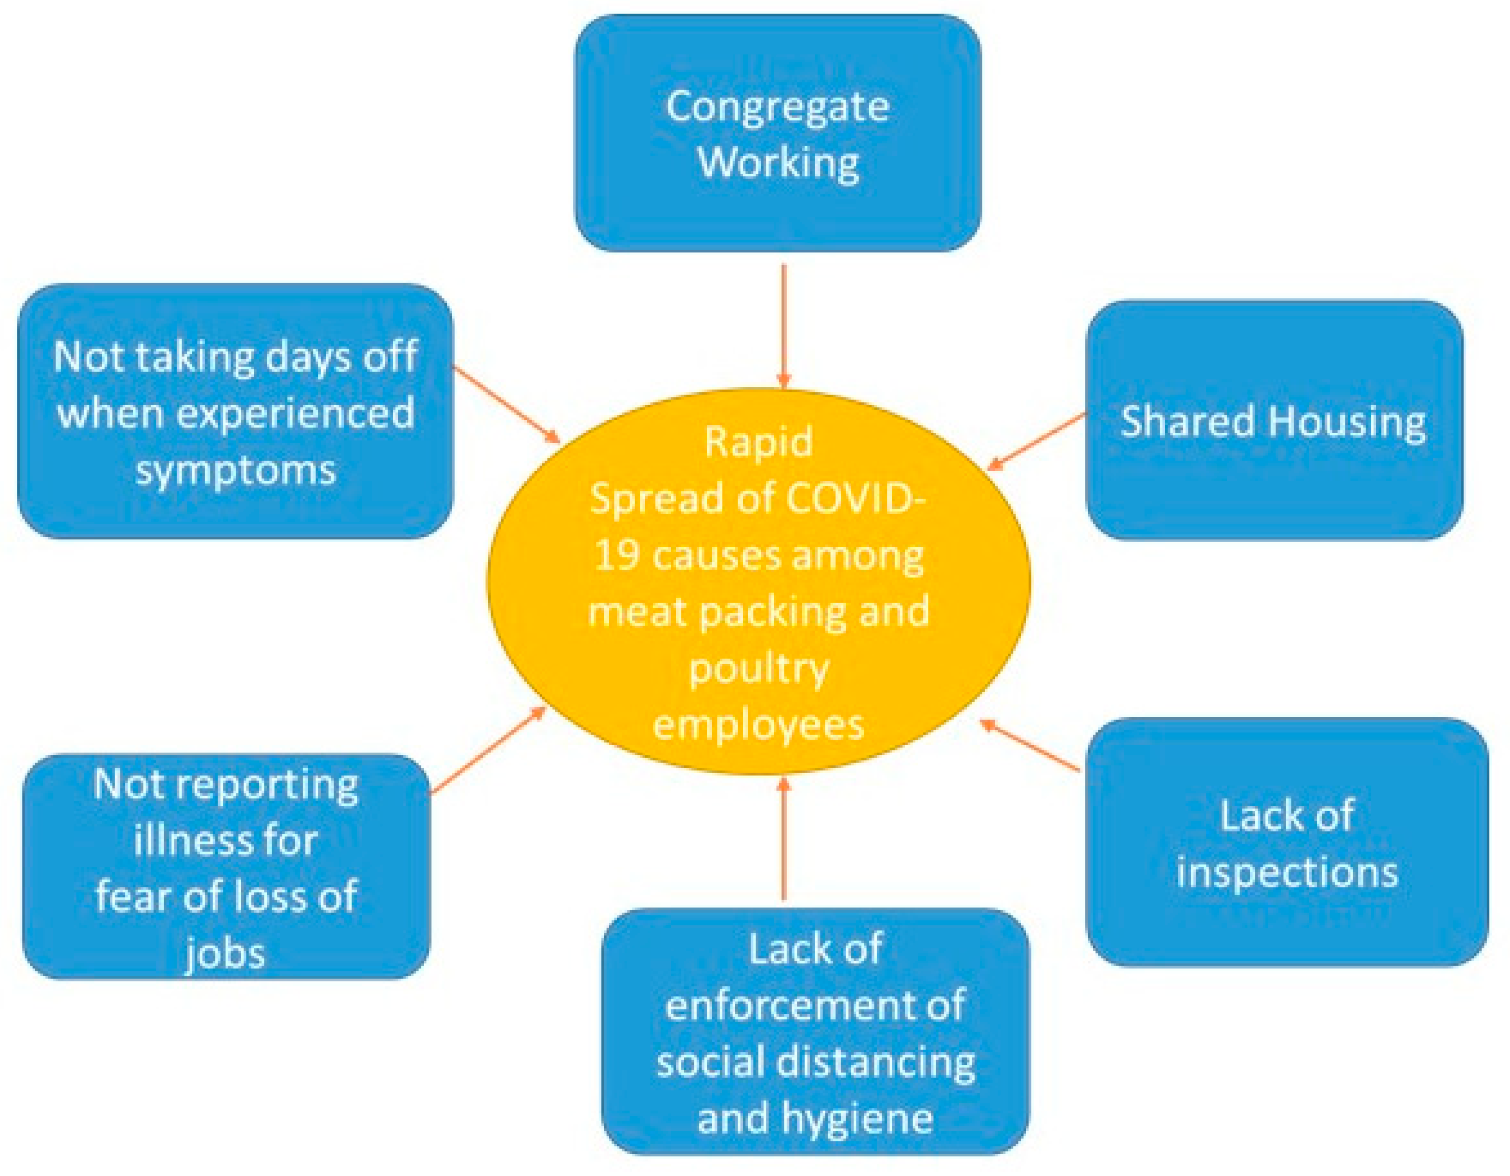

**Table-1 : Components & Technologies:**

**Airline Management System – Components Table**

|  |  |  |  |  |  |  |  |  |  |  |  |  |  |  |  |  |  |  |  |  |  |  |  |  |  |  |  |  |  |  |  |  |  |  |  |  |  |  |  |  |  |  |  |  |  |  |  |  |  |  |  |  |  |  |  |  |  |  |  |  |  |  |  |  |  |  |  |  |  |  |  |  |  |  |  |
| --- | --- | --- | --- | --- | --- | --- | --- | --- | --- | --- | --- | --- | --- | --- | --- | --- | --- | --- | --- | --- | --- | --- | --- | --- | --- | --- | --- | --- | --- | --- | --- | --- | --- | --- | --- | --- | --- | --- | --- | --- | --- | --- | --- | --- | --- | --- | --- | --- | --- | --- | --- | --- | --- | --- | --- | --- | --- | --- | --- | --- | --- | --- | --- | --- | --- | --- | --- | --- | --- | --- | --- | --- | --- | --- | --- |
| | **Component** | **Description** | **Technology / Platform** | | --- | --- | --- | |  |  |  | | **User Interface (UI)** | Front-end for passengers, staff, and admins to interact with the system. | HTML, CSS, JavaScript, Salesforce Lightning | | **Authentication Module** | Manages user login, registration, and roles (passenger, staff, admin). | Salesforce Identity, OAuth 2.0, Apex | |  |  |  | | **Flight Management** | Admin panel to create, edit, and manage flight schedules and aircrafts. | Apex, SOQL, Salesforce Objects, Lightning UI | | **Reservation System** | Handles flight search, seat availability, booking, and ticket generation. | Salesforce Service Cloud, Apex | |  |  |  | | **Payment Gateway** | Processes online payments and refunds securely. | Stripe/PayPal Integration via Salesforce APIs | |  |  |  | | **CRM Integration** | Maintains customer data, preferences, history, and marketing engagement. | Salesforce Sales Cloud / Marketing Cloud | |  |  |  | | **Check-in System** | Enables web/mobile check-in, seat selection, and generates boarding passes. | Apex, Lightning Components, QR generation APIs | |  |  |  | | **Staff Management** | Schedules pilots, cabin crew, and ground staff across flights. | Custom Salesforce App or third-party plugin | |  |  |  | | **Notification Engine** | Sends alerts and reminders for flight status, offers, etc. | Salesforce Flow, Twilio API, Email Studio | |  |  |  | | **Analytics & Reporting** | Provides dashboards for bookings, revenue, customer trends, etc. | Salesforce Einstein Analytics / Tableau CRM | |  |  |  | | **Mobile Access** | Mobile-friendly interface for passengers and staff. | Salesforce Mobile App / React Native | |  |  |  | | **Database** | Stores user, booking, flight, payment, and feedback data securely. | Salesforce Object Database (SObject), SOQL | |  |  |  | | **Security Layer** | Protects against unauthorized access and data breaches. | Salesforce Shield, Encryption, 2FA | |

**Table-2: Application Characteristics:**

Here’s a comprehensive **Application Characteristics Table** for an **Airline Management System** with Salesforce integration:

**Application Characteristics Table**

|  |  |  |
| --- | --- | --- |
| **Characteristic** | **Description** | **Technology / Tools** |
| **Scalability** | Ability to handle growing number of users, bookings, and flights. | Salesforce Cloud Platform, Elastic Load Balancers |
| **Availability** | System should be accessible 24/7 with minimal downtime. | Salesforce High Availability Cloud, Multi-zone Hosting |
| **Reliability** | Ensures consistent service and accurate data processing. | Salesforce Platform, Redundancy Mechanisms |
| **Security** | Protects user data, prevents unauthorized access and breaches. | Salesforce Shield, Encryption, OAuth 2.0, 2FA |
| **Usability** | Easy and intuitive interface for all types of users. | Salesforce Lightning Design System (SLDS), Mobile-first UI |
| **Performance** | Fast response times for booking, check-in, and search operations. | Apex Optimization, Asynchronous Processing, Caching |
| **Maintainability** | Ease of updates, bug fixes, and feature additions. | Modular Apex Code, Salesforce DX, Git CI/CD |
| **Integration** | Seamless connection with payment, email, SMS, and CRM services. | REST APIs, SOAP APIs, Salesforce AppExchange |
| **Portability** | Usable across web and mobile devices. | Salesforce Mobile SDK, Responsive Web Design |
| **Customizability** | Easy to configure workflows, business logic, and UI based on airline needs. | Salesforce Flows, Apex Triggers, Lightning Components |
| **Auditability** | Tracks user activity and system changes for compliance. | Salesforce Field History Tracking, Audit Trail |
| **Analytics Capability** | Real-time and historical insights into bookings, performance, and behavior. | Salesforce Einstein Analytics, Reports & Dashboards |