**AWS Basic Task**

2) configure MFA for aws account.

Go to aws account and security credentials.

Click on assign MFA(multi-Factor Authentication).

Download the google authenticator app and enter the codes .

Than MFA device assigned.

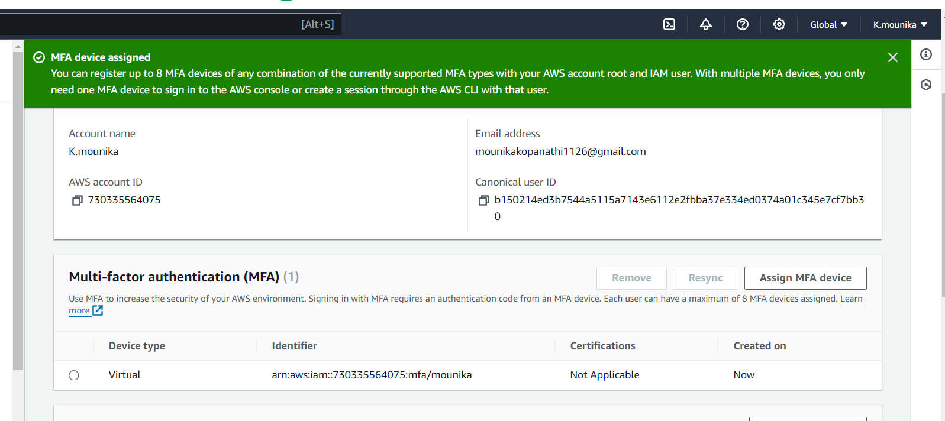

3) Install aws cli in windows.

Go to browser search aws cli and download.

Check in cmdpromt

aws –version : To check the version of aws-cli.

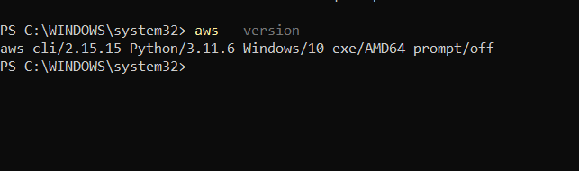

4) Setup ec2 in N.virginia region using aws cli command.

Aws configuration to start the aws cli. Enter the access key id,secret access key enter the region name and output format.

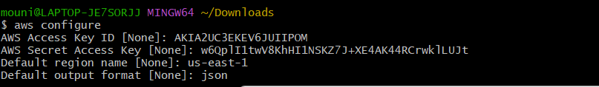

aws ec2 run-instances --image-id ami-0a3c3a20c09d6f366 --instance-type t2.micro --region us-east-1 : To create ec2 instance from cli.

ami -xxxxx(amazon machine image) will copy at access key as ami-xxxxxxxx.

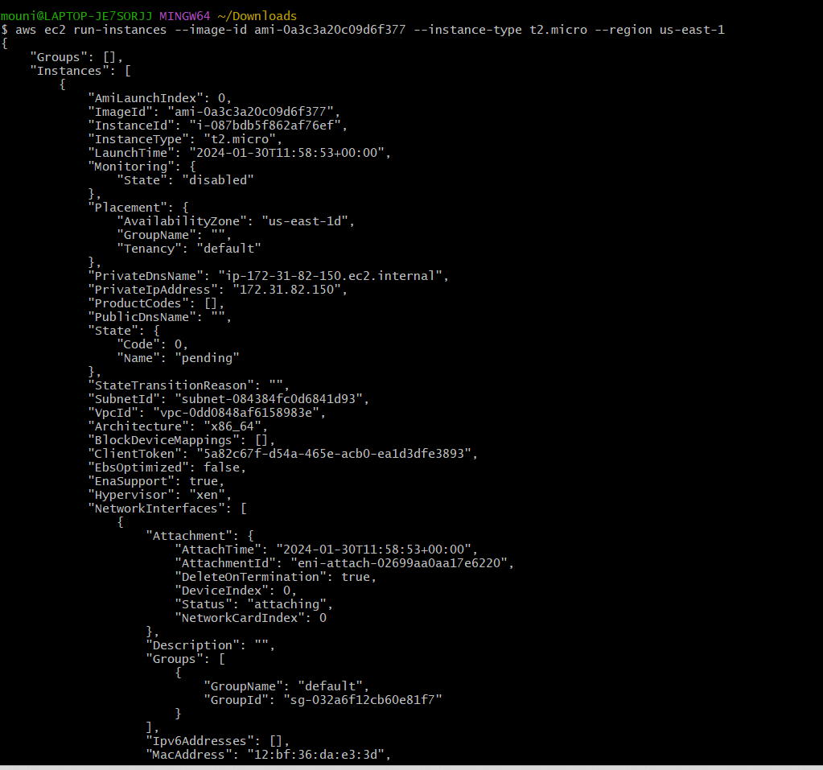

Refresh the instances

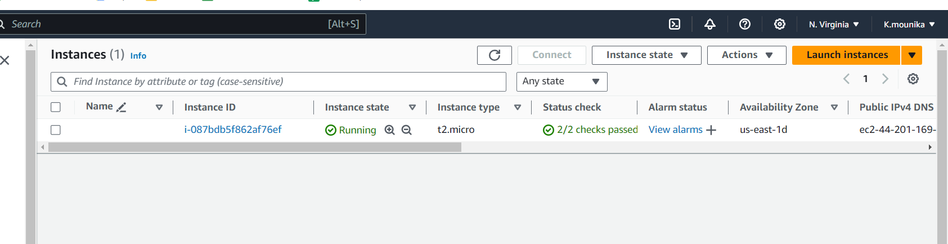

5) Setup security group in ohio region with name - Techie-sg and open port 22.

Create security group with name as Techie-sg.

Select ssh type for port no 22.

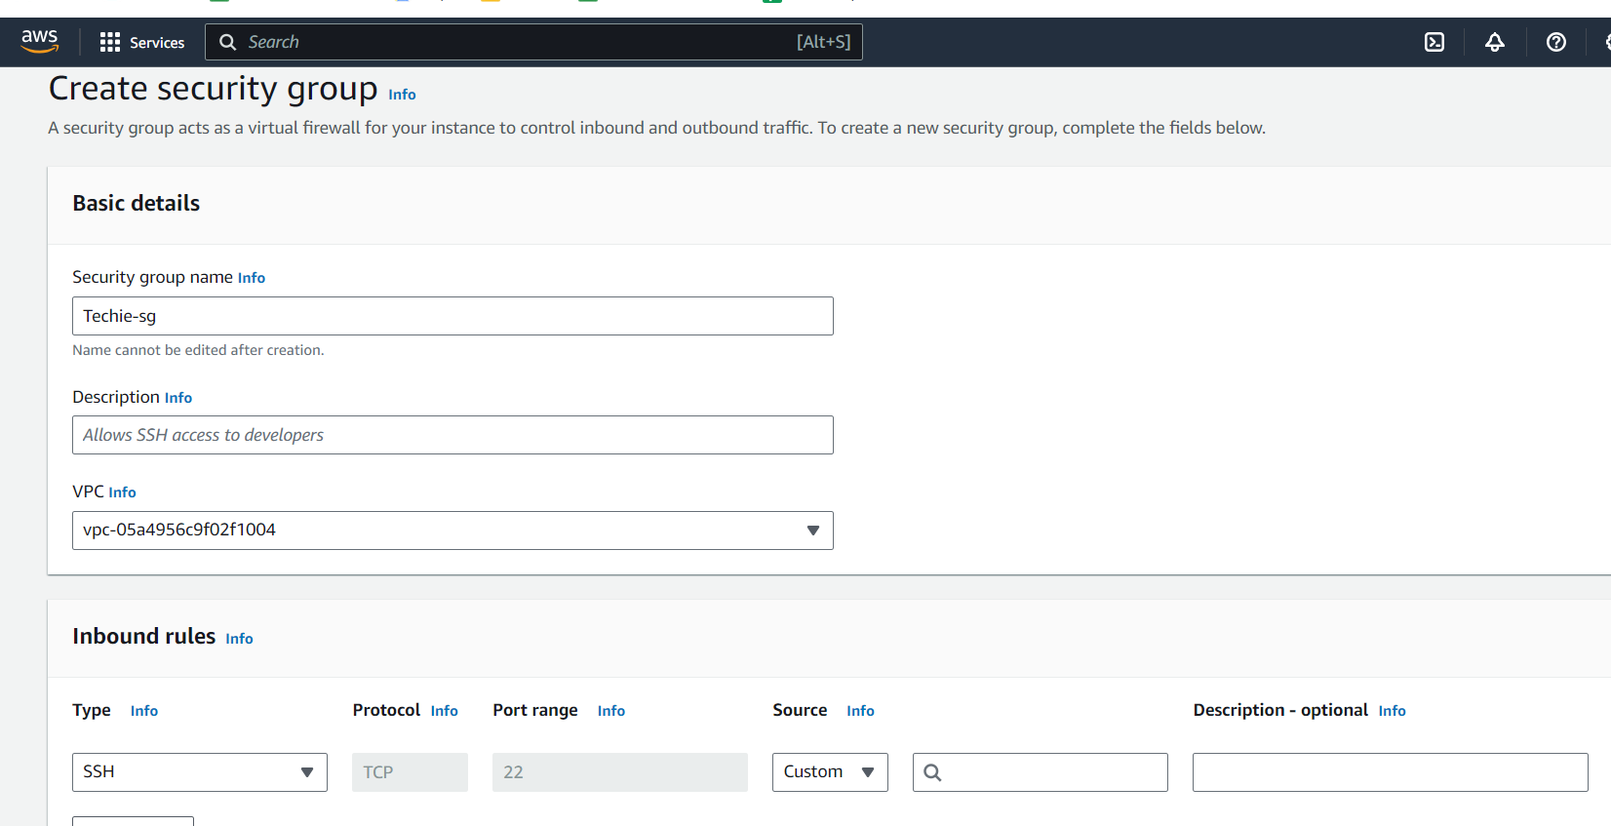

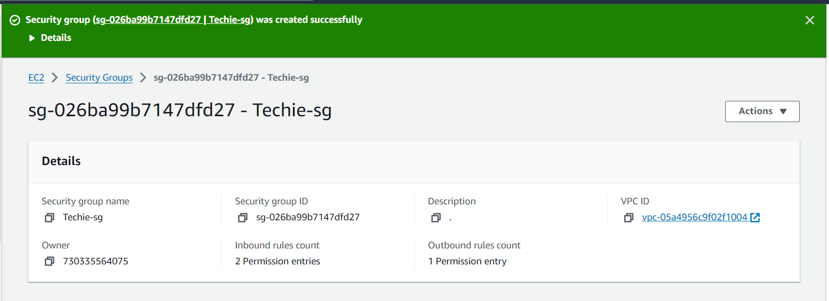

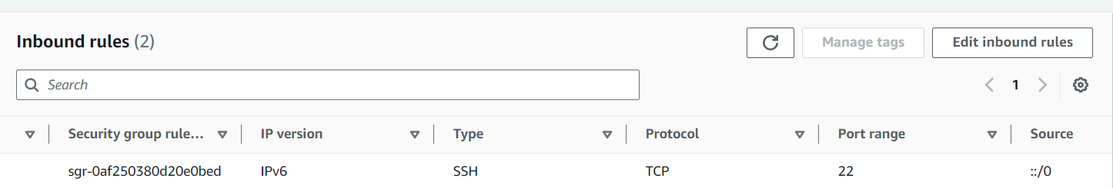

6) setup ec2,security group in Mumbai region using single aws cli command.

aws ec2 run-instances --image-id ami-00952f27cf14db9cd --security-group-ids sg-0b0979024a2fba893 --instance-type t2.micro --region ap-south-1 :To create ec2 instance with given security group.

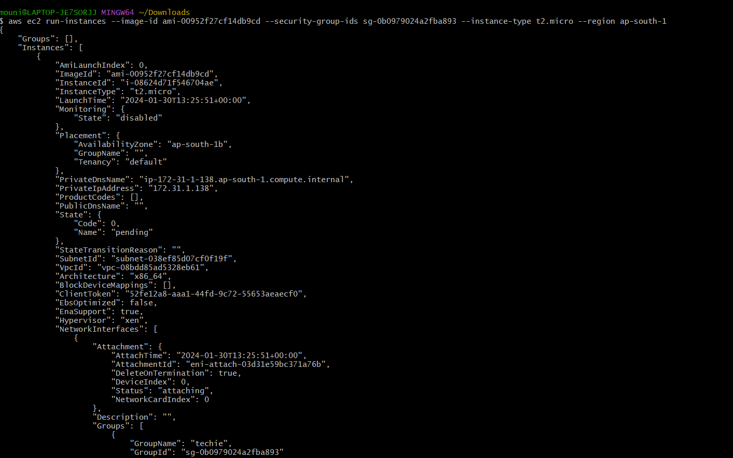

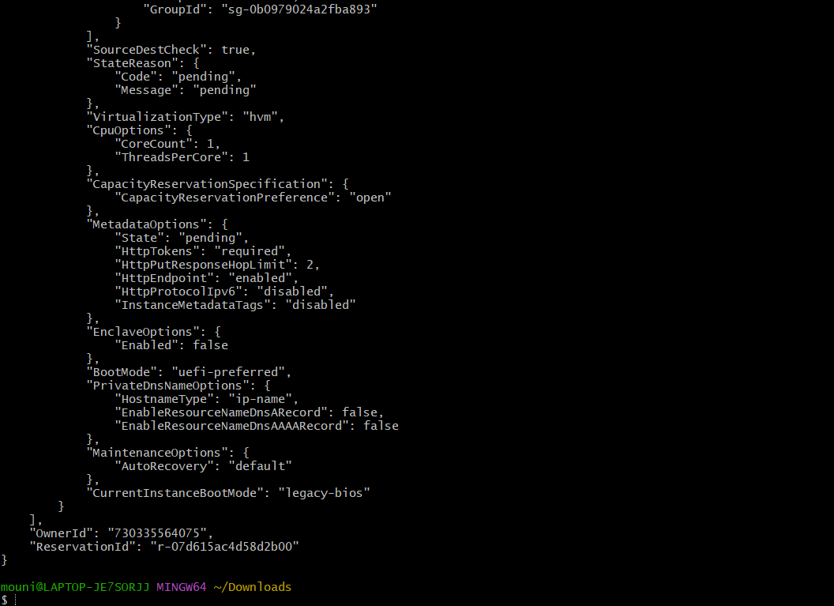

Ec2 instance has been created in Mumbai region.

