1. **Set a seed and take a random sample of 25 observations and find the mean Glucose and highest Glucose values of this sample and compare these statistics with the population statistics of the same variable.**

**RESULTS:**

From the above glucose statistics, it is clear that both Population Mean, Sample Mean and Population Highest, Sample Highest are almost equal.

1. **Find the 98th percentile of BMI of your sample and the population and compare the results using charts.**

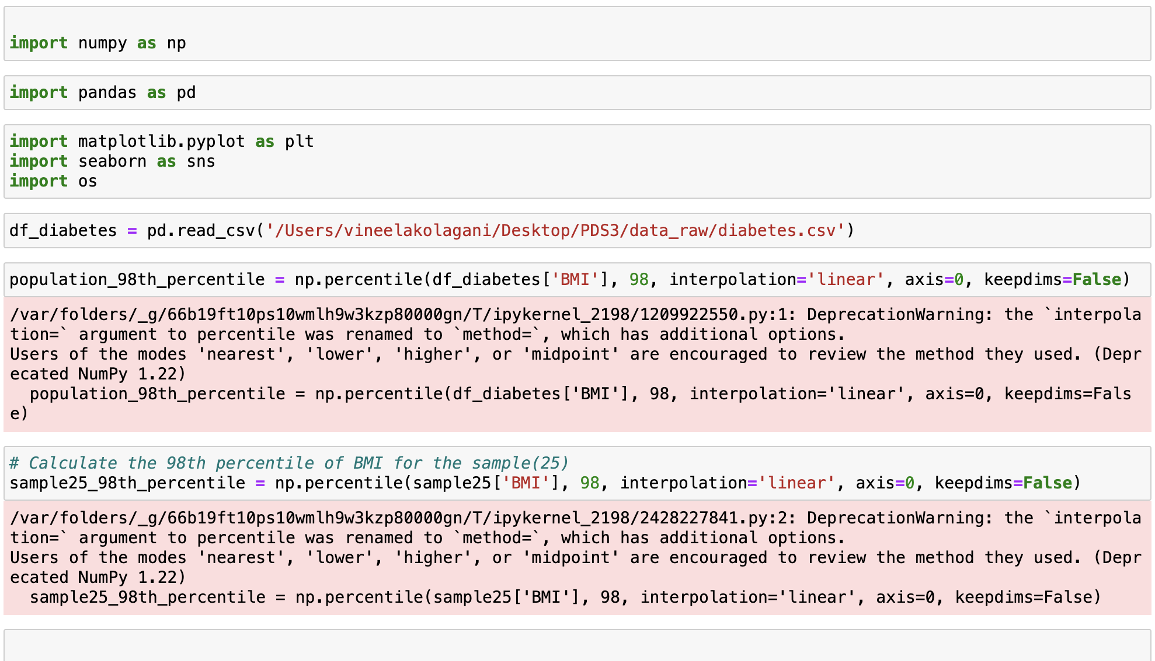

Output:

From the above observation, the BMI is similar for both the Sample and Population with only difference of 4.06

1. **Using bootstrap (replace= True), create 500 samples (of 150 observation each) from the population and find the average mean, standard deviation and percentile for BloodPressure and compare this with these statistics from the population for the same variable. Again, you should create charts for this comparison. Report on your findings.**

From the above statistics, we can see that the alignment between the population values in the line plots and histograms and the corresponding bootstrap means, standard deviations and percentiles suggests that the generated bootstrap samples accurately represent the underlying population. This alignment indicates that the statistical estimates derived from the bootstrap samples, such as means, standard deviations, and percentiles, closely mirror the true characteristics of the populations blood pressure distribution. Therefore, we can say that bootstrap is effective in providing reliable insights into population’s blood pressure statistics, it enhances our estimations accuracy.