Railway reservation system

**User -service:**

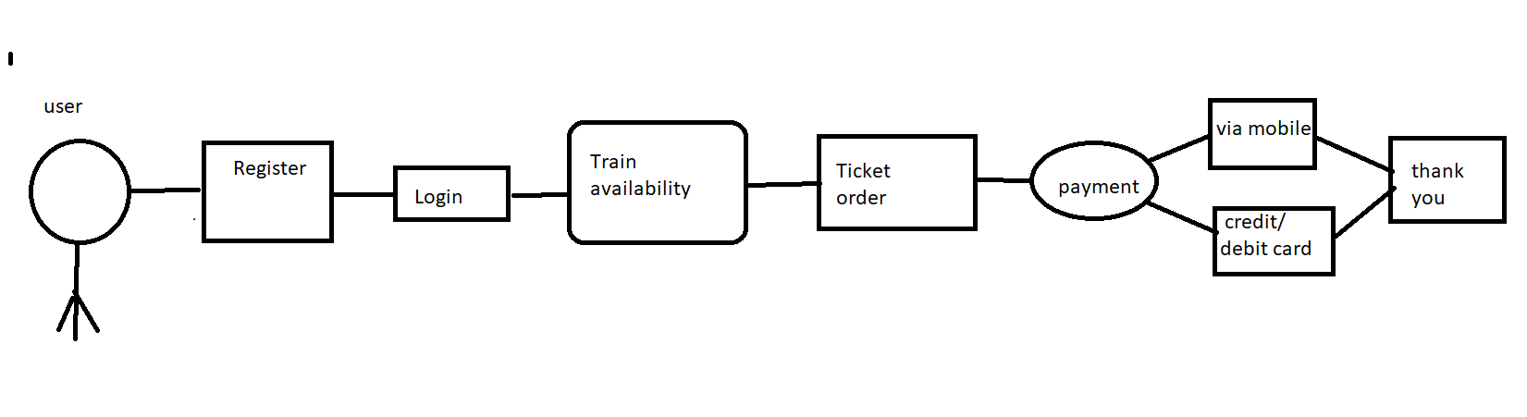

**LOGIN SERVICE**:

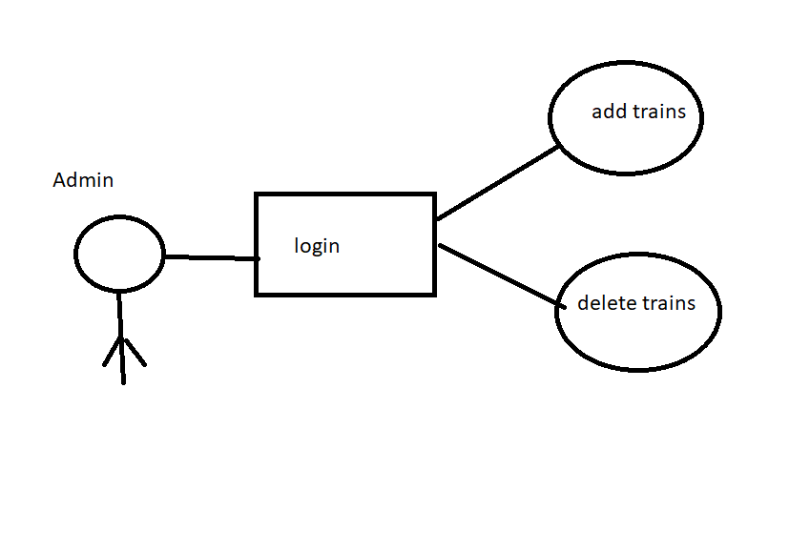

RAILWAY RESERVATIONSYSTEM ARCHITECTURE

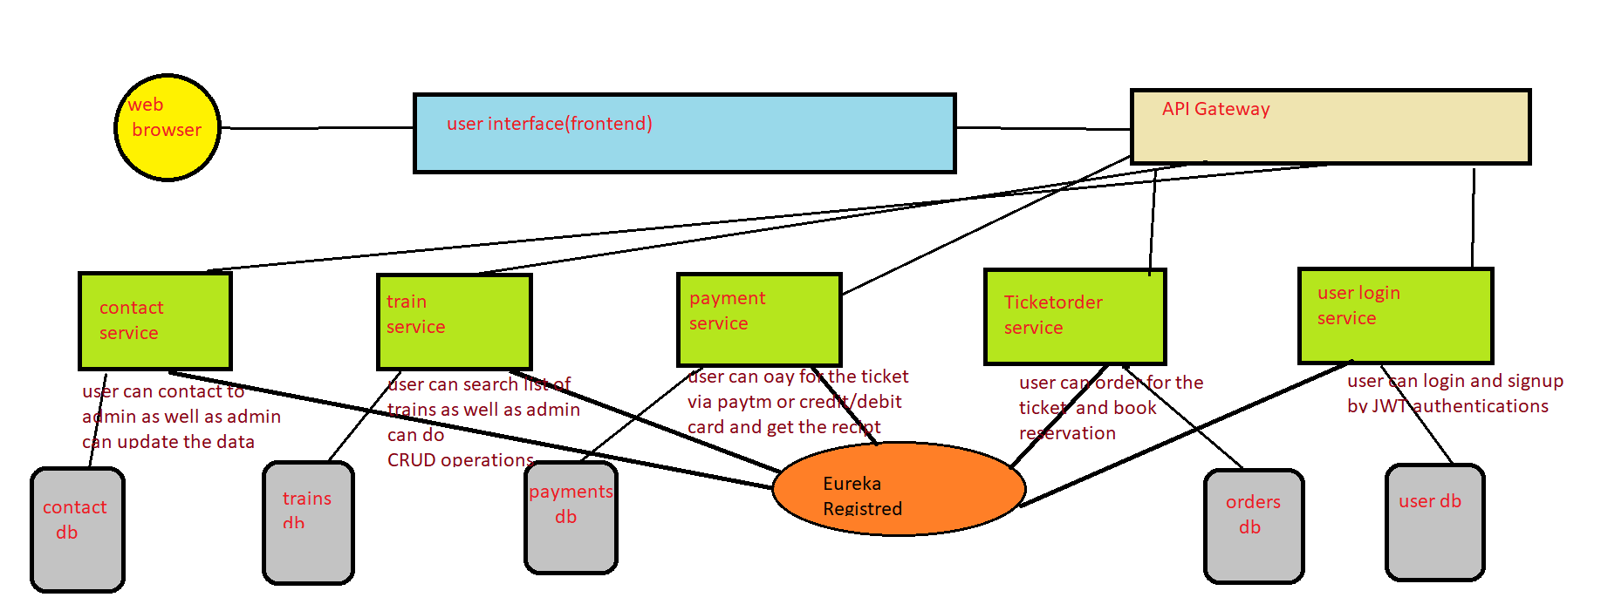

**This system is designed for the online reservation of railway system for travel b/w any destination.**

**This system enables the advance booking in any class against general and ladies quota ,on payment of fare in full for adults and childrens ,a maximum of the 6 seats at a time , for journey b/w any two stations served by a train**

**It also provides details about**

* **Time table**
* **Train fares**
* **Current status of reservation position**
* **Train available b/w a pair of stations**
* **Accommodation available for a train/date combination**

**To incorporate the above details we are going to implement the following services**

* *Contact service*-> in contact service the user can contact the admin regarding the booking details . at the same time the admin can update the train details such as train name, train id, source, destination
* *Booking order service->* in booking order service the user can book the train ticket and with respect to the source and destination and the train which the user chooses and the quantity (no of persons) .the user can even cancel the ticket if he is willing to do so.
* *Train service->*  in train service the user can search all the trains which is updated by the admin. The user can particularly search the train with respect to the source and destination.
* *Payment service->* in payment service after the confirmation of the ticket, the user has two option to pay the amount, that is via debit card/credit card or through phone number linking any UPI
* *User login service ->*  in user login service , there are two logins that is user login and admin login . the user has to enter the details such as user name, id, password. For which the user has to login again with username and password. The admin has to login with admin credentials.

*Mongo db->*  the above services which we are going to implement makes use of mongodb

*(FRONTEND)*

We are going to add the following tabs in our casestudy

* **Home tab**

The home page of the project is visible when the home tab is clicked

* **Train availability tab:**

The users can search the trains with help of source and destination parameter

Which is enter by the admin

* **Register tab:**

The users can register themselves with the help of forms

Enter username

Enter password

Enter Mobile Number

Enter gender

Register

* **Book train Tickets**:

After the user chooses the train from the train availability ,the user is redirected to the book train tickets tabs.

Choose option (from)

Choose option(to)

Regi

NEXT

Number of tickets

* **Payment Tab:**

After the user chooses the from option, to option and the number of tickets the user is redirected to the payment tab

sources

destination

No .of tickets

Total bill

**Select the payment method**

The user is given two options for the payment

**Credit/debit card**

Name on card

Credit/debit card number

CVV

Amount

Proced

**Mobile number**

Mobile number

Pin number

Amount

Proced

* **Admin tab:**

In this tab the admin of the website logins with username and password

Enter username

Enter password

SIGN IN